Exercise 9. Answer Sheet

Student's Name: ____Pham Xuan Loc_____ Student's ID: _____s1232006_____

Problem 1. (40 points) Find an optimal parenthesization of a matrix-chain product whose sequence of dimensions is <5, 10, 3, 12, 5, 50, 6>. Show your work (costs matrix m, number of multiplications).

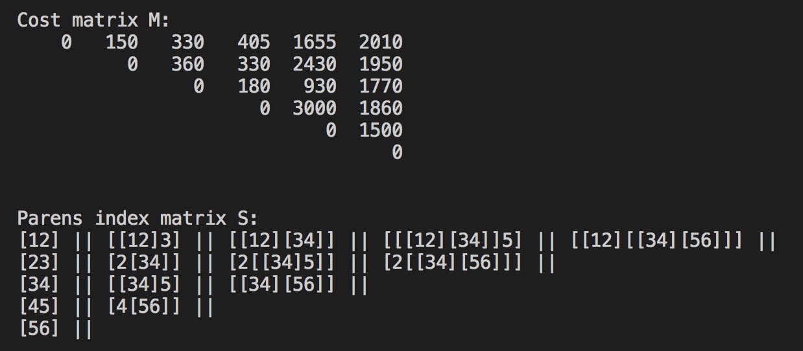

→ Minimum number of multiplications is 2010.
→ Optimal parens order is [[12][[34][56]]].

Problem 2. (60 points) Write a program implementing the algorithms Matrix-Chain-Order and Print-Optimal-Parens given in the lecture. Upload your code. Using your program, find the optimal parenthesization for the following matrix-chain products and show your m and s matrices.

a) (20 points) p = [30,35,15,5,10,20,25]

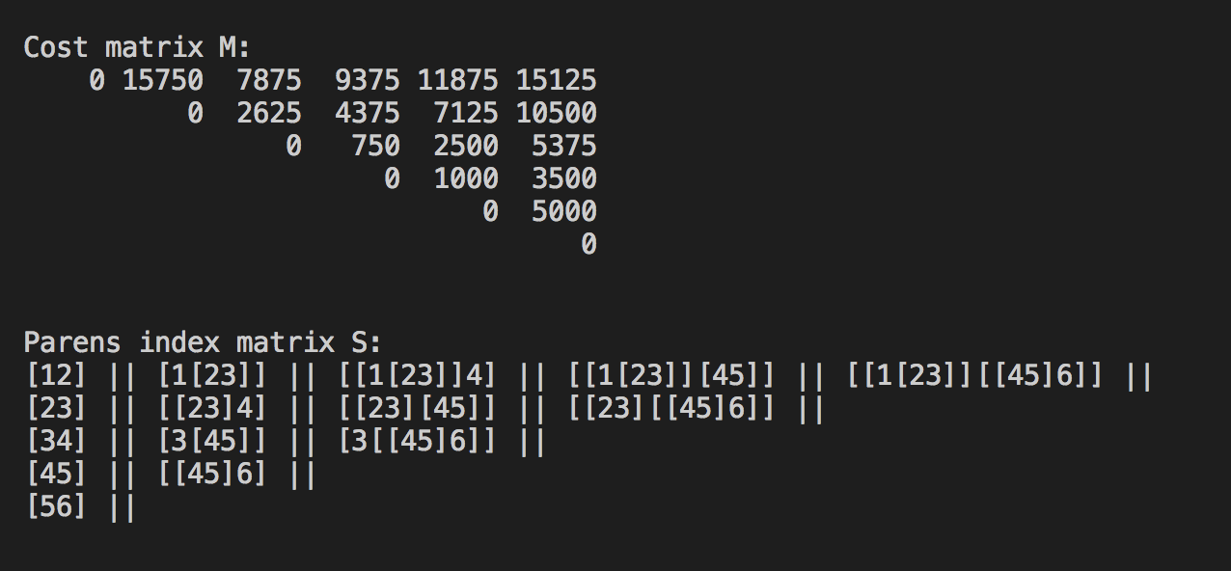

→ Minimum number of multiplications is 15125.
→ Optimal parens order is [[1[23]][[45]6].

b) (20 points) p = [10,20,10,15,20,10]

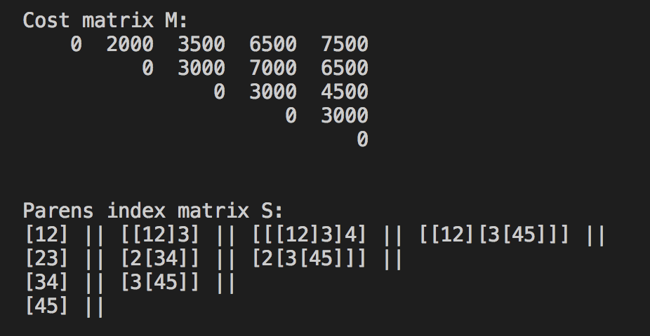

→ Minimum number of multiplications is 7500.
→ Optimal parens order is [[12][3[45]]].

c) (20 points) p = [100,10,100,1,1000,100]

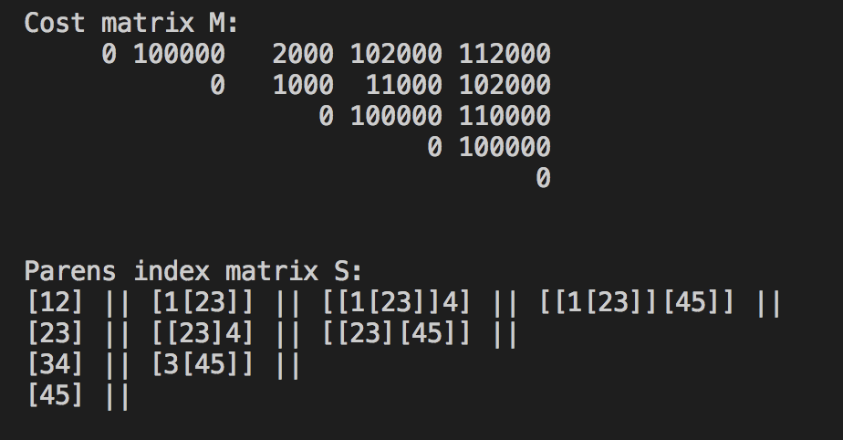

→ Minimum number of multiplications is 112000.
→ Optimal parens order is [[1[23]][45]].

compile and run command:
gcc dynamic_prog.c -o dynamic_prog && ./dynamic_prog

