Azure App Service & Dynatrace
Deployment Guide
Automated Deployment & Instrumentation Strategy
Version: 1.0 | Date: 2026

1. Introduction
This document outlines the automated deployment process for a .NET Web API hosted on Azure App Service (Linux), fully integrated with Dynatrace for Application Performance Monitoring (APM) and Log Management.

2. Setting Up Dynatrace
Before running the deployment script, you must configure a Dynatrace environment and generate a secure access token.

2.1 Create an Account
If you do not have an existing environment, start a free trial at: https://www.dynatrace.com/trial/

2.2 Identify Environment Details
You will need your Tenant ID and Domain. These are visible in your browser URL after logging in:
Format: https://{DT_TENANT}.{DT_DOMAIN}/ui/...
Variable | Example Value | Description
DT_TENANT | abc12345 | The unique ID at the start of the URL.
DT_DOMAIN | live.dynatrace.com | The domain following the tenant ID.

2.3 Create Access Token
The automation script requires specific API permissions to function.
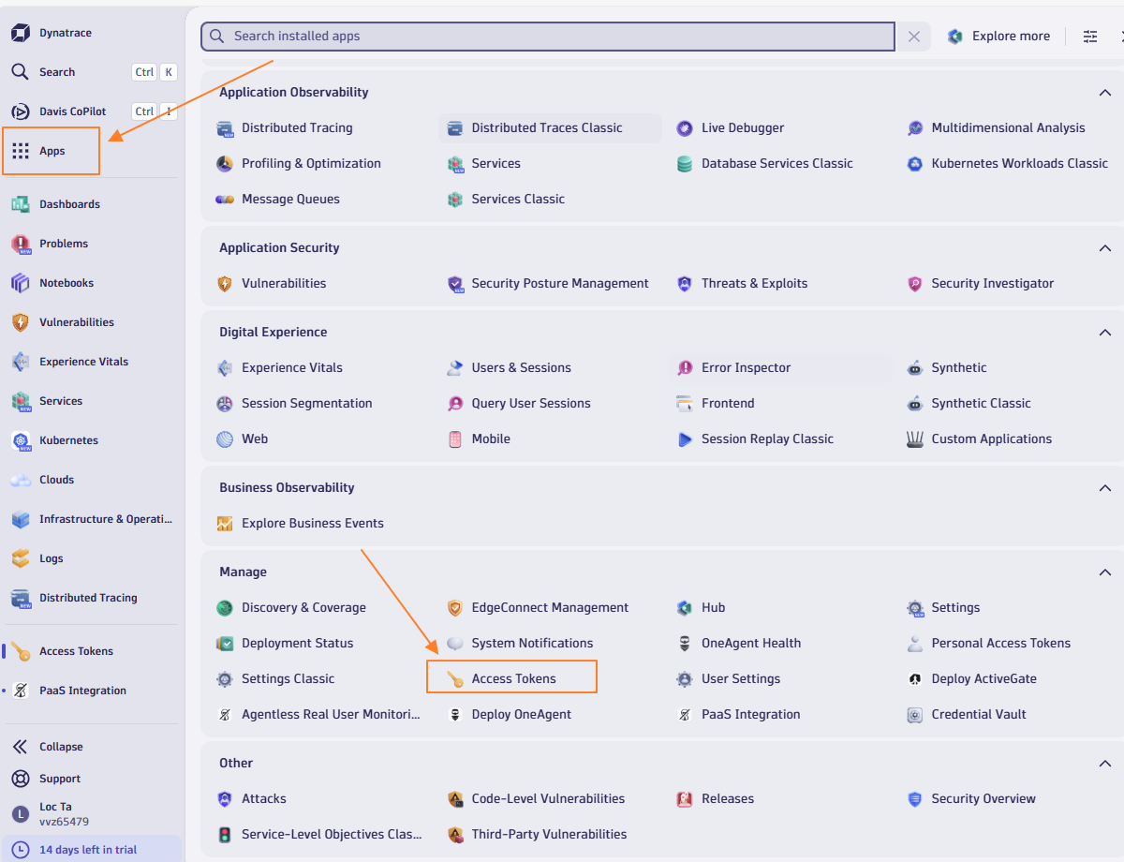
- Go to Manage > Access tokens.
- Click 'Generate new token'.
- Name the token (e.g., 'Azure-DevOps-Automation').
- Select the required scopes (see table below).
Required Scope | Purpose in Script
logs.ingest | Required for the C# app to push logs directly via API.
events.ingest | Required to send the "Deployment Completed" event.
entities.read | Allows verification of resources (Optional).
IMPORTANT: Copy the token immediately. You cannot view it again.

3. Prerequisites
Ensure the following are installed locally:
- Azure CLI (az): Logged in via `az login`.
- .NET SDK 8.0: Required to build the sample application.

4. Architecture & Integration Strategy
The deployment uses a specific strategy to ensure full observability on Azure Linux App Services:
- Infrastructure: Azure App Service (Linux) B1 Tier.
- APM Injection: The Dynatrace OneAgent is injected via a custom `Startup Command` rather than a site extension. This ensures the agent is loaded into the container environment before the .NET runtime starts.
- Dual-Layer Logging:
a. Native Console Logs: Captured by OneAgent.
b. Direct API Ingestion: The application includes a custom `DynatraceLogService.cs` that pushes structured logs directly to the Dynatrace Log Ingest API v2.

5. Script Configuration
Update the `CONFIGURATION` section at the top of the script with your details:
Variable | Description | Example
RESOURCE_GROUP | Azure Resource Group Name | dynatrace-demo-rg
APP_NAME | Unique App Name | dt-demo-api-v1
DT_TENANT | From Section 2.2 | abc12345
DT_TOKEN | From Section 2.3 | dt0c01.xxxxx...

6. Deployment Workflow

Step 1: Application Generation
The script automatically generates a .NET 8 WebAPI with:
- Controllers/HealthController.cs (Readiness probes)
- Services/DynatraceLogService.cs (Custom Log Ingester)

Step 2 & 3: Provisioning & Configuration
Provisions Azure resources and configures the `Startup Command` to download `oneagent-installer.sh`.

Step 4, 5 & 6: Deploy & Restart
Builds the app, deploys the ZIP package, and performs a double-restart to attach the OneAgent.

7. Verification
Once deployed, verify the installation:

App Validation
Visit the swagger endpoint: https://<your-app-name>.azurewebsites.net/swagger

Dynatrace Validation
1. Go to **Services** > Filter by `service.name`.
2. Go to **Logs** > Filter by `service.name`.
3. Look for the 'Deployment' annotation on the charts.

