BERKIN BELEROGLU
Experimental Design, Data Analysis and Presentation
Practicals#3 Report
Subject: One-way ANOVA
(instruction version 2025-11-24, edited by Paweł Koteja, based on materials from Joanna Rutkowska)
Packages used during this report:
- tidyverse
- ggplot2
- car (includes a very useful function leveneTest() for testing homogeneity of variance in ANOVA)

EXERCISES

3. ANOVA after data transformation
Silver nanoparticles (AgNPs) are widely used due to their effective bactericidal activities. However, safety concerns have been raised over the usage of AgNPs because they pose potential hazards. It has been shown that dietary exposure to AgNPs reduces lifespan in model organism, such as fruit files. A pilot study was designed to test whether flies’ lifespan differs depending on the shape of AgNPs (cubic, triangular, semi-spherical, rode and wire-like). 10-15 individual male files were fed medium with a given nano-particle shape and their lifespan was recorded.
Dataset “flies.txt”
Data on Drosophila melanogaster lifespan fed medium with five different shapes of silver nanoparticles.
Variable | Description
ID | Record index
Shape | Shape of silver nanoparticles (cubic, triangular, semi-spherical, rode and wire-like)
Lifespan | Age of death in days

Perform a complete analysis to answer the question whether the flies’ lifespan differs depending on the shape of AgNPs:
1. Get adequate descriptive statistics in the form of table and plots.
2. Perform ANOVA and use the diagnostic tools to check the assumptions of analysis of variance. If required assumptions are not met, do the appropriate transformation, re-run the analysis, and check the assumptions again.
3. If you find that lifespan differs among the five types (shapes) of nanoparticles, carry out an appropriate post-hoc analysis.
4. Write down results of the final analyses and formulate conclusions.
Solution:
# Objective:
# Test whether Drosophila lifespan differs depending on AgNP shape.
# H0: Mean lifespan does NOT differ among nanoparticle shapes.
# H1: Mean lifespan DOES differ among nanoparticle shapes.
flies <- read.delim("flies.txt", header = TRUE)
head(flies)
flies$Shape <- as.factor(flies$Shape)

###############################################################
# 2) DESCRIPTIVE STATISTICS
###############################################################
flies_summary <- flies %>% group_by(Shape) %>%
summarise(
mean = mean(Lifespan),
median = median(Lifespan),
maximum = max(Lifespan),
minimum = min(Lifespan),
sd = sd(Lifespan),
N = length(Lifespan)
)
flies_summary
# A tibble: 5 × 7
Shape mean median maximum minimum sd N
<fct> <dbl> <dbl> <int> <int> <dbl> <int>
1 cubic 6.93 5 26 1 6.58 15
2 rode 19.8 10 90 1 27.0 10
3 semi_spherical 15.5 12 56 4 13.2 15
4 triangular 9.15 4 34 1 10.4 13
5 wire_like 40.6 36.5 91 1 31.6 10
#From the descriptive statistics it is already possible to see there are large variability across groups. (cubic mean= 6.93, wire_like= 40.6)
###############################################################
# 3) PLOT
###############################################################

Boxplot_flies_dots <- ggplot(data = flies,
mapping = aes(x = Shape,
y = Lifespan,
fill = Shape)) +
geom_boxplot(alpha = 0.3, outlier.shape = NA) +
geom_point(color = "black",
position = position_jitterdodge(jitter.width = 0.1),
size = 3, alpha = 0.5, stroke = 0) +
theme_classic() +
theme(text = element_text(size = 14)) +
labs(x = "Shape", y = "Lifespan (median, quartiles, range)")
Boxplot_flies_dots 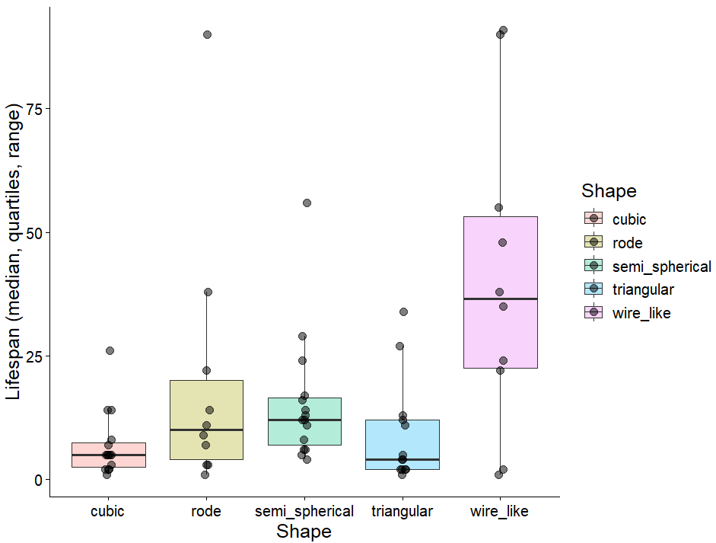

###############################################################
#ANOVA ON RAW DATA
###############################################################
flies_Anova <- aov(Lifespan ~ Shape, data = flies)
summary(flies_Anova)

# Normality of residuals
hist(flies_Anova$residuals, prob = TRUE)
curve(dnorm(x, 0, sd = sd(flies_Anova$residuals)),
col = "darkblue", lwd = 2, add = TRUE, yaxt = "n")
plot(flies_Anova, 2)
shapiro.test(flies_Anova$residuals)

Shapiro-Wilk normality test
data: flies_Anova$residuals
W = 0.83156, p-value = 5.546e-07

# The distribution of the data is not normal, as supported by the histograms,
# diagnostic plots, and the Shapiro–Wilk normality test (W = 0.8316, p = 5.546e-07).

# Homogeneity of variances
leveneTest(y = flies$Lifespan, group = flies$Shape, center = median)
Levene's Test for Homogeneity of Variance (center = median)
Df F value Pr(>F)
group 4 3.5678 0.01141 *
58
#As the data doesn't have the normal distribution and the variances are not equal
#data needs transformation.

# Conclusion:
# Because normality and variance homogeneity are violated,
# we apply a transformation and re-run the analysis.

###############################################################
#TRANSFORMATION (LOG10) + ANOVA AGAIN
###############################################################
flies$LogLifespan <- log10(flies$Lifespan)

fliesLog_Output <- aov(LogLifespan ~ Shape, data = flies)
summary(fliesLog_Output)

###############################################################
#ASSUMPTION CHECK (TRANSFORMED DATA)
###############################################################

# Normality after transformation
hist(fliesLog_Output$residuals, prob = TRUE)
curve(dnorm(x, 0, sd = sd(fliesLog_Output$residuals)),
col = "darkblue", lwd = 2, add = TRUE, yaxt = "n")
plot(fliesLog_Output, 2)
shapiro.test(fliesLog_Output$residuals)

Shapiro-Wilk normality test

data: fliesLog_Output$residuals
W = 0.97982, p-value = 0.388
# Interpretation:
# Shapiro–Wilk is not significant (W = 0.9798, p = 0.388),
# so residuals are approximately normal.

plot(fliesLog_Output, 1)
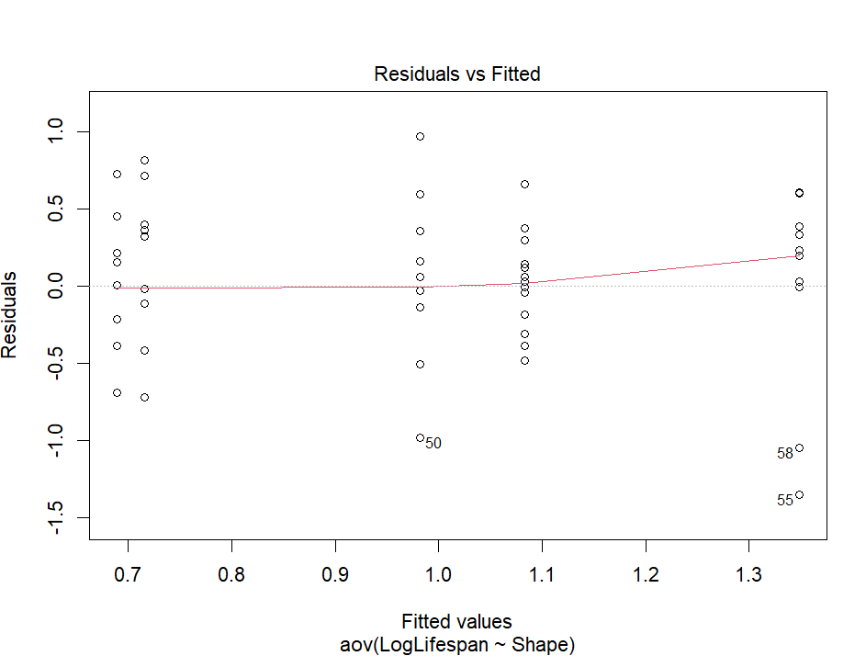

# Homogeneity after transformation
leveneTest(LogLifespan ~ Shape, data = flies)

Levene's Test for Homogeneity of Variance (center = median)
Df F value Pr(>F)
group 4 1.1166 0.3575
58
# Interpretation:
# Levene’s test is not significant (F = 1.1166, p = 0.3575),
# so variances are homogeneous.

###############################################################
#FINAL ANOVA RESULT (TRANSFORMED DATA)
###############################################################
summary(fliesLog_Output)
Call:
aov(formula = LogLifespan ~ Shape, data = flies)

Terms:
Shape Residuals
Sum of Squares 3.592035 13.071322
Deg. of Freedom 4 58

Residual standard error: 0.474729
# Interpretation:
# ANOVA is significant (F(4,58) = 3.985, p = 0.00635),
# indicating that at least one shape differs in mean lifespan.

###############################################################
# 9) MEANS PLOT (MEAN ± SE + 95% CI)
###############################################################
Mean_SE_95CI <- function(Y) {
v <- c(mean(Y) - qt(0.975, df = length(Y)-1) * sd(Y) / sqrt(length(Y)),
mean(Y) - sd(Y) / sqrt(length(Y)),
mean(Y),
mean(Y) + sd(Y) / sqrt(length(Y)),
mean(Y) + qt(0.975, df = length(Y)-1) * sd(Y) / sqrt(length(Y)))
names(v) <- c("ymin", "lower", "middle", "upper", "ymax")
v
}

Meansplot_fliesLog <- ggplot(data = flies, mapping = aes(x = Shape, y = LogLifespan)) +
stat_summary(fun.data = Mean_SE_95CI, geom = "boxplot", width = 0.7) +
theme_classic() +
theme(text = element_text(size = 14)) +
labs(x = "Shape", y = "log10(Lifespan [days]) (mean±SE and 95% CI)")
Meansplot_fliesLog
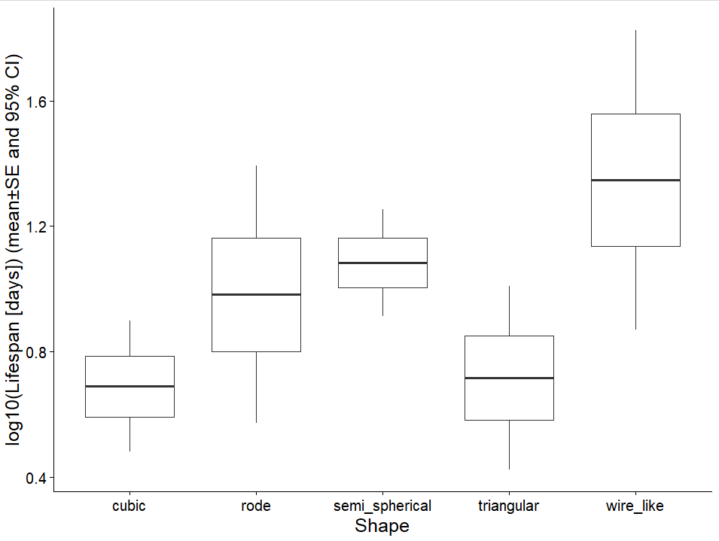
# Mean values with standard errors and 95% confidence intervals indicate that
# wire_like nanoparticles are associated with higher lifespan compared to cubic
# and triangular shapes, while other shapes show intermediate values.

###############################################################
# 10) POST-HOC TEST — TUKEY HSD
###############################################################
TukeyHSD(fliesLog_Output)

Tukey multiple comparisons of means
95% family-wise confidence level
Fit: aov(formula = LogLifespan ~ Shape, data = flies)

$Shape
diff lwr upr p adj
rode-cubic 0.29305668 -0.25259624 0.8387096 0.5589753
semi_spherical-cubic 0.39434243 -0.09370437 0.8823892 0.1678832
triangular-cubic 0.02703757 -0.47943253 0.5335077 0.9998817
wire_like-cubic 0.65954176 0.11388884 1.2051947 0.0102652
semi_spherical-rode 0.10128576 -0.44436716 0.6469387 0.9847163
triangular-rode -0.26601911 -0.82821070 0.2961725 0.6724918
wire_like-rode 0.36648508 -0.23124774 0.9642179 0.4263231
triangular-semi_spherical -0.36730487 -0.87377497 0.1391652 0.2595606
wire_like-semi_spherical 0.26519932 -0.28045359 0.8108522 0.6500138
wire_like-triangular 0.63250419 0.07031260 1.1946958 0.0199380

# The Tukey post-hoc comparison shows that most pairwise differences between
# nanoparticle shapes are not statistically significant, as their adjusted
# p-values are high. Significant differences were found for wire_like vs cubic
# (p adj = 0.0103) and wire_like vs triangular (p adj = 0.0199), indicating that
# the wire_like shape is associated with a significantly higher mean lifespan
# than the cubic and triangular shapes.

4. Non-parametric ANOVA: Kruskal-Wallis test
For the same problem and data as described in exercise 3 perform the analysis using non-parametric Kruskal-Wallis test – which would be the method of choice if no reasonable transformation would lead to normal distribution (e.g. if the data contained outliers which should be not removed, because with high certainty they were not due to sampling or measurement errors).

Optional, to satisfy curiosity:
The non-parametric Kruskal-Wallis test is based on the ANOVA performed on the original data converted to ranks. You can try to see the similarity in the following way:
- Create a new column of data, which will have Lifespan values replaced by their ranks (use rank function).
- Perform analysis of variance again - but for the values converted to the ranks.
- Compare the results obtained in this way with those obtained with kruskal.test() function and those obtained exercise 3 (parametric ANOVA on transformed data).
Solution:
#Exercise 4
#In this exercise, till the transformation step, the code is the same. In this case, we don’t apply the transformation but conduct the non-parametric test instead.
#Rank Transformation
flies$Rank_Lifespan <- rank(flies$Lifespan)
# KRUSKAL–WALLIS TEST
flies_rank_Output <- kruskal.test(Rank_Lifespan ~ Shape, data = flies)
flies_rank_Output
Kruskal-Wallis rank sum test
data: Rank_Lifespan by Shape
Kruskal-Wallis chi-squared = 13.626, df = 4, p-value = 0.008591
# The Kruskal–Wallis test is significant (chi-squared = 13.626, p = 0.008591),
# indicating that lifespan differs among at least some nanoparticle shapes.

# NON-PARAMETRIC POST-HOC TEST (PAIRWISE WILCOXON)
pairwise.wilcox.test(x = flies$Lifespan,
g = flies$Shape,
p.adjust.method = "holm",
exact = FALSE)
data: flies$Lifespan and flies$Shape
cubic rode semi_spherical triangular
rode 0.618 - - -
semi_spherical 0.076 1.000 - -
triangular 1.000 0.828 0.222 -
wire_like 0.100 0.603 0.312 0.142
# Results:
# In the non-parametric post-hoc test we can see that the p-values
# are overall higher than in the ANOVA test from Exercise 3,
# but the lowest p-values are observed for semi_spherical vs cubic
# and wire_like vs cubic.

