Experimental Design, Data Analysis and Presentation p. I
Practicals #4 Berkin Beleroglu Report
Simple regression and correlation, multiple regression
(instruction version 2024-12-09, edited by Paweł Koteja, based on materials from Joanna Rutkowska)

EXERCISES

2. Applying a data transformation and comparing regression coefficient to a pre-defined value
It has been known since the 19th century that the resting metabolic rate (RMR) of animals increases with body mass (M) not linearly but "allometrically": approximately according to a power function: RMR = a M^{b}. Initially it was thought that this relationship was proportional to body surface area, so that the slope of the allometric relation (the power coefficient, b) should be about 2/3 (0.67). However, it was later found that the slope was closer to 3/4 (0.75). A similar, 3/4 scaling coefficient of the allometric relation to body mass has been later described for several other physiological, life history and ecological characteristics. A number of theories have been developed to justify why such a scaling slope should appear for so many variables. Many authors consider the 3/4 allometric slope as representing the “Metabolic theory of ecology”, and the idea remains subject of a fierce debate: https://en.wikipedia.org/wiki/Metabolic_theory_of_ecology
The scaling of the physiological and ecological variables to body mass is indeed important not only from theoretical perspective, but also in practical environmental issues and conservation biology. relation are indeed important in do remains subject to scientific debate.
In this exercise, answer the question whether the resting metabolic rate in rodents increases with body mass to the power of 0.75 or whether it follows the "law of area" (2/3 power).

Dataset “rodents.txt”
Data table with results of RMR measurements in 114 rodent species.
Variable | Description
No | Species number (the species names have been omitted for simplicity)
M | Body mass (g), (species average)
RMR | Resting metabolic rate, measured as the rate of oxygen consumption rate (mlO2/h), species average

Perform the analysis according the same scheme as described in exercise 1, but with the addition of testing the specific two alternative hypotheses concerning the slope of the relationship. Thus, the complete must answer the following three questions:
(a) does the metabolic rate increase with body mass?
(b) does the slope of this relationship (the exponent in the allometric equation) agrees with the predictions of the “metabolic theory of ecology” (the 3/4 power)
(c) or rather the slope agrees with the prediction of the “low of area” (2/3 power)?
Hints and notes:
- Recall how the linear model can be effectively used to analyze the allometric relationship, described by the power equation (the answer is in lecture presentation).
- This exercise provides an example of different meanings of the term “alternative hypothesis”. In the “language” of the research problem, we have here two “alternative working hypotheses”: that the slope is 2/3 or 3/4. In the language of statistical analyses, they can be expressed and tested as two null hypotheses: H₀: slope=2/3, H₀: slope = 3/4. In addition, we ask whether RMR at all depends on body mass, but as the hypothesis “RMR depends on body mass” cannot be tested directly, we test the null hypothesis H₀: slope = 0. In the language of statistics, each of these null hypotheses is accompanied by the “statistical alternative hypothesis”, which say that the slope is different than that assumed in H₀.
An extra task: In this exercise, when we apply the simple linear model with parameters estimated with the ordinary least-squares method, we violate one of the important assumptions, and the problem cannot be solved by just applying a transformation. Try to explain, which assumption is violated and why. A hint: understanding this problem does not require a knowledge of statistics, but knowledge about the fundamental theory in biology. A proper analysis would require not only additional data, but also applying more advanced statistical methods, which go beyond the scope of our course (so called “generalized linear model”). In our course, however, it will be enough if you can recognize the problem and know, that a solution exists.

SOLUTION:
library(tidyverse)
library(ggplot2)
library(scatterplot3d)
#Dataset
Rodents_Data <- read.delim("rodents.txt", header = TRUE)
head(Rodents_Data)
## No M RMR
## 1 1 5.2 28.1
## 2 2 34.6 64.7
## 3 3 23.5 40.0
## 4 4 42.3 57.5
## 5 5 27.0 49.4
## 6 6 76.8 110.6
#################################################################################
# Descriptive statistics of the variables
##################################################################################

# Descriptive statistics for body mass (M)
Rodents_Data %>%
summarise(N = n(), mean = mean(M), median = median(M),
maximum = max(M), minimum = min(M), sd = sd(M))
## N mean median maximum minimum sd
## 1 114 89.68947 42 1870.9 5.2 196.3169
# Descriptive statistics for resting metabolic rate (RMR)
Rodents_Data %>%
summarise(N = n(), mean = mean(RMR), median = median(RMR),
maximum = max(RMR), minimum = min(RMR), sd = sd(RMR))
## N mean median maximum minimum sd
## 1 114 93.96491 65.1 1029 13.5 119.6336
# NOTES:
# Here both M and RMR are measured variables (not controlled experimental treatments),
# so descriptive statistics for both variables are meaningful.

##################################################################################
# Graphs
#################################################################################

# Scatterplot on raw scale (M vs RMR)
# exploration is offered by X-Y scatterplots:
Plot1_RMR <- ggplot(data = Rodents_Data, aes(x = M, y = RMR)) +
geom_point() +
stat_smooth(method = lm) +
theme_classic() +
theme(text = element_text(size = 14)) +
labs(x = "Body mass [g]", y = "RMR [mlO2/h]")
Plot1_RMR
## `geom_smooth()` using formula = 'y ~ x'
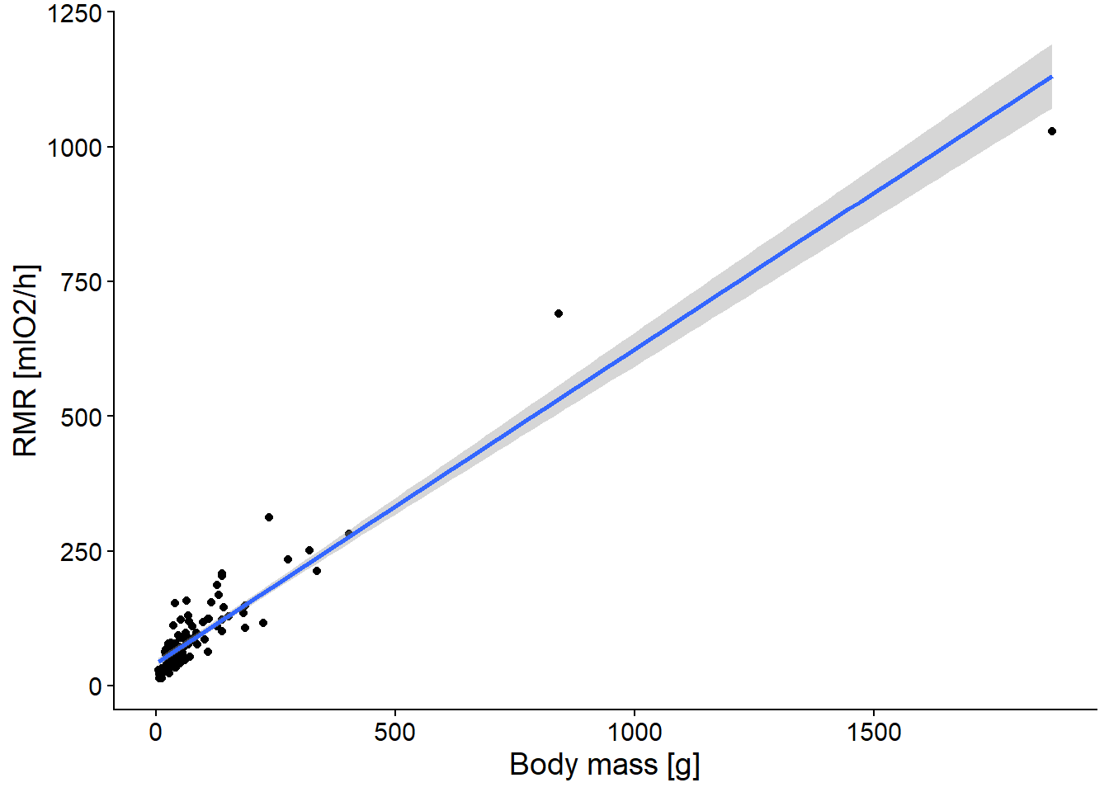
# The raw-scale relationship is curved (typical for allometry), so log transformation is needed.

##################################################################################
# Data transformation
##################################################################################
# Data transformation - with log10
# Transform the variables for linear analysis of the allometric relation.
# Here we create new variables: logM and logRMR.
Rodents_Data <- mutate(Rodents_Data, LogM = log10(M), LogRMR = log10(RMR))

##################################################################################
# Plot of LogRMR vs LogM
#################################################################################
Plot1_logRMR <- ggplot(data = Rodents_Data, aes(x = LogM, y = LogRMR)) +
geom_point() +
theme_classic() +
theme(text = element_text(size = 14)) +
labs(x = "log10(Body mass [g])", y = "log10(RMR [mlO2/h])")
Plot1_logRMR
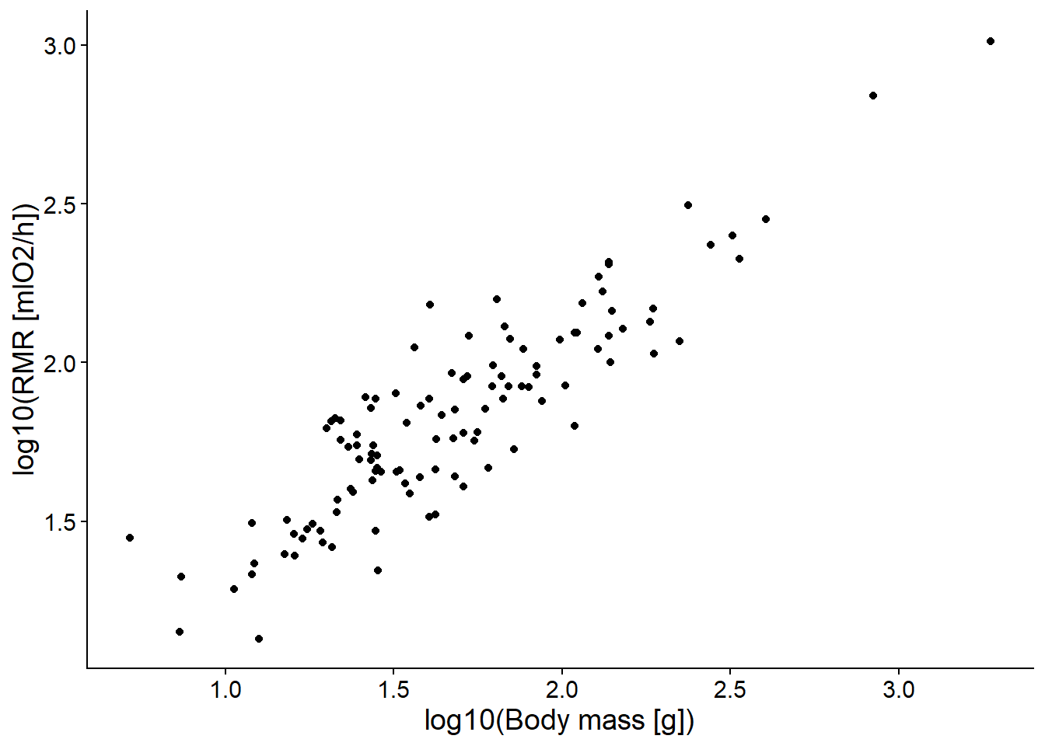
# Now the relation appears approximately linear; normality is checked later using residual diagnostics.

##################################################################################
# Fitting the linear model to log transformed values
##################################################################################
LogRMR_Output <- lm(LogRMR ~ LogM, data = Rodents_Data)

##################################################################################
# Analysis of residuals
##################################################################################

# Analysis or residuals
# Checking normality - histogram, quantile plot, and Shapiro-Wilk test
hist(LogRMR_Output$residuals)
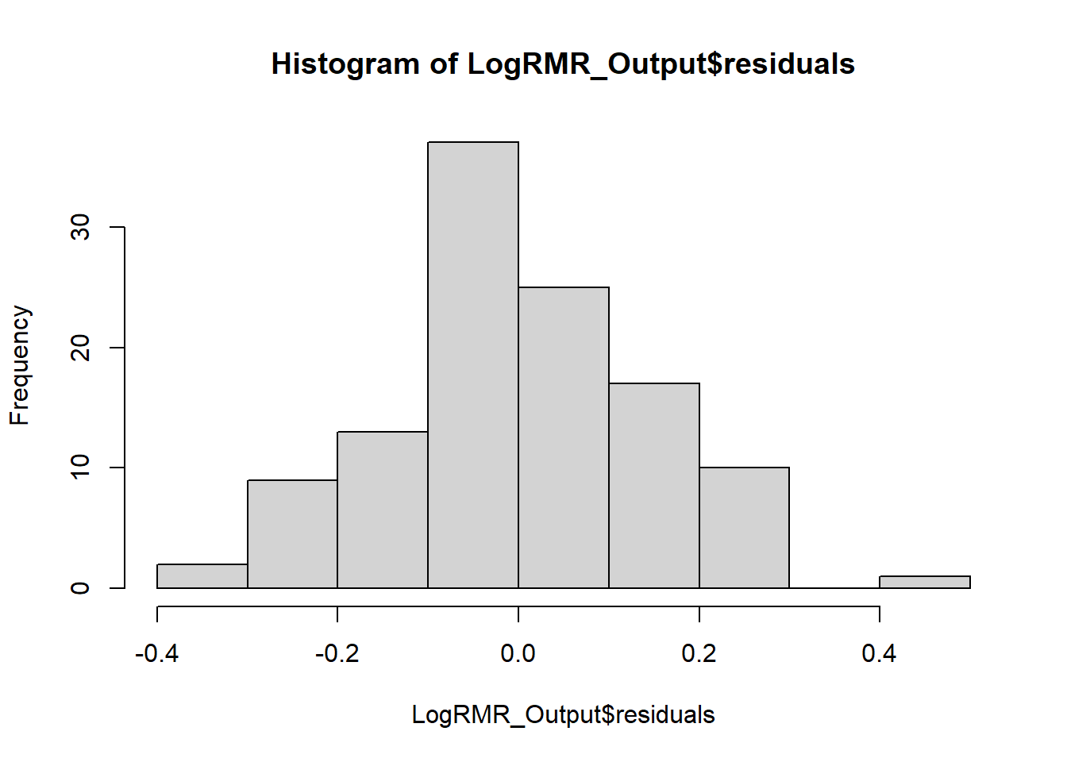
plot(LogRMR_Output,2)
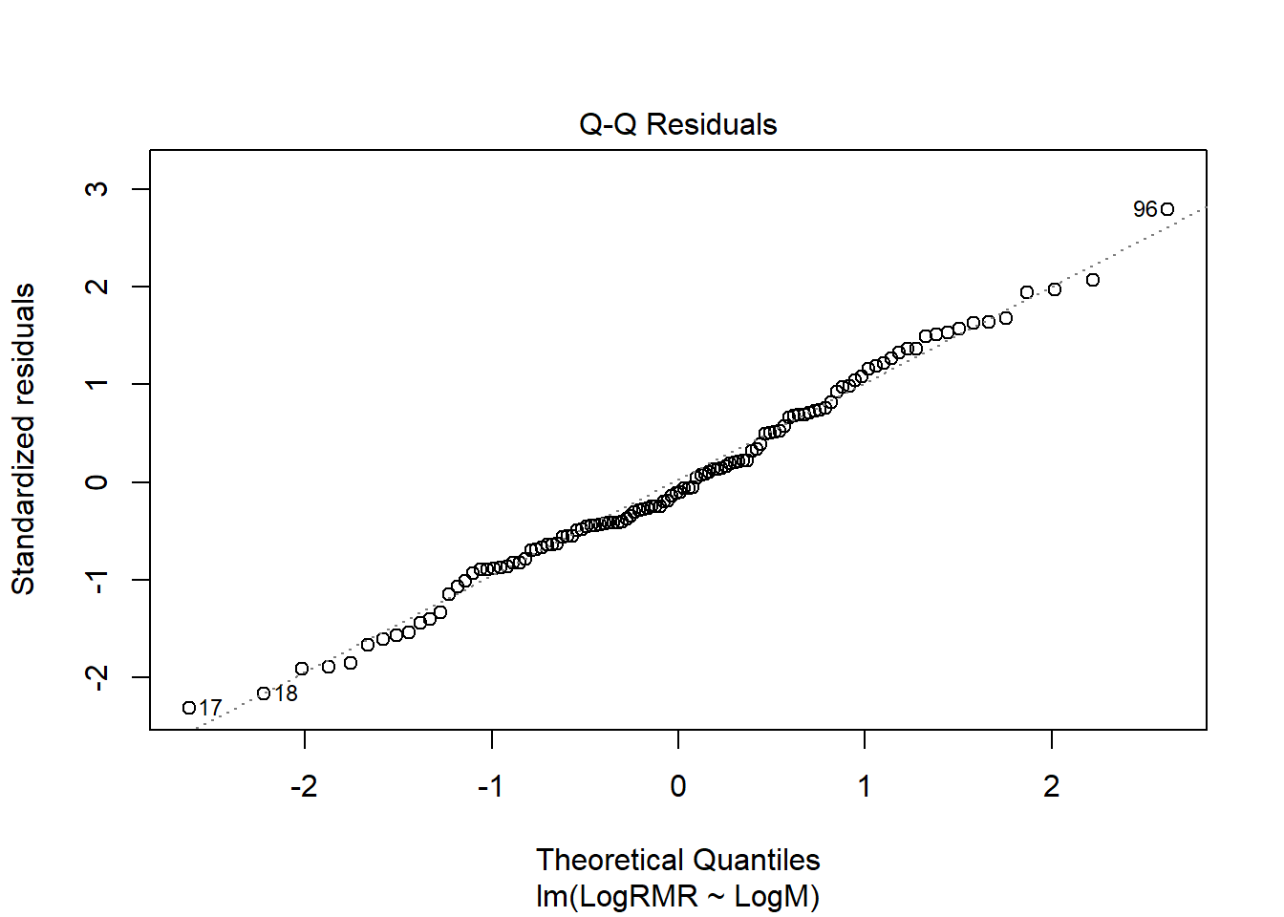
shapiro.test(LogRMR_Output$residuals)
##
## Shapiro-Wilk normality test
##
## data: LogRMR_Output$residuals
## W = 0.99106, p-value = 0.6673
# Distribution looks normal

# Checking linearity homogeneity of variance - plot of residual vs predicted values
plot(LogRMR_Output,1)
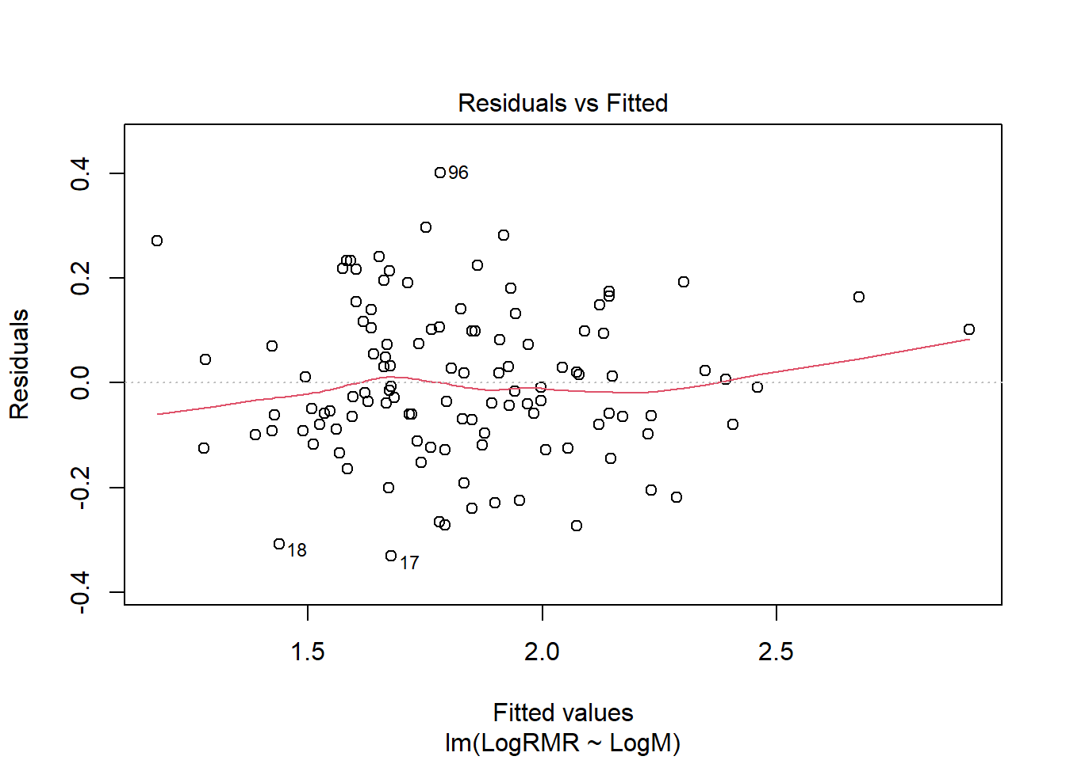
# The plot indicates a linear relationship and constant variance of the
#residuals (homoscedasticity)

# Checking distribution of the points influence - Cook's distance, and plot of
#residual vs leverage
plot(LogRMR_Output,4)
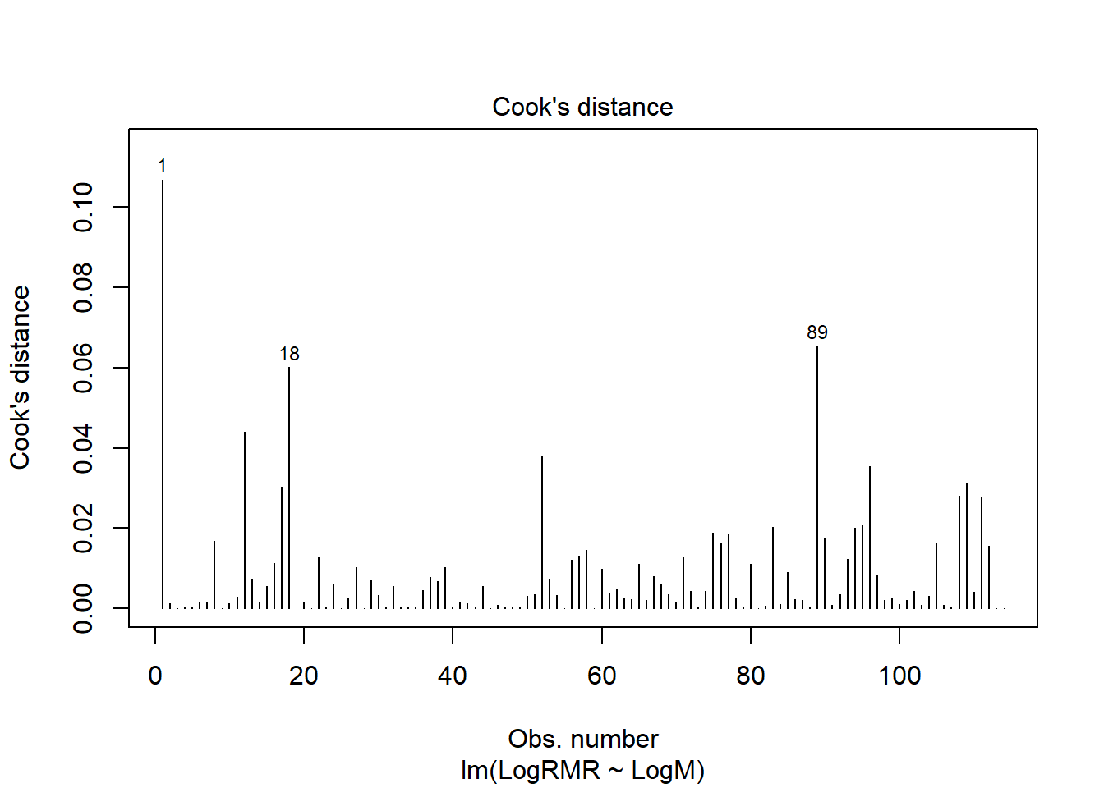
plot(LogRMR_Output,5)
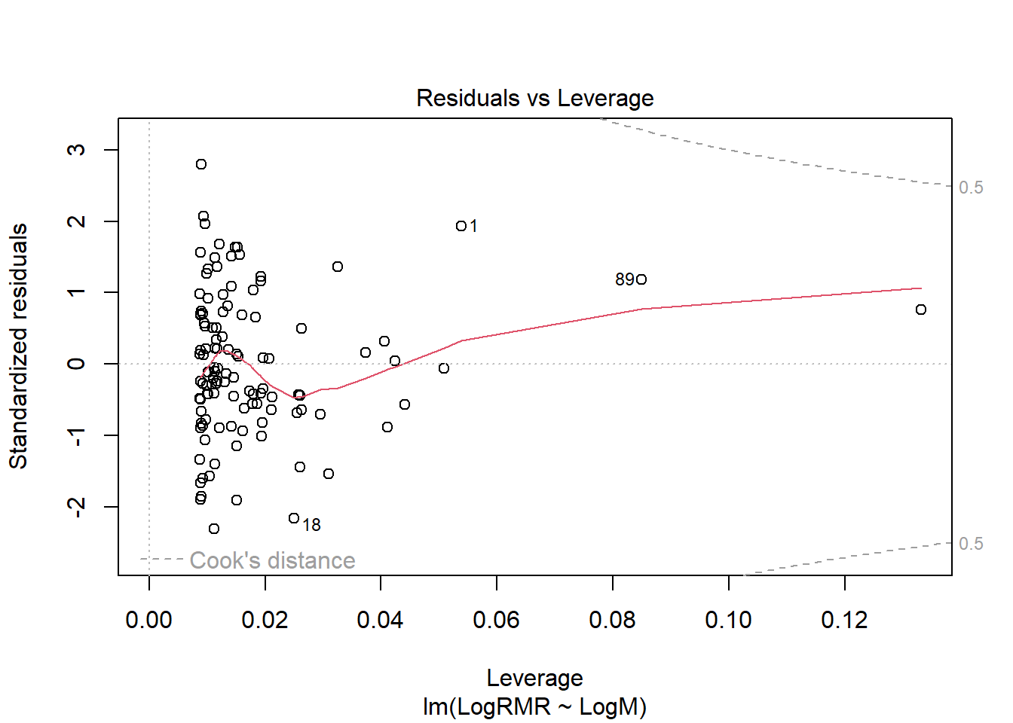
# The influence of the data points appears more balanced, with no observations
#showing an excessively large Cook’s.

# Summary of the diagnostics: assumptions of linearity and distribution of residuals
# (normality, homogeneity of variances) are satisfied. None of the points are too influential.

# Printing the main results of the analysis:
# tables with coefficients of regression and their confidence intervals
# and plot illustrating the relation
summary(LogRMR_Output)
##
## Call:
## lm(formula = LogRMR ~ LogM, data = Rodents_Data)
##
## Residuals:
## Min 1Q Median 3Q Max
## -0.33113 -0.09080 -0.01536 0.09915 0.40068
##
## Coefficients:
## Estimate Std. Error t value Pr(>|t|)
## (Intercept) 0.69180 0.05503 12.57 <2e-16 ***
## LogM 0.67823 0.03182 21.31 <2e-16 ***
## ---
## Signif. codes: 0 '***' 0.001 '**' 0.01 '*' 0.05 '.' 0.1 ' ' 1
##
## Residual standard error: 0.1439 on 112 degrees of freedom
## Multiple R-squared: 0.8022, Adjusted R-squared: 0.8005
## F-statistic: 454.3 on 1 and 112 DF, p-value: < 2.2e-16
confint(LogRMR_Output)
## 2.5 % 97.5 %
## (Intercept) 0.5827629 0.8008407
## LogM 0.6151763 0.7412741
Plot2_LogRMR <- ggplot(data = Rodents_Data, aes(x = LogM, y = LogRMR)) +
geom_point() + stat_smooth(method = lm) +
theme_classic() +
theme(text = element_text(size = 14)) +
labs(x = "Log10(Body mass [g])", y = "log10(RMR [mlO2/h])")
Plot2_LogRMR
## `geom_smooth()` using formula = 'y ~ x'
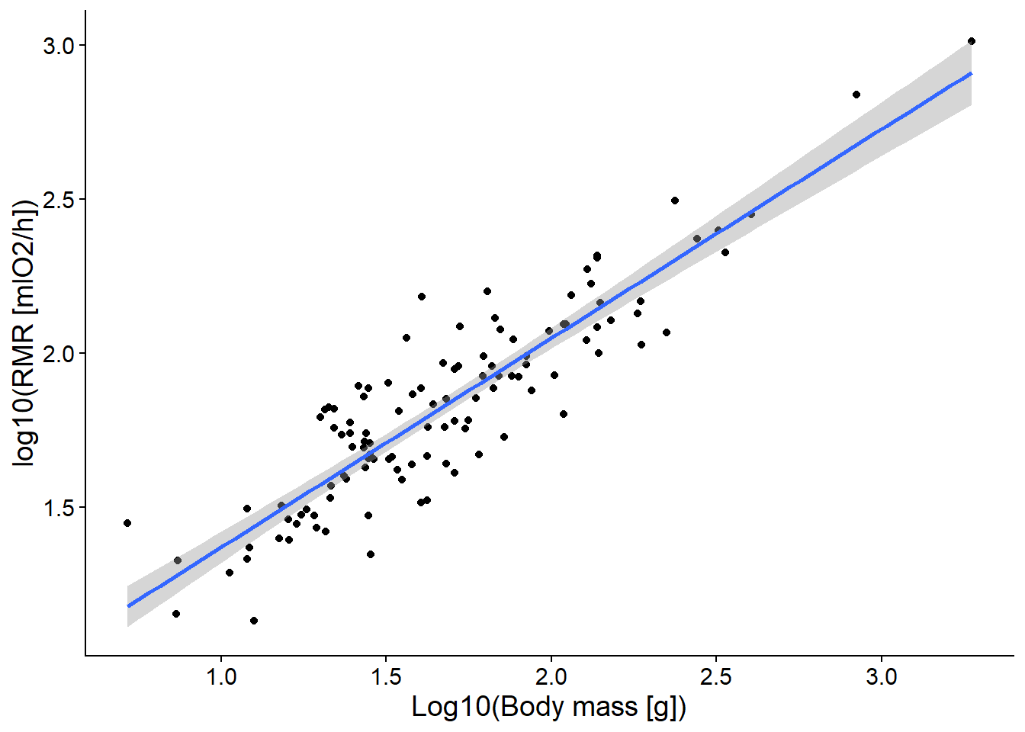
# Summary of results and conclusions:
# RMR increases significantly with body mass following an allometric (power-law) relationship.
# The estimated slope is 0.68 ± 0.032 (t(112) = 21.31, p < 2e-16).

# The 95% confidence interval for the slope is 0.61–0.74.
# Since this interval excludes 0.75, the hypothesis of 3/4-power scaling is rejected (p < 0.05).

# In contrast, the interval includes 0.66(6), indicating no significant difference
# from 2/3-power scaling (p > 0.05), which supports the alternative hypothesis.

# Testing hypotheses based solely on confidence intervals does not yield exact p-values.
# A more robust approach is to test slope values directly using an offset in the linear model.

# To test the hypothesis that the slope equals 0.75:
RMR_Output_075 <- lm(LogRMR ~ LogM + offset(0.75*LogM), data = Rodents_Data)
summary(RMR_Output_075)
##
## Call:
## lm(formula = LogRMR ~ LogM + offset(0.75 * LogM), data = Rodents_Data)
##
## Residuals:
## Min 1Q Median 3Q Max
## -0.33113 -0.09080 -0.01536 0.09915 0.40068
##
## Coefficients:
## Estimate Std. Error t value Pr(>|t|)
## (Intercept) 0.69180 0.05503 12.571 <2e-16 ***
## LogM -0.07177 0.03182 -2.256 0.026 *
## ---
## Signif. codes: 0 '***' 0.001 '**' 0.01 '*' 0.05 '.' 0.1 ' ' 1
##
## Residual standard error: 0.1439 on 112 degrees of freedom
## Multiple R-squared: 0.04345, Adjusted R-squared: 0.03491
## F-statistic: 5.088 on 1 and 112 DF, p-value: 0.02604
# When the slope is fixed at 0.75 using an offset, the estimated deviation from zero
# is significant: (slope − 0.75) = −0.071 ± 0.032, t(112) = −2.56, p = 0.026.
# This indicates that the observed slope differs significantly from 0.75.

# To test the hypothesis that the slope equals 2/3 (~0.67):
RMR_Output_067 <- lm(LogRMR ~ LogM + offset(2/3*LogM), data = Rodents_Data)
summary(RMR_Output_067)
##
## Call:
## lm(formula = LogRMR ~ LogM + offset(2/3 * LogM), data = Rodents_Data)
##
## Residuals:
## Min 1Q Median 3Q Max
## -0.33113 -0.09080 -0.01536 0.09915 0.40068
##
## Coefficients:
## Estimate Std. Error t value Pr(>|t|)
## (Intercept) 0.69180 0.05503 12.571 <2e-16 ***
## LogM 0.01156 0.03182 0.363 0.717
## ---
## Signif. codes: 0 '***' 0.001 '**' 0.01 '*' 0.05 '.' 0.1 ' ' 1
##
## Residual standard error: 0.1439 on 112 degrees of freedom
## Multiple R-squared: 0.001177, Adjusted R-squared: -0.007741
## F-statistic: 0.1319 on 1 and 112 DF, p-value: 0.7171
# With the slope constrained to 2/3, the deviation from zero is not significant:
# (slope − 0.67) = 0.011 ± 0.032, t(112) = 0.36, p = 0.72.
# Therefore, the observed slope does not differ significantly from 2/3.

# GENERAL SUMMARY AND CONCLUSIONS:
# The analysis shows that rodent RMR scales allometrically with body mass,
# with an estimated slope of 0.68 ± 0.032.
# This value is consistent with the 2/3 exponent predicted by the surface law (p = 0.72),
# but is significantly different from the 3/4 exponent proposed by Kleiber’s law
# and the Metabolic Theory of Ecology (p = 0.026).

##################################################################################
# NEW TASK "MONKEYS"
##################################################################################
# RESERCH PROBLEM:
# Association between social dominance and "quality" of individuals
# WORKING HYPOTHESIS:
# Dominance ranking of monkeys is correlated with the degree of parasite load
# NULL HYPOTHESIS:
# There is no relationship between dominance rank and number of parasitic eggs

Monkeys_Data <- read.delim("Monkeys.txt", header = TRUE)
head(Monkeys_Data)
## Nr Monkey_name DomRank NEggs
## 1 1 Alfa 1 5777
## 2 2 Beta 2 1625
## 3 3 Gamma 3 1174
## 4 4 Delta 4 949
## 5 5 Theta 5 749
## 6 6 Omega 6 870
# The dataset contains only a few observations, so instead of calculating
# descriptive statistics, we focus on visual inspection of the data.

Plot1_Monkeys <- ggplot(data = Monkeys_Data, aes(x = DomRank, y = NEggs)) +
geom_point(shape = 1, size = 3, color = "black") +
theme_classic() +
theme(text = element_text(size = 14)) +
labs(x = "Dominance rank position", y = "Parasite eggs number")
Plot1_Monkeys
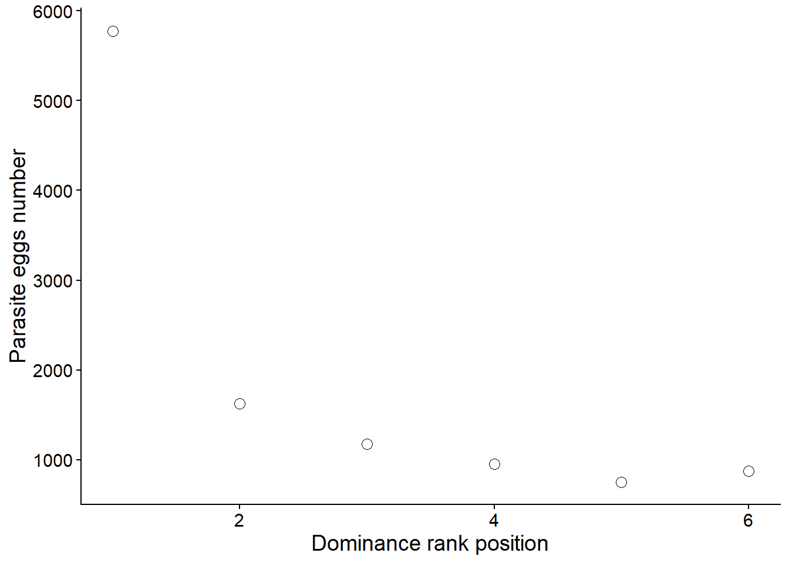
# The relation appears non-linear. In such case we have two possible approaches:
# 1) try data transformation and use Pearson correlation (parametric),
# 2) use non-parametric correlation (Spearman), which is appropriate for ranks.
#Note: here Log will not work since we are working with ranks. However, for didactic
#purposes we will approach and test.

# Perform log-transformation and make plot for log-transformed egg number
Monkeys_Data <- mutate(Monkeys_Data, Log_NEggs = log(NEggs,10), Log_DomRank = log(DomRank,10))

Plot2_Monkeys <- ggplot(data = Monkeys_Data, aes(x = Log_DomRank, y = Log_NEggs)) +
geom_point(shape = 1, size = 3, color = "black") +
theme_classic() +
theme(text = element_text(size = 14)) +
labs(x = "log(Dominance rank position)", y = "log(Parasite eggs number)")
Plot2_Monkeys
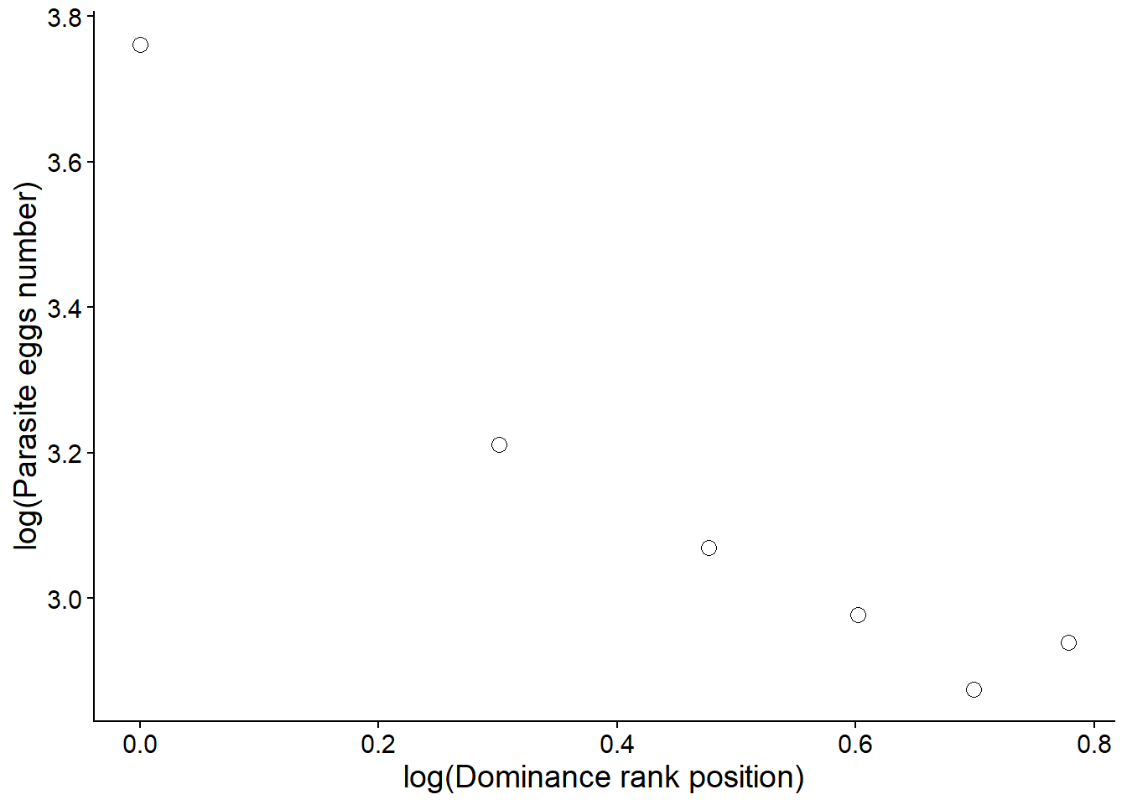
# The association is still not strictly linear, although it is approximately so.
# Because we are only interested in testing the presence of a correlation
# and not in fitting a linear model, the data meet the assumptions well enough
# to justify using the Pearson correlation coefficient.
Monkeys_Corr_Pearson <- cor.test(Monkeys_Data$Log_DomRank,
Monkeys_Data$Log_NEggs, method="pearson")
Monkeys_Corr_Pearson
##
## Pearson's product-moment correlation
##
## data: Monkeys_Data$Log_DomRank and Monkeys_Data$Log_NEggs
## t = -6.4016, df = 4, p-value = 0.003058
## alternative hypothesis: true correlation is not equal to 0
## 95 percent confidence interval:
## -0.9951688 -0.6342652
## sample estimates:
## cor
## -0.9545015
cor.test(~ Log_DomRank + Log_NEggs, data = Monkeys_Data)
##
## Pearson's product-moment correlation
##
## data: Log_DomRank and Log_NEggs
## t = -6.4016, df = 4, p-value = 0.003058
## alternative hypothesis: true correlation is not equal to 0
## 95 percent confidence interval:
## -0.9951688 -0.6342652
## sample estimates:
## cor
## -0.9545015
# The result shows a correlation coefficient of -0.95 with a 95% confidence interval
# ranging from -0.995 to -0.634,
# and a p value of 0.003.
# This demonstrates a significant negative correlation between dominance rank
# and parasite egg infestation.
#
# Because dominance rank is an ordinal variable (as previously mentioned above), it would also be reasonable
# to use the non-parametric Spearman rank correlation,
# even if the assumption of linearity was not violated.

#Continuing with non parametric option.
# Spearman rank correlation
Monkeys_Corr_Spearman <- cor.test(Monkeys_Data$DomRank,
Monkeys_Data$NEggs, method="spearman")
Monkeys_Corr_Spearman
##
## Spearman's rank correlation rho
##
## data: Monkeys_Data$DomRank and Monkeys_Data$NEggs
## S = 68, p-value = 0.01667
## alternative hypothesis: true rho is not equal to 0
## sample estimates:
## rho
## -0.9428571
# Spearman correlation also indicates a significant negative association
# between dominance rank and parasite egg number (rho = -0.94, p = 0.017).

# Plot of ranked values
# To create the plot first we need to create a variable with ranked number of eggs.
# We create a ranked egg variable because Spearman correlation is based on ranks,
# and while dominance position is already ordinal, the number of eggs must be converted into
# ranks to properly visualize and interpret the rank-based association.

Monkeys_Data <- mutate(Monkeys_Data, Eggs_rank = rank(NEggs, ties.method = 'average'))

Plot3_Monkeys <- ggplot(data = Monkeys_Data, aes(x = DomRank, y = Eggs_rank)) +
geom_point(shape = 1, size = 3, color = "black") +
theme_classic() +
theme(text = element_text(size = 14)) +
labs(x = "Dominance rank position", y = "Rank of eggs number)")
Plot3_Monkeys
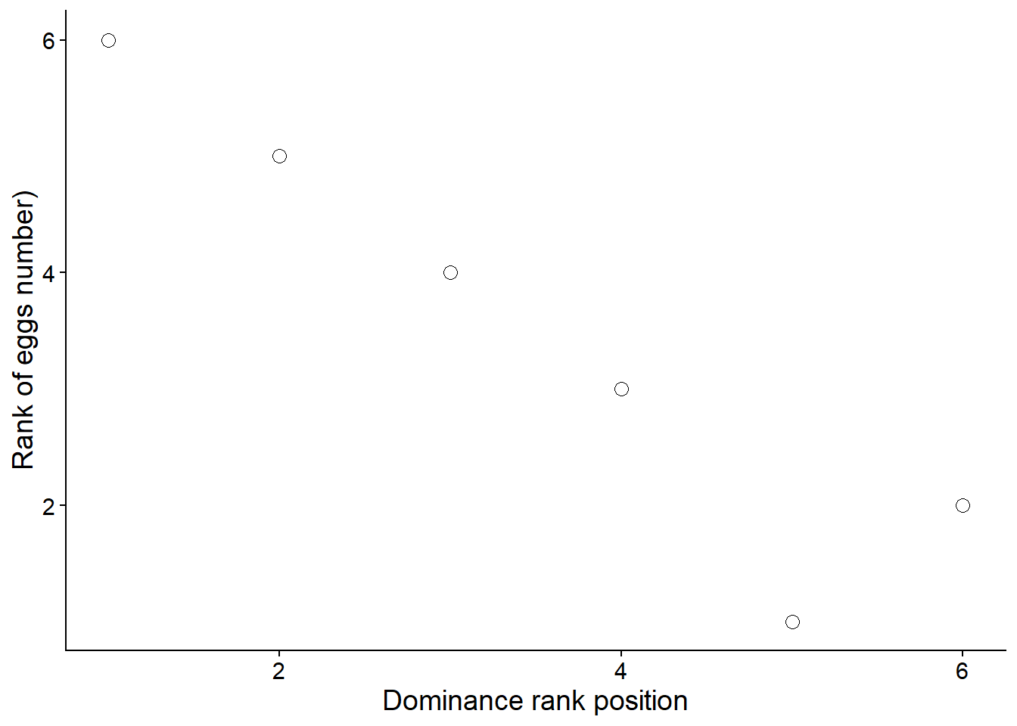
# CONCLUSIONS
# A strong negative Spearman rank correlation (rS = -0.94, p = 0.017)
# shows that high-ranking males (low rank values) have higher parasite loads.
# This supports the idea that maintaining social dominance is associated

