Berkin Beleroglu 21.01.2026

Practical class 5 (factorial ANOVA) report

EXERCISES

2. Two-way ANOVA with significant interaction term
Research problem: toxic effects of Cu and Zn
It is generally known that ions of copper (Cu) and zinc (Zn) are needed for proper functioning of some enzymes, but in the large concentrations the metals can be toxic. What is important, the effect of one of the compound may depend on presence of the other.
An experiment has been performed in which the researchers investigated how the growth rate of mice (G; g/day) is affected by adding salts of Cu or Zn or both of the metals to standard food. The animals from base group were assigned randomly to four groups, with 10 individuals in each group (codes of the groups are in parentheses):
a) fed a standard diet (Cu=0, Zn=0)
b) fed a diet contaminated with zinc (Cu=0, Zn=1)
c) fed a diet contaminated with copper (Cu=1, Zn=0)
d) fed a diet contaminate with both copper and zinc (Cu=1, Zn=1)
Variable | Description
Individual | ID of the mice
Group | experimental group (as described above)
Cu | presence (1) or absence (0) of copper
Zn | presence (1) or absence (0) of zinc
M20 | Body mass (g) at the age of 20 days
M35 | Body mass (g) at the age of 35 days
dataset “metals.txt”
For each individual compute the growth rate per day (G; g/d) and perform appropriate analyses, which will give (within the framework of one model) answers to the following three questions:
i) Did contamination with copper affect growth rate?
ii) Did contamination with zinc affect growth rate?
iii) Did the effect of contamination with zinc depend on whether the food was also contaminated with copper (or vice versa)?

# Experimental Design, Data Analysis and Presentation
# Practical 5: Two-way ANOVA with interaction (factorial design)
# Name: Berkin Beleroglu
#
# Research question:
# Does growth rate (G) depend on Zinc (Zn), Copper (Cu), and their interaction?
library(tidyverse)
library(ggplot2)
library(car) # leveneTest()
library(effects) # allEffects()
library(emmeans) # emmeans()
# Data import
Metals_Data <- read.delim("metals.txt", header = TRUE, stringsAsFactors = FALSE)
head(Metals_Data)
## Individual Group Cu Zn M20 M35
## 1 1 a 0 0 9.56 17.6
## 2 2 a 0 0 8.50 19.4
## 3 3 a 0 0 10.87 16.4
## 4 4 a 0 0 10.27 21.1
## 5 5 a 0 0 9.24 21.2
## 6 6 a 0 0 11.41 21.6
# Hypotheses
# Main effect of Zn:
# H0: Mean growth rate is the same across Zn levels (averaged across Cu).
# H1: Mean growth rate differs between Zn levels.

# Main effect of Cu:
# H0: Mean growth rate is the same across Cu levels (averaged across Zn).
# H1: Mean growth rate differs between Cu levels.
# Preparing variables for ANOVA (predictors as factors)
Metals_Data$Cu <- as.factor(Metals_Data$Cu)
Metals_Data$Zn <- as.factor(Metals_Data$Zn)
# Computing response variable: growth rate per day
# G = (mass at day 35 - mass at day 20) / 15 days
Metals_Data <- Metals_Data %>%
mutate(G = (M35 - M20) / 15)
# Descriptive statistics
Metals_DesStat <- Metals_Data %>%
drop_na(G) %>%
group_by(Zn, Cu) %>%
summarise(
N = n(),
mean = mean(G),
median = median(G),
sd = sd(G),
.groups = "drop"
)

Metals_DesStat
## # A tibble: 4 × 6
## Zn Cu N mean median sd
## <fct> <fct> <int> <dbl> <dbl> <dbl>
## 1 0 0 10 0.679 0.710 0.148
## 2 0 1 10 0.742 0.835 0.254
## 3 1 0 10 0.835 0.843 0.260
## 4 1 1 10 0.567 0.496 0.270
# Plotting for visual check of group differences (Descriptive Statistics)
Metals_Boxplot <- ggplot(data = Metals_Data,
mapping = aes(x = Cu, y = G, color=Zn, fill=Zn)) +
geom_boxplot(alpha = 0.3) + theme_classic() +
theme(text = element_text(size = 14)) +
labs(x = "Presence of Zn", y = "Growth rate (g/g) [median, quartiles, range]")
Metals_Boxplot
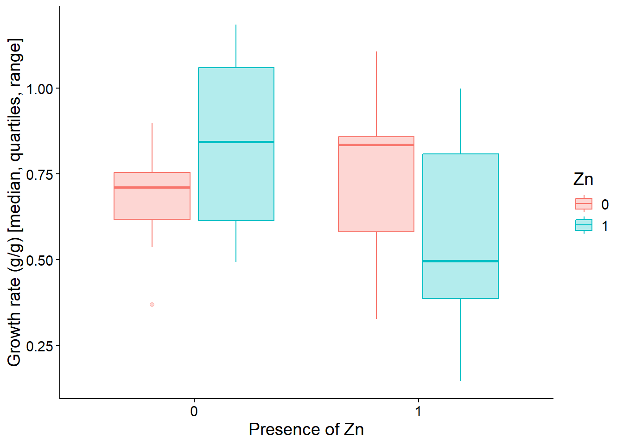
# Differences in median growth rate between Zn levels appear to vary depending on whether Cu is present,
# suggesting a possible Zn × Cu interaction. This plot is descriptive only so we cannot decide; formal inference is based on the ANOVA model.
# Fit the full factorial model with interaction
# Fit linear model with interaction
Metals_Model <- lm(G ~ Cu + Zn + Cu:Zn, data=Metals_Data)
Metals_Model
##
## Call:
## lm(formula = G ~ Cu + Zn + Cu:Zn, data = Metals_Data)
##
## Coefficients:
## (Intercept) Cu1 Zn1 Cu1:Zn1
## 0.67867 0.06333 0.15667 -0.33120
# Checking assumptions of Anova
# Normality - histogram, quantile plot and Shapiro-Wilk test
# Normality of residuals: histogram + Q-Q plot + Shapiro test
hist(residuals(Metals_Model), main = "Histogram of residuals", xlab = "Residuals")
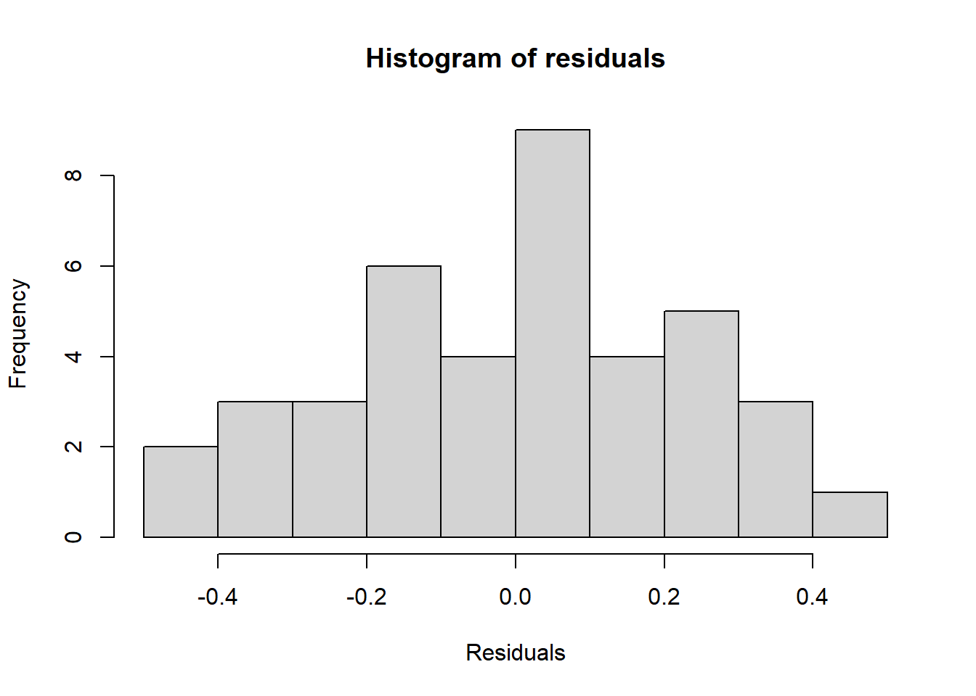
plot(Metals_Model, 2) # Q-Q plot
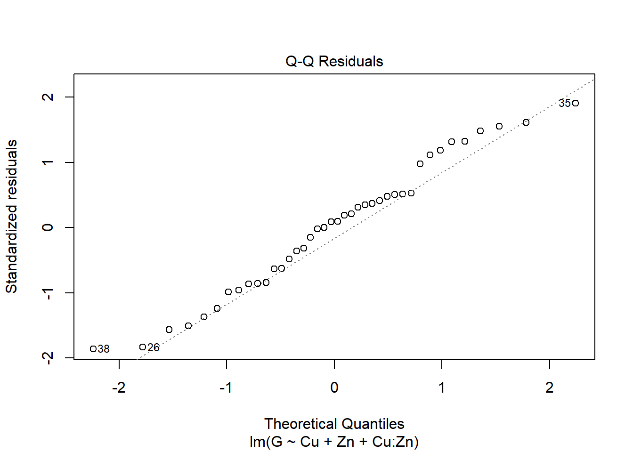
shapiro.test(residuals(Metals_Model))
##
## Shapiro-Wilk normality test
##
## data: residuals(Metals_Model)
## W = 0.9734, p-value = 0.458
#From the histograms and Q-Q plot, distributions look normal.
#Shapiro–Wilk test (W = 0.973, p = 0.458), which showed no significant departure from normality.
#Therefore, the normality assumption for ANOVA was considered satisfied.

# Homogeneity of variance: residuals vs fitted + Levene test on Zn:Cu subgroups
plot(Metals_Model, 1) # residuals vs fitted
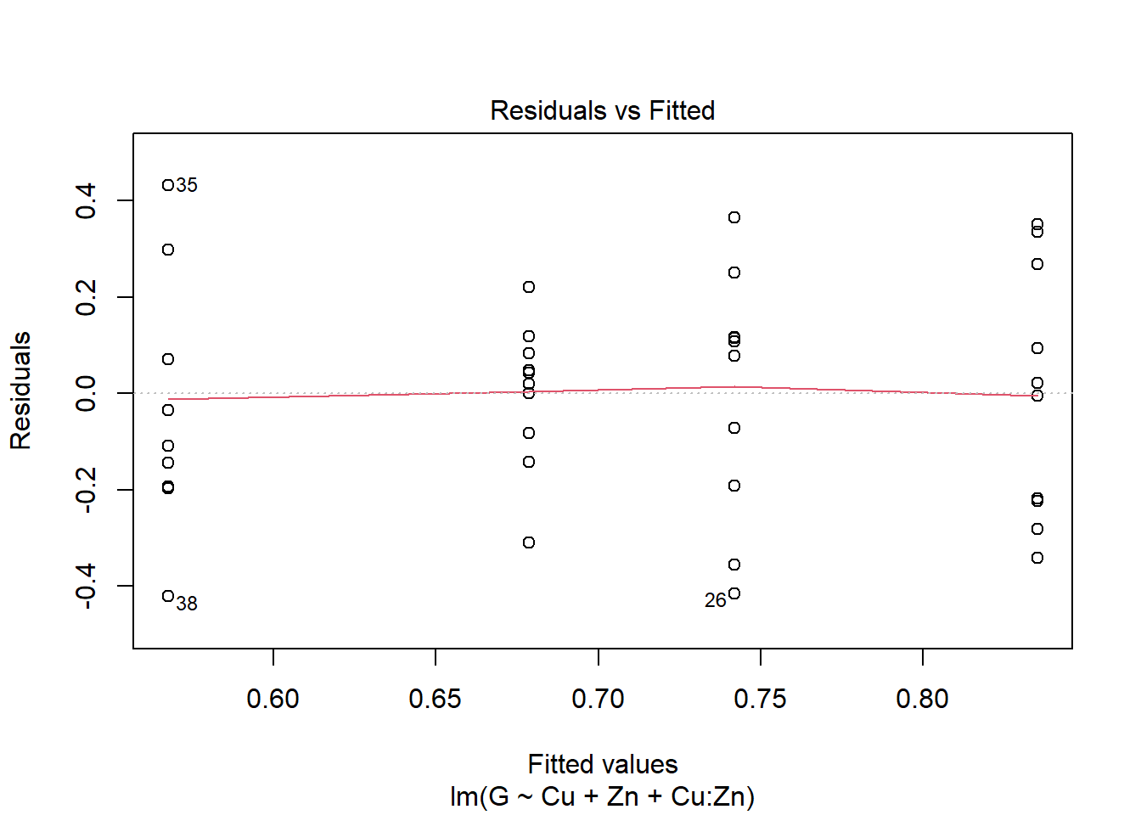
leveneTest(G ~ Cu:Zn, data=Metals_Data, center=mean)
## Levene's Test for Homogeneity of Variance (center = mean)
## Df F value Pr(>F)
## group 3 1.8297 0.1592
## 36
# The variance is homogeneous
# The assumptions of normality and homoscedasticity are satisfied.
# Main result of the ANOVA table
anova(Metals_Model)
## Analysis of Variance Table
##
## Response: G
## Df Sum Sq Mean Sq F value Pr(>F)
## Cu 1 0.10458 0.104585 1.8416 0.1832
## Zn 1 0.00080 0.000798 0.0141 0.9063
## Cu:Zn 1 0.27423 0.274234 4.8289 0.0345 *
## Residuals 36 2.04443 0.056790
## ---
## Signif. codes: 0 '***' 0.001 '**' 0.01 '*' 0.05 '.' 0.1 ' ' 1
#A significant Zn × Cu interaction was detected (p = 0.0345),
#while main effects were not significant; therefore, interpretation focuses on simple effects.
# Visualisation of model results (marginal means)
plot(allEffects(Metals_Model))
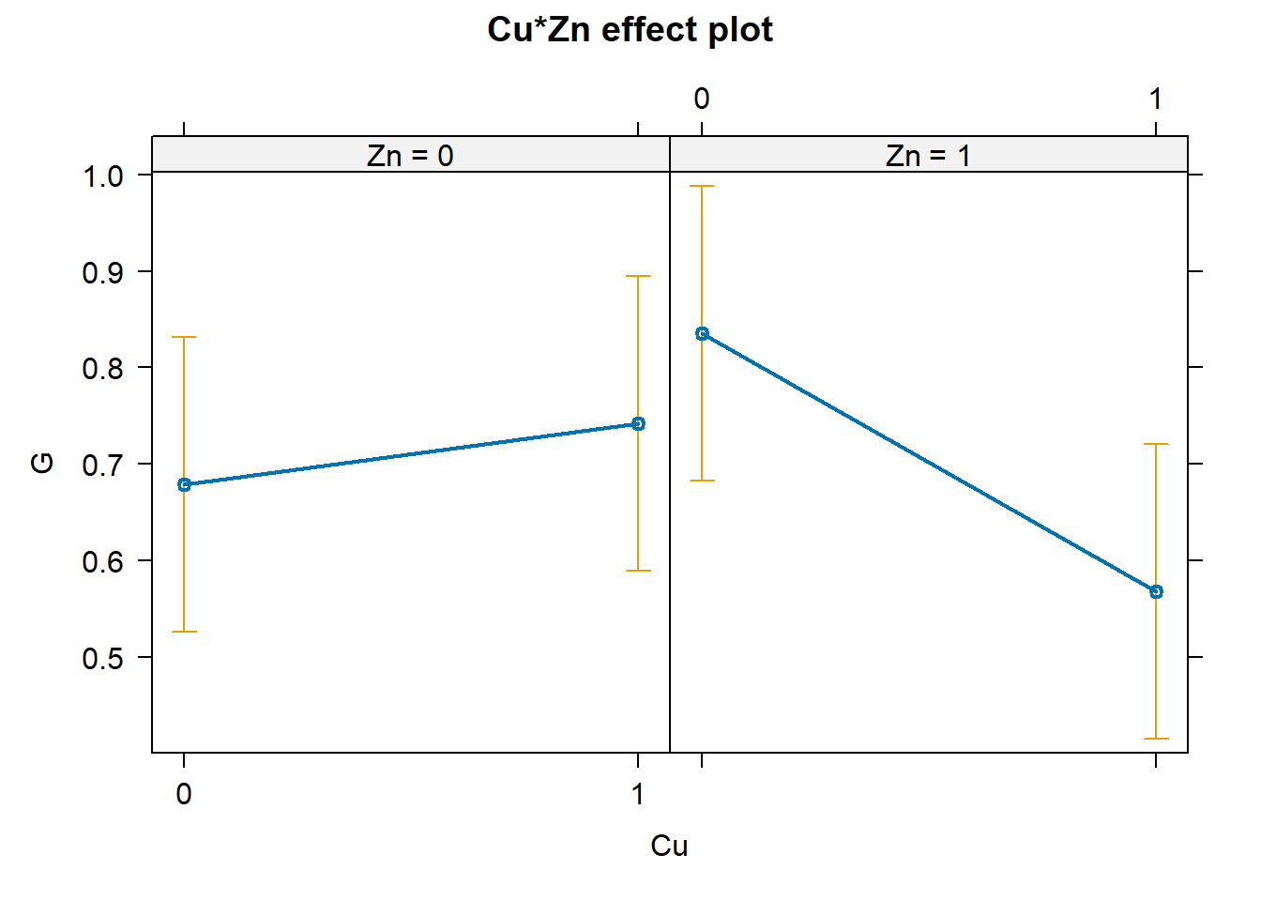
# The lines in the effect plot do not run in parallel, which supports a Zn × Cu interaction.
# In practical terms, Zn does not shift growth the same way when Cu is absent vs present.
# When Cu = 0, adding Zn is linked with higher growth, while at Cu = 1 the Zn condition shows lower growth.
#
# Because this interaction is significant, it is not appropriate to make one overall statement
# like “Cu increases/decreases growth” across all Zn groups (or vice versa).
# Instead, we examine differences within each combination of treatments.
#
# For illustration, we use two post-hoc approaches: Tukey comparisons of all four groups,
# and simple-effect comparisons (Zn within Cu and Cu within Zn).

plot(allEffects(Metals_Model))

# Since the interaction is significant, interpretation should focus on subgroup (simple) effects
# rather than only main effects averaged across the other factor.
#
# We therefore proceed using one of two suggested follow-up strategies:
# (1) Tukey comparisons among the four Zn:Cu combinations,
# (2) comparisons of Zn within each Cu level and Cu within each Zn level.
# For this report, a method of 2 was selected.

# Generating tables with expected means for the Cu:Zn subgroups and performing comparisons
# of the effect of one of the metals split by the groups of the other,
# using emmeans function with the "split by" option.
# Firstly, Zn Group.
emmeans(Metals_Model, pairwise ~ Cu|Zn)
## $emmeans
## Zn = 0:
## Cu emmean SE df lower.CL upper.CL
## 0 0.679 0.0754 36 0.526 0.832
## 1 0.742 0.0754 36 0.589 0.895
##
## Zn = 1:
## Cu emmean SE df lower.CL upper.CL
## 0 0.835 0.0754 36 0.682 0.988
## 1 0.567 0.0754 36 0.415 0.720
##
## Confidence level used: 0.95
##
## $contrasts
## Zn = 0:
## contrast estimate SE df t.ratio p.value
## Cu0 - Cu1 -0.0633 0.107 36 -0.594 0.5560
##
## Zn = 1:
## contrast estimate SE df t.ratio p.value
## Cu0 - Cu1 0.2679 0.107 36 2.513 0.0166
# When Zn is absent (Zn = 0), growth rates do not differ between Cu levels (p = 0.56).
# In contrast, when Zn is present (Zn = 1), growth is significantly lower under Cu = 1 than Cu = 0
# (difference ≈ 0.27 g/day, p = 0.0166), indicating that the Cu effect does depend on Zn presence.

# This analysis tests the effect of Zn separately within each Cu group.
emmeans(Metals_Model, pairwise ~ Zn|Cu)
## $emmeans
## Cu = 0:
## Zn emmean SE df lower.CL upper.CL
## 0 0.679 0.0754 36 0.526 0.832
## 1 0.835 0.0754 36 0.682 0.988
##
## Cu = 1:
## Zn emmean SE df lower.CL upper.CL
## 0 0.742 0.0754 36 0.589 0.895
## 1 0.567 0.0754 36 0.415 0.720
##
## Confidence level used: 0.95
##
## $contrasts
## Cu = 0:
## contrast estimate SE df t.ratio p.value
## Zn0 - Zn1 -0.157 0.107 36 -1.470 0.1502
##
## Cu = 1:
## contrast estimate SE df t.ratio p.value
## Zn0 - Zn1 0.175 0.107 36 1.638 0.1102
# Within both Cu = 0 and Cu = 1 groups, the difference between Zn levels is not statistically significant
# (p = 0.15 and p = 0.11, respectively).
# Therefore, there is no clear evidence that Zn affects growth rate at either level of Cu.

p.adjust(c(0.5560, 0.0166, 0.1502, 0.1102), method="holm")
## [1] 0.5560 0.0664 0.3306 0.3306
# When all four simple-effect tests are considered together, adjusting for multiple comparisons
# (Bonferroni or Holm) increases the p value of the lowest contrast to about 0.066.
# After adjusting the four simple-effect tests using the Holm method,
# the lowest p value increases from 0.0166 to 0.0664.

# CONCLUSIONS
# A significant Zn × Cu interaction was detected, indicating that the effect of Cu on growth
# depends on the presence of Zn (F(1,36) = 4.83, p = 0.034).
# When Zn was present, adding Cu was associated with lower growth rates (from ~0.83 to ~0.57 g/day),
# although after Holm adjustment for four comparisons this effect was marginal (p = 0.066).
# In contrast, Cu had no effect when Zn was absent, and Zn showed no significant effect
# at either level of Cu (Holm-adjusted p ≥ 0.33).

