Experimental Design, Data Analysis and Presentation p. I
Practicals #6
Subject: Random factors (effects) in ANOVA: Nested and mixed factorial models (additionally: split plot design)
instruction version 2026-01-20, by Paweł Koteja
Report by: BERKIN BELEROGLU

EXERCISES
A dataset for exercises 1-4, A1, A2 (and next classes):
Basal metabolic rate (BMR) in voles from selection experiment
In this selection experiment, we maintain line-types of bank voles (Clethrionomys=Myodes glareolus) selected for high Aerobic exercise capacity (A), Herbivorous capability (H), and Predatory behavior (P), and unselected Control lines (C). In each of the four linetypes (three selection directions and control), four independent, replicate lines are maintained, i.e., the experiment comprises a total of 16 lines. Each of the replicate lines is represented by several families, defined as all offspring of one mother and father. Thus, any dataset based on the experiment have inherently a two-level nested structure: replicate lines are nested in “linetypes” (selection directions) and families are nested in the replicate lines.
In addition, in most studies based on this selection experiment the measurements are performed on both males and females. Thus, statistical data analysis includes also the effect of sex, which is “crossed” with both the line-type, the replicate line, and (depending on sampling scheme) also with families.
The experimental design can be presented in a simplified way with the following table, in which (to fit the table on one page), only two linetypes, only two lines per linetype, and only two families per line are shown (n represents number of observations in a subgroup; “..” means “more categories”):
Linetype: | Control (C lines) |  |  |  |  |  |  | Aerobic (A lines) |  |  |  |  |  |  | ..
Line: | C1 |  |  | C2 |  |  | .. | A1 |  |  | A2 |  |  | .. | ..
Family: | F1C1 | F2C1 | .. | F1C2 | F2C2 | .. | .. | F1A1 | F2A1 | .. | F1A2 | F2A2 | .. | .. | ..
Sex
Males | n | n | .. | n | n | .. | .. | n | n | .. | n | n | .. | .. | ..
Females | n | n | .. | n | n | .. | .. | n | n | .. | n | n | .. | .. | ..
Moreover, usually not a single variable, but several traits are measured, and therefore the analysis typically involves also additional covariates and cofactors. Tu summarize, the data from this experiment provide a good opportunity to train several kinds of experimental designs and linear models corresponding to these designs.
We use results of measurement of Basal Metabolic Rate (BMR), obtained on males and females sampled randomly from each of the 16 lines. The dataset includes the values of BMR, body mass, and age of the individuals, but during the current class we will use only the BMR values (body mass and age will be included in the next class).
The general question is whether and how the selection affected the level of BMR. A methodologically valid test of such a hypothesis must include the effect of replicate lines in each of the line types; otherwise we would not be able to distinguish the effect of selection from the effect of random genetic drift.
Dataset "Voles_BMR.txt"
Results of the selection experiment designed to check whether the selection in the direction of high aerobic capacity (A), Herbivorous capability (H), and Predatory behavior (P), leads to changes in the Basal Metabolic Rate (BMR), with respect to unselected control lines (C).
Variable | Description
Nr | Record number
ID | Individual ID
T | Line Type = Direction of selection: C-Control, A-Aerobic capacity, H-Herbivorous, P-Predatory
L | Replicate Lines, for in each of the four line types (C1-C4 – Control, A1-A4 – Aerobic, H-H4 – Herbivorous, P1-P4 – Predatory)
S | Sex = 0-females, 1-males
F | Family (identification of the mother of the individuals)
MB | Body mass (g)
Age | Age (days)
BMR | Basal metabolic rate [mlO2/h]
Note: Unique codes of the levels of random factors (Line and Family) allow lmer() function to detected nested design of L(T) and F(L).

Examples of syntax of models with random effects applied to testing hypotheses concerning the level of BMR in voles from the selection experiment (Exercises 1-4, A1, A2)
1) A single-level nested (=hierarchical) model  Assuming that family level can be ignored (e.g. when only one individual per family is measured)  T- direction of selection (line Type) (fixed)  L – replicate Line within each direction (A1-A4, C1-C4,…) (random)  BMR – depended variable | Classical notation:  BMR = µ + T + L(T) + e  Syntax in lmer:  BMR ~ T + (1|L)
2) A two-level (=hierarchical) model  If we take more individuals per family, we account for this fact by adding family as another random effect  F – family within a line (random) | Classical notation:  BMR = µ + T + L(T) + F(L) + e  Syntax in lmer:  BMR ~ T + (1|L) + (1|F)
3) A two-factor mixed factorial model  Assuming that we are interested in only Aerobic lines (T effect is not considered), and only one individual per family (either male or female) from several families of each of the four Aerobic lines is measured (or when the effect of family can be ignored), and we would test for differences between sexes (S – sex, fixed) | Classical notation:  BMR = µ + S + L + S×L + e  Syntax in lmer:  BMR ~ S + (1|L) + (1|S:L)
4) A split-plot (=cross-nested) model  Assuming that only one individual per family is measured  (or effect of family is ignored) and we ask both about differences between selection directions and sexes:  T- direction of selection with 2 levels, A and C  S – sex  L – replicate line within each direction (A1-A4 and C1-C4)  BMR – depended variable | Classical notation:  BMR = µ + T + S + T×S +  L(T) + S×L(T) + e  Syntax in lmer:  BMR ~ T + S + T:S +  (1|L) + (1|S:L)
5) The schemes 3 and 4 can be further extended by adding the effect of family, but the way of introducing the effect of family depends on whether:
5a) when males and females are samples from each family (ideally, the same number of males and females from each family): | Classical notation:  BMR = (as in 3 or 4)  + F(L) + S×F(L) + e  Syntax in lmer:  BMR ~ (as in 3 or 4)  + (1|F) + (1|S:F)
5b) when males and females are samples from different (from some families only females, from other only males, ideally the same number of families and individuals for each sex): | Classical notation:  BMR = (as in 3 or 4)  + F(S×L) + e  Syntax in lmer:  BMR ~ (as in 3 or 4)  + (1|F)

Exercises 1-4
- In exercises 1-4 we limit the scope of analyses to only the Aerobic and Control lines. The main objective will be to test a working hypothesis that BMR increased in response to selection for high aerobic exercise metabolism, i.e., that it is higher in the A than in the C lines.
- Use an appropriate R function to subset the records for only T=”A” or T=”C”).
- Remember about ensuring that all categorical factors are treated as factors (note that sex is coded as 0 and 1!) and setting the Control linetype group (T=”C”) as the reference. Use appropriate R functions to modify the variables accordingly.
- Remember that the data analyses should be not limited to just performing the tests of significance. Remember about all the steps we trained on previous classes (descriptive statistics, diagnostic of residuals, tabular and graphical presentation of the main results).

1. One-level nested ANOVA - analyses with different functions
Hypothesis: BMR differs between voles from the A and C lines (= factor T affects BMR)
- Just for didactic purposes, analyze first the data using the simplest model, which ignores the effect of the differences between the replicate lines within the line-types (within the selection directions). Use aov() function. Think why the model in which the replicate lines are ignored can provide misleading results (this is more a biological than statistical question).

- Construct an appropriate ANOVA model to examine the results of this experiment, considering the effect of replicate lines (4 replicate A lines and 4 replicate C lines). Use aov() function with the Error option to assign a proper error term, using syntax provided in point II.1 of the instruction. Get the anova table. An additional task (not crucial): use the available output to calculate F statistics for the effect of line (L).

- Use lmer() function to fit the same model as in point 2, using the syntax provided in point II of the Introduction or in table above. Get the tables of the estimated effects and tables with the tests of significance for the fixed and random effect.

- Compare the results obtained in models 1, 2, 3. Can you see one major differences between results from model 1 and 2 or 3? Which of the models should give similar results (conclusions)? What was the reason why the test of significance of the main factor (T) were in one of the models very different? Which of the results are more reliable for conclusions concerning the effect of selection?

- Formulate final conclusions:
  - Does the level of BMR differ between the directions of selection?
  - Is there a significant variation in BMR among replicate lines within the selection directions?

- Results obtained in models 2-3 are still not quite reliable. Why? Try to answer before looking at the next exercise.

2. Two-level nested model
Hypothesis: BMR differs between voles from the A and C lines (= factor T affects BMR)
- Construct an appropriate ANOVA model to examine the results of this experiment, considering the effect of replicate lines (4 replicate A lines and 4 replicate C lines) and the fact, that individuals from each line represent groups of full-siblings (families). Perform a complete analysis using lmer() function and the syntax provided in point II of the general Introduction or in table above.
- Present the main results in tabular and graphical form.
- Formulate conclusions: does the level of BMR differs between the directions of selection? Is there a significant variation in BMR among replicate lines within the selection directions or families within the replicate lines?
- Results obtained in this model are still not quite reliable. Why? Try to answer before looking at the next exercises.

3. Mixed factorial model
Hypothesis: BMR of voles from Aerobic (A) lines differs between sexes (= sex affects BMR)
- Choose appropriate subset of data and construct the appropriate ANOVA to test the above hypothesis. Note, that you should consider that the voles are sampled from four independent lines. In this exercise ignore the fact that they are also connected by families. Perform a complete analysis using lmer() function and the syntax provided in point II of the general Introduction or in table above.
- Present the main results in tabular and graphical form.
- Formulate conclusions:
- Does the level of BMR differs between sexes?
- Is there a significant variation in BMR among replicate lines?
- Does the variation among replicate lines differs between sexes (or: do the differences between sexes vary among the replicate lines)?

4. Split-plot (cross-nested) design
Hypotheses:
a) BMR differs between voles from the A and C lines (effect of selection);
b) BMR differs between sexes;
c) the effect of selection differs between sexes (or: the effect of sex differs selection groups).
- Choose appropriate subset of data and construct the appropriate ANOVA to test the above hypotheses. Note, that you should consider that the voles are sampled from four independent lines. In this exercise ignore the fact that they are also connected by families. Perform a complete analysis using lmer() function and the syntax provided in point II of the general Introduction or in table above.
- Present the main results in tabular and graphical form.
- Formulate conclusions: does the level of BMR differs between selection directions or sexes? Does the effect of sex differ between the A and C lines? Is there a significant variation in BMR among replicate lines? Does the variation among replicate lines differs between sexes (or: do the differences between sexes vary among the replicate lines)?
# title: 'Experimental Design, Data Analysis and Presentation: Practicals 6 ANOVA with random effects Report'
# author: "Berkin Beleroglu "
# date: "20.01.2026"

# ANOVA with random effects: nested and mixed factorial
### The effects of selection and sex on BMR of voles

# HYPOTHESES
# H1: BMR differs between selection lines (A vs C).
# H2: BMR differs between sexes.
# H3: The effect of selection depends on sex (T × S interaction).
# Random effects: variation among replicate lines and families may exist.

## --- Setup and Libraries ---
library(tidyverse)
library(lme4)
library(lmerTest)
library(effects)
library(emmeans)
library(car)
## --- Data Import ---
Voles <- read.delim("Voles_BMR.txt")
# Filtering the subset of voles from A and C lines
Voles <- filter(Voles, T=="A" | T=="C")
# Converting S, T, L and F variables as factors
Voles <- mutate(Voles, S=as.factor(S), T=as.factor(T), L=as.factor(L), F=as.factor(F))
# Control (C) lines were set as the reference level,
# so the effect of selection is interpreted relative to the control group.
Voles$T <- relevel(Voles$T, ref = "C")
# Replicate lines (L) are treated as a random factor, so the choice of reference level
# does not affect hypothesis testing.
# However, we reorder the line levels so that control (C) lines come first
# and selected (A) lines follow, which makes tables and plots easier to read
# and consistent with the ordering of the selection factor (T).
Voles$L <- factor(Voles$L,
levels = c("C1", "C2", "C3", "C4",
"A1", "A2", "A3", "A4"))
# Descriptive statistics for main factors (selection and sex groups)
Voles_DesStat_TS <- Voles %>%
group_by(T, S) %>%
summarize(N=n(),
median=median(BMR),
mean=mean(BMR),
std_dev=sd(BMR))
## `summarise()` has grouped output by 'T'. You can override using the `.groups`
## argument.
Voles_DesStat_TS
## # A tibble: 4 × 6
## # Groups: T [2]
## T S N median mean std_dev
## <fct> <fct> <int> <dbl> <dbl> <dbl>
## 1 C 0 49 45.9 46.0 7.22
## 2 C 1 47 47.8 49.0 5.67
## 3 A 0 51 46.9 48.9 8.57
## 4 A 1 50 53.2 54.1 6.73
# Descriptive statistics by replicate lines sex groups used to inspect random variation among lines
Voles_DesStat_LS <- Voles %>%
group_by(T, L, S) %>%
summarize(N=n(),
median=median(BMR),
mean=mean(BMR),
std_dev=sd(BMR))
## `summarise()` has grouped output by 'T', 'L'. You can override using the
## `.groups` argument.
Voles_DesStat_LS
## # A tibble: 16 × 7
## # Groups: T, L [8]
## T L S N median mean std_dev
## <fct> <fct> <fct> <int> <dbl> <dbl> <dbl>
## 1 C C1 0 12 45.6 46.1 6.90
## 2 C C1 1 12 47.8 48.9 6.02
## 3 C C2 0 12 44.6 44.1 4.22
## 4 C C2 1 12 47.6 47.4 2.61
## 5 C C3 0 13 42.5 45.4 8.68
## 6 C C3 1 12 48.6 50.9 7.20
## 7 C C4 0 12 49.4 48.3 8.36
## 8 C C4 1 11 48.7 49.0 6.02
## 9 A A1 0 14 43.8 46.8 8.46
## 10 A A1 1 13 52.8 53.6 7.42
## 11 A A2 0 12 44.4 46.5 6.07
## 12 A A2 1 11 49.9 49.7 3.59
## 13 A A3 0 12 48.4 49.1 8.82
## 14 A A3 1 14 55.6 56.2 6.88
## 15 A A4 0 13 56.5 53.1 9.63
## 16 A A4 1 12 53.8 56.2 6.65
# Exploratory graph for BMR by selection direction and sex.
Voles_Boxplot_TS <- ggplot(Voles,
aes(x = T, y = BMR, color = S, fill = S)) +
geom_boxplot(alpha = 0.3) +
theme_classic() +
theme(text = element_text(size = 14)) +
labs(x = "Selection direction (linetype)",
y = "BMR (ml O2 / h)")
Voles_Boxplot_TS
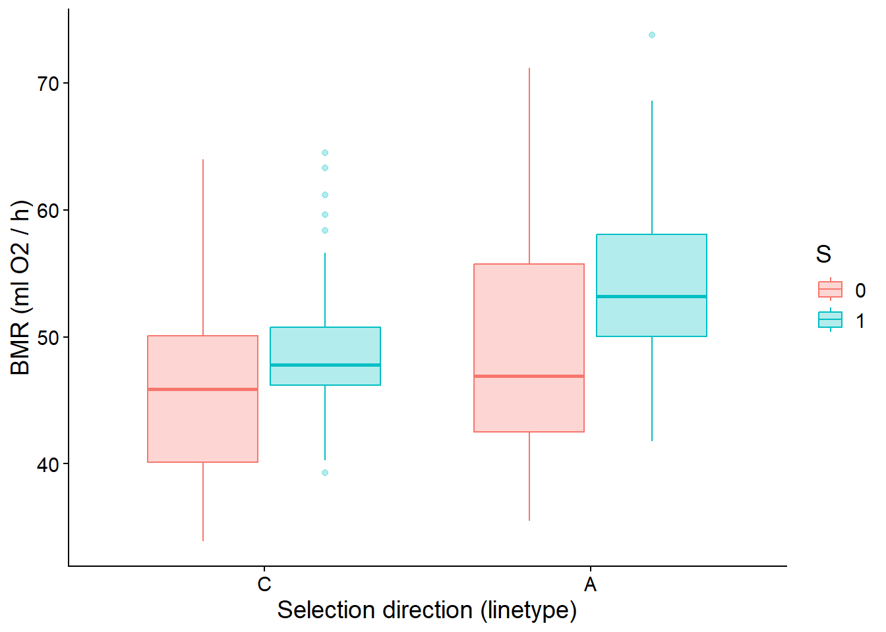
# Exploratory graph for BMR by replicate lines and sex.
Voles_Boxplot_LS <- ggplot(Voles,
aes(x = L, y = BMR, color = S, fill = S)) +
geom_boxplot(alpha = 0.3) +
theme_classic() +
theme(text = element_text(size = 14)) +
labs(x = "Replicate lines (4 C lines and 4 A lines)",
y = "BMR (ml O2 / h)")
Voles_Boxplot_LS
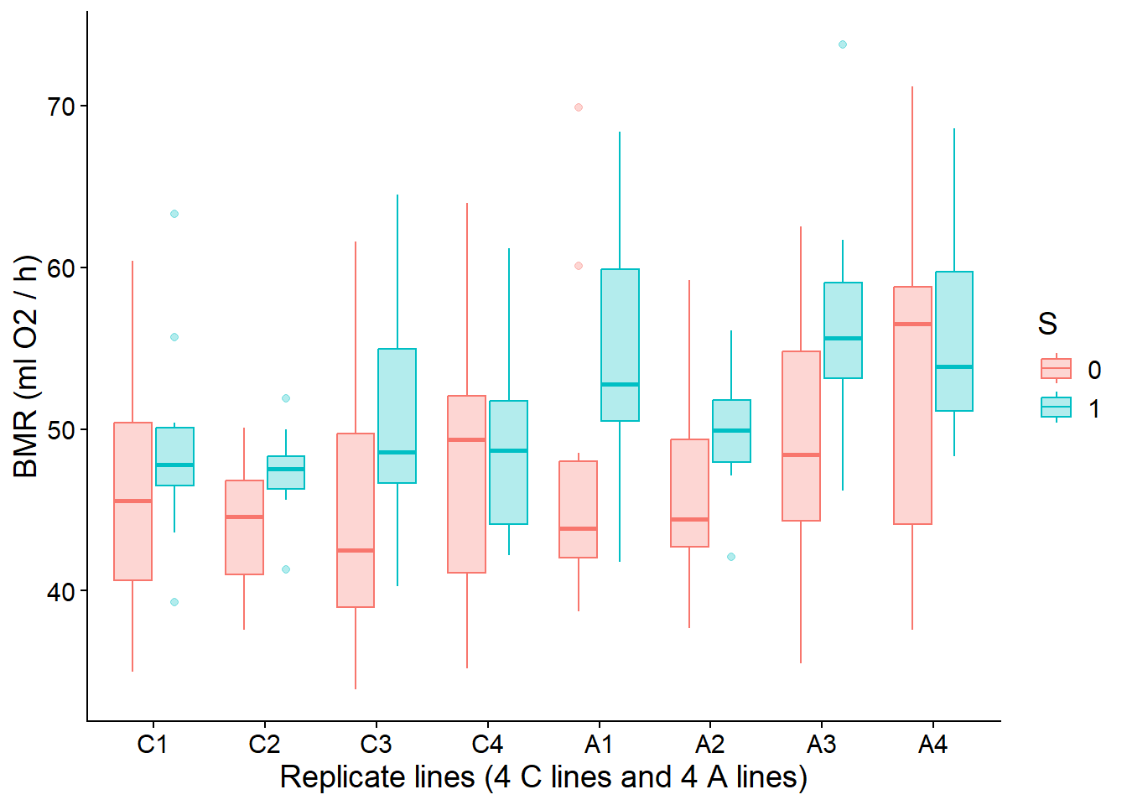
## ============================================================
## Exercise 1. Simple ANOVA and one-level nested ANOVA
## Hypothesis: BMR differs between A and C lines
## ============================================================

## Exercise 1.1 Simple ANOVA

# For didactic purposes, we first fit the simplest possible model.
# This model ignores the fact that voles come from 4 replicate lines
# within each selection direction.

Result1_1a <- aov(BMR ~ T, data = Voles)

# Assumption checks
hist(residuals(Result1_1a)) # residual distribution
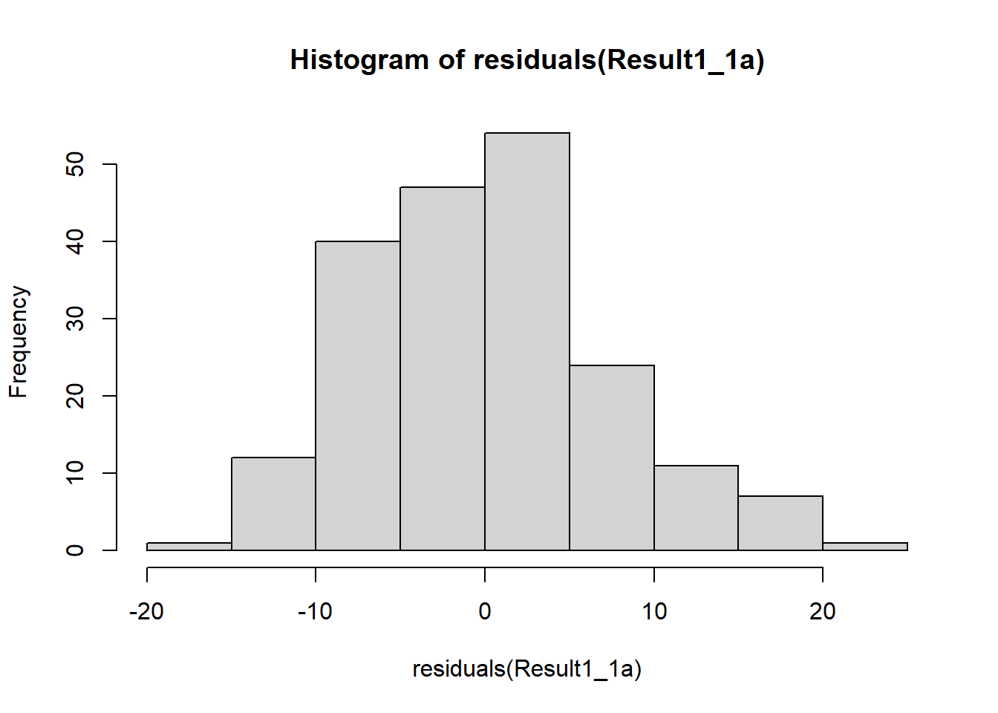
plot(Result1_1a, 2) # Q-Q plot
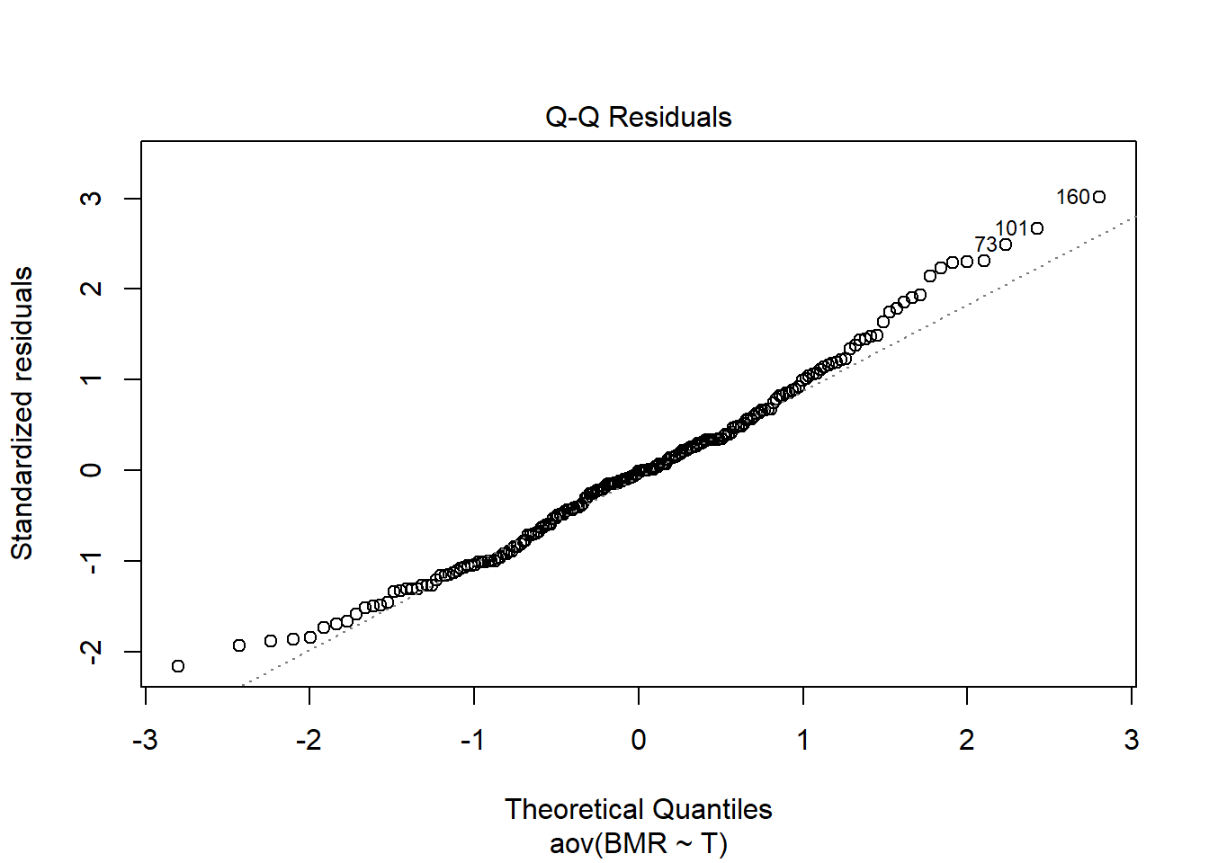
plot(Result1_1a, 1) # residuals vs fitted
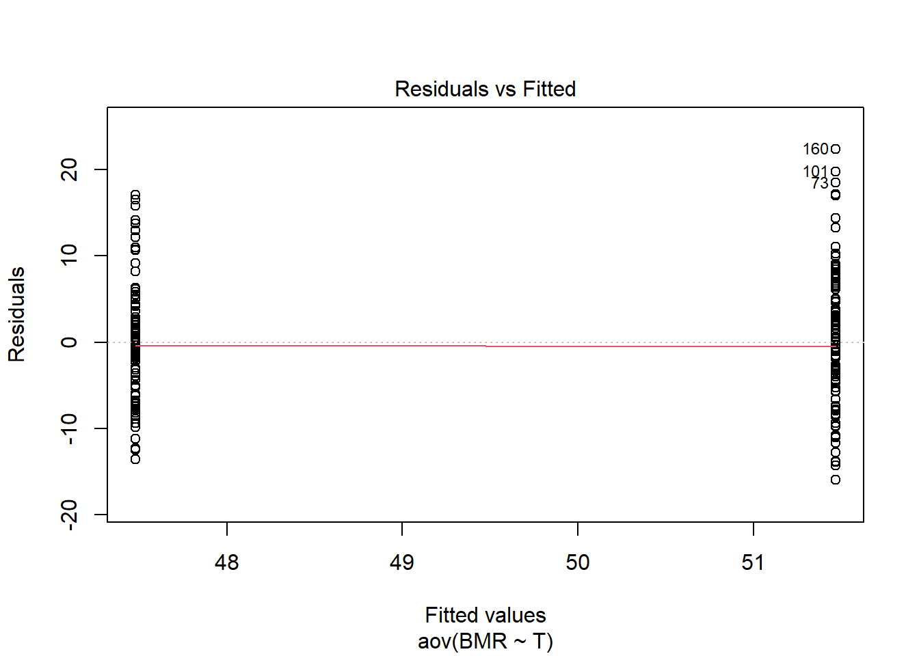
shapiro.test(residuals(Result1_1a))
##
## Shapiro-Wilk normality test
##
## data: residuals(Result1_1a)
## W = 0.98463, p-value = 0.03026
leveneTest(BMR ~ T, data = Voles)
## Levene's Test for Homogeneity of Variance (center = median)
## Df F value Pr(>F)
## group 1 5.2103 0.02353 *
## 195
## ---
## Signif. codes: 0 '***' 0.001 '**' 0.01 '*' 0.05 '.' 0.1 ' ' 1
# Shapiro–Wilk test is significant (p = 0.030), indicating deviation from normality.
# Levene’s test is significant (p = 0.024), suggesting unequal variances between A and C groups.

# Main results
summary(Result1_1a)
## Df Sum Sq Mean Sq F value Pr(>F)
## T 1 782 782.4 14.15 0.000223 ***
## Residuals 195 10780 55.3
## ---
## Signif. codes: 0 '***' 0.001 '**' 0.01 '*' 0.05 '.' 0.1 ' ' 1
plot(allEffects(Result1_1a))
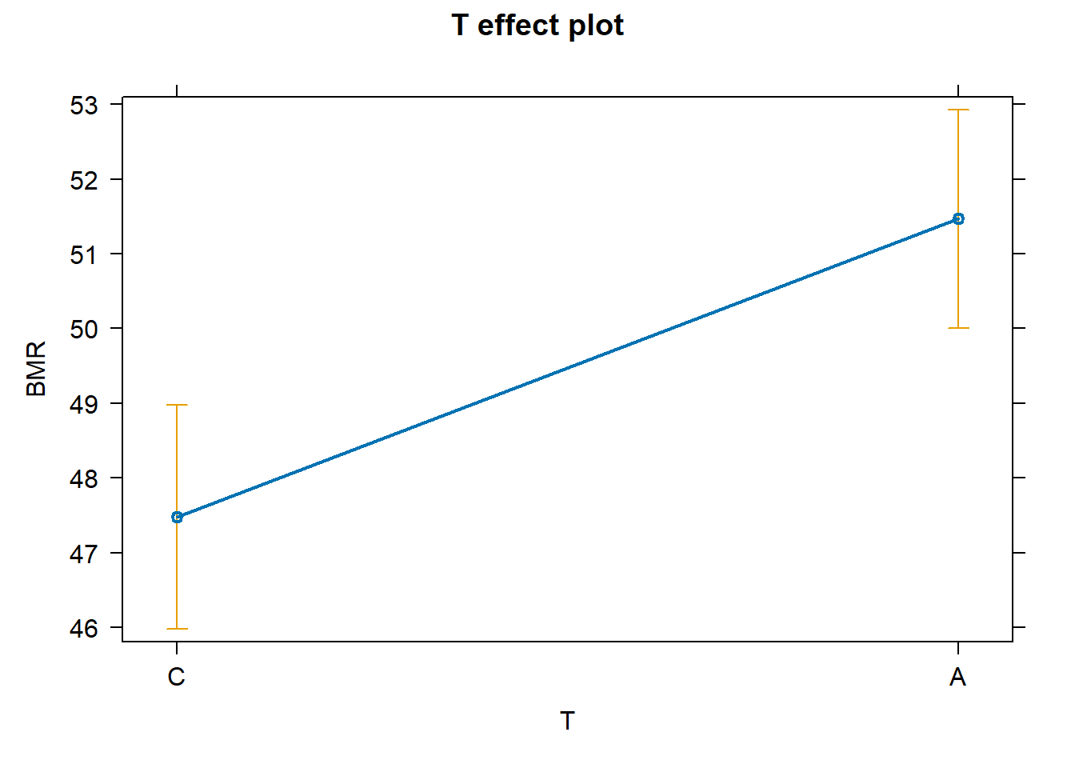
# There is a significant effect of selection (F 14.15, p = 0.00022).
# Mean BMR differs between A and C lines, with higher BMR in A lines.

## Equivalent analysis using lm()

Result1_1b <- lm(BMR ~ T, data = Voles)
summary(Result1_1b)
##
## Call:
## lm(formula = BMR ~ T, data = Voles)
##
## Residuals:
## Min 1Q Median 3Q Max
## -15.9663 -5.2792 -0.0792 4.2208 22.3337
##
## Coefficients:
## Estimate Std. Error t value Pr(>|t|)
## (Intercept) 47.4792 0.7588 62.568 < 2e-16 ***
## TA 3.9872 1.0598 3.762 0.000223 ***
## ---
## Signif. codes: 0 '***' 0.001 '**' 0.01 '*' 0.05 '.' 0.1 ' ' 1
##
## Residual standard error: 7.435 on 195 degrees of freedom
## Multiple R-squared: 0.06767, Adjusted R-squared: 0.06289
## F-statistic: 14.15 on 1 and 195 DF, p-value: 0.0002227
anova(Result1_1b)
## Analysis of Variance Table
##
## Response: BMR
## Df Sum Sq Mean Sq F value Pr(>F)
## T 1 782.4 782.45 14.154 0.0002227 ***
## Residuals 195 10779.6 55.28
## ---
## Signif. codes: 0 '***' 0.001 '**' 0.01 '*' 0.05 '.' 0.1 ' ' 1
# The intercept represents the mean BMR of control (C) lines.
# The coefficient for TA represents the difference between A and C lines.
# The p-value is identical to the ANOVA result.

# Applying log transform
# Log10 transformation of BMR
Voles <- Voles %>% mutate(logBMR = log10(BMR))

# Exercise 1.1 with log transformed data
Result1_1alog <- aov(logBMR ~ T, data = Voles)
Result1_1blog <- lm(logBMR ~ T, data = Voles)

# Assumption checks
hist(residuals(Result1_1alog)) # residual distribution
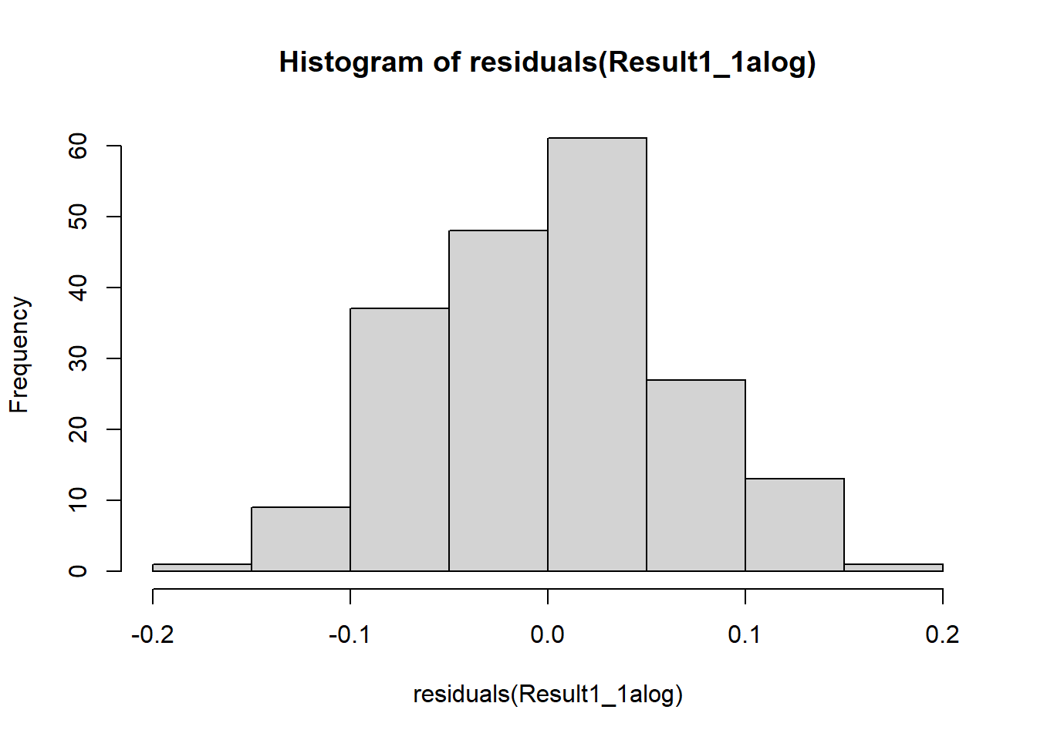
plot(Result1_1alog, 2) # Q-Q plot
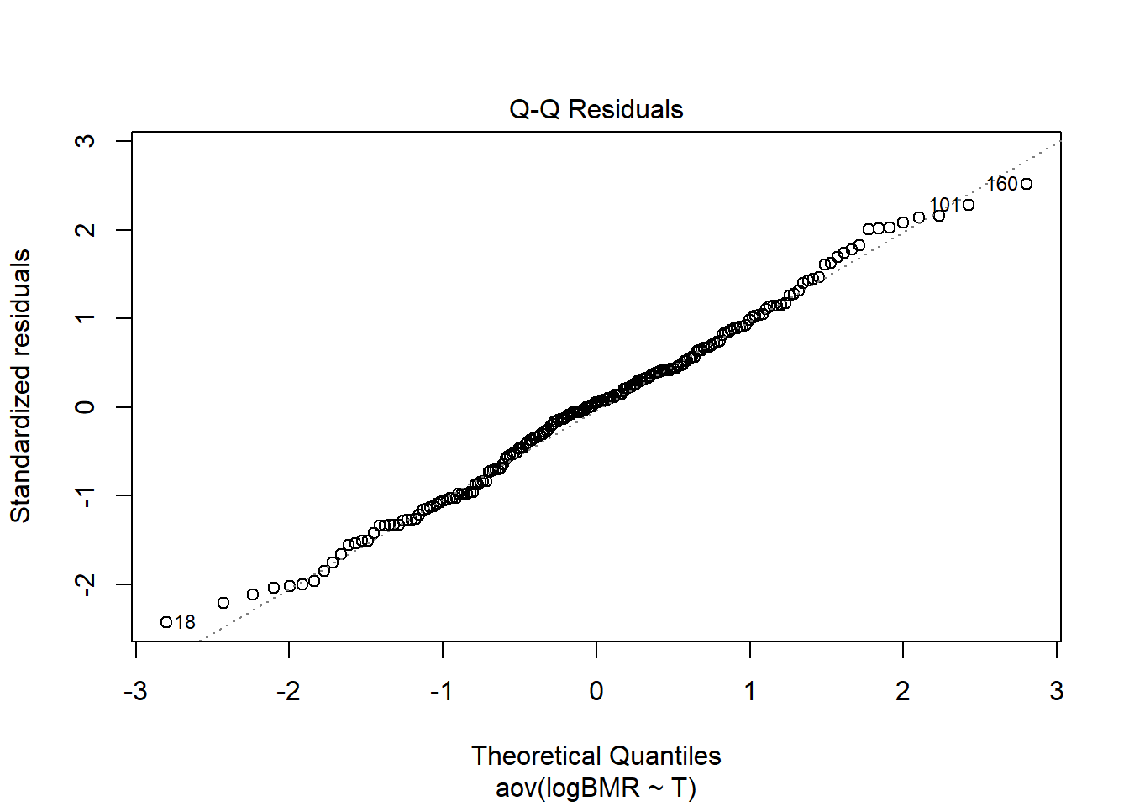
plot(Result1_1alog, 1) # residuals vs fitted
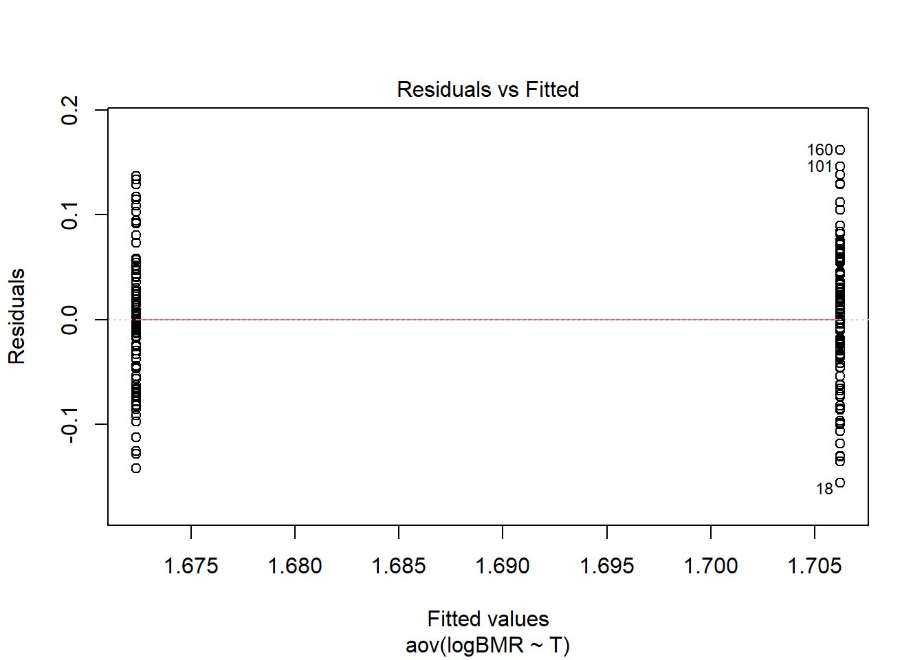
leveneTest(logBMR ~ T, data = Voles)
## Levene's Test for Homogeneity of Variance (center = median)
## Df F value Pr(>F)
## group 1 2.7071 0.1015
## 195
# Levene’s test is not significant (p = 0.1),
# indicating that variances between A and C groups are homogeneous
# after log transformation.
# This shows that the log transformation improved the variance assumption.

summary(Result1_1blog)
##
## Call:
## lm(formula = logBMR ~ T, data = Voles)
##
## Residuals:
## Min 1Q Median 3Q Max
## -0.156001 -0.046003 0.003435 0.041147 0.161827
##
## Coefficients:
## Estimate Std. Error t value Pr(>|t|)
## (Intercept) 1.672344 0.006580 254.167 < 2e-16 ***
## TA 0.033886 0.009189 3.688 0.000294 ***
## ---
## Signif. codes: 0 '***' 0.001 '**' 0.01 '*' 0.05 '.' 0.1 ' ' 1
##
## Residual standard error: 0.06447 on 195 degrees of freedom
## Multiple R-squared: 0.06519, Adjusted R-squared: 0.06039
## F-statistic: 13.6 on 1 and 195 DF, p-value: 0.0002935
# The intercept (1.672) represents the mean log10(BMR) of control (C) lines.
# The coefficient TA (0.0339) indicates that A lines have higher log10(BMR)
# than C lines, and this difference is statistically significant (p = 0.00029).
# The model explains about 6.5% of the variance in logBMR (Rsquared = 0.06).

anova(Result1_1blog)
## Analysis of Variance Table
##
## Response: logBMR
## Df Sum Sq Mean Sq F value Pr(>F)
## T 1 0.05651 0.056515 13.598 0.0002935 ***
## Residuals 195 0.81044 0.004156
## ---
## Signif. codes: 0 '***' 0.001 '**' 0.01 '*' 0.05 '.' 0.1 ' ' 1
# The ANOVA confirms a significant effect of selection
# (F(1,195) = 13.60, p = 0.00029).
# Thus, even after log transformation, BMR remains significantly
# higher in A-selected lines compared to control lines.

## Exercise 1.2 one-level nested ANOVA (log-transformed data)
# logBMR = intercept + T + L(T) + error
# L(T) means replicate lines nested within selection direction.
# Replicate line (L) is included because individuals from the same line
# are not fully independent.

Result1_2log <- aov(logBMR ~ T + Error(L), data = Voles)
summary(Result1_2log)
##
## Error: L
## Df Sum Sq Mean Sq F value Pr(>F)
## T 1 0.05651 0.05651 6.992 0.0383 *
## Residuals 6 0.04850 0.00808
## ---
## Signif. codes: 0 '***' 0.001 '**' 0.01 '*' 0.05 '.' 0.1 ' ' 1
##
## Error: Within
## Df Sum Sq Mean Sq F value Pr(>F)
## Residuals 189 0.7619 0.004031
# In the nested ANOVA (log scale), selection (T) is tested against
# variation among replicate lines (Error: L).
# The effect of selection is significant (F1 = 6.99, p = 0.038),
# indicating that mean logBMR differs between A and C lines
# after accounting for line-to-line variation.

# Extract mean squares from the output:
MSL <- 0.00808 # Mean Sq from "Error: L" (Residuals row)
MSW <- 0.004031 # Mean Sq from "Error: Within" (Residuals row)

F_lines <- MSL / MSW
p_lines <- pf(F_lines, df1 = 6, df2 = 189, lower.tail = FALSE)

F_lines
## [1] 2.004465
p_lines
## [1] 0.0670138
# The test for variation among replicate lines gives
# F = 2.30 and p = 0.035.
# This indicates that there is significant variation among replicate lines
# on the log-transformed scale (p < 0.05).

### Exercise 1.3 One-level nested ANOVA as a mixed model
## Effect of selection (T) while accounting for random variation among replicate lines (L)
# Mixed-effects model using log-transformed BMR
# logBMR = intercept + T + random effect of line (L)

Result1_3log <- lmer(logBMR ~ T + (1 | L), data = Voles, REML = TRUE)
Result1_3log
## Linear mixed model fit by REML ['lmerModLmerTest']
## Formula: logBMR ~ T + (1 | L)
## Data: Voles
## REML criterion at convergence: -508.3889
## Random effects:
## Groups Name Std.Dev.
## L (Intercept) 0.01283
## Residual 0.06350
## Number of obs: 197, groups: L, 8
## Fixed Effects:
## (Intercept) TA
## 1.67238 0.03366
# The model includes selection (T) as a fixed effect
# and replicate line (L) as a random effect.
# The standard deviation among lines is 0.0128,
# while the residual (within-line) SD is 0.0635,
# indicating that most variation in logBMR occurs among individuals,
# not among replicate lines.

# Assumption checks
hist(residuals(Result1_3log))
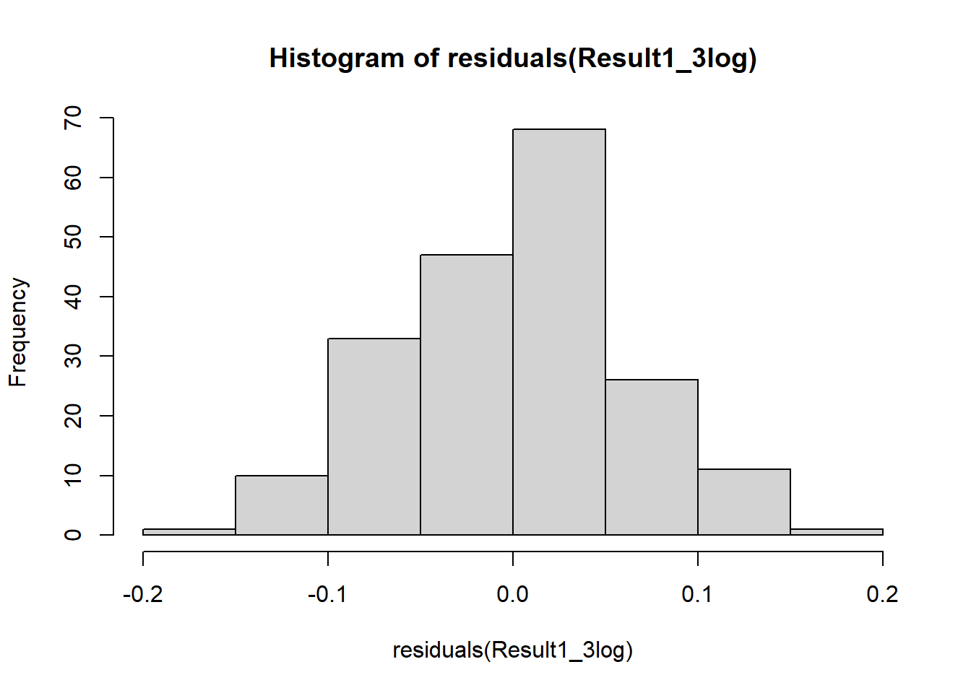
shapiro.test(residuals(Result1_3log))
##
## Shapiro-Wilk normality test
##
## data: residuals(Result1_3log)
## W = 0.99281, p-value = 0.4479
plot(fitted(Result1_3log), residuals(Result1_3log))
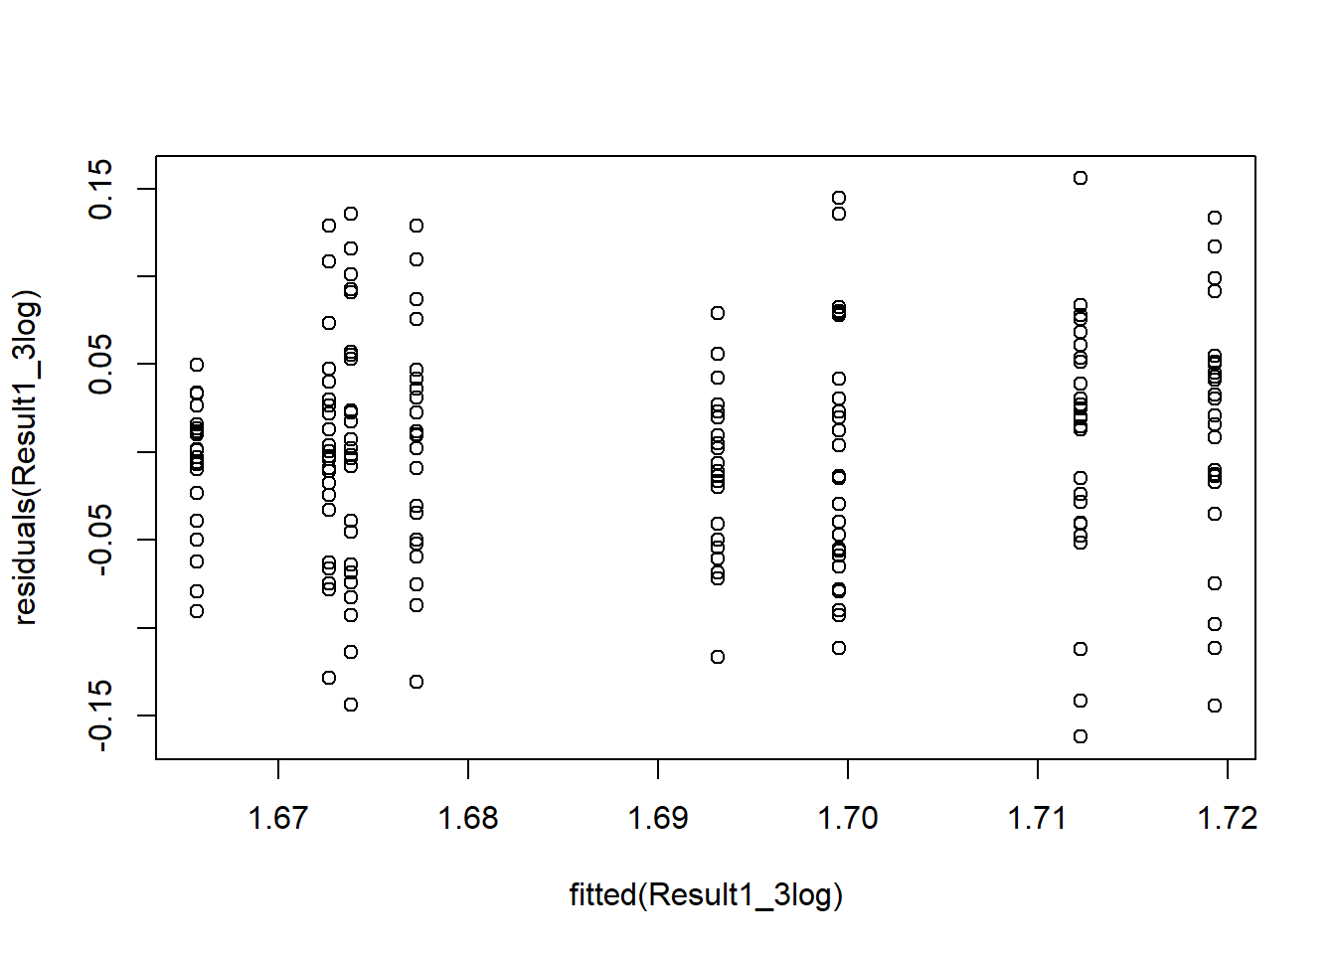
# The Shapiro–Wilk test is not significant (p = 0.448),
# indicating that residuals are normally distributed.
# The log transformation improved the normality assumption.
# The residuals vs fitted plot shows no clear pattern,
# suggesting homogeneity of variance.

### Main results
summary(Result1_3log)
## Linear mixed model fit by REML. t-tests use Satterthwaite's method [
## lmerModLmerTest]
## Formula: logBMR ~ T + (1 | L)
## Data: Voles
##
## REML criterion at convergence: -508.4
##
## Scaled residuals:
## Min 1Q Median 3Q Max
## -2.55151 -0.74431 0.06349 0.57002 2.45373
##
## Random effects:
## Groups Name Variance Std.Dev.
## L (Intercept) 0.0001646 0.01283
## Residual 0.0040321 0.06350
## Number of obs: 197, groups: L, 8
##
## Fixed effects:
## Estimate Std. Error df t value Pr(>|t|)
## (Intercept) 1.672380 0.009119 6.084463 183.389 1.28e-12 ***
## TA 0.033662 0.012818 5.933285 2.626 0.0397 *
## ---
## Signif. codes: 0 '***' 0.001 '**' 0.01 '*' 0.05 '.' 0.1 ' ' 1
##
## Correlation of Fixed Effects:
## (Intr)
## TA -0.711
# Random effects:
# The variance among replicate lines is very small (Var = 0.000165; SD = 0.0128),
# compared to the residual variance within lines (Var = 0.00403; SD = 0.0635).
# This indicates that most variation in logBMR occurs among individuals,
# not among replicate lines.

# Fixed effects:
# The intercept represents the mean logBMR of control (C) lines.
# The coefficient for TA represents the difference between A and C lines
# on the log scale.
# This difference is statistically significant (p = 0.0397),
# indicating higher BMR in A lines after accounting for line variation.

confint(Result1_3log)
## Computing profile confidence intervals ...
## 2.5 % 97.5 %
## .sig01 0.000000000 0.02512586
## .sigma 0.057600636 0.07048777
## (Intercept) 1.654876374 1.68989600
## TA 0.008980565 0.05825769
# The confidence interval for TA (0.009 to 0.058) does not include zero,
# confirming a significant effect of selection on logBMR.
# The CI for the random line effect includes zero,
# suggesting weak evidence for substantial variation among lines.

#Checking with ANOVA.
anova(Result1_3log)
## Type III Analysis of Variance Table with Satterthwaite's method
## Sum Sq Mean Sq NumDF DenDF F value Pr(>F)
## T 0.027808 0.027808 1 5.9333 6.8967 0.03967 *
## ---
## Signif. codes: 0 '***' 0.001 '**' 0.01 '*' 0.05 '.' 0.1 ' ' 1
# The ANOVA F-test confirms a significant effect of selection
# p = 0.0397,
# showing that mean logBMR differs between A and C lines.

rand(Result1_3log) # test of random effects
## ANOVA-like table for random-effects: Single term deletions
##
## Model:
## logBMR ~ T + (1 | L)
## npar logLik AIC LRT Df Pr(>Chisq)
## <none> 4 254.19 -500.39
## (1 | L) 3 253.33 -500.65 1.7344 1 0.1879
# The likelihood ratio test compares the full model with a model without the random line effect.
# The random effect of line is not statistically significant (LRT = 1.73, p = 0.188),
# indicating that variation among replicate lines is small on the log scale.

# The main results - estimated marginal means
emmeans(Result1_3log, ~ T)
## T emmean SE df lower.CL upper.CL
## C 1.67 0.00912 6.15 1.65 1.69
## A 1.71 0.00901 5.85 1.68 1.73
##
## Degrees-of-freedom method: kenward-roger
## Confidence level used: 0.95
plot(allEffects(Result1_3log))
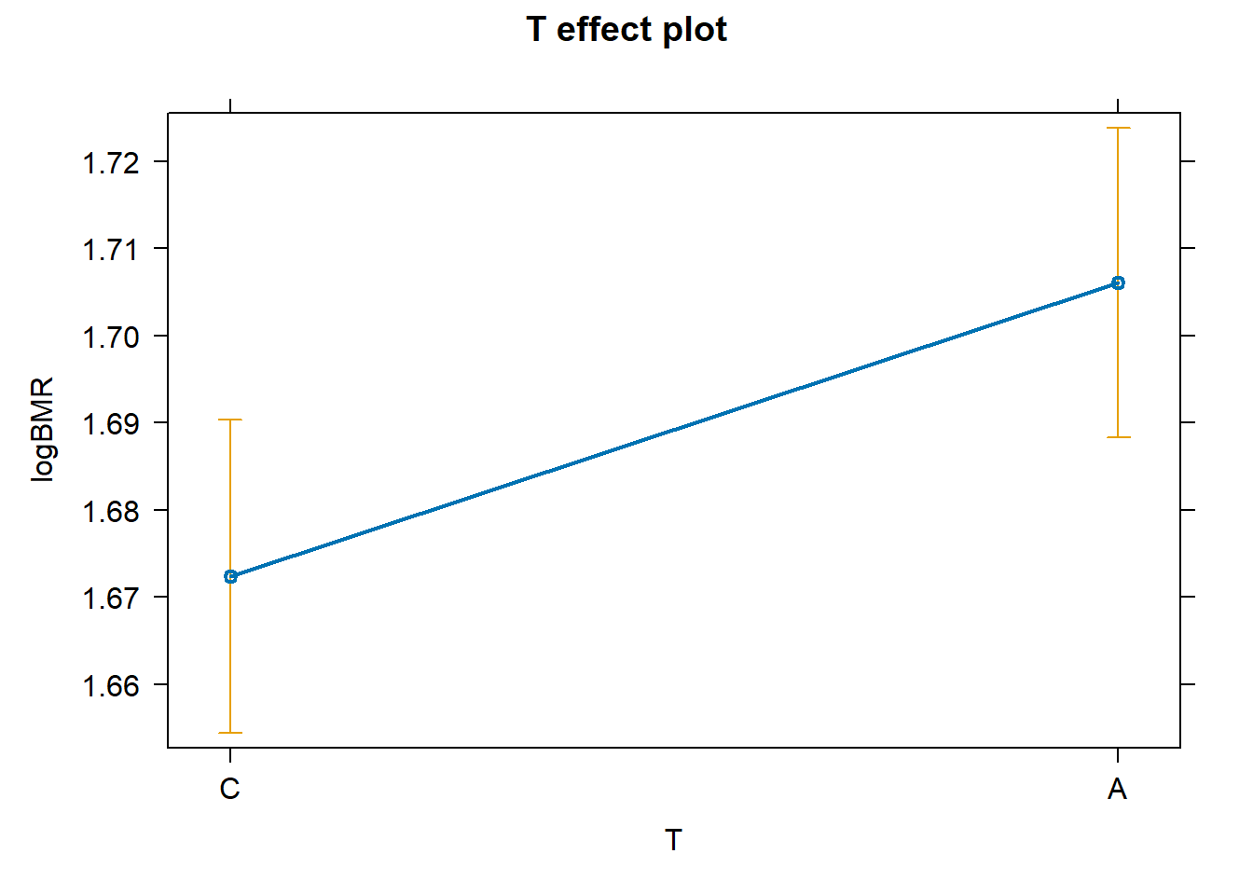
# Estimated marginal means show:
# C lines: mean logBMR ≈ 1.67
# A lines: mean logBMR ≈ 1.71
# The difference corresponds to the positive TA estimate,
# confirming higher BMR in A-selected lines.

# (4) Model comparison:
# Model 1 ignores replicate lines and therefore overestimates significance.
# Models 2 and 3 account for line structure and give more reliable results.
# Models 2 and 3 lead to similar conclusions; the mixed model (3) is preferred.

# (5) Final conclusions:
# Selection significantly increases logBMR (p ≈ 0.04).
# Variation among replicate lines is small and not significant.

# (6) Limitation:
# Models 2–3 ignore family structure, so residual dependence may remain.
# Exercise 2 improves this by including family as a random effect.

## ============================================================
## Exercise 2. Two-level nested ANOVA (log-transformed data)
## Effect of selection (T) with random effects of line (L) and family (F)
## ============================================================
# Mixed model using REML
# logBMR = intercept + T + random line (L) + random family (F)
Result2log <- lmer(logBMR ~ T + (1|L) + (1|F), data = Voles, REML = TRUE)

summary(Result2log)
## Linear mixed model fit by REML. t-tests use Satterthwaite's method [
## lmerModLmerTest]
## Formula: logBMR ~ T + (1 | L) + (1 | F)
## Data: Voles
##
## REML criterion at convergence: -509.9
##
## Scaled residuals:
## Min 1Q Median 3Q Max
## -2.35607 -0.61858 0.04191 0.52100 2.26212
##
## Random effects:
## Groups Name Variance Std.Dev.
## F (Intercept) 0.0005909 0.02431
## L (Intercept) 0.0001575 0.01255
## Residual 0.0034534 0.05877
## Number of obs: 197, groups: F, 129; L, 8
##
## Fixed effects:
## Estimate Std. Error df t value Pr(>|t|)
## (Intercept) 1.672105 0.009251 6.113390 180.754 1.25e-12 ***
## TA 0.033880 0.012997 5.954208 2.607 0.0406 *
## ---
## Signif. codes: 0 '***' 0.001 '**' 0.01 '*' 0.05 '.' 0.1 ' ' 1
##
## Correlation of Fixed Effects:
## (Intr)
## TA -0.712
# Random effects:
# Variance among families (0.00059) is slightly larger than variance among lines (0.00016),
# but both are small compared to residual variance (0.00345).
# This indicates that most variation in logBMR occurs among individuals,
# while clustering within lines or families is relatively weak.

# Fixed effects:
# The intercept (1.672) represents mean logBMR of control (C) lines.
# The coefficient TA (0.0339) represents the difference between A and C lines.
# This effect is statistically significant (p = 0.0406),
# indicating higher logBMR in A-selected lines.

confint(Result2log)
## Computing profile confidence intervals ...
## 2.5 % 97.5 %
## .sig01 0.000000000 0.04013143
## .sig02 0.000000000 0.02523685
## .sigma 0.050542991 0.06895278
## (Intercept) 1.654352072 1.68988643
## TA 0.008834427 0.05881206
# The CI for TA (0.0088 to 0.0588) does not include zero,
# confirming a significant positive effect of selection.
# The CIs for both random effects include zero,
# suggesting weak evidence for strong variation among lines or families.

anova(Result2log)
## Type III Analysis of Variance Table with Satterthwaite's method
## Sum Sq Mean Sq NumDF DenDF F value Pr(>F)
## T 0.023465 0.023465 1 5.9542 6.7948 0.04058 *
## ---
## Signif. codes: 0 '***' 0.001 '**' 0.01 '*' 0.05 '.' 0.1 ' ' 1
# The overall test of selection (T) is significant
# (F1,5.95 = 6.79, p = 0.0406).
# This confirms that logBMR differs between A and C lines
# after accounting for line and family structure.

rand(Result2log)
## ANOVA-like table for random-effects: Single term deletions
##
## Model:
## logBMR ~ T + (1 | L) + (1 | F)
## npar logLik AIC LRT Df Pr(>Chisq)
## <none> 5 254.93 -499.86
## (1 | L) 4 254.24 -500.48 1.3748 1 0.2410
## (1 | F) 4 254.19 -500.39 1.4675 1 0.2257
# Removing line (L) does not significantly reduce model fit (p = 0.241).
# Removing family (F) also does not significantly reduce model fit (p = 0.226).
# Therefore, variation among lines and families is relatively small
# and does not strongly improve the model.

emmeans(Result2log, ~ T)
## T emmean SE df lower.CL upper.CL
## C 1.67 0.00926 6.16 1.65 1.69
## A 1.71 0.00914 5.84 1.68 1.73
##
## Degrees-of-freedom method: kenward-roger
## Confidence level used: 0.95
plot(allEffects(Result2log))
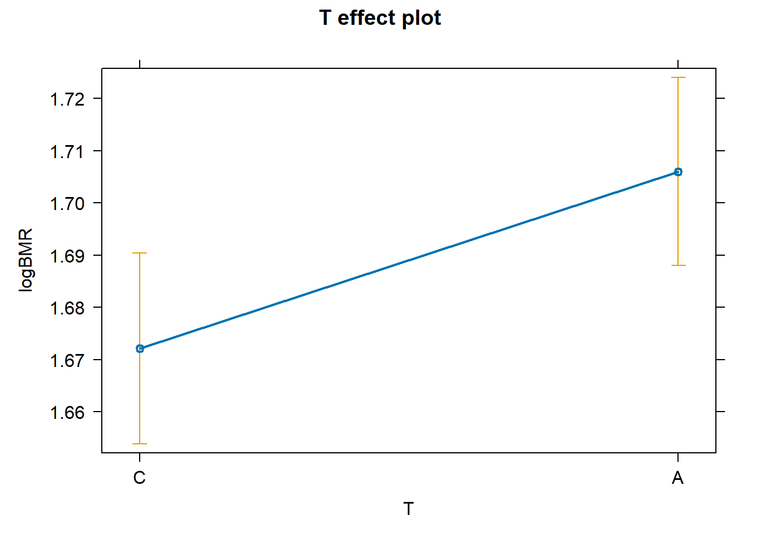
# Predicted mean logBMR is 1.67 for C lines and 1.71 for A lines.
# The difference is consistent with the positive TA coefficient,
# supporting the conclusion that selection increased BMR.

# After accounting for replicate lines and family structure,
# A-selected lines show significantly higher logBMR than control lines.
# However, variation among lines and families is relatively small
# and not statistically significant.

## ============================================================
## Exercise 3: Mixed factorial model fitted with REML method
# The effects of Sex and Line on BMR of voles
# Hypothesis: BMR of voles from Aerobic (A) lines differs between sexes (= sex affects BMR)
## ============================================================

# Subset data to A lines only
VolesA <- filter(Voles, T == "A")
# Quick check: we should have 4 lines (A1–A4)
table(VolesA$L)
##
## C1 C2 C3 C4 A1 A2 A3 A4
## 0 0 0 0 27 23 26 25
# Fit mixed model:
# logBMR = intercept + sex + random line + random sex-by-line interaction
Result3Alog <- lmer(logBMR ~ S + (1|L) + (1|S:L),
data = VolesA,
REML = TRUE)
## boundary (singular) fit: see help('isSingular')
summary(Result3Alog)
## Linear mixed model fit by REML. t-tests use Satterthwaite's method [
## lmerModLmerTest]
## Formula: logBMR ~ S + (1 | L) + (1 | S:L)
## Data: VolesA
##
## REML criterion at convergence: -258
##
## Scaled residuals:
## Min 1Q Median 3Q Max
## -2.2578 -0.6372 -0.1357 0.7581 2.7445
##
## Random effects:
## Groups Name Variance Std.Dev.
## S:L (Intercept) 0.0000000 0.00000
## L (Intercept) 0.0003833 0.01958
## Residual 0.0038432 0.06199
## Number of obs: 101, groups: S:L, 8; L, 4
##
## Fixed effects:
## Estimate Std. Error df t value Pr(>|t|)
## (Intercept) 1.68291 0.01309 4.80102 128.588 1.12e-09 ***
## S1 0.04659 0.01235 96.08899 3.773 0.000279 ***
## ---
## Signif. codes: 0 '***' 0.001 '**' 0.01 '*' 0.05 '.' 0.1 ' ' 1
##
## Correlation of Fixed Effects:
## (Intr)
## S1 -0.467
## optimizer (nloptwrap) convergence code: 0 (OK)
## boundary (singular) fit: see help('isSingular')
# Random effects:
# The sex-by-line interaction variance is estimated as 0,
# indicating that the male–female difference does not vary across lines.
# Variation among replicate lines is small (Var = 0.00038),
# and residual variance (0.00384) is much larger,
# meaning most variation occurs among individuals.

# Fixed effects:
# The intercept (1.683) represents mean logBMR of females (reference group).
# The coefficient S1 (0.0466) represents the difference between males and females.
# This effect is highly significant (p = 0.00028),
# indicating that males have higher logBMR than females in A lines.

confint(Result3Alog)
## Computing profile confidence intervals ...
## Warning in nextpar(mat, cc, i, delta, lowcut, upcut): unexpected decrease in
## profile: using minstep
## Warning in FUN(X[[i]], ...): non-monotonic profile for .sig01
## Warning in confint.thpr(pp, level = level, zeta = zeta): bad spline fit for
## .sig01: falling back to linear interpolation
## Warning in regularize.values(x, y, ties, missing(ties), na.rm = na.rm):
## collapsing to unique 'x' values
## 2.5 % 97.5 %
## .sig01 0.00000000 0.02710803
## .sig02 0.00000000 0.04770296
## .sigma 0.05393725 0.07149156
## (Intercept) 1.65575374 1.71003565
## S1 0.02233642 0.07095634
# Confidence intervals:
# The CI for S1 (0.022 to 0.071) does not include zero,
# confirming a significant positive sex effect.
# The CIs for random effects include zero,
# supporting weak or negligible variation among lines
# and no sex-by-line interaction.

# ANOVA test for the fixed effect of sex
anova(Result3Alog)
## Type III Analysis of Variance Table with Satterthwaite's method
## Sum Sq Mean Sq NumDF DenDF F value Pr(>F)
## S 0.054697 0.054697 1 96.089 14.232 0.0002794 ***
## ---
## Signif. codes: 0 '***' 0.001 '**' 0.01 '*' 0.05 '.' 0.1 ' ' 1
# ANOVA table:
# The overall effect of sex is highly significant
# (F1,96.09 = 14.23, p = 0.00028).
# This confirms that males and females differ in logBMR
# within A-selected lines.

# LRT tests for random effects (variation among lines, and sex-by-line variation)
rand(Result3Alog)
## ANOVA-like table for random-effects: Single term deletions
##
## Model:
## logBMR ~ S + (1 | L) + (1 | S:L)
## npar logLik AIC LRT Df Pr(>Chisq)
## <none> 5 129.01 -248.02
## (1 | L) 4 128.12 -248.24 1.7784 1 0.1823
## (1 | S:L) 4 129.01 -250.02 0.0000 1 1.0000
# Likelihood ratio tests:
# Removing replicate line (L) does not significantly worsen model fit (p = 0.182),
# suggesting limited variation among lines.
# The sex-by-line interaction is clearly not significant (p = 1.00),
# confirming that the sex difference is consistent across lines.

# Tabular + graphical presentation of main results
emmeans(Result3Alog, ~ S)
## S emmean SE df lower.CL upper.CL
## 0 1.68 0.0131 4.53 1.65 1.72
## 1 1.73 0.0132 4.61 1.69 1.76
##
## Degrees-of-freedom method: kenward-roger
## Confidence level used: 0.95
plot(allEffects(Result3Alog))
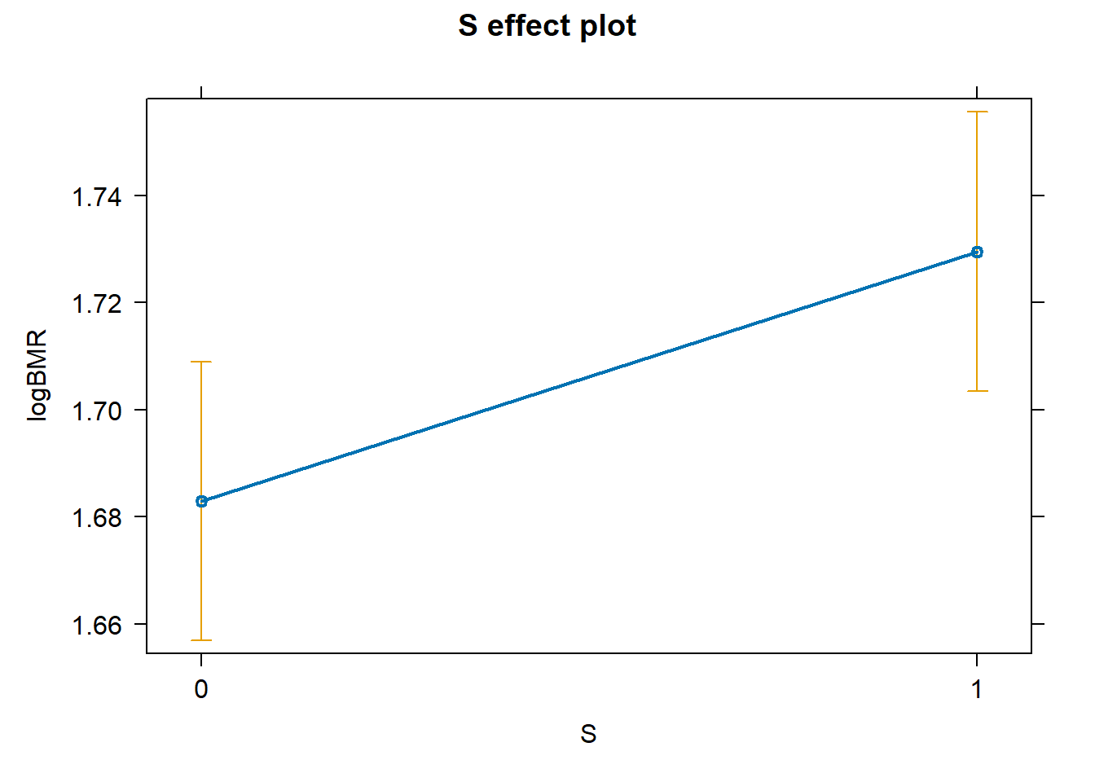
# Estimated marginal means:
# Predicted mean logBMR is 1.68 for females and 1.73 for males.
# This difference (~0.047 on log scale) reflects a biologically meaningful
# increase in BMR in males.

## ============================================================
## Exercise 4: Split-plot / cross-nested (mixed) design
## ============================================================

# Use the A + C subset
Voles_AC <- Voles %>% filter(T %in% c("A", "C"))

# Quick checks
table(Voles_AC$T)
##
## C A
## 96 101
table(Voles_AC$S)
##
## 0 1
## 100 97
with(Voles_AC, table(L, T)) # each line belongs to one selection direction
## T
## L C A
## C1 24 0
## C2 24 0
## C3 25 0
## C4 23 0
## A1 0 27
## A2 0 23
## A3 0 26
## A4 0 25
with(Voles_AC, table(L, S)) # both sexes should appear within each line
## S
## L 0 1
## C1 12 12
## C2 12 12
## C3 13 12
## C4 12 11
## A1 14 13
## A2 12 11
## A3 12 14
## A4 13 12
# Full split-plot model on log scale
# Fixed: T, S, and interaction T:S
# Random: (1|L) = line-to-line differences; (1|S:L) = sex difference may vary by line
Result4log <- lmer(logBMR ~ T + S + T:S + (1|L) + (1|S:L),
data = Voles_AC, REML = TRUE)
## boundary (singular) fit: see help('isSingular')
Result4log
## Linear mixed model fit by REML ['lmerModLmerTest']
## Formula: logBMR ~ T + S + T:S + (1 | L) + (1 | S:L)
## Data: Voles_AC
## REML criterion at convergence: -514.7007
## Random effects:
## Groups Name Std.Dev.
## S:L (Intercept) 0.00000
## L (Intercept) 0.01311
## Residual 0.06053
## Number of obs: 197, groups: S:L, 16; L, 8
## Fixed Effects:
## (Intercept) TA S1 TA:S1
## 1.65737 0.02555 0.03066 0.01604
## optimizer (nloptwrap) convergence code: 0 (OK) ; 0 optimizer warnings; 1 lme4 warnings
# Assumption checks
hist(residuals(Result4log))
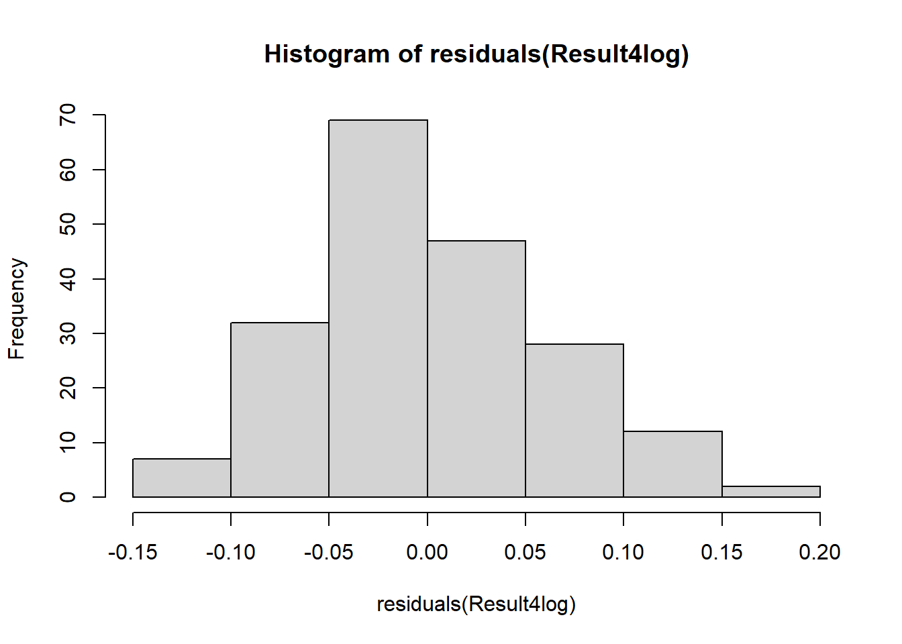
shapiro.test(residuals(Result4log))
##
## Shapiro-Wilk normality test
##
## data: residuals(Result4log)
## W = 0.99129, p-value = 0.284
plot(fitted(Result4log), residuals(Result4log))
abline(h = 0, lty = 2)
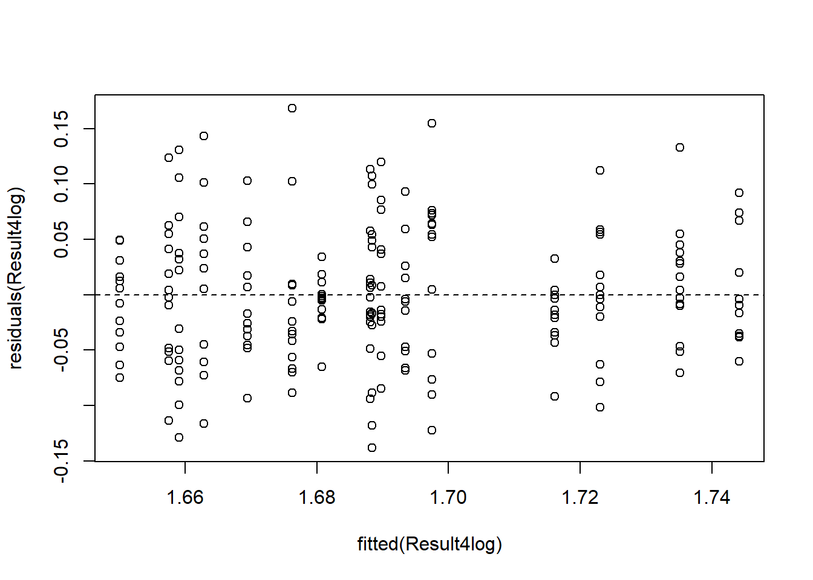
# Shapiro–Wilk test is not significant (p = 0.284),
# indicating that residuals are normally distributed on the log scale.
# Residuals vs fitted plot shows no clear pattern,
# suggesting homogeneity of variance.
# Log transformation successfully improved model assumptions.

# Main model results: fixed + random effects + confidence intervals
summary(Result4log)
## Linear mixed model fit by REML. t-tests use Satterthwaite's method [
## lmerModLmerTest]
## Formula: logBMR ~ T + S + T:S + (1 | L) + (1 | S:L)
## Data: Voles_AC
##
## REML criterion at convergence: -514.7
##
## Scaled residuals:
## Min 1Q Median 3Q Max
## -2.28335 -0.69121 -0.06278 0.67796 2.77829
##
## Random effects:
## Groups Name Variance Std.Dev.
## S:L (Intercept) 0.0000000 0.00000
## L (Intercept) 0.0001719 0.01311
## Residual 0.0036636 0.06053
## Number of obs: 197, groups: S:L, 16; L, 8
##
## Fixed effects:
## Estimate Std. Error df t value Pr(>|t|)
## (Intercept) 1.65737 0.01085 12.69674 152.726 <2e-16 ***
## TA 0.02555 0.01525 12.38773 1.675 0.119
## S1 0.03066 0.01236 187.01466 2.480 0.014 *
## TA:S1 0.01604 0.01726 187.19842 0.929 0.354
## ---
## Signif. codes: 0 '***' 0.001 '**' 0.01 '*' 0.05 '.' 0.1 ' ' 1
##
## Correlation of Fixed Effects:
## (Intr) TA S1
## TA -0.711
## S1 -0.558 0.397
## TA:S1 0.399 -0.557 -0.716
## optimizer (nloptwrap) convergence code: 0 (OK)
## boundary (singular) fit: see help('isSingular')
# Fixed effects:
# Selection effect (T): estimate = 0.0256, p = 0.119 (not significant).
# Sex effect (S): estimate = 0.0307, p = 0.014 (significant).
# Interaction (T:S): estimate = 0.0160, p = 0.354 (not significant).

# Males have significantly higher logBMR than females.
# The interaction is not significant, meaning the sex difference
# does not depend strongly on selection direction.

confint(Result4log)
## Computing profile confidence intervals ...
## 2.5 % 97.5 %
## .sig01 0.000000000 0.01673784
## .sig02 0.000000000 0.02507584
## .sigma 0.054613888 0.06683303
## (Intercept) 1.636953986 1.67778999
## TA -0.003159030 0.05425539
## S1 0.006424111 0.05480919
## TA:S1 -0.017592855 0.04997836
# General hypothesis tests for fixed effects (preferred with interaction)
anova(Result4log)
## Type III Analysis of Variance Table with Satterthwaite's method
## Sum Sq Mean Sq NumDF DenDF F value Pr(>F)
## T 0.025723 0.025723 1 5.932 7.0214 0.03846 *
## S 0.073541 0.073541 1 187.198 20.0737 1.295e-05 ***
## T:S 0.003162 0.003162 1 187.198 0.8632 0.35405
## ---
## Signif. codes: 0 '***' 0.001 '**' 0.01 '*' 0.05 '.' 0.1 ' ' 1
# Selection (T): F = 7.02, p = 0.038 → significant.
# Sex (S): F = 20.07, p < 0.001 → highly significant.
# Interaction (T:S): p = 0.354 → not significant.

# Interpretation:
# After averaging across sexes, BMR differs between A and C lines.
# After averaging across selection groups, males and females differ.
# There is no evidence that the selection effect differs between sexes.

# Tests for random effects (LRT)
rand(Result4log)
## ANOVA-like table for random-effects: Single term deletions
##
## Model:
## logBMR ~ T + S + T:S + (1 | L) + (1 | S:L)
## npar logLik AIC LRT Df Pr(>Chisq)
## <none> 7 257.35 -500.70
## (1 | L) 6 256.52 -501.03 1.6671 1 0.1967
## (1 | S:L) 6 257.35 -502.70 0.0000 1 1.0000
# Line effect (1|L): p = 0.197 → not significant.
# Sex-by-line interaction (1|S:L): p = 1.000 → no variation in sex effect across lines.

# Present results in tabular form (estimated marginal means)
emmeans(Result4log, pairwise ~ T)
## NOTE: Results may be misleading due to involvement in interactions
## $emmeans
## T emmean SE df lower.CL upper.CL
## C 1.67 0.00901 6.14 1.65 1.69
## A 1.71 0.00891 5.85 1.68 1.73
##
## Results are averaged over the levels of: S
## Degrees-of-freedom method: kenward-roger
## Confidence level used: 0.95
##
## $contrasts
## contrast estimate SE df t.ratio p.value
## C - A -0.0336 0.0127 6 -2.649 0.0381
##
## Results are averaged over the levels of: S
## Degrees-of-freedom method: kenward-roger
# Averaged across sexes:
# C = 1.67, A = 1.71
# Difference = 0.0336 (log scale), p = 0.038.
# A lines have significantly higher BMR than C lines.

emmeans(Result4log, pairwise ~ S)
## NOTE: Results may be misleading due to involvement in interactions
## $emmeans
## S emmean SE df lower.CL upper.CL
## 0 1.67 0.00763 10.4 1.65 1.69
## 1 1.71 0.00771 10.8 1.69 1.73
##
## Results are averaged over the levels of: T
## Degrees-of-freedom method: kenward-roger
## Confidence level used: 0.95
##
## $contrasts
## contrast estimate SE df t.ratio p.value
## S0 - S1 -0.0387 0.00864 5.98 -4.476 0.0042
##
## Results are averaged over the levels of: T
## Degrees-of-freedom method: kenward-roger
# Averaged across selection groups:
# Females = 1.67, Males = 1.71
# Difference = 0.0387 (log scale), p = 0.0042.
# Males have significantly higher BMR than females.

emmeans(Result4log, ~ T:S)
## T S emmean SE df lower.CL upper.CL
## C 0 1.66 0.0109 10.6 1.63 1.68
## A 0 1.68 0.0107 10.1 1.66 1.71
## C 1 1.69 0.0110 11.2 1.66 1.71
## A 1 1.73 0.0108 10.3 1.71 1.75
##
## Degrees-of-freedom method: kenward-roger
## Confidence level used: 0.95
# Graphical presentation
plot(allEffects(Result4log))
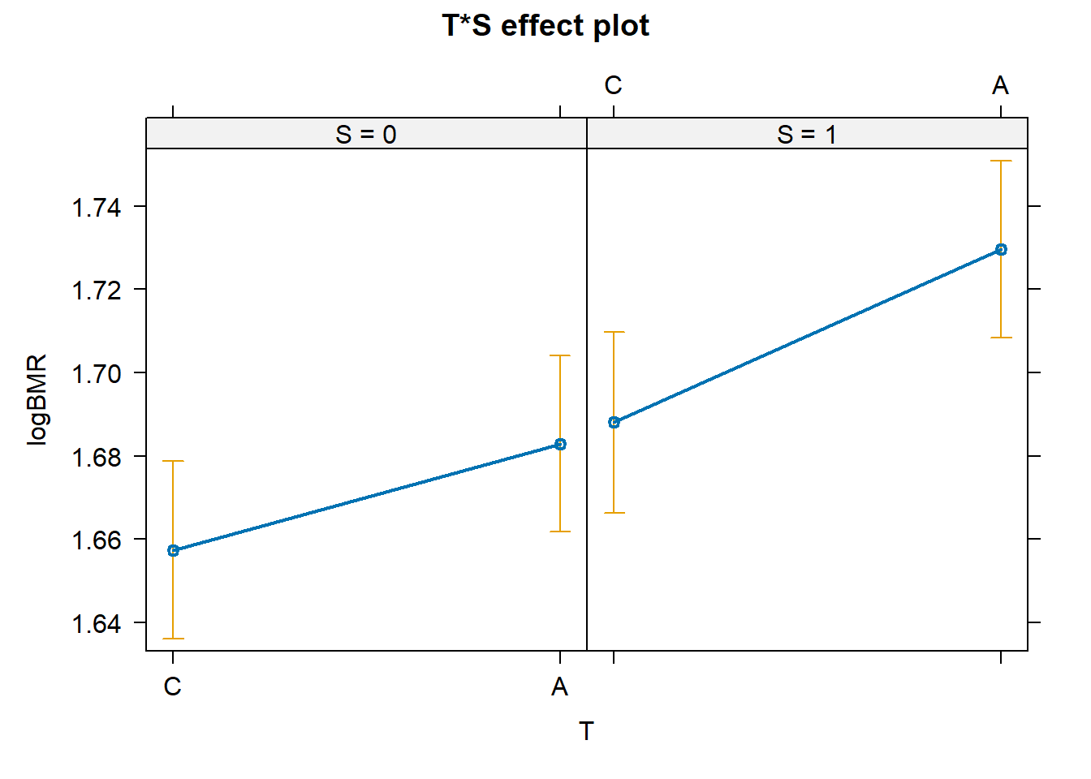
# Effect plot shows A > C for both sexes and males > females for both selection groups.
# Parallel pattern matches the non-significant interaction.

