POST /check_available_areas
Function: check_available_areas.
Description: check if region available to add for new branch or no
Authentication: Requires a valid employee token in the header.
Request
- lang: ar | en (default: ar)
-region_id -> required
-city_id -> required
Success Response
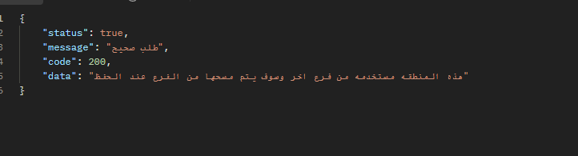
Error Responses
Code | Description
401 | Unauthorized – Invalid or missing token
422 | Validation error – Missing or invalid parameters
500 | Internal server error

