Step 1. Download the files from github and upload them directly in wp-content/plugin directory.
Step 2. Go the admin page of your wordpress and go to the Plugins – Installed Plugins screen and make sure you activate the localexpress plugin
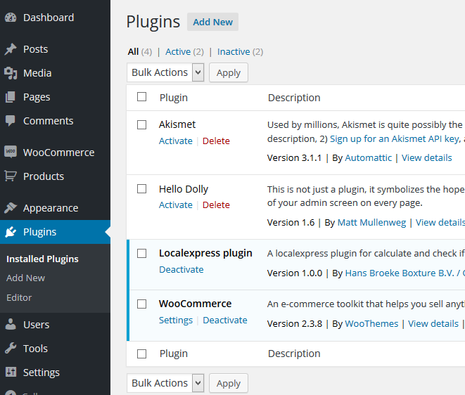

Step 3. Now you’ll find in woocommerce – settings – shipping screen the localexpress option
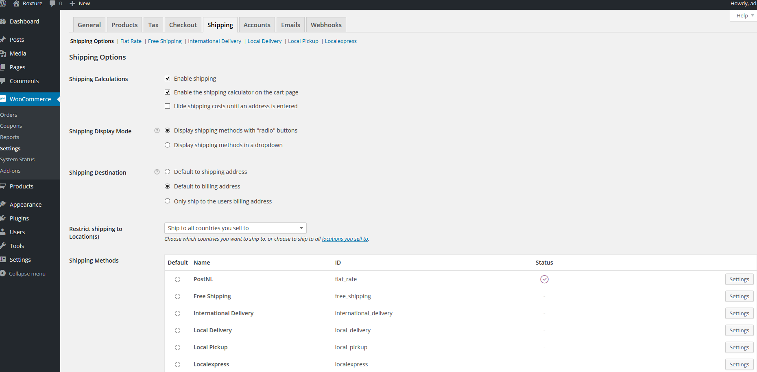
There you click the settings and fill in all details. Make sure you enable the option to use it.
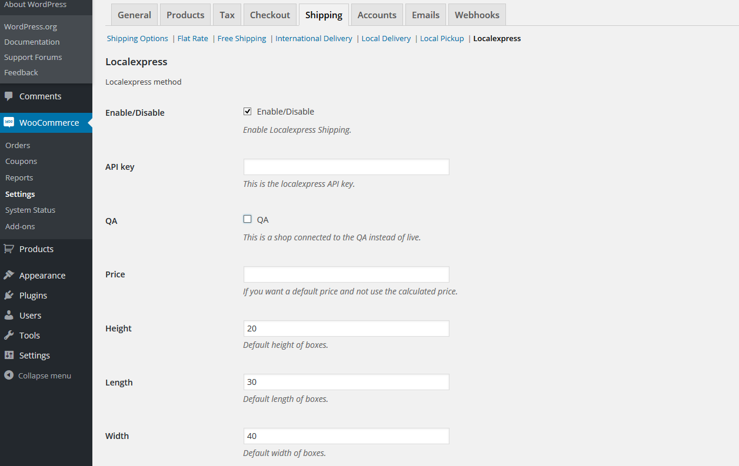
Step 4.

