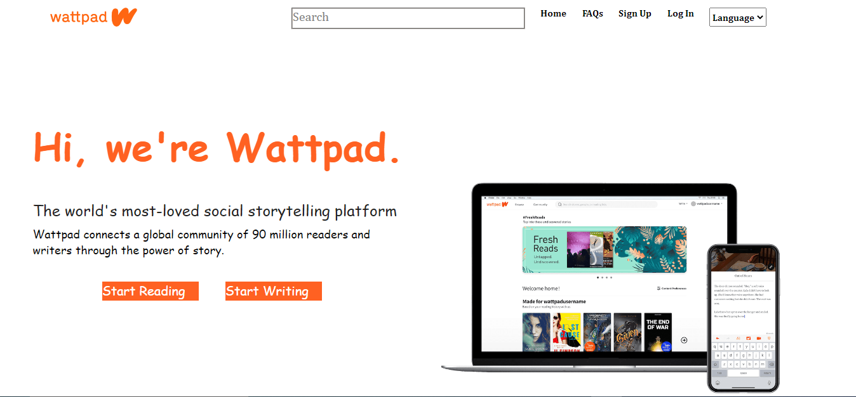

**Project Name : Wattpad**

**By : Lochan Singoria**

**Overview**

**Wattpad is an online social reading platform intended for users to read and write original stories. Founders Allen Lau and Ivan Yuen say that the platform aims to create social communities around stories and remove the barriers between readers and writers.The platform allows users to write and publish stories, or read stories generated by other users. In January 2021, Naver Corporation announced that it would be acquiring Wattpad; the deal was completed in May 2021. As of November 2021, Wattpad has a monthly audience of more than 90 million users, who can directly interact with the writers and share their opinions with fellow readers.**

**Wattpad has stories available in more than 50 languages, and nearly 300,000 writers from 35 countries take part every year in the largest writing competition, The Watty Awards.Some of these stories are being transformed into TV dramas and movies, examples are *After and* *The Kissing Booth.*  In January 2019, Wattpad launched a publishing division named Wattpad Books, in an effort to take the "guesswork" out of publishing for authors.**

**Goals**

* **Homepage**
* **Premium and payment page**
* **Login and Logout page**

**History**

**Wattpad was developed in 2006, as the result of a collaboration between Allen Lau and Ivan Yuen. The company is based in Toronto, Ontario. In February 2007, Wattpad announced the addition of over 17,000 e-books from Project Gutenberg making them available to mobile users. According to a June 2009 Wattpad press release, the application had been downloaded over 5 million times. In March 2009, an iPhone version was released. This was followed by the launch on Blackberry App World in April 2009 Google Android in June 2009 and Apple iPad in April 2010. In December 2015, Windows Phone 8.1 and Windows 10 Mobile Version was released. Currently, Wattpad has more than 90 million users who collectively spend 15 billion minutes each month using Wattpad.As of 2018, there are more than 400 million fanfiction uploads on Wattpad**.

**Technologies Used In Spotify**

**Front-End:**

1. **Html**
2. **CSS**
3. **Bootstrap**
4. **Reacts**

**Dynamic:**

1. **Javascript**
2. **Login and Logout**

**Database:**

1. **Mongodb**

**Code compilers:**

1. **Visual studio code**
2. **Git bash**
3. **Git hub**
4. **Node js and express**

