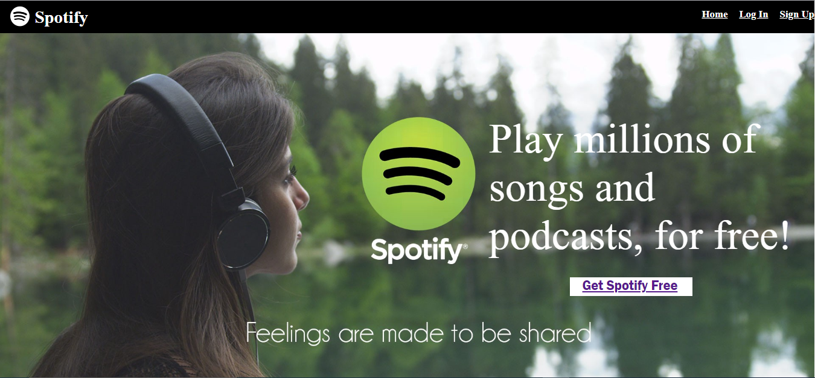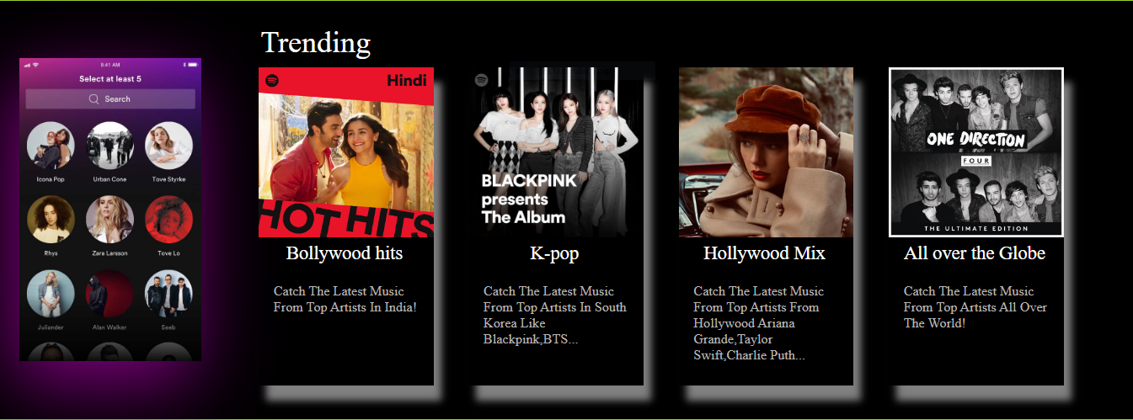

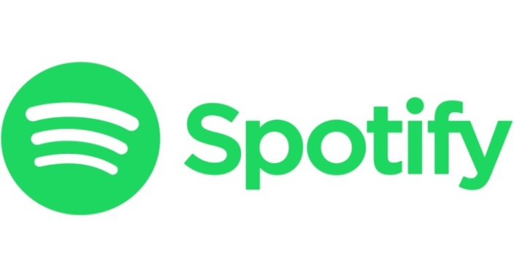

**Project Name : Spotify**

**By : Lochan Singoria**

**Overview**

**Spotify is a digital music and podcast service that gives you access to millions of songs and other content from creators all over the world. Basic functions such as playing music are totally free, but you can also choose to upgrade to spotify through premium.**

**Whether you have premium or not, you can:**

* **Get recommendations based on your taste.**
* **Build collections of music**
* **And more!**

**Spotify is available across a range of devices, including computers, phones, tablets, speakers, TVs, and cars and you can easily transit from one to another with spotify connect.**

**Goals**

* **Home page**
* **Playlist page**
* **Premium and payment page**
* **Login and Logout page**

**History**

**Spotify was founded in 2006 in Stockholm, Sweden, by Daniel Ek, former CTO of Stardoll, and Martin Lorentzon, co-founder of Tradedoubler. According to Ek, the company’s title was initially misheard from a name shouted by Lorentzon. Later they thought out a portmanteau of “spot” and “identify” which nowadays we all know it as spotify.**

**Technologies Used In Spotify**

**Front-End:**

1. **Html**
2. **CSS**
3. **Bootstrap**
4. **React**

**Dynamic:**

1. **Javascript**
2. **Login and Logout**

**Database:**

1. **Mongodb**

**Code compilers:**

1. **Visual studio code**
2. **Git bash**
3. **Git hub**
4. **Node js and express**