BSc (Hons) in Information Technology — Year 3 IT3060 – Human Computer Interaction | Semester 2, 2026
Name -: Chandira A G A L IT No -: IT23776500 Group -: WE.05.01

Lab Exercise 05

Activity 1: Frontend Technology Comparison — Flutter vs React Native vs Kotlin Multiplatform vs Swift/SwiftUI

Strengths and Weaknesses

Flutter
    - Strengths: Single Dart codebase for iOS, Android, web and desktop; excellent widget-based UI control for pixel-perfect, animation-heavy screens; hot reload speeds up iteration; strong for consistent branding across platforms.
    - Weaknesses: Dart has a smaller talent pool than JavaScript; app sizes tend to be larger; native module bridging for niche health/wearable SDKs can be more effortful; web output is heavier than a purpose-built web app.

React Native
    - Strengths: JavaScript/TypeScript codebase shared with a very large ecosystem of libraries; React Native Web extends the same codebase to browsers; large hiring pool; strong support for third-party SDKs (Firebase, analytics, ML kits, payment gateways); mature tooling (Expo) accelerates delivery.
    - Weaknesses: Bridge/JSI overhead can affect very heavy animations or intensive on-device ML unless native modules are used; version fragmentation across native dependencies can create maintenance overhead.

Kotlin Multiplatform (KMP)
    - Strengths: Shares business logic (networking, validation, data models) across iOS and Android while keeping fully native UI (Jetpack Compose / SwiftUI), giving the best native look-and-feel and performance per platform.
    - Weaknesses: UI layer is not shared, so two UI codebases must still be built and kept visually consistent; no first-class web target; smaller community and fewer ready-made libraries than React Native; steeper learning curve for teams unfamiliar with both native ecosystems.

Swift / SwiftUI
    - Strengths: Best possible performance and platform-native feel on Apple devices; first access to new iOS APIs (HealthKit, camera, sensors) — valuable for a fitness app; excellent developer tooling (Xcode Previews).
    - Weaknesses: iOS-only — Android and web would need entirely separate codebases and teams, roughly tripling frontend development and maintenance cost for a cross-platform product like FitFlow.

Comparison Across Key Criteria

Criterion | Flutter | React Native | Kotlin Multiplatform | Swift/SwiftUI
Development speed | High | High | Medium | Medium (iOS only)
Code reusability | Very high (~95%) | Very high (~90%) | Medium (logic only,  ~40–60%) | None (single platform)
Performance | Near-native | Near-native (native modules for hot paths) | Native | Native (best)
Ecosystem support | Growing, good | Very large / mature | Growing, smaller | Mature (Apple only)
Learning curve | Medium (Dart) | Low–Medium (JS/TS) | Medium–High | Medium (Swift)
Web compatibility | Yes (Flutter Web) | Yes (React Native Web) | No native web target | No
AI/ML integration | Good (TFLite plugins) | Good (TFLite, ML Kit, cloud SDKs) | Good via native SDKs | Best on-device (Core ML)
Real-time features | Good (sockets/Firebase) | Good (sockets/Firebase) | Good (native sockets) | Good (native sockets)
Maintenance cost | Low (1 codebase) | Low (1 codebase) | Medium (2 UI codebases) | High (3 codebases needed)
Security | Good, standard practices | Good, standard practices | Good, native security | Best (Apple ecosystem controls)
Table 1.1 — Frontend technology comparison across key evaluation criteria

Suitability for FitFlow (iOS / Android / Web, High Performance)
FitFlow needs one team to ship consistently across iOS, Android and web, at speed, while still supporting camera-based food recognition and smooth animations for workout tracking. Swift/SwiftUI is eliminated immediately because it cannot reach Android or web without duplicating the entire frontend. Kotlin Multiplatform is attractive for logic-sharing but still requires two separate UI implementations and offers no web target, which does not fit FitFlow's "seamless" cross-platform requirement. Flutter and React Native are the realistic finalists, both offering single-codebase delivery across all three targets with near-native performance.

Recommendation: React Native (with native modules where needed)
React Native is recommended as the primary frontend technology for the FitFlow redesign, consistent with the technology decision reached in the case study.
    - A single JavaScript/TypeScript codebase covers iOS, Android and (via React Native Web) a browser experience, minimizing team size and maintenance cost.
    - Its ecosystem has ready-made, well-maintained libraries for Firebase, camera access, charts/dashboards, and social feeds — all core FitFlow features.
    - Performance-critical pieces (the on-device AI workout engine and camera-based nutrition logging) are implemented as native modules bridging to TensorFlow Lite / ML Kit, giving near-native speed exactly where it is needed while keeping the rest of the app in the shared codebase.
    - A hybrid approach — React Native for the app shell and business screens, with native modules only for AI/camera-heavy features — gives FitFlow the fastest time-to-market without sacrificing the performance the fitness experience demands.

Activity 2: Backend, Database and Authentication Comparison

Backend Frameworks

Criterion | Node.js / NestJS | Python / FastAPI | Go
Development speed | Very fast (huge npm ecosystem) | Fast, especially for AI/data teams | Slower to write, very fast to run
Real-time capability | Excellent (native async I/O, WebSockets) | Good (ASGI + WebSockets) | Excellent (goroutines)
AI/ML integration | Good via SDKs/APIs to Python AI services | Best — native Python ML ecosystem (TensorFlow, PyTorch) | Possible but ecosystem is thinner
Team/hiring fit | Same language as React Native frontend (JS/TS) | Requires Python skills alongside JS frontend | Requires separate Go expertise
Performance under load | Good | Good | Best (compiled, low overhead)
Maturity/ecosystem | Very mature, huge library base | Mature, growing fast | Mature, smaller web-framework ecosystem
Table 2.1 — Backend framework comparison

Database Options

Criterion | PostgreSQL | MongoDB | Firebase (Firestore) | DynamoDB
Scalability | Vertical + read replicas; horizontal needs sharding | Horizontal scaling built-in | Auto-scales, managed | Auto-scales, managed, very high throughput
Query performance | Excellent for relational/structured queries and joins | Fast for document lookups, weaker for complex joins | Fast simple queries; limited complex querying | Very fast key-based lookups; limited ad-hoc queries
Health data handling | Strong fit — ACID compliance, schema integrity for sensitive records | Flexible schema, needs app-level integrity checks | Needs care for compliance; good for non-sensitive real-time data | Strong consistency options; needs compliance controls
Real-time support | Requires add-ons (e.g., LISTEN/NOTIFY, external tools) | Change streams available | Native real-time sync — best fit for live feeds | Streams available via DynamoDB Streams
Cost/maintainability | Predictable, self-managed or managed options (RDS) | Managed options available (Atlas) | Low ops overhead, usage-based pricing | Low ops overhead, usage-based pricing
Table 2.2 — Database comparison

Authentication & Authorization

Criterion | Firebase Auth | AWS Cognito | Auth0 | Supabase Auth
Setup speed | Very fast, tight fit with Firestore/RN | Moderate, more configuration | Fast, polished dashboard | Fast, pairs with Postgres
Social/SSO login | Excellent, wide provider support | Good, supports SAML/OIDC | Excellent, very wide provider support | Good, growing provider support
Compliance features | Good baseline; GDPR-capable with configuration | Strong enterprise compliance (HIPAA-eligible) | Strong enterprise compliance options | Good, improving compliance tooling

Criterion | Firebase Auth | AWS Cognito | Auth0 | Supabase Auth
Cost at scale | Low at small–mid scale, rises with MAU | Competitive at enterprise scale | Can become costly at scale | Low, transparent pricing
Best fit | Teams already using Firebase for real-time/social data | Teams needing strict enterprise/HIPAA controls | Teams wanting a dedicated identity platform | Teams standardized on PostgreSQL
Table 2.3 — Authentication and authorization comparison

Assessment: Security, Real-time, AI Integration, Cost, Maintainability
For a mid-sized team building a health-adjacent consumer app, the priorities are: (1) shipping fast without an oversized DevOps footprint, (2) genuinely real-time social/notification features, (3) straightforward integration with an AI microservice, and (4) sufficient data-protection controls to support GDPR/HIPAA-style obligations as the product scales.
    - Security & compliance: PostgreSQL gives the strongest guarantees for structured health data (schema validation, ACID transactions, mature encryption-at-rest/in-transit tooling), while Firebase covers ephemeral/real-time social data acceptably with proper security rules.
    - Real-time capability: Firebase Firestore/Realtime Database is purpose-built for this and requires the least custom engineering for live feeds, presence, and notifications.
    - AI integration: Node.js/Express backend calls out to a dedicated AI microservice (which can itself be Python-based) for heavier model inference, keeping the core API fast while giving the AI team language flexibility.
    - Cost & maintainability for a mid-sized team: Firebase's managed services (Auth + Firestore) minimize infrastructure operations, letting a small team focus engineering effort on product features rather than server management.

Recommendation
Node.js with Express is recommended for the core backend API, paired with PostgreSQL for structured, sensitive data (user profiles, health metrics, subscriptions) and Firebase (Firestore/Realtime Database + Firebase Auth) for real-time social features, presence, and notifications. This combination matches the language of the React Native frontend (JavaScript/TypeScript throughout), minimizes operational overhead for a mid-sized team, and gives FitFlow both strong data integrity where it matters most and genuine real-time behaviour where the product needs it — consistent with the stack adopted in the case study.

Activity 3: Weighted Technology Comparison Matrix
The matrix below consolidates the frontend, backend, database and authentication findings into a single weighted decision. Each option is scored 1 (poor) to 5 (excellent) against FitFlow's project needs; weights reflect the relative importance of each criterion for a real-time, AI-driven, health-adjacent consumer app.

Frontend Decision Matrix

Criterion | Weight | Flutter | React Native | KMP | Swift/SwiftUI
Cross-platform reach | 20% | 5 | 5 | 3 | 1
Development speed | 18% | 4 | 5 | 3 | 3
Performance | 15% | 4 | 4 | 5 | 5
Ecosystem/library support | 15% | 3 | 5 | 3 | 4
AI/ML integration | 12% | 4 | 4 | 4 | 5
Maintenance cost | 12% | 5 | 5 | 3 | 1
Team hiring fit | 8% | 3 | 5 | 3 | 3
Weighted score | 100% | 4.03 | 4.71 | 3.32 | 2.86
Table 3.1 — Frontend weighted decision matrix (React Native scores highest)

Backend / Database / Auth Decision Matrix

Criterion | Weight | Node.js+Express / PostgreSQL+Firebase / Firebase Auth | Python FastAPI / MongoDB / Auth0 | Go / DynamoDB / Cognito
Development speed | 20% | 5 | 4 | 3
Real-time capability | 18% | 5 | 3 | 4
Data integrity (health data) | 17% | 5 | 3 | 4
AI/ML integration ease | 15% | 4 | 5 | 3
Security/compliance | 15% | 4 | 4 | 5
Cost & maintainability | 15% | 5 | 3 | 3
Weighted score | 100% | 4.68 | 3.65 | 3.66
Table 3.2 — Backend/database/auth weighted decision matrix

Recommended Technology Stack

Layer | Recommended Technology
Frontend | React Native (+ React Native Web), native modules for AI/camera
Backend | Node.js + Express
Primary database | PostgreSQL (structured/health data)
Real-time/social database | Firebase Firestore / Realtime Database
Authentication | Firebase Auth
AI/ML | TensorFlow Lite (on-device) + cloud model; ML Kit for computer vision

Layer | Recommended Technology
Caching | Redis
Media storage | Firebase Storage / Amazon S3
Table 3.3 — FitFlow recommended technology stack summary

This stack scores highest across both matrices because it maximizes development speed and code reuse for a mid-sized team, provides genuine real-time behavior for social features, gives strong data integrity for health-related records, and integrates cleanly with an AI microservice for personalization and computer-vision nutrition logging — while keeping infrastructure operations light through managed services.

Activity 4: High-Level Architecture

Architecture Diagram
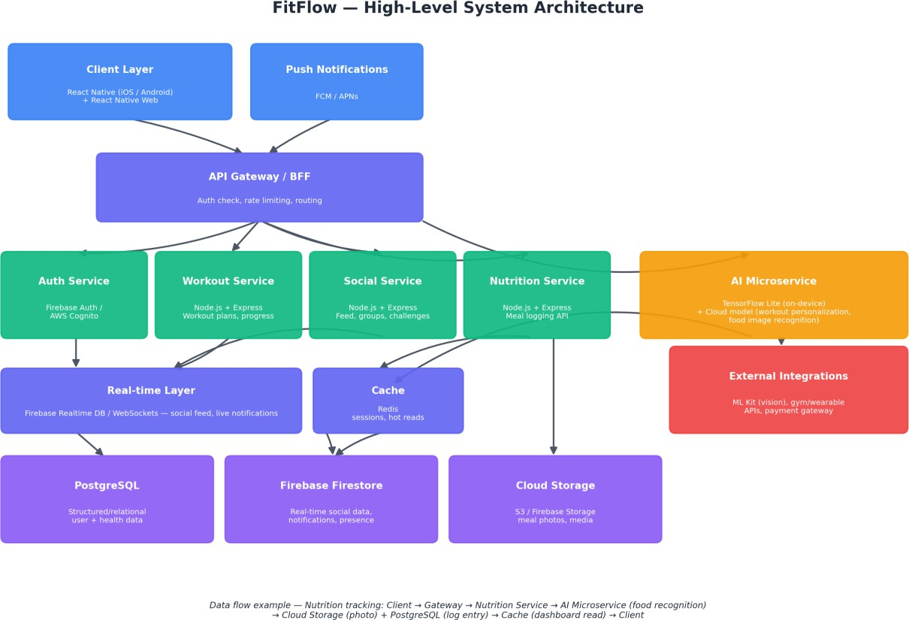

Key Components
    - Client Layer: React Native app (iOS, Android) plus React Native Web for browser access; receives push notifications via FCM/APNs.
    - API Gateway / BFF: Single entry point that authenticates requests, applies rate limiting, and routes traffic to the correct backend microservice.
    - Backend services (Node.js + Express): Auth Service, Workout Service, Social Service, and Nutrition Service — each independently deployable and scalable.
    - AI Microservice: Combines on-device TensorFlow Lite inference (fast, private, offline-capable) with cloud-hosted models for heavier personalization and food-image recognition.

    - Real-time layer: Firebase Realtime Database/WebSocket’s deliver live social feed updates, challenge progress, and notifications.
    - Caching: Redis reduces repeated load on the database layer for session data and frequently read dashboard content.
    - Data layer: PostgreSQL holds structured, sensitive user data; Fire store holds real-time social data; Cloud Storage holds meal photos and other media.
    - External integrations: ML Kit for computer vision, gym/wearable device APIs, and payment gateway for premium subscriptions.

Data Flow Examples

Personalized Workout Plans
Client requests a plan → API Gateway routes to Workout Service → Workout Service calls the AI Microservice with the user's history and goals → AI Microservice returns a ranked plan (on-device model first, cloud model for deeper personalization) → Workout Service stores the plan in PostgreSQL and returns it to the client, with progress cached in Redis for fast dashboard reads.

Social Sharing
Client posts an update or joins a challenge → API Gateway routes to Social Service → Social Service writes to Fire store → Fire store’s real-time sync pushes the update to other participants' clients instantly via the Real-time Layer, while a summarized record is retained in PostgreSQL for analytics.

Nutrition Tracking
Client captures a meal photo → API Gateway routes to Nutrition Service → Nutrition Service sends the image to the AI Microservice (computer vision via ML Kit/TensorFlow Lite) for food recognition → the photo is stored in Cloud Storage, the structured log entry (food, calories, macros) is written to PostgreSQL, and the dashboard is refreshed from Cache.

Security, Scalability and Integration Considerations
    - Security: All traffic is routed through the API Gateway over HTTPS/TLS; PostgreSQL holds health-adjacent data with encryption at rest and role-based access; Firebase security rules restrict Fire store access to authenticated, authorized users; tokens issued by Firebase Auth are short-lived and refreshed via secure flows.
    - Scalability: Backend services are stateless and independently scalable (horizontal scaling behind the gateway); Firebase and cloud-managed databases auto-scale for read/write spikes typical of social features; Redis absorbs read pressure on hot paths like the home dashboard.
    - Integration: The AI Microservice is decoupled from core backend services via internal APIs, allowing the data-science team to iterate on models independently; external integrations (wearables, payment) are isolated behind dedicated adapters so a third-party outage does not affect core app functionality.

Architecture Decision Record (ADR)

Field | Details
Title | ADR-001: Adopt React Native + Node.js/Express + PostgreSQL/Firebase for FitFlow Redesign
Status | Accepted
Context | FitFlow needed a single technology stack capable of delivering consistent iOS/Android/web experience, real-time social features, AI-powered personalization, and camera-based nutrition logging, while remaining maintainable for a mid-sized team and cost-effective to operate.
Decision | Use React Native (with native modules for AI/camera features) for the frontend; Node.js + Express for backend services; PostgreSQL for structured/health data;

Field | Details
 | Firebase (Fire store, Realtime Database, Auth) for real-time social features and authentication; TensorFlow Lite + cloud models for AI; Redis for caching.
Alternatives considered | Flutter (strong cross-platform option but smaller JS-aligned ecosystem); Kotlin Multiplatform and Swift/Swift UI (rejected — do not meet the single-team, cross-platform-including-web requirement); Python/Fast API backend (kept as the AI microservice's language rather than the core API, to preserve JS/TS consistency with the frontend); MongoDB/DynamoDB (rejected as primary store — PostgreSQL better suits structured health data integrity).
Consequences | Positive: single JS/TS skillset across most of the stack, fast delivery, strong real-time behavior, solid data integrity for sensitive records, low operations overhead via managed services. Negative: running two database technologies (PostgreSQL + Firestore) adds some operational complexity and requires clear data-ownership boundaries between them.

