

**Sri Lanka Institute of Advanced Technological Education Higher National Diploma in Information Technology**

Advanced Technological Institute Anuradhapura

**Higher National Diploma in Information Technology**

# Project Proposal

**“LS Transport”**

(Desktop Application for Cab Service)

|  |  |  |
| --- | --- | --- |
| Name Of the student | Register Number | Signature |
| H.A.L.E.S.Gunasekara | ANU/IT/2019/F/0055 |  |

(HNDIT2404)

Project(individual)

Supervisor: Mr. Pavaridu sahansith

Academic Year: 2019/2021 Year 2-Semester 02(Fulltime)

Submission Date: (22/08/2021)

**Contents page No:**

1. Introduction……………………………………………………………………. 03
2. Background & motivation……………………………………………………… 04
   1. Background………………………………………………………………. 04
   2. Motivation………………………………………………………………... 04
3. Problem in brief………………………………………………………………. 05

4. Aims & objectives……………………………………………………………… 06

* 1. Aim……………………………………………………………………… 06
  2. Objectives……………………………………………………………….. 06

1. Proposed solution…………………………………………………………….. 07
2. Resource requirements & support……………………………………………. 08
3. Gantt chart…………………………………………………………………… 09
4. 8. References…………………………………………………………………. 10

## 1.Introduction

The project proposal is submitted to meet software development requirements of the individual project module conduct by the Sri Lanka Institute of Advanced Technological Education (SLIATE).

This document outlines the background to the project, the problem that led to the project, and the solutions to the problem, as well as the resources and resources required to carry out the project.

The project describes its background and its motivations. Here can get an idea of ​​the project, the problems and related solutions, and aim and objectives to get an idea of ​​the project's scope. Studying this document will help you identify the relationship between the software and hardware component and get an idea of ​​the technology and strategies used to create this project, as well as understand the client's needs and end result.

This is a desktop application designed for a car rental company. Today, people use vehicles for their daily commute, but there is no formal procedure for doing so.

The information system designed to more closely manager’s needs and the system set up as major computer application area. The Management Information System as a computer-based system makes information available to users with similar needs. Manager used the output information. The earlier studies shown that Management information system could use to manage car rental, expected to accelerate as well as archiving services to customers better and safer, making it easier when required at any time. The windows-based application implementation of management information system provided and supported the customers for reservations, assist management in knowing rental car inventory at a specified time, to process transactions between branches car rental, transportation transaction processing, which supports satisfactory service to customers and support the company's operational processes. computer based car rental information system increases the customers, and help promotion. The aim of this research is solving the problems that occur in LS transport; propose development of computer base application car rental management information system.

### 2. Background & Motivation

#### 2.1 Background

Nowadays, every organization operates on the basis of desktop applications. Today, written usage is very low. This desktop application method is widely used in private companies. The use of desktop applications in government institutions is somewhat less. Due to this the efficiency of government institutions is also reduced to some extent.

Today, many car rental companies use the Internet as a basis for making their business easier, and create a desktop application to make their business easier. For example, SS cab service, Wasana cab service, YOGO, PickMe, Lesstaxi, ceylon taxi, these companies also use computer applications and web based web applications for the convenience and efficiency of their organizations. Proper computerization of the customer's needs will enable them to meet their needs.

I intend to create this desktop application based on these functions.

#### 2.2 Motivation

To the current marketing background, I identify some difficulties from there. The main problem marketing is they did not have proper management method then I decide application and get an idea to implement this project.

After that I proposed solutions for current process and motivated to start this project properly.

.

### 3. Problem in Brief

car rental operators and vendors face different challenges while managing reservation and resources.

complex reservation and pricing management is one problem, managing and keeping all the booking data is very tedious task. Most of the car rentals find it very difficult, especially when they change the pricing or offer any deals. manual booking management is very difficult and there are chances of error also. one of the most important aspects of any successful business is customer satisfaction. for a car rental industry. It’s a challenge to provide the right information and complete transparency to their customers. good customer services are very important for retaining your customers and can be an amazing way to get referred.

The operation of the car rental management system is manually. Manual systems can waste both money and time. The systems suffer from higher rate of inaccuracy and they are much slower than computerized.

* Manual system was not efficient.
* Manual maintenance of documents is costly to store
* Large manpower was required.
* It is difficult to find available drivers and vehicles
* bookings are hard to find

### 4. Aims and Objectives

#### 4.1 Aims

Creates desktop applications to facilitate the activities of the company, provide an efficient service to the customers and increase the profitability of the company.

#### 4.2 Objectives

This project is based on the desktop application the main objective of this project is computerize the manual system and reduce the consumption. In other words, we can say that out project has following objectives.

* To develop a desktop based application.
* To increase profit through this application.
* To Make all the system computerize.
* To collect customer needed.
* To Reduce time consumption.
* To minimize errors that occur in documents

### 5. Problem Solution

In many countries, old and established rental companies are facing challenges of new competitors. Lots of new and independent companies are entering into the market with new ideas and advance technologies. it affects the business of well-established old car rental companies. For dealing with situation, what you can do. is to keep yourself updated with new technologies and always try to bring some new offers to grab customer attention

The solution for all this problem was to automate the system, automation of the client data maintenance would reduce the manpower, man days will result in accurate data and above all increase the efficiency of the concerned car rental company.

I will provide the following solutions through this desktop application

* The app includes information on the company's existing vehicles and drivers, and updates on changes to drivers and vehicles. This saves you time looking for information on drivers and vehicles
* No special knowledge is required to use this application.it is easy to use.
* All information about reservations, departing vehicles and customers is stored database. The admin can view that information
* When purchasing a vehicle, the model of the vehicle, the details of the driver who drove it, the details of the person who obtained the vehicle, the date of receipt of the vehicle and the date of return are included.

The system is designed to keep the car rental company running smoothly so that the client can perform the relevant tasks without any hassle and the workers can perform their duties properly without any hassles.

### 6. Resource requirements & support

#### Hardware requirements

* A minimum of 2GB of RAM
* Above dual core processor.
* A minimum of 120GB of available space on the hard disk.
* Internet connection broadband (high-speed) interne connection with a speed of 4Mbps or higher.
* Keyboard and mouse.
* Monitor resolution 1024×768 or higher.

#### Software requirements

* Windows 7 or above OS
* MySQL
* Visual studio

#### Programming language requirements

* MySQL
* JAVA SCRIPT
* .NET
* Visual c#

### 7. Gantt Chart

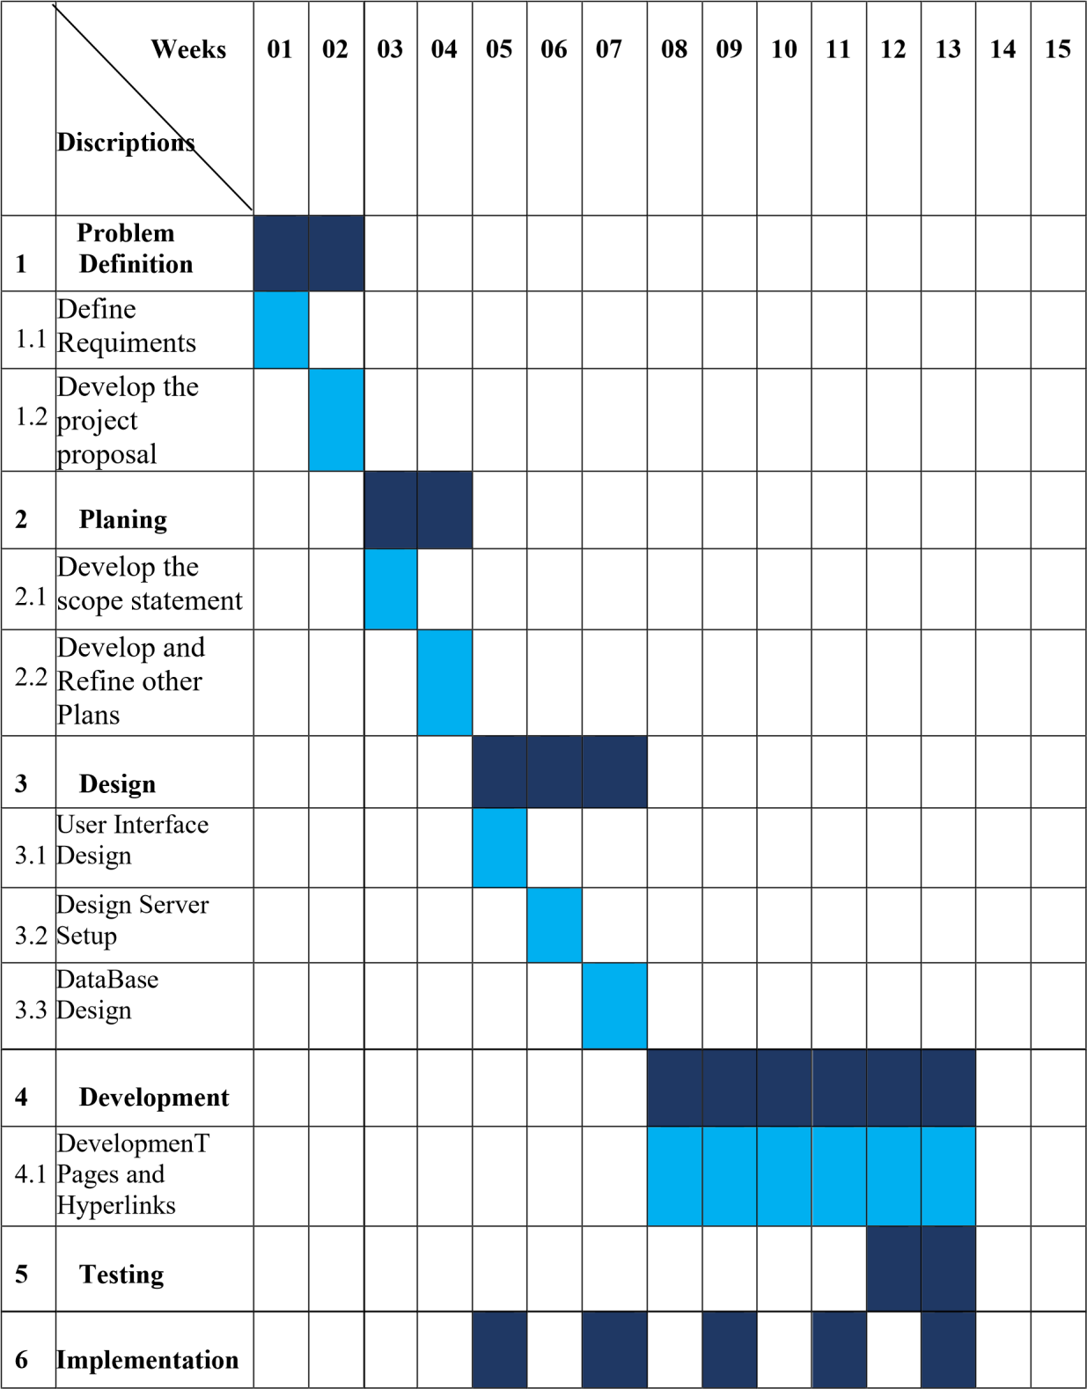

## 8. References

* Get the main idea for proposal[online]:  
   <https://www.googleadservices.com/pagead/aclk?sa=L&ai=DChcSEwjy_oujsKfzAhXSwUwCHWRMA6MYABABGgJ0bQ&ohost=www.google.com&cid=CAESP-D2VOlbOEUkhcCYuru8Q-xsqWakaTUwMzr387TqsDrpoVqGmbvtDV7h1Y0QAoNq7i_MiEgCZmJSzHAKYrclqQ&sig=AOD64_0G3BBrfD9Q2wC9j43BJK_BOXT0OQ&q&adurl&ved=2ahUKEwicyoKjsKfzAhUm7XMBHTLlClwQ0Qx6BAgDEAE>

<https://www.google.com/url?sa=t&rct=j&q=&esrc=s&source=web&cd=&cad=rja&uact=8&ved=2ahUKEwicyoKjsKfzAhUm7XMBHTLlClwQFnoECAYQAw&url=https%3A%2F%2Fwww.fool.com%2Fthe-blueprint%2Fproject-proposal%2F&usg=AOvVaw00_swJIHy203dbrHdGdhyk>

* Find details about current cab service[online]:  
  <https://www.googleadservices.com/pagead/aclk?sa=L&ai=DChcSEwib5_6tsafzAhVYW2AKHU87BIMYABAAGgJ0bQ&ohost=www.google.com&cid=CAESP-D23xpSjAoWMzHnb8T5CLMAjhA9BVsk-uDQwRT83Buo-x0YdulqN_XQTMHie7g1XEOhTKXOKXRyCAa7C4o3Kw&sig=AOD64_3aKGz5lnAfVOw7Ol0uqIRux8Ld6A&q&adurl&ved=2ahUKEwjc3_OtsafzAhWC63MBHcxFB2QQ0Qx6BAgCEAE>
* Find for details for how to draw Gantt chart [youtube]:  
  <https://www.google.com/url?sa=t&rct=j&q=&esrc=s&source=web&cd=&cad=rja&uact=8&ved=2ahUKEwiX4P-dsqfzAhX5H7cAHcAkBJsQFnoECA8QAw&url=https%3A%2F%2Fwww.youtube.com%2Fwatch%3Fv%3DNcOmJSrXYoQ&usg=AOvVaw24zhlXtRL85SiTS0E89LRR>