WEEK 4 MANDATORY HANDS – ON
Account Microservice
# AccountController.java:
package com.cognizant.account.controller;

import org.springframework.web.bind.annotation.*;
import java.util.*;

@RestController
@RequestMapping("/accounts")
public class AccountController {

@GetMapping("/{number}")
public Map<String, Object> getAccount(@PathVariable String number) {
Map<String, Object> account = new HashMap<>();
account.put("number", number);
account.put("type", "savings");
account.put("balance", 234343);
return account;
}
}

# AccountApllication.java:
package com.cognizant.account;

import org.springframework.boot.SpringApplication;
import org.springframework.boot.autoconfigure.SpringBootApplication;

@SpringBootApplication
public class AccountApplication {
public static void main(String[] args) {
SpringApplication.run(AccountApplication.class, args);
}
}

Output:
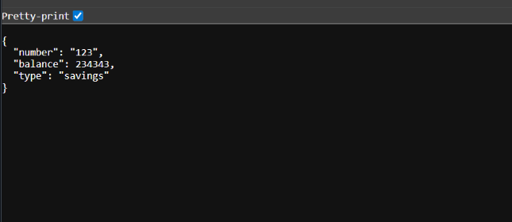

Loan Microservice
# LoanController.java:
package com.cognizant.loan.controller;

import org.springframework.web.bind.annotation.*;
import java.util.*;

@RestController
@RequestMapping("/loans")
public class LoanController {

@GetMapping("/{number}")
public Map<String, Object> getLoan(@PathVariable String number) {
Map<String, Object> loan = new HashMap<>();
loan.put("number", number);
loan.put("type", "car");
loan.put("loan", 400000);
loan.put("emi", 3258);
loan.put("tenure", 18);
return loan;
}
}

# LoanApplication.java:
package com.cognizant.loan;

import org.springframework.boot.SpringApplication;
import org.springframework.boot.autoconfigure.SpringBootApplication;

@SpringBootApplication
public class LoanApplication {
public static void main(String[] args) {
SpringApplication.run(LoanApplication.class, args);
}
}

Output:
