TDD (JUNIT, MOCKITO), LOGGING
DEPENDENCIES FORTESTING (XML FILE):
<project xmlns="http://maven.apache.org/POM/4.0.0"
xmlns:xsi="http://www.w3.org/2001/XMLSchema-instance"
xsi:schemaLocation="http://maven.apache.org/POM/4.0.0
http://maven.apache.org/xsd/maven-4.0.0.xsd">

<modelVersion>4.0.0</modelVersion>

<groupId>com.example</groupId>
<artifactId>my_project</artifactId>
<version>1.0-SNAPSHOT</version>

<properties>
<maven.compiler.source>11</maven.compiler.source>
<maven.compiler.target>11</maven.compiler.target>
<project.build.sourceEncoding>UTF8 </project.build.sourceEncoding>
</properties>

<dependencies>

<!-- JUnit 5 -->
<dependency>
<groupId>org.junit.jupiter</groupId>
<artifactId>junit-jupiter</artifactId>
<version>5.10.0</version>
<scope>test</scope>
</dependency>

<!-- Mockito Core -->
<dependency>
<groupId>org.mockito</groupId>
<artifactId>mockito-core</artifactId>
<version>4.11.0</version>
<scope>test</scope>
</dependency>

<!-- Mockito with JUnit 5 Integration -->
<dependency>
<groupId>org.mockito</groupId>
<artifactId>mockito-junit-jupiter</artifactId>
<version>4.11.0</version>
<scope>test</scope>
</dependency>

<dependency>
<groupId>org.slf4j</groupId>
<artifactId>slf4j-api</artifactId>
<version>1.7.30</version>
</dependency>

<dependency>
<groupId>ch.qos.logback</groupId>
<artifactId>logback-classic</artifactId>
<version>1.2.3</version>
</dependency>

</dependencies>

<build>
<plugins>
<plugin>
<groupId>org.apache.maven.plugins</groupId>
<artifactId>maven-surefire-plugin</artifactId>
<version>3.1.2</version>
<configuration>
<useModulePath>false</useModulePath>
</configuration>
</plugin>
</plugins>
</build>

</project>

JUNIT:
Exercise 1: Setting Up JUnit
Code:
// Code block that is to be tested
public class prime_test {
public boolean PrimeCheck(int num) {
if (num <= 1) {
return false;
}
if(num == 2) {
return true;
}
for (int i = 2; i <= Math.sqrt(num); i++) {
if (num % i == 0) {
return false;
}
}
return true;
}
}
// Test Class for testing code block(Tested using the libraries in maven dependencies)
import org.junit.Test;
import static org.junit.Assert.*;

public class test {

prime_test check = new prime_test();

@Test
public void testPrime() {
assertTrue(check.PrimeCheck(3));
assertTrue(check.PrimeCheck(13));
assertTrue(check.PrimeCheck(97));
assertFalse(check.PrimeCheck(0));
assertFalse(check.PrimeCheck(1));
assertFalse(check.PrimeCheck(4));
assertFalse(check.PrimeCheck(100));
}
}
Output: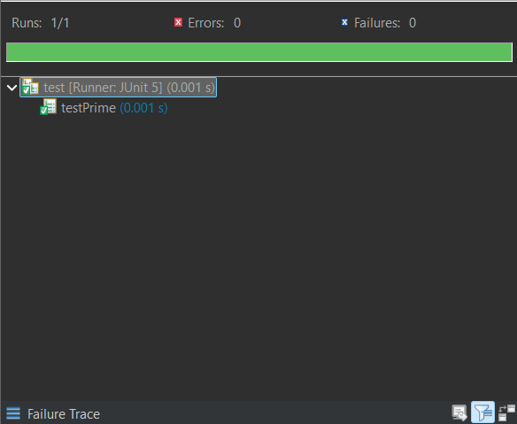

Exercise 3: Assertions in JUnit
Scenario: You need to use different assertions in JUnit to validate your test results.
Code:
// Code block that is to be tested
public class code {
public int add (int a, int b) {
return a + b;
}
public boolean even(int c) {
if (c % 2 == 0) {
return true;
}
return false;
}
}
// Test class to test the above code block
import org.junit.Test;
import static org.junit.Assert.*;

public class test {

code c = new code();

@Test
public void test_asserts() {
assertEquals(3,c.add(2, 1));
assertNotEquals(6,c.add(2, 1));
assertTrue(c.even(2));
assertFalse(c.even(3));
assertNull(null);
assertNotNull(c);
}
}
Output: 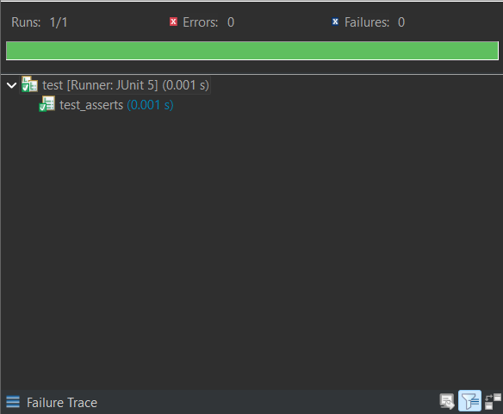

Exercise 4: Arrange-Act-Assert (AAA) Pattern, Test Fixtures, Setup and Teardown Methods in JUnit
Scenario: You need to organize your tests using the Arrange-Act-Assert (AAA) pattern and use setup and teardown methods.
Code:
// Code block that is to be tested
public class code {
public int add (int a, int b) {
return a + b;
}
public boolean even(int c) {
if (c % 2 == 0) {
return true;
}
return false;
}
}
// Test class for testing the above code block
import org.junit.Before;
import org.junit.After;
import org.junit.Test;
import static org.junit.Assert.*;

public class test{
// Arrange part of AAA Pattern
code c = new code();

@Before
public void setup() {
System.out.println("*Setup (@Before)*");
System.out.println("Setting up for tests");
System.out.println("Testing did not start yet");
}

@After
public void teardown() {
System.out.println("*TearDown (@After)*");
System.out.println("Testing Done, Check your code if error raises");
}

@Test
public void test_AAA() {
// Act part of AAA Pattern
int result = c.add(2, 1);
// Assert part of AAA Pattern
assertEquals(3,result);
}
}
Output:
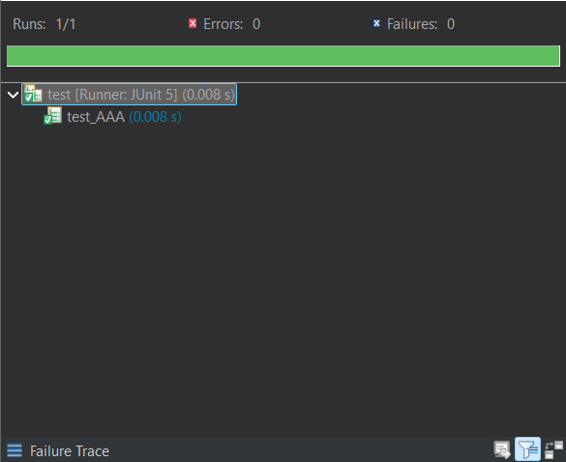

MOCKITO:
Exercise 1: Mocking and Stubbing
Scenario: You need to test a service that depends on an external API. Use Mockito to mock the external API and stub its methods.
Code:
// API
public interface ExternalApi {
String getData();
}

public class MyService {
private ExternalApi api;

public MyService(ExternalApi api) {
this.api = api;
}

public String fetchData() {
return api.getData();
}
}
// Test class to test the API using Mockito
import static org.mockito.Mockito.*;
import static org.junit.jupiter.api.Assertions.*;

import org.junit.jupiter.api.Test;
import org.mockito.Mockito;

public class test {

@Test
public void testExternalApi() {
// Create mock
ExternalApi mockApi = Mockito.mock(ExternalApi.class);

// Stub method
when(mockApi.getData()).thenReturn("Mock Data");

// Inject into service
MyService service = new MyService(mockApi);

// Act
String result = service.fetchData();

// Assert
assertEquals("Mock Data", result);
}
}
Output:
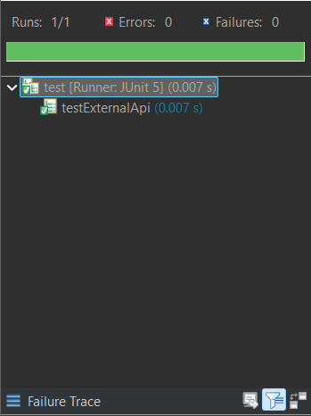
Exercise 2: Verifying Interactions
Scenario: You need to ensure that a method is called with specific arguments.
Code:
// API
public interface ExternalApi {
String getData(String s);
}
public class MyService {
private ExternalApi api;

public MyService(ExternalApi api) {
this.api = api;
}

public void fetchData(String s) {
api.getData(String s);
}
}
// Test Class to test using Mockito
import static org.mockito.Mockito.*;
import static org.junit.jupiter.api.Assertions.*;
import org.junit.jupiter.api.Test;
import org.mockito.Mockito;

public class test {

@Test
public void testVerifyInteraction() {
ExternalApi mockApi = Mockito.mock(ExternalApi.class);
when(mockApi.getData("SAZ")).thenReturn("Mock");
MyService service = new MyService(mockApi);
String result = service.fetchDataForUser("SAZ");
assertEquals("Mock ", result);
verify(mockApi).getData("SAZ");
}
}
Output:
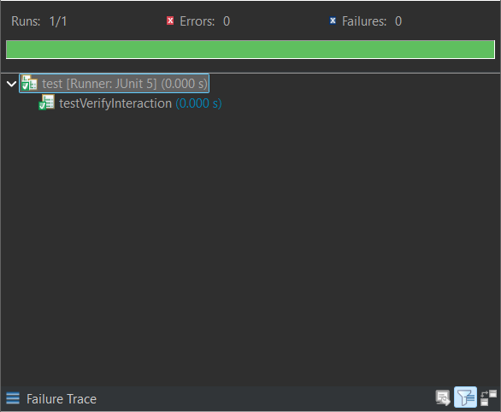

LOGGING:
Exercise 1: Logging Error Messages and Warning Levels
Task: Write a Java application that demonstrates logging error messages and warning levels using SLF4J.
Code:
import org.slf4j.Logger;
import org.slf4j.LoggerFactory;

public class LoggingExample {
private static final Logger logger = LoggerFactory.getLogger(LoggingExample.class);

public static void main(String[] args) {
logger.error("This is an error message");
logger.warn("This is a warning message");
}
}
Output:
