MANDATORY HANDS ON WEEK – 2
PART 1: Spring & Maven
Exercise 1: Configuring a Basic Spring Application
Scenario:
Your company is developing a web application for managing a library. You need to use the Spring Framework to handle the backend operations.
Code:
#BookRepository.java:
package com.library.repository;
public class BookRepository {
public void printRepo() {
System.out.println("BookRepository: Created A new Repository \n");
}
}
#BookService.java:
package com.library.service;
public class BookService {
public void printService() {
System.out.println("BookService: Created a new Service\n ");
}
}
#Main.java:
package com.library;
import com.library.repository.BookRepository;
import com.library.service.BookService;
import org.springframework.context.ApplicationContext;
import org.springframework.context.support.ClassPathXmlApplicationContext;

public class Main {
public static void main(String[] args) {
ApplicationContext context =
new ClassPathXmlApplicationContext("applicationContext.xml");
BookService bookService = context.getBean("bookService", BookService.class);
bookService.printService();
BookRepository bookRepository=context.getBean("bookRepository",BookRepository.class);
bookRepository.printRepo();
}
}
Output:
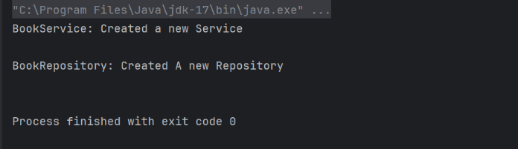

Exercise 2: Implementing Dependency Injection
Scenario:
In the library management application, you need to manage the dependencies between the BookService and BookRepository classes using Spring's IoC and DI.
Code:
#BookRepository.java:
package com.library.repository;
public class BookRepository {
public void accessRepository() {
System.out.println("BookRepository: accessing the database...");
}
}
#BookService.java:
package com.library.service;
import com.library.repository.BookRepository;

public class BookService {
private BookRepository bookRepository;
public void setBookRepository(BookRepository bookRepository) {
this.bookRepository = bookRepository;
}

public void performService() {
System.out.println("BookService: handling business logic...");
bookRepository.accessRepository();
}
}
#Main.java:
package com.library;
import com.library.service.BookService;
import org.springframework.context.ApplicationContext;
import org.springframework.context.support.ClassPathXmlApplicationContext;

public class Main {
public static void main(String[] args) {
ApplicationContext context =
new ClassPathXmlApplicationContext("applicationContext.xml");
BookService bookService = context.getBean("bookService", BookService.class);
bookService.performService();
}
}
Output:
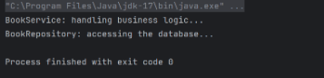

Exercise 4: Creating and Configuring a Maven Project
Scenario:
You need to set up a new Maven project for the library management application and add Spring dependencies.
Code:
#BookRepository.java:
package com.library.repository;
import org.springframework.stereotype.Repository;

@Repository
public class BookRepository {
public void save(String title) {
System.out.println("BookRepository: Saved " + title);
}
}
#BookService.java:
package com.library.service;
import com.library.repository.BookRepository;
import org.springframework.beans.factory.annotation.Autowired;
import org.springframework.stereotype.Service;

@Service
public class BookService {
private BookRepository bookRepository;
@Autowired
public BookService(BookRepository bookRepository) {
this.bookRepository = bookRepository;
}

public void addBook(String title) {
bookRepository.save(title);
System.out.println("BookService: Added book " + title);
}
}
#LogginAspect.java:
package com.library.aspect;
import org.aspectj.lang.ProceedingJoinPoint;
import org.aspectj.lang.annotation.Around;
import org.aspectj.lang.annotation.Aspect;
import org.springframework.stereotype.Component;

@Aspect
@Component
public class LoggingAspect {

@Around("execution(* com.library.service.*.*(..))")
public Object logExecutionTime(ProceedingJoinPoint joinPoint) throws Throwable {
long start = System.nanoTime();
Object result = joinPoint.proceed();
long end = System.nanoTime();
System.out.println("[AOP] " + joinPoint.getSignature()
+ " executed in " + (end - start) / 1_000_000 + " ms");
return result;
}
}
#Main.java:
package com.library;
import com.library.service.BookService;
import org.springframework.context.ApplicationContext;
import org.springframework.context.support.ClassPathXmlApplicationContext;

public class Main {
public static void main(String[] args) {
ApplicationContext context = new ClassPathXmlApplicationContext("applicationContext.xml");
BookService bookService = context.getBean(BookService.class);
bookService.addBook("Spring in Action");
}
}
Output:
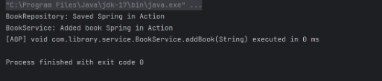
PART 1: Spring-Jpa-Hibernate
Spring Data JPA – Quick Example
Code:
#Country.java:
package com.cognizant.ormlearn.model;
import javax.persistence.Column;
import javax.persistence.Entity;
import javax.persistence.Id;
import javax.persistence.Table;

@Entity
@Table(name="country")
public class Country {
@Id
@Column(name="co_code")
private String code;

@Column(name="co_name")
private String name;

public Country() {}

public Country(String code, String name) {
this.code = code;
this.name = name;
}

public void setCode(String code) {
this.code = code;
}

public String getCode() {
return code;
}

public String getName() {
return name;
}

public void setName(String name) {
this.name = name;
}

@Override
public String toString() {
return "Country [code=" + code + ", name=" + name + "]";
}
}
#CountryRepository.java:
package com.cognizant.ormlearn.repository;
import org.springframework.data.jpa.repository.JpaRepository;
import org.springframework.stereotype.Repository;
import com.cognizant.ormlearn.model.Country;

@Repository
public interface CountryRepository extends JpaRepository<Country, String> {
// Additional custom methods can be added here if needed
}
#CountryService.java:
package com.cognizant.ormlearn.service;

import com.cognizant.ormlearn.model.Country;
import com.cognizant.ormlearn.repository.CountryRepository;
import org.springframework.beans.factory.annotation.Autowired;
import org.springframework.stereotype.Service;
import org.springframework.transaction.annotation.Transactional;

import java.util.List;

@Service
public class CountryService {

@Autowired
private CountryRepository countryRepository;

@Transactional
public List<Country> getAllCountries() {
return countryRepository.findAll();
}

@Transactional
public Country getCountryByCode(String code) {
return countryRepository.findById(code).orElse(null);
}

@Transactional
public Country saveCountry(Country country) {
return countryRepository.save(country);
}

@Transactional
public void deleteCountry(String code) {
countryRepository.deleteById(code);
}
}

# OrmLearnApplication.java:
package com.cognizant.ormlearn;
import com.cognizant.ormlearn.model.Country;
import com.cognizant.ormlearn.service.CountryService;
import org.slf4j.Logger;
import org.slf4j.LoggerFactory;
import org.springframework.boot.SpringApplication;
import org.springframework.boot.autoconfigure.SpringBootApplication;
import org.springframework.context.ApplicationContext;

import java.util.List;

@SpringBootApplication
public class OrmLearnApplication {

private static final Logger LOGGER = LoggerFactory.getLogger(OrmLearnApplication.class);
private static CountryService countryService;

public static void main(String[] args) {
ApplicationContext context = SpringApplication.run(OrmLearnApplication.class, args);
countryService = context.getBean(CountryService.class);

LOGGER.info("Inside main");

// Test the application
testGetAllCountries();
}

private static void testGetAllCountries() {
System.out.println("=== All Countries ===");
List<Country> countries = countryService.getAllCountries();
for (Country country : countries) {
System.out.println(country);
}
}
}
Output:
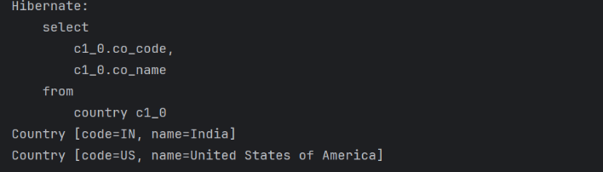

Difference between JPA, Hibernate and Spring Data JPA
Code:
#Employee.java:
package com.cognizant.Employee;
import jakarta.persistence.Column;
import jakarta.persistence.Entity;
import jakarta.persistence.Id;
import jakarta.persistence.Table;

@Entity
@Table(name="employee")
public class Employee {

@Id
@Column(name="emp_id")
private Integer id;

@Column(name="emp_name")
private String name;

@Column(name="emp_salary")
private Double salary;

public Employee() {}

public Employee(Integer id, String name, Double salary) {
this.id = id;
this.name = name;
this.salary = salary;
}

public Integer getId() { return id; }
public void setId(Integer id) { this.id = id; }

public String getName() { return name; }
public void setName(String name) { this.name = name; }

public Double getSalary() { return salary; }
public void setSalary(Double salary) { this.salary = salary; }

@Override
public String toString() {
return "Employee [id=" + id + ", name=" + name + ", salary=" + salary + "]";
}
}
#EmployeeRepository.java:
package com.cognizant.Employee;

import org.springframework.data.jpa.repository.JpaRepository;
import org.springframework.stereotype.Repository;

@Repository
public interface EmployeeRepository extends JpaRepository<Employee, Integer> {
}
#EmployeeService.java:
package com.cognizant.Employee;
import org.springframework.beans.factory.annotation.Autowired;
import org.springframework.stereotype.Service;
import org.springframework.transaction.annotation.Transactional;

import java.util.List;

@Service
public class EmployeeService {

@Autowired
private EmployeeRepository employeeRepository;

@Transactional
public List<Employee> getAllEmployees() {
return employeeRepository.findAll();
}

@Transactional
public Employee getEmployeeById(Integer id) {
return employeeRepository.findById(id).orElse(null);
}

@Transactional
public Employee saveEmployee(Employee employee) {
return employeeRepository.save(employee);
}

@Transactional
public void deleteEmployee(Integer id) {
employeeRepository.deleteById(id);
}
}
#EmployeeApplication.java:
package com.cognizant.Employee;

import org.springframework.boot.SpringApplication;
import org.springframework.boot.autoconfigure.SpringBootApplication;
import org.springframework.context.ApplicationContext;

import java.util.List;

@SpringBootApplication
public class EmployeeApplication {

private static EmployeeService employeeService;

public static void main(String[] args) {
ApplicationContext context = SpringApplication.run(EmployeeApplication.class, args);
employeeService = context.getBean(EmployeeService.class);

System.out.println("=== All Employees ===");
testGetAllEmployees();
}

private static void testGetAllEmployees() {
List<Employee> employees = employeeService.getAllEmployees();
for (Employee emp : employees) {
System.out.println(emp);
}
}
}

Output:
