WEEK 6 MANDATORY HANDS-ON
Exercise - 9
Code:
#App.css:
.App {
text-align: center;
}

.App-logo {
height: 40vmin;
pointer-events: none;
}

@media (prefers-reduced-motion: no-preference) {
.App-logo {
animation: App-logo-spin infinite 20s linear;
}
}

.App-header {
background-color: #282c34;
min-height: 100vh;
display: flex;
flex-direction: column;
align-items: center;
justify-content: center;
font-size: calc(10px + 2vmin);
color: white;
}

.App-link {
color: #61dafb;
}

@keyframes App-logo-spin {
from {
transform: rotate(0deg);
}
to {
transform: rotate(360deg);
}
}

#App.js:
import React, { useState } from 'react';
import ListofPlayers from './ListofPlayers';
import IndianPlayers from './IndianPlayers';

function App() {
const [flag, setFlag] = useState(true); // 🔄 state to control view

const toggleView = () => {
setFlag(!flag); // Flip the flag on button click
};

return (
<div className="App" style={{ padding: '20px' }}>
<h1>🏏 Cricket App</h1>

<button onClick={toggleView} style={{ marginBottom: '20px' }}>
{flag ? "Switch to IndianPlayers View" : "Switch to ListofPlayers View"}
</button>

{flag ? <ListofPlayers /> : <IndianPlayers />}
</div>
);
}

export default App;

#App.test.js:
import { render, screen } from '@testing-library/react';
import App from './App';

test('renders learn react link', () => {
render(<App />);
const linkElement = screen.getByText(/learn react/i);
expect(linkElement).toBeInTheDocument();
});

#index.css:
body {
margin: 0;
font-family: -apple-system, BlinkMacSystemFont, 'Segoe UI', 'Roboto', 'Oxygen',
'Ubuntu', 'Cantarell', 'Fira Sans', 'Droid Sans', 'Helvetica Neue',
sans-serif;
-webkit-font-smoothing: antialiased;
-moz-osx-font-smoothing: grayscale;
}

code {
font-family: source-code-pro, Menlo, Monaco, Consolas, 'Courier New',
monospace;
}

#index,js:
import React from 'react';
import ReactDOM from 'react-dom/client';
import './index.css';
import App from './App';
import reportWebVitals from './reportWebVitals';

const root = ReactDOM.createRoot(document.getElementById('root'));
root.render(
<React.StrictMode>
<App />
</React.StrictMode>
);

// If you want to start measuring performance in your app, pass a function
// to log results (for example: reportWebVitals(console.log))
// or send to an analytics endpoint. Learn more: https://bit.ly/CRA-vitals
reportWebVitals();

#ListofPlayer.js:
import React from 'react';

function ListofPlayers() {
const players = [
{ name: "Virat", score: 85 },
{ name: "Rohit", score: 40 },
{ name: "Dhoni", score: 90 },
{ name: "Raina", score: 30 },
{ name: "Gill", score: 75 },
{ name: "Bumrah", score: 65 },
{ name: "Rahul", score: 20 },
{ name: "Pant", score: 95 },
{ name: "Jadeja", score: 70 },
{ name: "Shami", score: 60 },
{ name: "Ashwin", score: 45 }
];

const filtered = players.filter(player => player.score < 70); // arrow function

return (
<div>
<h2>All Players</h2>
<ul>
{players.map((player, index) => (
<li key={index}>{player.name} - {player.score}</li>
))}
</ul>

<h2>Players with score below 70</h2>
<ul>
{filtered.map((player, index) => (
<li key={index}>{player.name} - {player.score}</li>
))}
</ul>
</div>
);
}

export default ListofPlayers;

#IndianPlayers.js:
import React from 'react';

function IndianPlayers() {
const allPlayers = ["Kohli", "Rohit", "Dhawan", "Shreyas", "Surya", "Hardik"];

// 🟦 Even Index Players (0, 2, 4...)
const evenTeam = allPlayers.filter((_, index) => index % 2 === 0);

// 🟥 Odd Index Players (1, 3, 5...)
const oddTeam = allPlayers.filter((_, index) => index % 2 !== 0);

// 🧩 Destructuring example
const [firstPlayer, secondPlayer, ...others] = allPlayers;

// 🟨 Merge Arrays (T20 + Ranji)
const T20Players = ["Iyer", "Kishan"];
const RanjiPlayers = ["Pujara", "Rahane"];
const mergedTeam = [...T20Players, ...RanjiPlayers];

return (
<div>
<h2>🟦 Even Team Players</h2>
<ul>
{evenTeam.map((player, index) => (
<li key={index}>{player}</li>
))}
</ul>

<h2>🟥 Odd Team Players</h2>
<ul>
{oddTeam.map((player, index) => (
<li key={index}>{player}</li>
))}
</ul>

<h2>🧩 Destructuring</h2>
<p>First Player: {firstPlayer}</p>
<p>Second Player: {secondPlayer}</p>
<p>Remaining: {others.join(", ")}</p>

<h2>🟨 Merged Team (T20 + Ranji)</h2>
<ul>
{mergedTeam.map((player, index) => (
<li key={index}>{player}</li>
))}
</ul>
</div>
);
}

export default IndianPlayers;

Output:
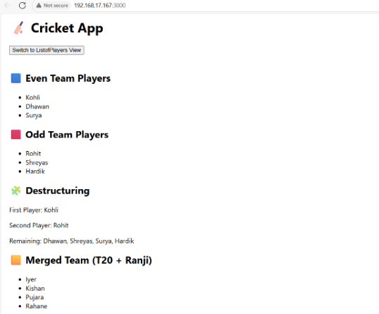

Exercise -10
Code:
#OfficeList.js:
import React from 'react';

// Heading element using JSX
const heading = <h1>🏢 Office Space Rental Listings</h1>;

// Image element using JSX
//onst imageUrl = "https://via.placeholder.com/600x200?text=Office+Space+Rental";
//const imageElement = <img src={imageUrl} alt="Office Space" style={{ width: '100%', borderRadius: '8px' }} />;

// List of office objects
const offices = [
{ name: "WeWork", rent: 45000, address: "Bangalore, MG Road" },
{ name: "Regus", rent: 72000, address: "Hyderabad, Banjara Hills" },
{ name: "91Springboard", rent: 55000, address: "Mumbai, Andheri" },
{ name: "Smartworks", rent: 80000, address: "Delhi, Connaught Place" }
];

function OfficeList() {
return (
<div style={{ padding: '20px', fontFamily: 'Arial' }}>
{heading}

<ul style={{ listStyleType: 'none', padding: 0 }}>
{offices.map((office, index) => {
// Conditional inline style for rent
const rentStyle = {
color: office.rent < 60000 ? 'red' : 'green',
fontWeight: 'bold'
};

return (
<li key={index} style={{ marginBottom: '20px', padding: '10px', border: '1px solid #ccc', borderRadius: '8px' }}>
<h3>{office.name}</h3>
<p><strong>Address:</strong> {office.address}</p>
<p><strong>Rent:</strong> <span style={rentStyle}>₹{office.rent}</span></p>
</li>
);
})}
</ul>
</div>
);
}

export default OfficeList;

Output:
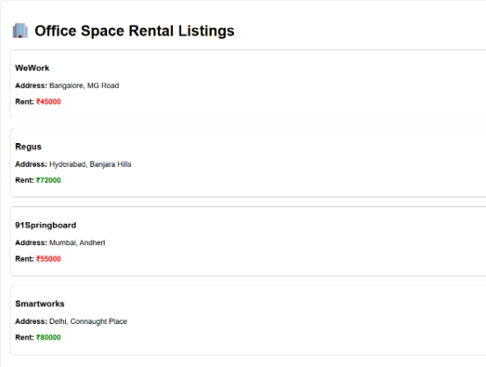

Exercise – 11
Code:
#Counter.js:
import React, { Component } from 'react';

class Counter extends Component {
constructor() {
super();
this.state = {
count: 0
};
}

incrementCount = () => {
this.setState(prev => ({ count: prev.count + 1 }));
};

decrementCount = () => {
this.setState(prev => ({ count: prev.count - 1 }));
};

sayHello = () => {
alert("Hello! You clicked the increment button.");
};

handleIncrement = () => {
this.incrementCount();
this.sayHello();
};

sayWelcome = (message) => {
alert(`Welcome message: ${message}`);
};

handleSynthetic = (event) => {
alert("I was clicked");
console.log("Synthetic Event:", event);
};

render() {
return (
<div>
<h2>Counter: {this.state.count}</h2>
<button onClick={this.handleIncrement}>Increment</button>
<button onClick={this.decrementCount}>Decrement</button>
<br /><br />
<button onClick={() => this.sayWelcome("Welcome to the Event App")}>Say Welcome</button>
<br /><br />
<button onClick={this.handleSynthetic}>Synthetic Event</button>
</div>
);
}
}

export default Counter;

#CurrencyConverter.js:
import React, { useState } from 'react';

function CurrencyConvertor() {
const [rupees, setRupees] = useState('');
const [euros, setEuros] = useState('');

const handleSubmit = () => {
if (!isNaN(rupees)) {
const euroValue = (parseFloat(rupees) / 90).toFixed(2);
setEuros(euroValue);
} else {
alert("Please enter a valid number");
}
};

return (
<div>
<h2>Currency Convertor</h2>
<label>Enter amount in ₹ Rupees: </label>
<input
type="text"
value={rupees}
onChange={(e) => setRupees(e.target.value)}
/>
<button onClick={handleSubmit}>Convert to € Euro</button>
{euros && <p>Converted Amount: € {euros}</p>}
</div>
);
}

export default CurrencyConvertor;

Output:
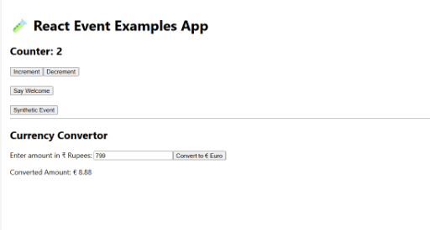

Exercise – 12
#Guest.js:
import React from 'react';

function Guest() {
return (
<div>
<h2>Welcome Guest ✈️</h2>
<p>You can view flight details but must log in to book tickets.</p>
</div>
);
}

export default Guest;

Output:
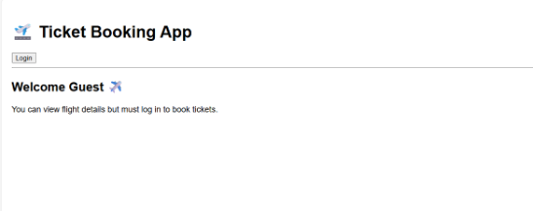

Exercise – 13
Code:
#BlogDetails.js:
import React from 'react';

function BlogDetails() {
const blogs = [
{
title: 'React Learning',
author: 'Stephen Biz',
content: 'Welcome to learning React!'
},
{
title: 'Installation',
author: 'Schewzdenier',
content: 'You can install React from npm.'
}
];

return (
<div className="section">
<h2>Blog Details</h2>
<div className="card-row">
{blogs.map((blog, i) => (
<div className="card" key={i}>
<h3>{blog.title}</h3>
<p><strong>{blog.author}</strong></p>
<p>{blog.content}</p>
</div>
))}
</div>
</div>
);
}

export default BlogDetails;

#BookDetails.js:
import React from 'react';

function BookDetails() {
const books = [
{ title: 'Master React', price: 670 },
{ title: 'Deep Dive into Angular 11', price: 800 },
{ title: 'Mongo Essentials', price: 450 }
];

return (
<div className="section">
<h2>Book Details</h2>
<div className="card-row">
{books.map((book, i) => (
<div className="card" key={i}>
<h3>{book.title}</h3>
<p>₹{book.price}</p>
</div>
))}
</div>
</div>
);
}

export default BookDetails;

#CourseDetails.js:
import React from 'react';

function CourseDetails() {
const courses = [
{ name: 'Angular', date: '4/5/2021' },
{ name: 'React', date: '6/3/2021' }
];

return (
<div className="section">
<h2>Course Details</h2>
<div className="card-row">
{courses.map((course, i) => (
<div className="card" key={i}>
<h3>{course.name}</h3>
<p>{course.date}</p>
</div>
))}
</div>
</div>
);
}

export default CourseDetails;

Output:
