WEEK 3 MANDATORY HANDS-ON
Spring-rest
1.Create a Spring Web Project using Maven

Code:
#HelloController.java:

package com.cognizant.Spring_learn;

import org.springframework.web.bind.annotation.GetMapping;
import org.springframework.web.bind.annotation.RestController;

@RestController
public class HelloController {

@GetMapping("/hello")
public String sayHello() {
return "Hello, Spring Boot!";
}
}

#SpringLearnApplication.java:

package com.cognizant.Spring_learn;

import org.slf4j.Logger;
import org.slf4j.LoggerFactory;
import org.springframework.boot.SpringApplication;
import org.springframework.boot.autoconfigure.SpringBootApplication;

@SpringBootApplication
public class SpringLearnApplication {

private static final Logger LOGGER = LoggerFactory.getLogger(SpringLearnApplication.class);

public static void main(String[] args) {
SpringApplication.run(SpringLearnApplication.class, args);
LOGGER.info("Inside main");
}
}

# SprinfLearnApplicationTests.java:

package com.cognizant.Spring_learn;

import org.junit.jupiter.api.Test;
import org.springframework.beans.factory.annotation.Autowired;
import org.springframework.boot.test.context.SpringBootTest;
import org.springframework.boot.test.web.client.TestRestTemplate;
import org.springframework.http.ResponseEntity;

import static org.assertj.core.api.Assertions.assertThat;

@SpringBootTest(webEnvironment = SpringBootTest.WebEnvironment.RANDOM_PORT)
class SpringLearnApplicationTests {

@Autowired
private TestRestTemplate restTemplate;

@Test
void helloEndpointReturnsExpectedString() {
ResponseEntity<String> response = restTemplate.getForEntity("/hello", String.class);
assertThat(response.getBody()).isEqualTo("Hello, Spring Boot!");
}
}
Output:
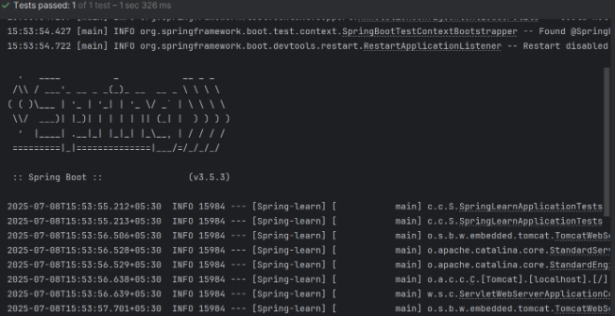

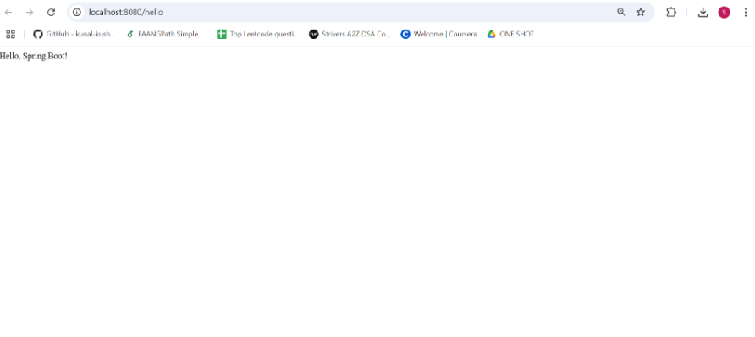

2. Spring Core – Load Country from Spring Configuration XML
Code:
#Country.java:
package com.cognizant.Spring_learn;

import org.slf4j.Logger;
import org.slf4j.LoggerFactory;

public class Country {
private static final Logger LOGGER = LoggerFactory.getLogger(Country.class);

private String code;
private String name;

public Country() {
LOGGER.debug("Inside Country Constructor.");
}

public String getCode() {
LOGGER.debug("Inside getCode()");
return code;
}

public void setCode(String code) {
LOGGER.debug("Inside setCode()");
this.code = code;
}

public String getName() {
LOGGER.debug("Inside getName()");
return name;
}

public void setName(String name) {
LOGGER.debug("Inside setName()");
this.name = name;
}

@Override
public String toString() {
return "Country [code=" + code + ", name=" + name + "]";
}
}

#SprinfLearnApplication.java:
package com.cognizant.Spring_learn;

import org.slf4j.Logger;
import org.slf4j.LoggerFactory;
import org.springframework.context.ApplicationContext;
import org.springframework.context.support.ClassPathXmlApplicationContext;

public class SpringLearnApplication {
private static final Logger LOGGER = LoggerFactory.getLogger(SpringLearnApplication.class);

public static void main(String[] args) {
LOGGER.debug("START");
displayCountry();
LOGGER.debug("END");
}

public static void displayCountry() {
ApplicationContext context = new ClassPathXmlApplicationContext("country.xml");
Country country = (Country) context.getBean("country", Country.class);
LOGGER.debug("Country : {}", country.toString());
}
}

#Country.xml:
<?xml version="1.0" encoding="UTF-8"?>
<beans xmlns="http://www.springframework.org/schema/beans"
xmlns:xsi="http://www.w3.org/2001/XMLSchema-instance"
xsi:schemaLocation="
http://www.springframework.org/schema/beans
http://www.springframework.org/schema/beans/spring-beans.xsd">

<bean id="country" class="com.cognizant.Spring_learn.Country">
<property name="code" value="IN" />
<property name="name" value="India" />
</bean>

</beans>
Output:
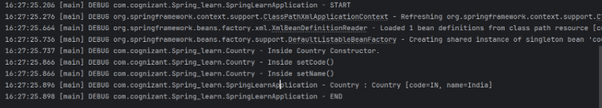

3. Hello World RESTful Web Service
Code:
#HelloController.java:
package com.cognizant.Spring_learn.controller;

import org.slf4j.Logger;
import org.slf4j.LoggerFactory;
import org.springframework.web.bind.annotation.GetMapping;
import org.springframework.web.bind.annotation.RestController;

@RestController
public class HelloController {

private static final Logger LOGGER = LoggerFactory.getLogger(HelloController.class);

@GetMapping("/hello")
public String sayHello() {
LOGGER.debug("START");
LOGGER.debug("END");
return " Hello, Spring Boot!";
}
}

# SpringLearnApplcation.java:
package com.cognizant.Spring_learn;

import org.springframework.boot.SpringApplication;
import org.springframework.boot.autoconfigure.SpringBootApplication;

@SpringBootApplication
public class SpringLearnApplication {

public static void main(String[] args) {
SpringApplication.run(SpringLearnApplication.class, args);
}
}
Output:


4. REST - Country Web Service
Code:
#Country.java:
package com.cognizant.Spring_learn.model;

public class Country {
private String code;
private String name;

public Country() {}

public Country(String code, String name) {
this.code = code;
this.name = name;
}

public String getCode() {
return code;
}
public void setCode(String code) {
this.code = code;
}
public String getName() {
return name;
}
public void setName(String name) {
this.name = name;
}
}
#CountryController.java:
package com.cognizant.Spring_learn.controller;

import org.springframework.context.ApplicationContext;
import org.springframework.context.support.ClassPathXmlApplicationContext;
import org.springframework.web.bind.annotation.RequestMapping;
import org.springframework.web.bind.annotation.RestController;
import com.cognizant.Spring_learn.model.Country;

@RestController
public class CountryController {

@RequestMapping("/country")
public Country getCountryIndia() {
ApplicationContext context = new ClassPathXmlApplicationContext("country.xml");
Country country = (Country) context.getBean("in");
return country;
}
}
#SpringLearnApplication.java:
package com.cognizant.Spring_learn;

import org.springframework.boot.SpringApplication;
import org.springframework.boot.autoconfigure.SpringBootApplication;

@SpringBootApplication
public class SpringLearnApplication {

public static void main(String[] args) {
SpringApplication.run(SpringLearnApplication.class, args);
}
}
Output:
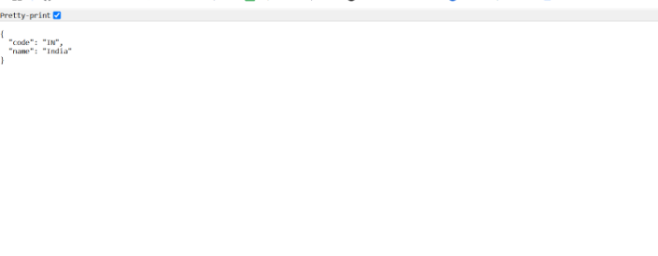

5. REST - Get country based on country code
Code:
#Country.java:
package com.cognizant.Spring_learn.model;

public class Country {
private String code;
private String name;

// Getters and Setters
public String getCode() {
return code;
}
public void setCode(String code) {
this.code = code;
}
public String getName() {
return name;
}
public void setName(String name) {
this.name = name;
}
}
#CountrySearvice.java:
package com.cognizant.Spring_learn.service;

import com.cognizant.Spring_learn.model.Country;
import org.springframework.context.ApplicationContext;
import org.springframework.context.support.ClassPathXmlApplicationContext;
import org.springframework.stereotype.Service;

import java.util.List;

@Service
public class CountryService {

public Country getCountry(String code) {
ApplicationContext context = new ClassPathXmlApplicationContext("country.xml");
List<Country> countries = (List<Country>) context.getBean("countryList");

// Using lambda to find case-insensitive match
return countries.stream()
.filter(c -> c.getCode().equalsIgnoreCase(code))
.findFirst()
.orElse(null);
}
}
#CountryController.java:
package com.cognizant.Spring_learn.controller;

import com.cognizant.Spring_learn.model.Country;
import com.cognizant.Spring_learn.service.CountryService;
import org.springframework.beans.factory.annotation.Autowired;
import org.springframework.web.bind.annotation.*;

@RestController
public class CountryController {

@Autowired
private CountryService countryService;

@GetMapping("/countries/{code}")
public Country getCountry(@PathVariable String code) {
return countryService.getCountry(code);
}
}
#SpringLearnApplication.java:
package com.cognizant.Spring_learn;

import org.springframework.boot.SpringApplication;
import org.springframework.boot.autoconfigure.SpringBootApplication;

@SpringBootApplication
public class SpringLearnApplication {
public static void main(String[] args) {
SpringApplication.run(SpringLearnApplication.class, args);
}
}

Output:
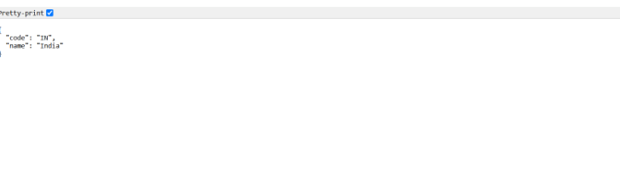
JWT
1. Create authentication service that returns JWT
Code:
#Country.java:
package com.cognizant.Spring_learn.model;

public class Country {
private String code;
private String name;

public Country() {}
public Country(String code, String name) {
this.code = code;
this.name = name;
}

public String getCode() { return code; }
public void setCode(String code) { this.code = code; }

public String getName() { return name; }
public void setName(String name) { this.name = name; }
}

#CountryService.java:
package com.cognizant.Spring_learn.service;

import com.cognizant.Spring_learn.model.Country;
import org.springframework.context.ApplicationContext;
import org.springframework.context.support.ClassPathXmlApplicationContext;
import org.springframework.stereotype.Service;

import java.util.List;

@Service
public class CountryService {
public Country getCountry(String code) throws Exception {
ApplicationContext context = new ClassPathXmlApplicationContext("country.xml");
List<Country> countries = (List<Country>) context.getBean("countryList");
return countries.stream()
.filter(c -> c.getCode().equalsIgnoreCase(code))
.findFirst()
.orElseThrow(() -> new Exception("Country not found"));
}
}

#CountryController.java:
package com.cognizant.Spring_learn.controller;

import com.cognizant.Spring_learn.model.Country;
import com.cognizant.Spring_learn.service.CountryService;
import org.springframework.web.bind.annotation.*;

@RestController
@RequestMapping("/country")
public class CountryController {

private final CountryService countryService;

public CountryController(CountryService countryService) {
this.countryService = countryService;
}

@GetMapping("/{code}")
public Country getCountry(@PathVariable String code) throws Exception {
return countryService.getCountry(code);
}
}

#SecurityConfig.java:
package com.cognizant.Spring_learn.security;

import org.springframework.context.annotation.Bean;
import org.springframework.context.annotation.Configuration;
import org.springframework.security.config.annotation.web.configuration.EnableWebSecurity;
import org.springframework.security.web.SecurityFilterChain;
import org.springframework.security.config.annotation.web.builders.HttpSecurity;

@Configuration
@EnableWebSecurity
public class SecurityConfig {
@Bean
public SecurityFilterChain filterChain(HttpSecurity http) throws Exception {
http.csrf().disable()
.authorizeHttpRequests(auth -> auth.anyRequest().permitAll());
return http.build();
}
}

#AuthenticationController.java:
package com.cognizant.Spring_learn.controller;

import io.jsonwebtoken.Jwts;
import io.jsonwebtoken.SignatureAlgorithm;
import jakarta.servlet.http.HttpServletRequest;
import org.springframework.web.bind.annotation.*;

import java.util.Base64;
import java.util.Date;
import java.util.HashMap;
import java.util.Map;

@RestController
public class AuthenticationController {
private static final String SECRET_KEY = "secret123";

@GetMapping("/authenticate")
public Map<String, String> authenticate(HttpServletRequest request) {
String authHeader = request.getHeader("Authorization");

if (authHeader != null && authHeader.startsWith("Basic ")) {
String base64Credentials = authHeader.substring("Basic ".length());
String credentials = new String(Base64.getDecoder().decode(base64Credentials));
String[] userDetails = credentials.split(":", 2);

if ("user".equals(userDetails[0]) && "pwd".equals(userDetails[1])) {
String jwt = Jwts.builder()
.setSubject(userDetails[0])
.setIssuedAt(new Date())
.setExpiration(new Date(System.currentTimeMillis() + 1000 * 60 * 60))
.signWith(SignatureAlgorithm.HS256, SECRET_KEY)
.compact();

Map<String, String> response = new HashMap<>();
response.put("token", jwt);
return response;
}
}
throw new RuntimeException("Invalid credentials");
}

@GetMapping("/ping")
public String ping() {
return "Server up!";
}
}

#SpringLearnApplication.java:
package com.cognizant.Spring_learn;

import org.springframework.boot.SpringApplication;
import org.springframework.boot.autoconfigure.SpringBootApplication;

@SpringBootApplication
public class SpringLearnApplication {
public static void main(String[] args) {
SpringApplication.run(SpringLearnApplication.class, args);
}
}

Output:
