MANDATORY HANDS-ON WEEK – 2
TDD using JUnit5 and Mockito

Exercise 1: Setting Up JUnit
Scenario:
I created a new Java project in my IDE and configured JUnit so that I could start writing and executing unit test cases for my application.
Steps Performed:
- I created a new Java project in IntelliJ IDEA/Eclipse.
- I added the JUnit dependency to my project. Since I used Maven, I added the JUnit dependency in the pom.xml file.
- I created a new test class in my project and verified that JUnit was configured successfully.
Solution Code:
<dependency>
<groupId>org.junit.jupiter</groupId>
<artifactId>junit-jupiter</artifactId>
<version>5.10.2</version>
<scope>test</scope>
</dependency>
public class Calculator {
public int add(int a,int b){ return a+b; }
}
import org.junit.jupiter.api.Test;
import static org.junit.jupiter.api.Assertions.*;
public class CalculatorTest {
@Test
void testAdd(){
Calculator c=new Calculator();
assertEquals(8,c.add(5,3));
}
}
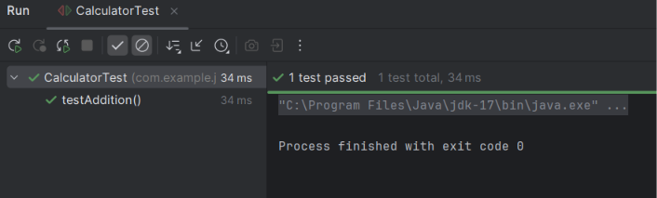
Exercise 3: Assertions in JUnit
Scenario:
I wrote unit tests using different JUnit assertions to validate that my program produced the expected results.
Steps Performed:
- I wrote test cases using various JUnit assertions such as assertEquals, assertTrue, assertFalse, assertNull, and assertNotNull.
Solution Code:
import org.junit.jupiter.api.Test;
import static org.junit.jupiter.api.Assertions.*;
public class AssertionsTest{
@Test
void testAssertions(){
assertEquals(5,2+3);
assertTrue(5>3);
assertFalse(5<3);
assertNull(null);
assertNotNull(new Object());
}
}
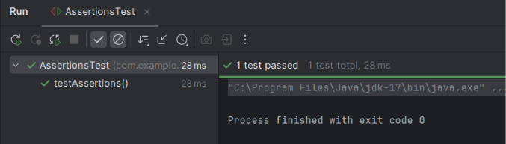
Exercise 4: Arrange-Act-Assert (AAA) Pattern, Test Fixtures, Setup and Teardown Methods in JUnit
Scenario:
I organized my test cases using the Arrange-Act-Assert (AAA) pattern and used setup and teardown methods to initialize and clean up test resources before and after each test execution.
Steps Performed:
- I wrote test cases by following the Arrange-Act-Assert (AAA) pattern.
- I used @BeforeEach and @AfterEach annotations to implement setup and teardown methods.
Solution Code:
import org.junit.jupiter.api.*;
import static org.junit.jupiter.api.Assertions.*;
class Calculator{ int add(int a,int b){return a+b;} }
public class CalculatorAAATest{
Calculator calculator;
@BeforeEach
void setUp(){ calculator=new Calculator(); }
@AfterEach
void tearDown(){ calculator=null; }
@Test
void testAdd(){
// Arrange
int a=10,b=20;
// Act
int result=calculator.add(a,b);
// Assert
assertEquals(30,result);
}
}