3. Branching and Merging
1. move to gitdemo and create a new branch
mkdir gitdemo
cd gitdemo
git init
Initial commit was required because the new repository was empty.
touch file1.txt
git add file1.txt
git commit -m "Initial commit"
git branch newbranch
git branch
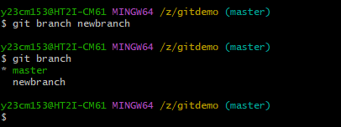
2. list all local and remote branches available in current trunck and move to new branch
git checkout newbranch
git branch
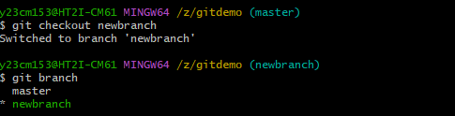
3. add files in new branch with contents and commit them
touch file2.txt
git add file2.txt
git commit -m "Added file2"
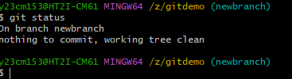
4. check status and checkout to main(switch to master)
git status
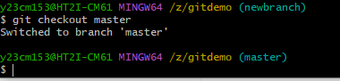
git checkout master

MERGING
5. list out differences between trunck and branch and merge branch and trunck
git diff master newbranch
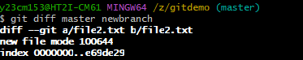
git merge newbranch
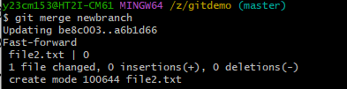
6. logging after merging and delete branch
git log --oneline
git branch -d newbranch
