1.

2. a

2. b

2. c

3. a

3. b

3. c 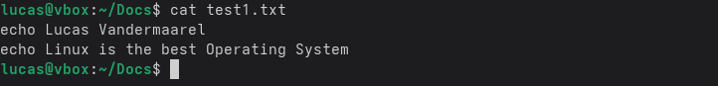

4. a



4. b

4. c

4. d



5. a



5. b



5. c



5. d



5. e



6. a

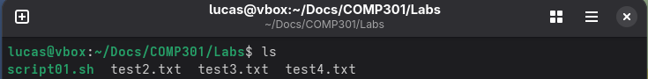

6. b

6. c

7. a



7. b

7. c

