Basic Programming Tasks

Name: Lochlan Marchinko

Give an example of each of the following concepts in the c# language. Write the code, screenshot it and add it to this document:

1.How to print a message:



2.How to take int or double input from the user:



3.How to take a string input from the user:



4.How to declare and initialize a boolean type:

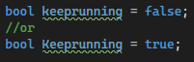

5.How to declare and use arrays:

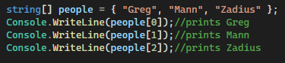

Or

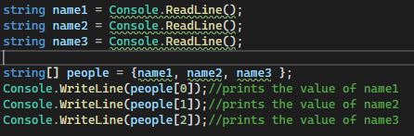

6.How to use the if conditional statement:



7.How to use the if else conditional statement:

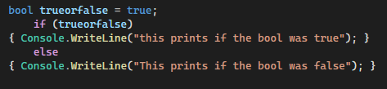

8.how to use a switch statement:

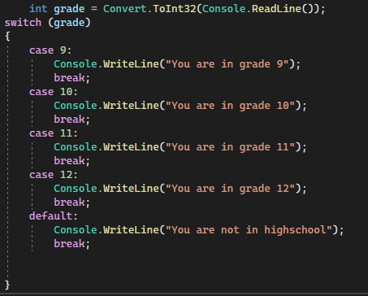

9.How to use the goto label to create a loop:

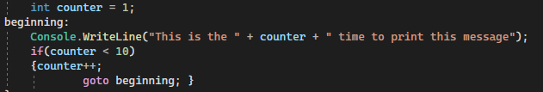

10.How to use for loops:



11. How to use while loops:

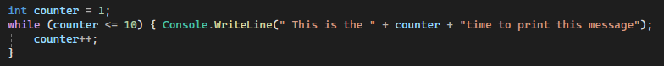

Or

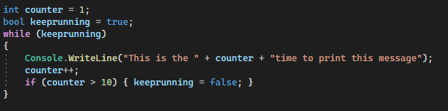

12.How to use do while loops:

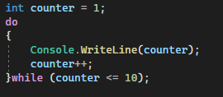

13. How to use foreach with an array:

