Year 03 Group Project

Author: Gerardo Ancheta Jr.

Group 11

Team members: Lochlann O Neill, Keith Bullman, Daniels Pikurs, Gerardo Ancheta Jr.

Module: Year 03 Group Project

Fin-Ai Web app screenshot

# Homepage: index.html

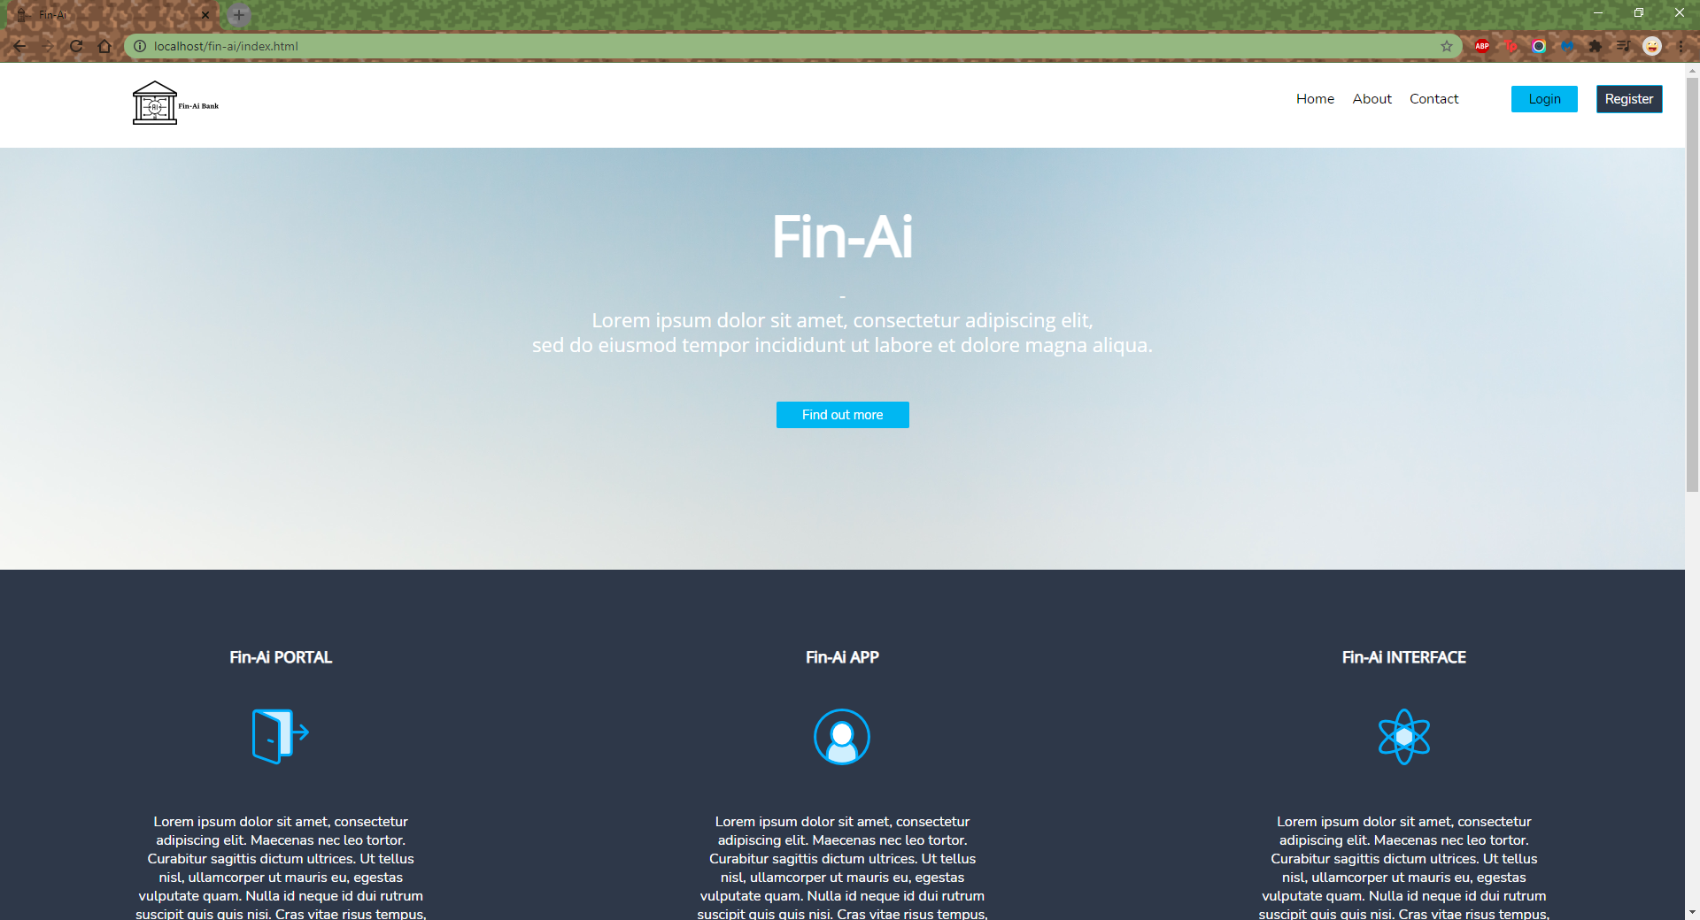

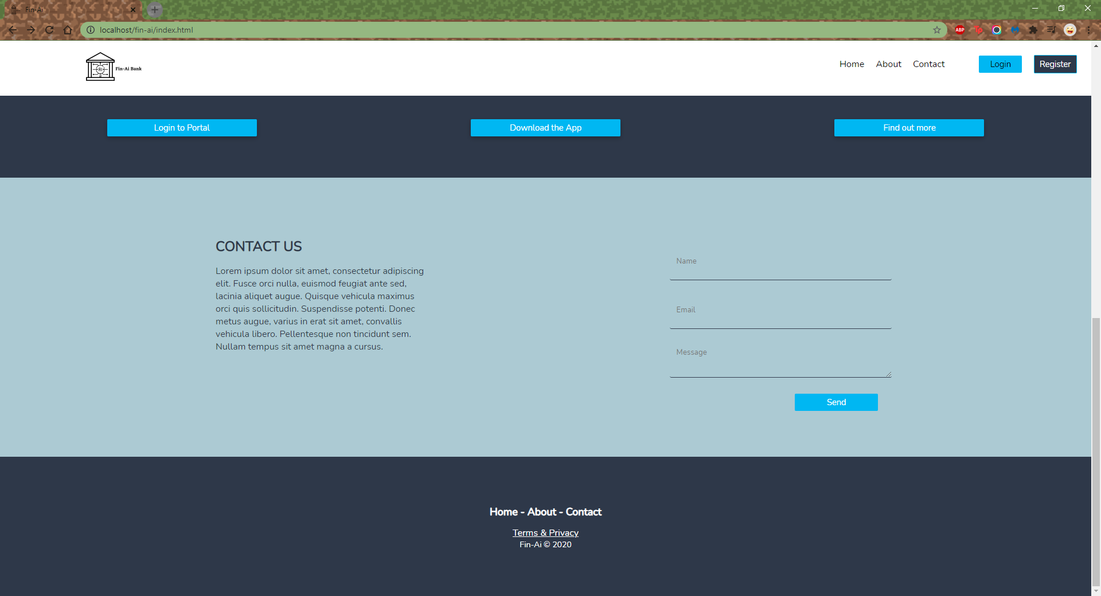

# Register page (broker): registerPage.php

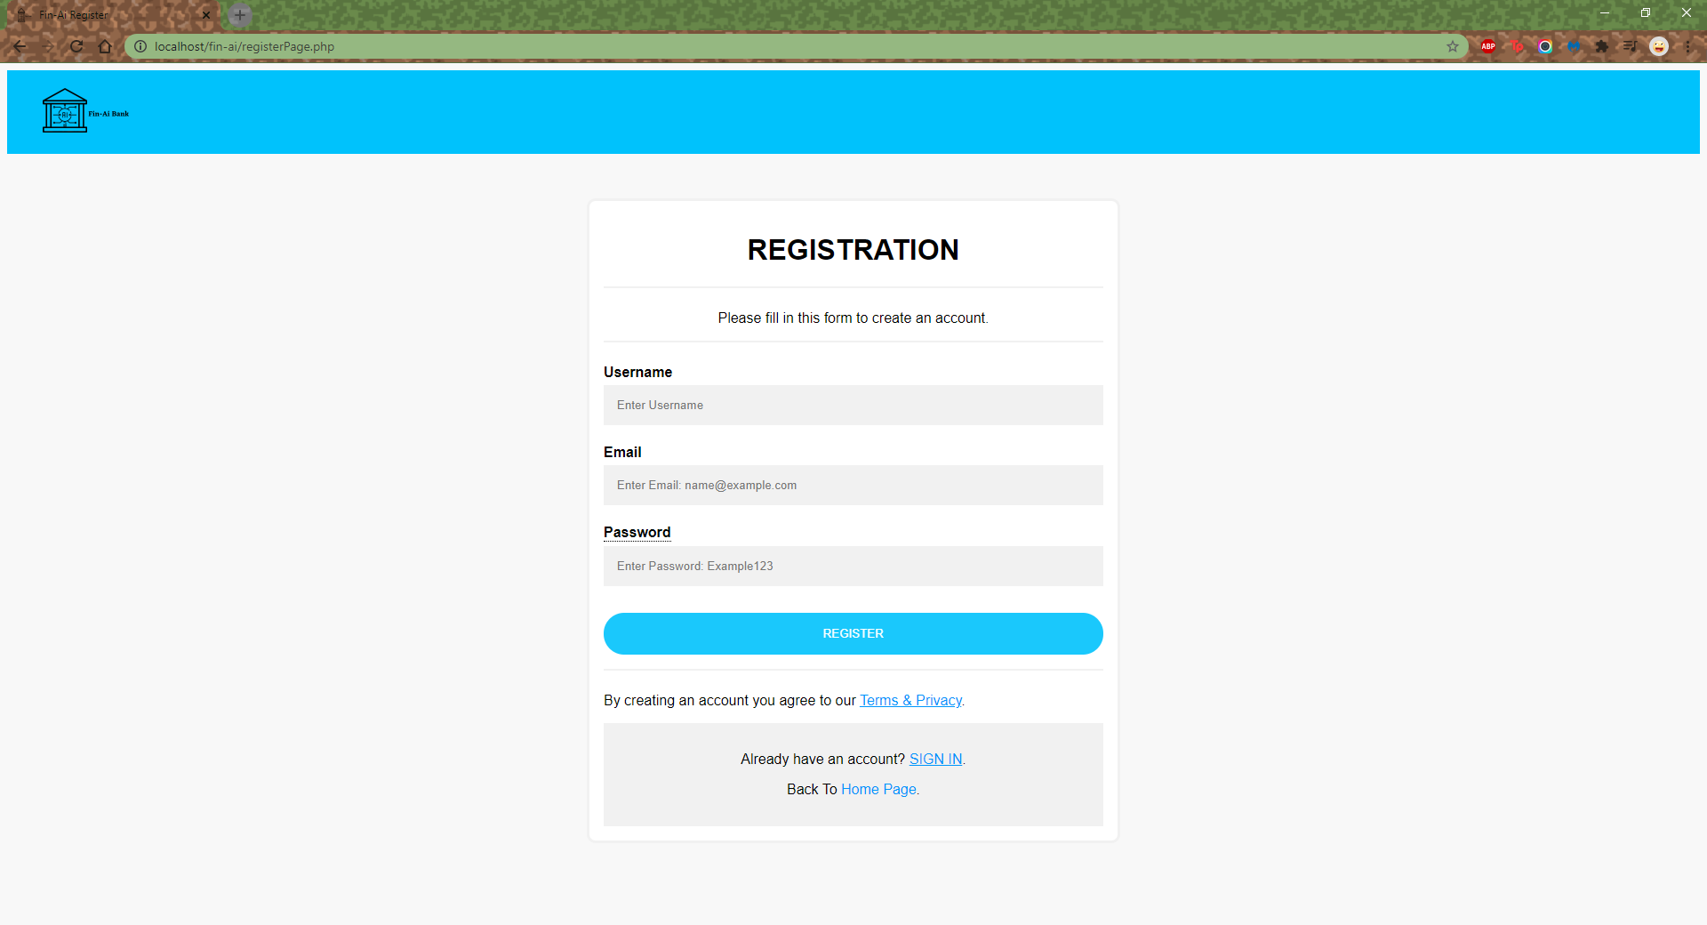

# Register page (banker[own URL link]): admin-reg.php

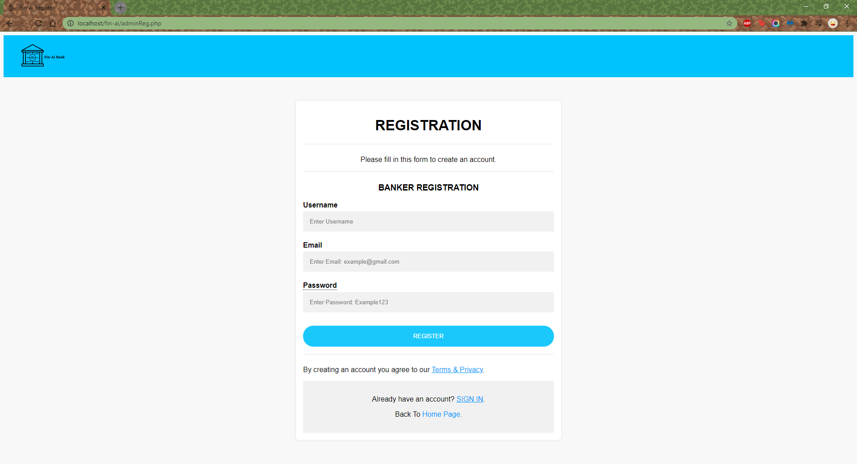

# Login page: loginPage.php

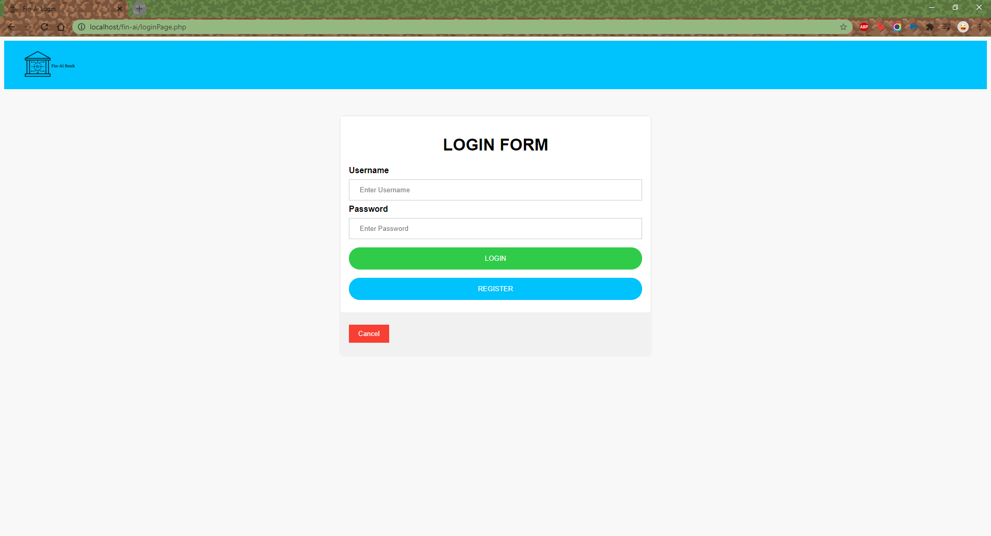

# Broker Dashboard: dashboard.php

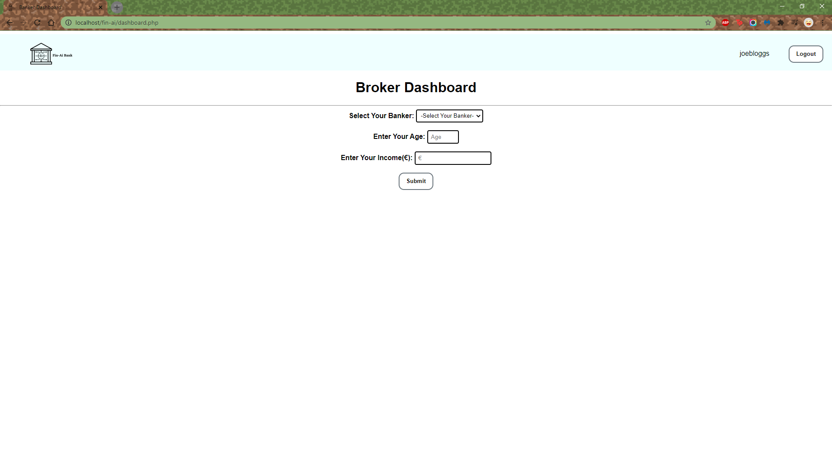

# Banker Dashboard: admin_view.php

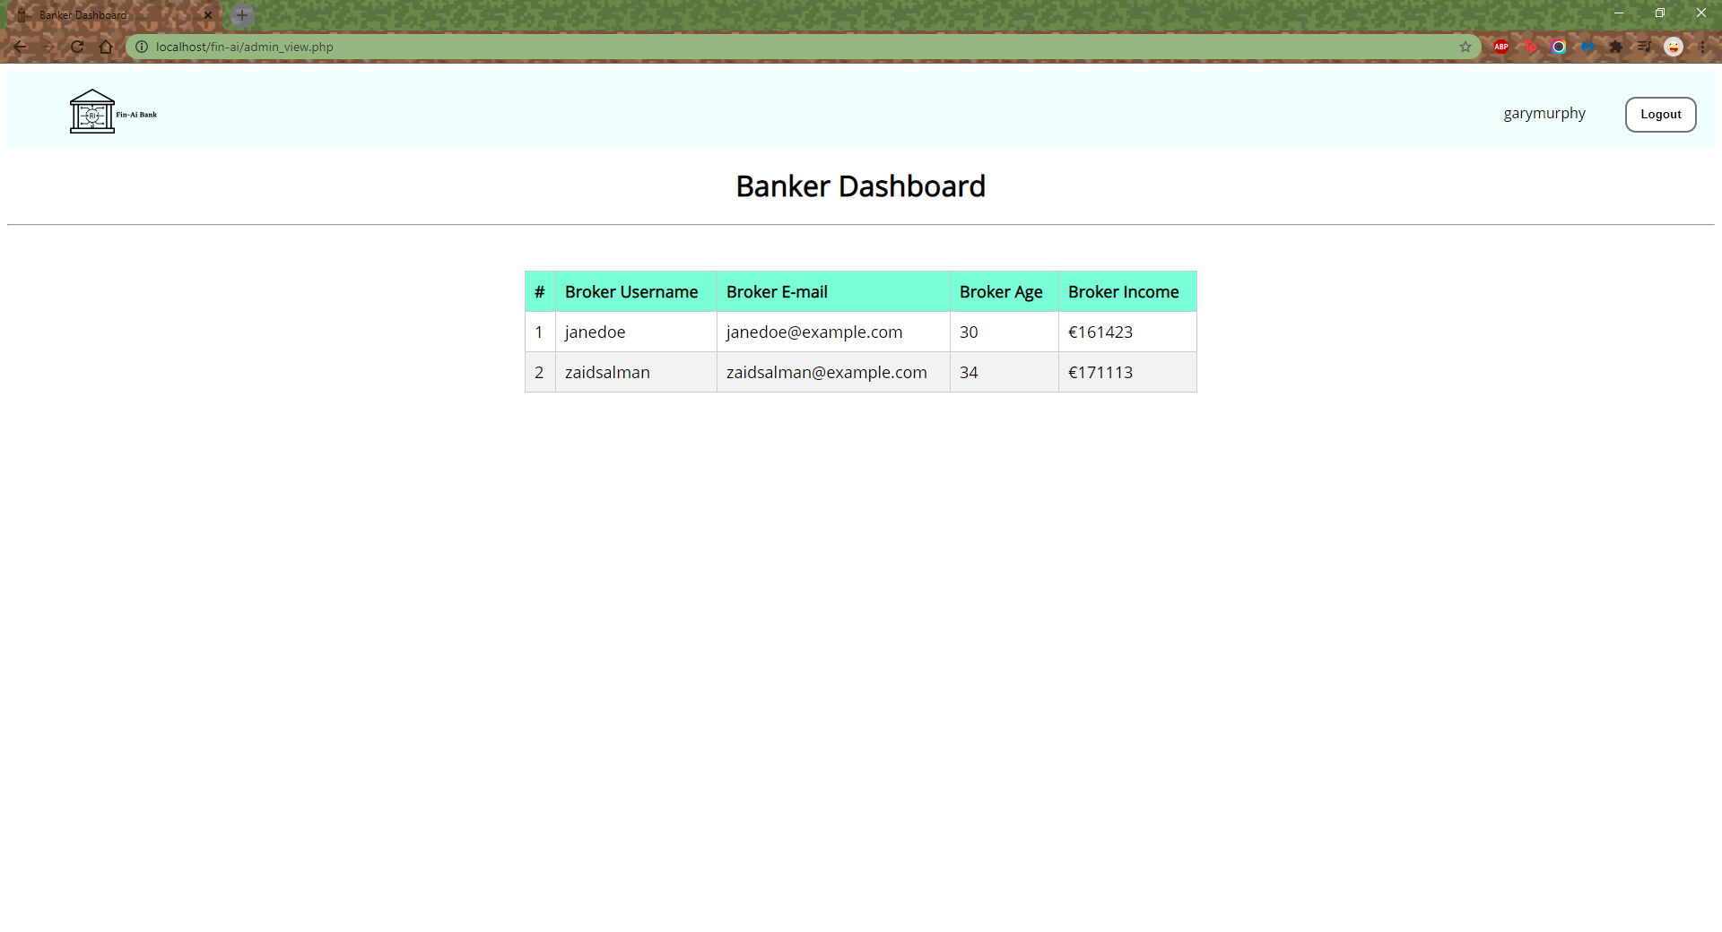

# Terms & Privacy: tp.html

