Fin-Ai Bank

Screenshots initial website

14/11/2020

Home/Landing Page, I’m going to edit the CSS manually. Still the initial website.

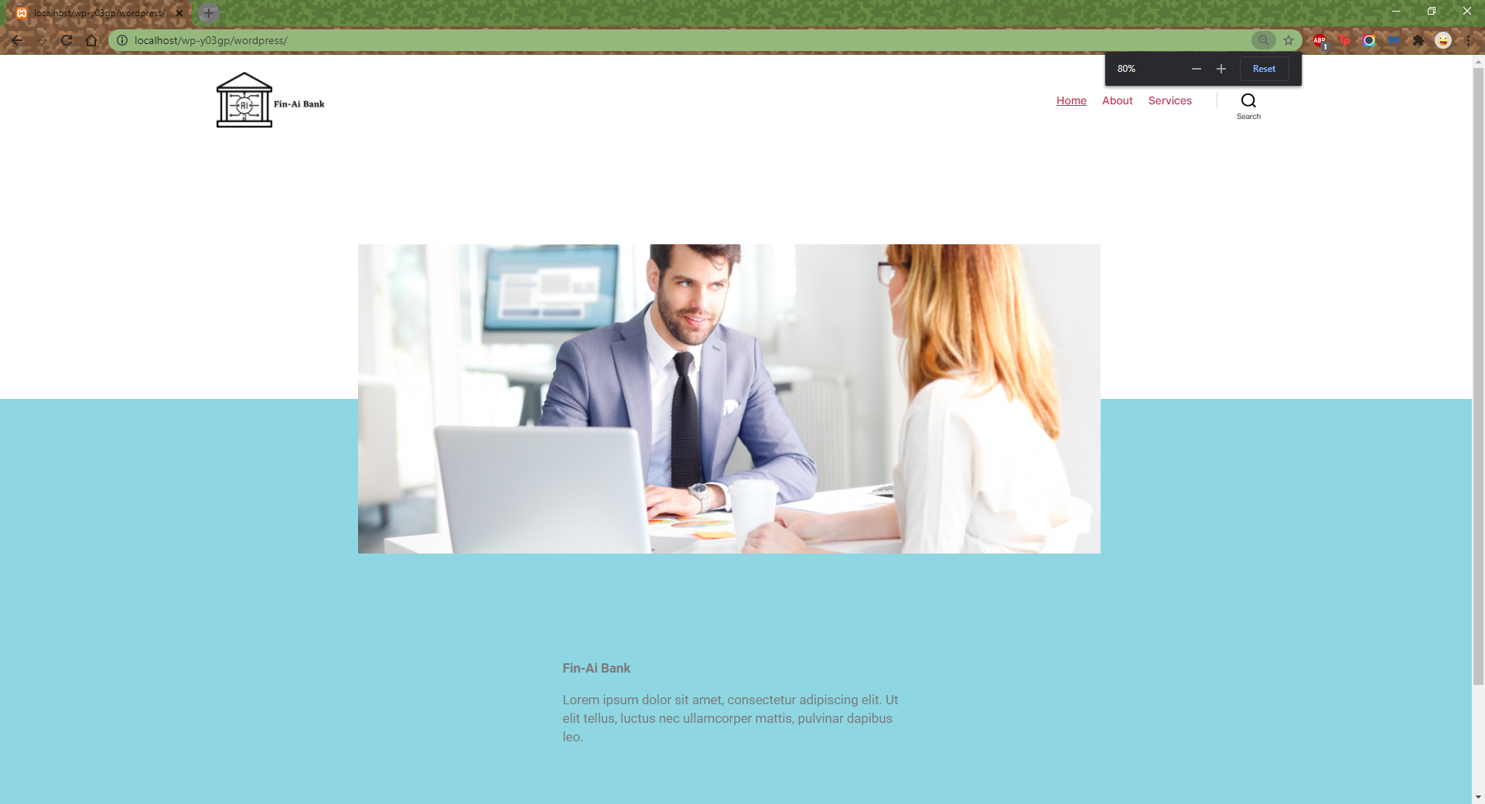

About Page

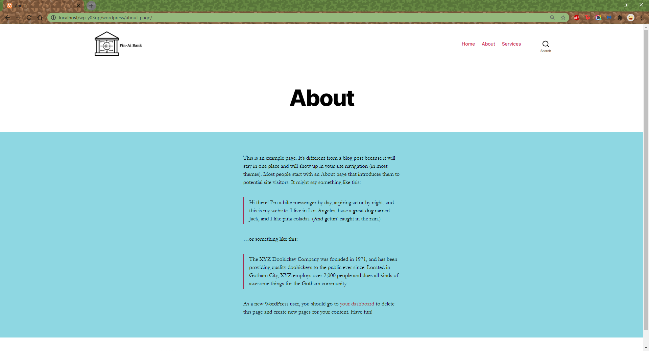

Services Page

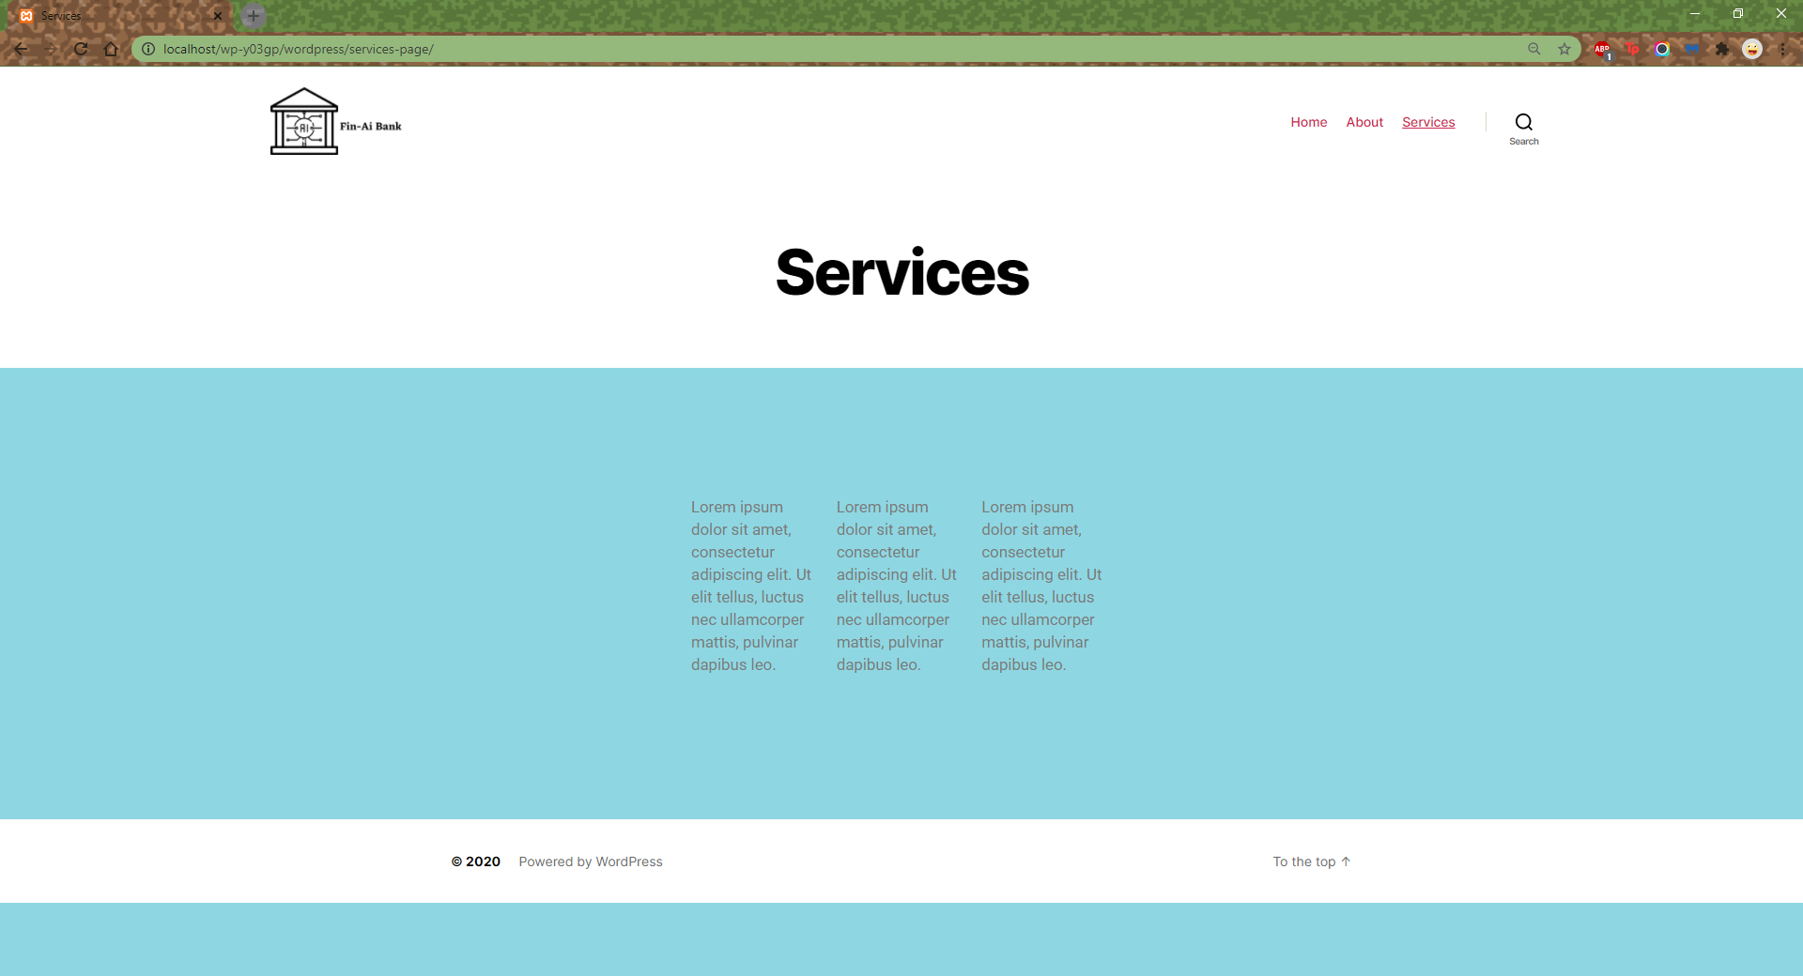

Y03GP WordPress auth

Database auth:-

username: root

pwd:

Site Auth:-

Site Title: FinAi Bank

username: slime11

pwd: //Y03gp2020