

Capstone Project Report
Report 2 – Project Management Plan

– Ho Chi Minh City, October 2026 –
Table of Contents
I. Record of Changes 4
II. Project Management Plan 4
1. Overview 4
1.1 Scope & Estimation 4
1.2 Project Objectives 6
1.3 Project Risks 6
2. Management Approach 8
2.1 Project Process 8
2.2 Quality Management 9
2.3 Training Plan 9
3. Project Deliverables 9
4. Responsibility Assignments 10
5. Project Communications 11
5.1 Communication Plan 11
5.2 External Interface 11
6. Configuration Management 12
6.1 Document Management 12
6.2 Source Code Management 12
6.3 Tools & Infrastructures 12

List of Tables
Table 2.1.1: Project Management Plan 4
Table 2.1.2: Project Objectives 6
Table 2.1.3: Project Risks 6
Table 2.2.3: Training Plan 9
Table 2.3: Project Deliverables 9
Table 2.4: Responsibility Assignments 10
Table 2.5.1: Communication plan 11
Table 2.5.2: External Interface 11
Table 2.6.3: Tools & Infrastructure 12

List of Figures
Figure 2.2.1: Project Process 8

I. Record of Changes
Date | A*  M, D | In charge | Change Description
23/09/2026 | A | Nguyễn Quốc Bảo Huy (SE180211) | Initial version of the project management plan.
27/10/2026 | M | Nguyễn Quốc Bảo Huy (SE180211) | Rewritten in the structure of the capstone report template: work breakdown by project phase, project objectives, risks, Agile process, training plan, deliverables, responsibility assignments, communications and configuration management.

*A - Added M - Modified D - Deleted

II. Project Management Plan

1. Overview

1.1 Scope & Estimation
Table 2.1.1: Project Management Plan
# | WBS Item | Complexity | Est. Effort  (man-days)
1 | Initiating
1.1 | Collect requirements of the five business flows | Medium | 10
1.2 | Deliver Report 1 – Project Introduction | Simple | 5
1.3 | Deliver Report 2 – Project Management Plan | Simple | 5
1.4 | Deliver Report 3 – Software Requirement Specification | Medium | 12
2 | Design
2.1 | Design user interface prototypes (mobile app, admin web, kiosk) | Complex | 8
2.2 | Design the microservice architecture, databases and message contracts | Complex | 8
2.3 | Deliver Report 4 – Software Design Description | Medium | 12
3 | Training
3.1 | Learn Spring Boot and Spring Cloud microservices | Medium | 4
3.2 | Learn Flutter and React for the client applications | Medium | 4
3.3 | Study Raspberry Pi GPIO, relays and MQTT for the locker cabinet | Complex | 5
3.4 | Study drone autopilot (ArduPilot, MAVLink) and ArUco precision landing | Complex | 5
3.5 | Research retrieval-augmented generation (embeddings, pgvector) | Medium | 3
3.6 | Research payment gateway solutions (VNPay, MoMo, SePay) | Simple | 2
4 | Implementation (Core Features)
4.1 | Platform (Back end)
4.1.1 | Service discovery, API gateway and token authorization | Complex | 5
4.1.2 | Sign-up and sign-in (phone, Google, email OTP) and user roles | Complex | 5
4.1.3 | Store, locker and cell management with the cell lifecycle | Complex | 5
4.2 | Mobile Application (Customer)
4.2.1 | Send a parcel through a locker | Complex | 6
4.2.2 | Rent a cell by the hour | Medium | 5
4.2.3 | Book a drone delivery and track the flight | Complex | 6
4.2.4 | Wallet, vouchers and loyalty points | Medium | 4
4.2.5 | Receive notifications (in-app, push, SMS, email) | Medium | 3
4.2.6 | Ask the document assistant | Simple | 2
4.3 | Mobile Application (Technicians)
4.3.1 | Locker technician: maintenance tickets, inspections, assigned lockers | Complex | 6
4.3.2 | Drone technician: missions, telemetry and drone maintenance | Medium | 4
4.4 | Web Application (Admin)
4.4.1 | Dashboard, orders, payments and revenue reports | Complex | 5
4.4.2 | Lockers and cabinet layout, drones, tickets and inspection schedules | Complex | 5
4.4.3 | Users, stores, promotions, system settings and knowledge base | Medium | 4
4.5 | Devices (Locker cabinet, Drone)
4.5.1 | Cabinet controller on Raspberry Pi: relays, door sensors, sliding lid | Complex | 6
4.5.2 | Kiosk screen on the cabinet | Medium | 4
4.5.3 | Drone companion: telemetry, marker landing and payload release | Complex | 6
5 | Integration
5.1 | Integrate the message broker (RabbitMQ) and MQTT with cabinets and drones | Complex | 5
5.2 | Integrate the payment gateway (SePay bank transfer by VietQR) | Medium | 3
5.3 | Integrate cloud services (Firebase, Cloudinary, SMS and email) | Medium | 3
5.4 | Integrate the AI document assistant (Claude, Voyage AI) | Complex | 5
5.5 | Implement a CI/CD pipeline using GitHub Actions | Complex | 5
6 | Testing
6.1 | Unit tests for backend services | Complex | 10
6.2 | Unit tests for the mobile and web applications | Medium | 6
6.3 | Integration and system tests of the five business flows | Complex | 8
6.4 | Deliver Report 5 – Software Test Documentation | Complex | 12
7 | Deployment
7.1 | Deploy the back end on an Azure virtual machine with Docker Compose | Medium | 4
7.2 | Deploy the admin web, landing page and mobile web on Cloudflare | Simple | 2
7.3 | Install the physical locker cabinet and prepare the delivery drone | Complex | 5
7.4 | Final deployment and launch | Medium | 4
8 | Closing
8.1 | Deliver Report 6 – Software User Guide | Medium | 5
8.2 | Deliver Report 7 – Final Project Report | Simple | 10

Total Estimated Effort: 251 (man-days)

1.2 Project Objectives
Table 2.1.2: Project Objectives
# | Testing Stage | No. of Defects | % of Defect | Notes
1 | Reviewing | 45 | 35 | Pull request and document review
2 | Unit Test | 39 | 30 | Automated in CI on every pull request
3 | Integration Test | 25 | 19 | Services, message broker, cabinet and drone
4 | System Test | 16 | 12 | Five business flows on the deployed system
5 | Acceptance Test | 5 | 4 | Demonstration with the supervisor
 | Total | 130 | 100

1.3 Project Risks
Table 2.1.3: Project Risks
No. | Risk Description | Impact | Possibility | Response Plans
1 | Out of scope change in requirements | High | High | - Create a deliverable plan with clear objectives and requirements.  - Agree the scope of every sprint with the supervisor.
2 | Team members are new to part of the technology stack (Spring Cloud, Flutter, MQTT, drone autopilot) | Medium | High | Follow the training plan, pair on the first task of each area.
3 | Members of the team get sick or are busy with other courses | Medium | Medium | Keep tasks small (at most three days) so they can be reassigned; share the progress file.
4 | Delay in timeline task | High | Medium | Review progress every week and keep a buffer of effort for defects and late tasks.
5 | Insufficient testing | High | Medium | Run unit tests automatically on every pull request and write a test scenario for every flow.
6 | The locker cabinet hardware (relays, locks, sliding lid) is late or faulty | High | Medium | Keep a cabinet simulator so the software can be tested without hardware; test each part on the bench first.
7 | The drone cannot land precisely on the cabinet or release the parcel | High | Medium | Use marker-based precision landing, test the release on the bench and in a tethered hover before free flight.
8 | People are hurt or devices damaged during hardware tests | High | Low | Remove the propellers during bench tests and never move hardware remotely when nobody is next to it.
9 | Failures of payment systems | High | Medium | Confirm every transfer by the bank webhook, match the amount and the order reference, refund late transfers.
10 | Personal information leakage | High | Low | Use role-based access, check ownership on every request and encrypt all connections (TLS).
11 | Security attacks (brute force on pickup codes, forged requests) | High | Medium | Lock a cell after repeated wrong codes, two-factor sign-in for administrators, automatic security scans.
12 | Unauthorized commands sent to a cabinet or a drone | High | Low | Use a private MQTT broker with one account and access rules per device.
13 | No staging environment: a merged change goes straight to production | High | Medium | Mandatory checks and one review before merging, smoke test after each deployment, automatic rollback.
14 | System overload on the single server that hosts all services | Medium | Medium | Limit the memory of every service, monitor the server and scale it up when needed.
15 | Free build minutes or cloud credit run out | Medium | Medium | Track monthly usage, remove duplicated builds and keep a plan to move the server.
16 | External services (SMS, push, AI) are unavailable or not delivered | Medium | Medium | Deliver pickup codes through the application and email first; treat SMS as optional.
17 | Response from the AI assistant may be wrong or too costly | Medium | Medium | Answer only from the knowledge base with cited sources, refuse off-topic questions, limit questions per user.
18 | Lost or damaged data | High | Low | Perform regular database backups and use versioned migrations.

2. Management Approach

2.1 Project Process
Figure 2.2.1: Project Process
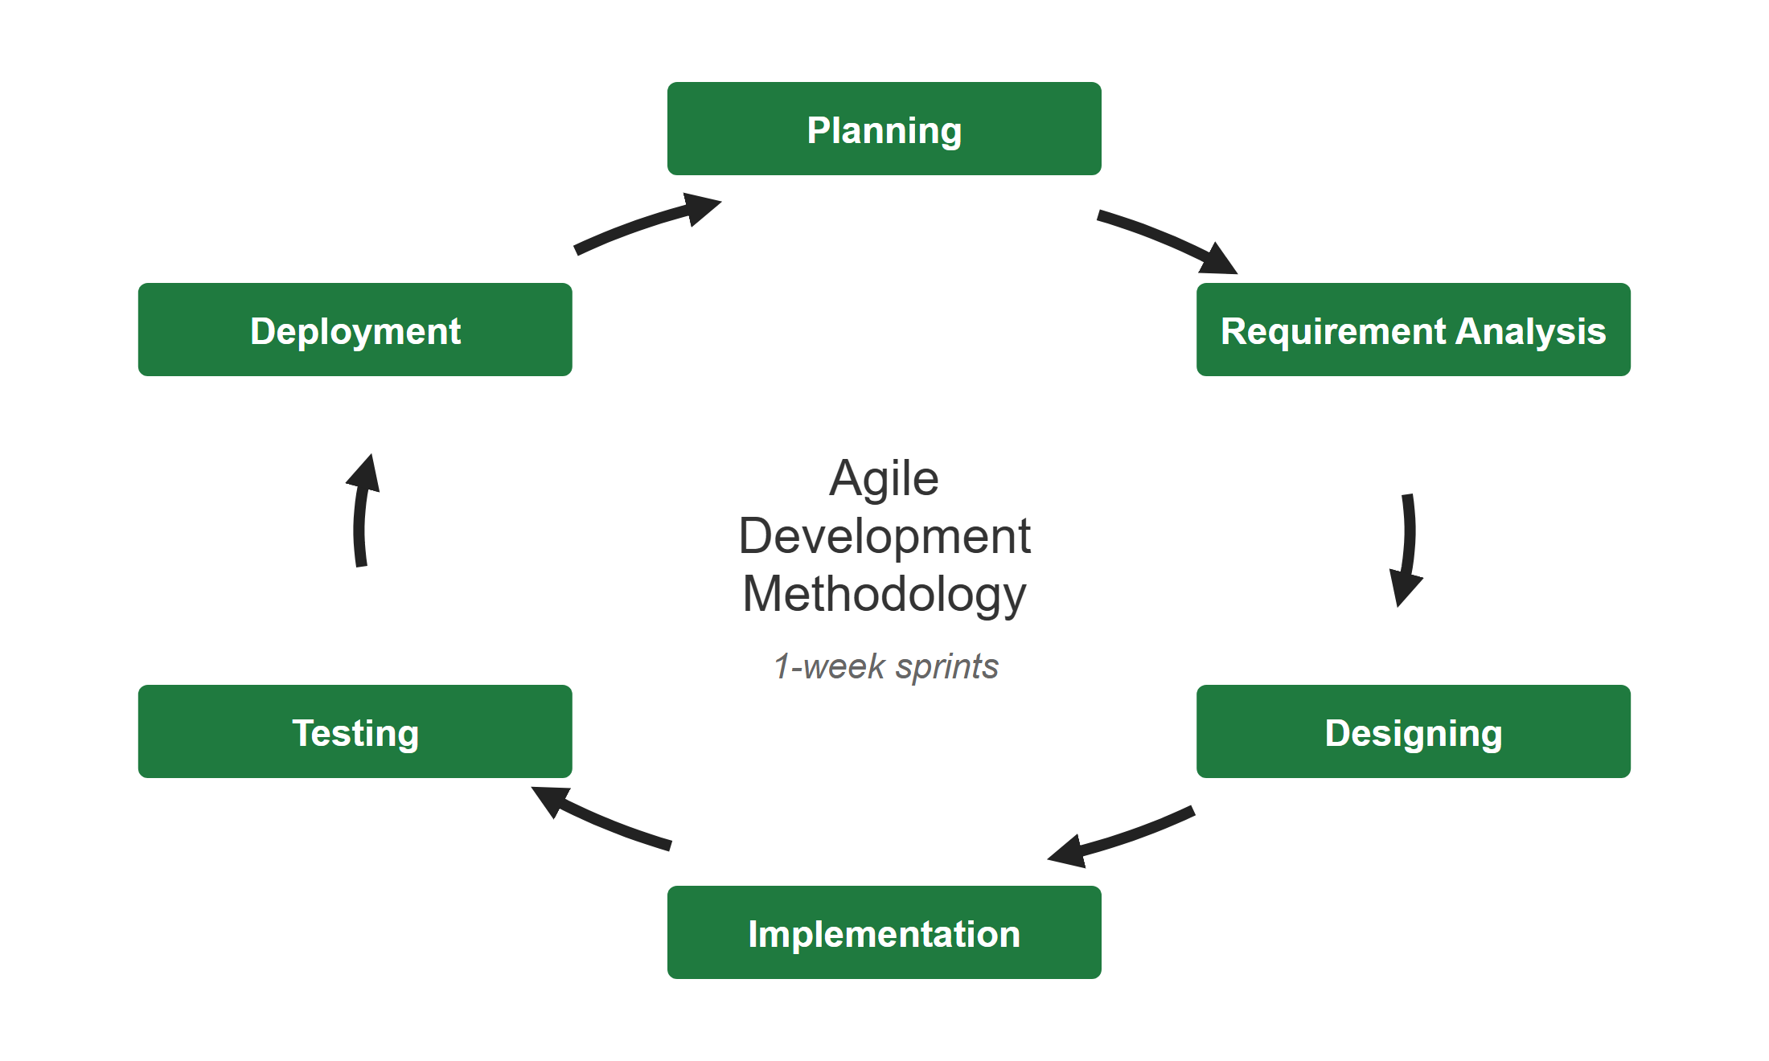
This project applied the Agile model to ensure the flexibility and adaptability to changes. It is separated into 1-week-long sprints and includes the following stages for each sprint.
- Planning – The initial phase where the backlog is reviewed, the goals of the sprint are defined and the tasks are assigned to the members.
- Requirement Analysis – Gather and define the requirements of the business flow, its rules and acceptance criteria.
- Designing – Creating screen designs, database schema, API and message contracts to guide the development process.
- Implementation – Writing and implementing code to build the software, the cabinet controller and the drone companion.
- Testing – Conducting testing (unit, integration, system and hardware testing) to ensure quality and functionality.
- Deployment – Releasing the product to users in the production environment and demonstrating it to the supervisor.

2.2 Quality Management
To ensure the quality of Lock.R, the following practices will be followed:
- Code Review: Code must be reviewed by at least one other team member before merging into the main branch.
- API convention: Clear route naming by user role and standard response structures.
- Unit Testing: Ensure individual components work as expected; tests run automatically on every pull request.
- Integration Testing: Ensure seamless interaction between services, client applications, cabinets and drones.
- System Testing: Full system validation of the five business flows to ensure stability.
- Security Scan: Automatic code and dependency scans on every pull request.

2.3 Training Plan
Table 2.2.3: Training Plan
Training Area | Participants | When, Duration | Waiver Criteria
Java 21, Spring Boot and Spring Cloud | All members | Week 1 - 8 hours | Mandatory
Git and GitHub Flow, CI/CD with GitHub Actions | All members | Week 1 - 4 hours | Mandatory
Flutter mobile application | Trương Nguyễn Thái Bình, Lê Thị Yến Vi, Trần Kim Nhã | Week 2 - 8 hours | Mandatory
React and TypeScript for the admin web | Nguyễn Quốc Bảo Huy, Trương Nguyễn Thái Bình | Week 2 - 6 hours | Mandatory
Docker, Linux server and cloud deployment | Nguyễn Quốc Bảo Huy | Week 3 - 6 hours | Mandatory
Integrate payment gateway (SePay, VietQR) | Nguyễn Quốc Bảo Huy, Trương Nguyễn Thái Bình | Week 3 - 4 hours | Mandatory
Raspberry Pi GPIO, relays and MQTT | Nguyễn Quốc Bảo Huy, Trần Kim Nhã | Week 4 - 6 hours | Mandatory
Drone autopilot (ArduPilot, MAVLink) and ArUco landing | Lê Thị Yến Vi, Trần Kim Nhã | Week 4 - 8 hours | Mandatory
Retrieval-augmented generation (embeddings, pgvector) | Nguyễn Quốc Bảo Huy, Trương Nguyễn Thái Bình | Week 6 - 6 hours | Mandatory

3. Project Deliverables
Table 2.3: Project Deliverables
No | Deliverable | Due Date | Deliverable Scope
1 | Project Introduction Document | Week 2 | Report 1: problem statement, product vision, users and the five business flows of the smart locker platform.
2 | Project Management Plan | Week 3 | Report 2: scope and estimation, objectives, risks, process, deliverables, responsibilities, communications and configuration management.
3 | SRS Document | Week 5 | Report 3: functional and non-functional requirements, use cases, screen flows, business rules and the entity relationship diagrams.
4 | Core Features Implementation (Phase 1) | Week 6 | Platform foundation, accounts, locker network, sending a parcel and hourly cell rental with payment, wallet and the admin web.
5 | Design Document | Week 7 | Report 4: system architecture, component interactions, database schema, API and message contracts and the user interface design.
6 | Extended Features Implementation (Phase 2) | Week 10 | Drone delivery, operations and maintenance, the document assistant, the physical locker cabinet and the delivery drone.
7 | Integration & Testing | Week 12 | Integrates payment, cloud services, cabinets and drones. Conducts unit, integration and system tests. Report 5: Software Test Documentation.
8 | Deployment | Week 14 | Final deployment of the back end, web and mobile applications, installation of the cabinet; source code and deployment guide.
9 | Final Documentation & Closure | Week 15 | Report 6: Software User Guide and Report 7: Final Project Report; demonstration and hand-over of all documentation.

4. Responsibility Assignments
D~Do; R~Review; S~Support; I~Informed; <blank>- Omitted
Table 2.4: Responsibility Assignments
Responsibility | HuyNQB  SE180211 | BinhTNT  SE182370 | ViLTY  SE182544 | NhaTK  SE182290 | DucDNM | TienDH
Project Planning & Tracking | D | R | S | S | I | I
Prepare Project Introduction Document | D | S | S | S | I | I
Prepare Project Management Plan | D | R | S | S | I | I
Prepare SRS Document | R | D | S | S | I | I
Prepare Software Design Document | D | D | S | S | I | I
Create and Prioritize Backlog | D | S | I | I | I | I
Sprint Planning | D | S | S | S | I | I
Development of Back-end Services | D | D | S | S | I | I
Development of Mobile Application | S | D | D | D | I | I
Development of Admin Web | D | D | S | S | I | I
Development of Cabinet & Drone Devices | D | S | D | D | I | I
Testing & Quality Assurance | R | D | S | D | I | I
Sprint Review | D | S | S | S | I | I
Release Planning & Deployment | D | S | I | I | I | I

5. Project Communications

5.1 Communication Plan
Table 2.5.1: Communication plan
Communication Item | Who/ Target | Purpose | When, Frequency | Type, Tool, Method(s)
Working with advisor | Supervisor and team members | • Review documentation  • Demonstrate features  • Evaluate progress and result | 1 time per week | Meeting on site or online
Working in team | Team members | • Raise opinions, problems  • Ask for help from other members | Many times per day | Team group chat
Working in team | Team members | • Report the working status to the leader  • Plan the next sprint | 1 time per week | Team meeting
Code review | Team members | • Review every change before it is merged | Every pull request | GitHub pull requests

5.2 External Interface
Table 2.5.2: External Interface
Function | Contact Person  (name, position) | Contact address  (email, telephone) | Responsibility
Supervisor | Đặng Ngọc Minh Đức, Supervisor | ducdnm2@fe.edu.vn | - Provide document template  - Give instructions to the project team  - Review deliverables  - Supervise project status
Supervisor | Đỗ Hữu Tiến, Supervisor | TienDH6@fe.edu.vn | - Provide document template  - Give instructions to the project team  - Review deliverables  - Supervise project status

6. Configuration Management

6.1 Document Management
- Use the docs repository on GitHub to save flow documents, decision records, runbooks, the progress file and the change log; documents are reviewed through pull requests.
- Word reports and the project tracking workbook: rp2 and rp3 folders of the docs repository.
- Public GitHub organization: github.com/LockR-Tech

6.2 Source Code Management
- Our team uses GitHub to manage our source code efficiently. The version control system enables team members to track commits, collaborate seamlessly, and merge code effectively.
- Follow Git management best practices:
  - Commit frequently with meaningful messages (Conventional Commits).
  - Use a short-lived branch for every feature or fix; never push directly to the main branch.
  - Open a pull request; the build, tests and security scan must pass before merging.
  - Review changes by at least one other member, then squash merge into the main branch.
  - Review and resolve conflicts before merging.

6.3 Tools & Infrastructures
Table 2.6.3: Tools & Infrastructure
Category | Tools / Infrastructure
Technology | Java Spring Boot, Spring Cloud (back end), React (admin web), Flutter (mobile app), Python (Raspberry Pi cabinet controller, kiosk, drone companion)
Database | PostgreSQL, pgvector
Messaging | RabbitMQ, MQTT (Mosquitto), WebSocket
IDEs/Editors | IntelliJ IDEA, Visual Studio Code, Android Studio
Diagramming | draw.io, Mermaid
Documentation | Microsoft Office, Markdown
Version Control | GitHub (source code and documents)
Deployment server | Azure virtual machine with Docker, Cloudflare Pages / Workers
Project management | GitHub, Excel project tracking workbook
Hardware | Raspberry Pi 5, relay module, electric locks, stepper motor; drone with Pixhawk flight controller

