**DriveSenseTM Final Project Report**

**Document Version: 1.10**

Author: Keith Tran

Author E-Mail: ktran033@uottawa.ca

Author Department: Engineering

Author Division: University of Ottawa

www.eecs.uottawa.ca

2023F

# Document Control Information

## Document Approval

|  |  |  |  |
| --- | --- | --- | --- |
| **Name** | **Responsibility** | **E-Mail** | **Date** |
| Saurav Guduru | *Scrum Master* | sgudu104@uottawa.ca | 4/14/2025 |
| Keith Tran | *Management Lead* | Ktran033@uottawa.ca | 4/14/2025 |
| Abdullah Ramadan | *CAD Specialist* | arama014@uottawa.ca | 4/14/2025 |
| Kevin Dang | *Web Developer* | kdang038@uottawa.ca | 4/14/2025 |
| Hajer Fguir | *Web Developer* | hfgui039@uottawa.ca | 4/14/2025 |
| Aaditya Shah | *Tech Lead* | ashah203@uottawa.ca | 4/14/2025 |

## Change History

|  |  |  |  |  |
| --- | --- | --- | --- | --- |
| **Version** | **Date** | **E-Mail** | **Flag** | **Change Description** |
| 1.0 | 02/13/2025 | Ktran033@uottawa.ca | INIT | Version 1.0 - Original Document |
| 1.1 | 02/18/2025 | Ktran033@uottawa.ca | CHG | Added to sections 3.1, 3.4, 3.7, 3.8, 3.11, 4.1 and 4.2 |
| 1.2 | 02/19/2025 | Ktran033@uottawa.ca | CHG | Added to sections 3.6, 4.2, 4.3, 4.5, 5, 6.2, 8, 8.1.1, 8.1.2, 8.2, 9.2, 9.3, 9.4, 9.5, 9.6, 10. Merged sections 7.1 and (previously) 7.2 into 7.1 |
| 1.3 | 02/20/2025 | Ashah2033@uottawa.ca | CHG | Added to sections 3.8, 7.1, 7.2, and 8.2 |
| 1.4 | 2/20/2025 | Arama014@uottawa.ca | CHG | Added to sections 3.5, 3.8, and 6.1 |
| 1.6 | 2/24/2025 | Sgudu104@uottawa.ca | CHG | Added sections 5.3 and 8.1 |
| 1.7 | 2/25/2025 | [hfgui039@uottawa.ca](mailto:hfgui039@uottawa.ca), [kdang038@uottawa.ca](mailto:kdang038@uottawa.ca), [ashah2033@uottawa.ca](mailto:ashah2033@uottawa.ca), [ktran033@uottawa.ca](mailto:ktran033@uottawa.ca), [arama014@uottawa.ca](mailto:arama014@uottawa.ca), [sgudu104@uottawa.ca](mailto:sgudu104@uottawa.ca) | CHG | Added to sections 3.4, 5.2, 8.1, 9 |
| 1.8 | 4/11/2025 | Ktran033@uottawa.ca | CHG | Edited sections 5.2, 8.2, 8.3, 8.5 |
| 1.9 | 4/13/2025 | Kdang038@uottawa.ca | CHG | Edited section 7.1 |
| 1.10 | 4/14/2025 | [Ktran033@uottawa.ca](mailto:Ktran033@uottawa.ca),  [sgudu104@uottawa.ca,](mailto:sgudu104@uottawa.ca)  [kdang038@uottawa.ca,](mailto:kdang038@uottawa.ca)  [ashah2033@uottawa.ca](mailto:ashah2033@uottawa.ca),  [hfgui039@uottawa.ca](mailto:hfgui039@uottawa.ca) | CHG | Edited sections 2.6, 5.3, 6.1, 6.2, 7, 7.1.1, 7.1.2, 7.2, 8.2 |

1 Document Control Information 2

1.1 Document Approval 2

1.2 Change History 2

2 Introduction 5

2.1 Project Description 5

2.2 Goals, Objectives & Scope 5

2.3 Assumptions, Constraints & Risks 6

2.4 Project Deliverables 6

2.5 Schedule & Budget Summary 6

150W Car Power Inverter DC 12V to 110V AC Converter 7

2.6 Acronyms, Terms and Definitions 7

2.7 References 8

2.8 Limitations, Issues and Concerns 8

2.9 Change of information 9

2.10 Confidential Information 9

2.11 Third Party Confidentiality Restriction 9

3 Roles & Responsibilities 9

3.1 Objective 9

3.2 Project Stages 9

3.3 Clients 9

3.4 Participants 9

3.5 Market Space and Industry Sector 10

4 Requirements 10

4.1 Functional Requirements 10

4.2 Non-Functional Requirements 10

4.3 Constraints 10

5 Software Architecture 11

5.1 High Level Design: Architectural Views 11

5.2 Front-End (Graphical User Interface) 12

5.3 Back-End 18

6 Hardware Design 20

6.1 Hardware Components and Specifications 21

6.2 Hardware Block Diagram 22

7 Testing 23

7.1 Software 25

7.1.1 Verification 25

7.1.2 Validation 25

7.2 Hardware Testing 27

8 Project Management 28

8.1 Protocols and Procedures 28

8.2 Tasks and Timelines 29

8.3 Work Force 31

8.4 Work Breakdown Structure 32

8.5 Jira Board 32

8.6 Risk Management Plan 33

9 Future Works & Closing Remarks 35

10 APPENDIX A: PROJECT CODE 35

11 APPENDIX B: PROJECT DIARIES 35

# Introduction

## Project Description

This document provides an outline of the architecture and high-level design of DriveSenseTM, a device designed for detection of driver drowsiness, and its components. Specifically, this document describes, in detail, the roles and responsibilities of the parties involved in the project’s development, the functional and non-functional requirements to be achieved by the project, the architecture of both the software and hardware modules, testing procedures, and the management of the project.

## Goals, Objectives & Scope

The primary goal of the DriveSenseTM project is to develop a real-time system for monitoring the driver of a vehicle for signs of drowsiness, in the event of which it will either give a harsh warning or take direct action. The device will also allow a third party to monitor the driver, accessing information in real time. A key goal of the project is to keep the device small and adaptable, as to allow retrofitting in the anterior of any vehicle. The device also aims to be inobtrusive, having no impact on the driver’s awareness nor their ability to pilot the vehicle. With these features, DriveSenseTM aims to increase driver safety and ease of access to critical information, especially for older vehicles that may lack modern safety measures and whose drivers are thus at greater risk.

The objectives of the DriveSenseTM project are as follows:

**Design, planning, research, and project management:**

* Formation of the project idea, key goals, functional and non-functional requirements, and constraints
* Designing the software and hardware architecture
* Picking and ordering components, research on drowsiness detection and relevant datasets

**Software development**

* Developing a web application designed for a third party to remotely monitor and interact with the system
* Developing an on-device application for interacting with the driver and/or passenger in the vehicle; serves as the interface between the driver and the system
* Integrating the system with an online database, where collected data can be uploaded to the cloud in real-time and can be accessed via the web application
* Integrating a ML model in the microcontroller that can analyze visual input and determine the presence of drowsiness
* Develop drivers for the various sensors that can store and process collected data

**Hardware development**

* Implement a microcontroller capable of processing visual and accessory inputs while simultaneously hosting an ML model capable of decision-making
* Implementing sensors for detecting symptoms of drowsiness, most notably a camera
* Integrating a touch-screen display that will serve as the interface between the user and the system

**Integration**

* Designing and creating CAD models to create a structure that will house and protect components and ensure compatibility between components and between the system and the vehicle’s interior
* Ensure that individual components comply with the microcontroller and resolve any related issues that may arise
* Ensure that the system is adaptable so that it can be fitted into the interior of any vehicle without impairing the driver’s awareness or ability to drive

**Testing, prototyping, and feedback**

* Create prototypes and perform testing on various aspects of the device with an emphasis on reliability and safety
* Rigorous testing and debugging of the web application and to ensure smooth functionality and an accessible UI
* Collect external user feedback to gather a variety of perspectives, especially from a consumer standpoint

**Documentation**

* Comprehensively document every aspect of the project, including the internal design and development process, as well as detailed descriptions and user manuals concerning the product itself
* Store all deliverables, files, and documents to a central database that is shared by all members of the project and can be freely accessed on the web, with back-ups in the event of system failure

The scope of this document is to provide a basis for the design and implementation of the DriveSenseTM project. This prototype stems from the set of requirements obtained and listed in Section 3.6.

## Assumptions, Constraints & Risks

Assumptions:

* The ideal user regularly drives a vehicle that they have personal access to
* The user lacks a vehicle with internal safety detection measures as well as real-time remote monitoring
* The device will sustain minimal environmental resistance, as it will not encounter factors unusual to the internal environment of a vehicle
* The user has access to the IoT devices

Constraints:

* The design will have to be flexible to be able to fit into the internals of various vehicles of different dimensions
* The budget should be kept low to keep the price low as a consumer incentive

Risks:

* Network failure
* Power failure
* Microcontroller malfunction
* Overheating
* Failure to send messages

## Project Deliverables

The deliverables of the project include the project proposal, this project report, the mid-term and final presentations, a working device with both hardware and software components and a web application.

## Schedule & Budget Summary

Tentative schedule and budget estimate for entire project (4912 and 4913)

|  |  |  |
| --- | --- | --- |
| **Component** | **Cost (CAD$)** | **Link** |
| Nvidia Jetson Orin Nano Super Developer Kit | 480.85 | <https://www.arrow.com/en/products/945-13766-0000-000/nvidia> |
| PI NOIR CAMERA V2 IMX219 8MP | 27.06 | <https://www.digikey.ca/en/products/detail/raspberry-pi/SC0024/6152811?gQT=2> |
| 4.3inch HDMI LCD 800x480 IPS Capacitive Touch Screen | 73.44 | <https://a.co/d/5GLenRh> |
| DC 3.3-5V Passive Low-Level Trigger Buzzer Alarm Sound Module | 11.29 | <https://a.co/d/fjKHHs3> |
| 30cm Camera Cable for Raspberry pi High Flexibility Ribbon FFC Flat Cable Wire for Raspberry Pi Zero V1.3 Cameras | 15.36 | https://a.co/d/fkIsxPF |
| GY-521 MPU-6050 MPU6050 Sensor Module 3 Axis Accelerometer and Gyroscope Module | 18.07 | <https://a.co/d/gGHhDEE> |
| Thin Film Pressure Sensor Flex Bend Sensor SF15 600 10kg | 28.02 | <https://a.co/d/0nDhxGG> |
| Digital ADC Module 16-Bit ADS1115 I2C 4-Channel ADC | 18.07 | <https://a.co/d/h63XlNY> |
| Heart Rate Sensor Module MAX30102 Pulse Detection Blood Oxygen Concentration | 43.93 | <https://a.co/d/ftirkyS> |
| 4 Channels IIC I2C Logic Level Converter Bi-Directional Module 3.3V to 5V Shifter | 14.45 | https://a.co/d/1hsF3Fc |
| 150W Car Power Inverter DC 12V to 110V AC Converter | 23.72 | https://a.co/d/1qFEiB0 |
| Total Expenses: $754.25 | | |

## Acronyms, Terms and Definitions

|  |  |
| --- | --- |
| **Terms, acronyms, abbreviations** | **Definitions** |
| AI | Artificial intelligence |
| ML | Machine learning |
| EEF | Engineering Endowment Fund |
| CAD | Computer-aided design |
| FPS | Frames per second |
| IMU | Inertial measurement unit |
| QA | Quality assurance |
| CRUD | Create, read, update, and delete |
| PWM | Pulse width modulation |
| UI | User interface |
| SBC | Single board computer |
| ADC | Analog-to-digital converter |
| LTE | Long term evolution |
| GSM | Global system for mobile communications |
| API | Application programming interface |
| OBD | On-board diagnostics |
| IoT | Internet of things |
| IR | Infrared |
| PPG | Photoplethysmography |
| REST | Representational state transfer |
| JSON | JavaScript Object Notation |
| SEG | Software engineering |
| CNN | Convolutional neural network |
| EAR | Eye aspect Ratio |

Table 1: Table of Definitions, Acronyms and Terms

## References

This document contains no references to outside material.

## Limitations, Issues and Concerns

Some limitations, issues, or concerns that have been or are anticipated to be experienced are:

* Availability of an optimal microcontroller: There was difficulty in finding a microcontroller capable of meeting the requirements of the project while remaining affordable relative to the project’s budget, as well as available on the market. Eventually, the Nvidia Jetson Orin Nano was found, and was obtained after direct contact with a supplier at a price amicable with the project’s budget.
* Implementing AI model training: Implementing AI model training: Collecting and relevant datasets for drowsiness detection is time-consuming and requires many different data points such as different lighting conditions, facial features, and angles. Additionally, optimizing the AI model to run efficiently on edge devices like the Nvidia Jetson Orin Nano is a challenge. The Nvidia Jetson Orin Nano acts as an edge device because it runs the AI model locally in the car, processing video input from a camera to detect signs of drowsiness in real time.
* LTE/GSM connection: Due to the development time required for cellular technology, the prototype must use Wi-Fi in lieu of an LTE/GSM connection. An API will also be used to simulate calls.
* CAD design in relation to different car models: ensuring the system fits seamlessly into various car interiors presents challenges. Differences in dashboard layout, mounting points, and space constraints require adaptable or modular CAD designs.
* Driver hand position: The system includes a sensor that requires the driver to keep at least one hand on the steering wheel at all times.
* Working cigarette tray: We plan to power our system through the car’s cigarette tray (12V socket), which presents some challenges. Some vehicles may have limited space around the socket. Additionally, older car models may not provide a stable power supply, potentially causing interruptions. Ensuring consistent power delivery and managing heat dissipation will be important considerations for system reliability.

## Change of information

The information in this document is for informational purposes and may change at the sole discretion of CEG4912-13 without notice.

## Confidential Information

This documentation contains confidential regarding DriveSenseTM design specification information and is purely intended for the University of Ottawa and not for release/disclosure in whole or in part to any other party unless agreed upon in writing by CEG4912-13, Inc.

## Third Party Confidentiality Restriction

There are no third-party confidentiality restrictions concerning the DriveSenseTM project.

# Roles & Responsibilities

## Objective

The objective of the DriveSenseTM project is to create a device that can be fitted inside a vehicle and detect drowsiness in the driver based on stimuli measured internally to the vehicle and provide warning or emergency assistance if deemed necessary.

## Project Stages

* **Initialization:** the idea of the project is created, and a project proposal is submitted and approved. Research is conducted to produce clear objectives for the project.
* **Design:** The design of the project is created and finalized, and the necessary components are identified and requisitioned. Functional and non-functional requirements are identified. Funding for the project is secured.
* **Management:** roles and responsibilities are identified and assigned to project members. Project objectives are broken down into tasks, which are scheduled for completion throughout the project period.
* **Development, testing, and prototyping:** completion of tasks involving development, testing, and prototyping of software and hardware components is carried out in SCRUM development cycles.
* **Finalization and presentation:** Completed components are assembled and tested for compatibility. A presentation and demonstration of the final product is prepared, along with detailed and extensive technical documentation logging the development process and the product itself.

## Clients

The following is a list of clients being satisfied by the project, accompanied by background information and their vested interest in the project:

* Professor Dan Ionescu: the professor of the course CEG4192, and the one responsible for grading the project and the students responsible based on their efforts.
* Course teacher’s assistants: assist the professor in tracking the project’s progress, giving feedback, and marking deliverables.

## Participants

|  |  |  |  |  |  |
| --- | --- | --- | --- | --- | --- |
| **Person** | **Org.** | ***Contact*** | **Role** | **Contribution** | **CEG4912-13 Liaison** |
| Saurav Guduru | uOttawa | sgudu104@uottawa.ca | *Scrum Master* | Project development | Ahmed Hassanein |
| Keith Tran | uOttawa | Ktran033@uottawa.ca | *Management Lead* | Project development | Ahmed Hassanein |
| Abdullah Ramadan | uOttawa | arama014@uottawa.ca | *CAD Specialist* | Project development | Ahmed Hassanein |
| Kevin Dang | uOttawa | kdang038@uottawa.ca | *Web Developer* | Project development | Ahmed Hassanein |
| Hajer Fguir | uOttawa | hfgui039@uottawa.ca | *Web Developer* | Project development | Ahmed Hassanein |
| Aaditya Shah | uOttawa | ashah203@uottawa.ca | *Tech Lead* | Project development | Ahmed Hassanein |

Table 2: Project Participants

## Market Space and Industry Sector

This project aims to target the smart assistive technology market. It targets consumers who are concerned about safety but for whom it is inconvenient or out of their price range to purchase a new vehicle with similar pre-existing technology. It also finds its place in the burgeoning industry of AI, using an ML model to help determine drowsiness and make decisions based on gathered data in real time. This industry is one that is disruptive and constantly changing and will require adaptability for the product to stay relevant and competitive in the market.

# Requirements

## Functional Requirements

* The system must detect when the driver is drowsy.
* The system must alert the driver if drowsiness is detected.
* The system should notify a third party (emergency contact or healthcare provider) if it detects that the driver is drowsy or in distress.
* The system should store all logs/event details in the cloud.
* The system should retrieve logs from the cloud for third-party access upon request.
* The system should display information about the driver to any third parties.
* The user must authenticate the system to their user management account.
* The user-interface must contain an embedded video for every major event that occurs.
* The system must allow user to immediately reach out to the emergency contact.
* The user must be able to dismiss alerts.

## Non-Functional Requirements

* The internal system should be protected and hidden from the user.
* The system should be easy to install.
* The software UI should be simple to navigate.
* The system’s UI should use O-Auth to allow users to login.
* The system emergency contact feature should notify the contact within 2 seconds.

## Constraints

* The driver must hold the steering wheel at the 10 and 2 position.
* The system cannot obstruct the driver’s view of the windows or dashboard.
* The sensors must not be obstructed from detecting the driver (e.g. face coverings).
* The system must have Wi-Fi connectivity to upload events/logs.

# Software Architecture

The end product will feature a website accessible on the internet for external management and monitoring of the device, with a database storing user information and event logs. An application for the display screen interacts with the user directly, giving information and warnings based on gathered data.

## High Level Design: Architectural Views

Figure 5.1: UML use-case diagram

The architectural design of the system is represented by using UML diagrams to illustrate system interactions and functionalities. The Use Case Diagram (as shown in the provided image) highlights key actors, including the User, Admin, and System, and their respective interactions. The system receives sensor data, processes it, and performs critical functions such as alerting the driver and administrator in case of drowsiness detection. User authentication is facilitated through email or phone-based login, enabling access to features like viewing driver status, event logs, and recorded event clips. Admins can manage driver profiles, edit system settings, and oversee event records. Additionally, the system integrates network connectivity for data transmission and emergency contact alerts.

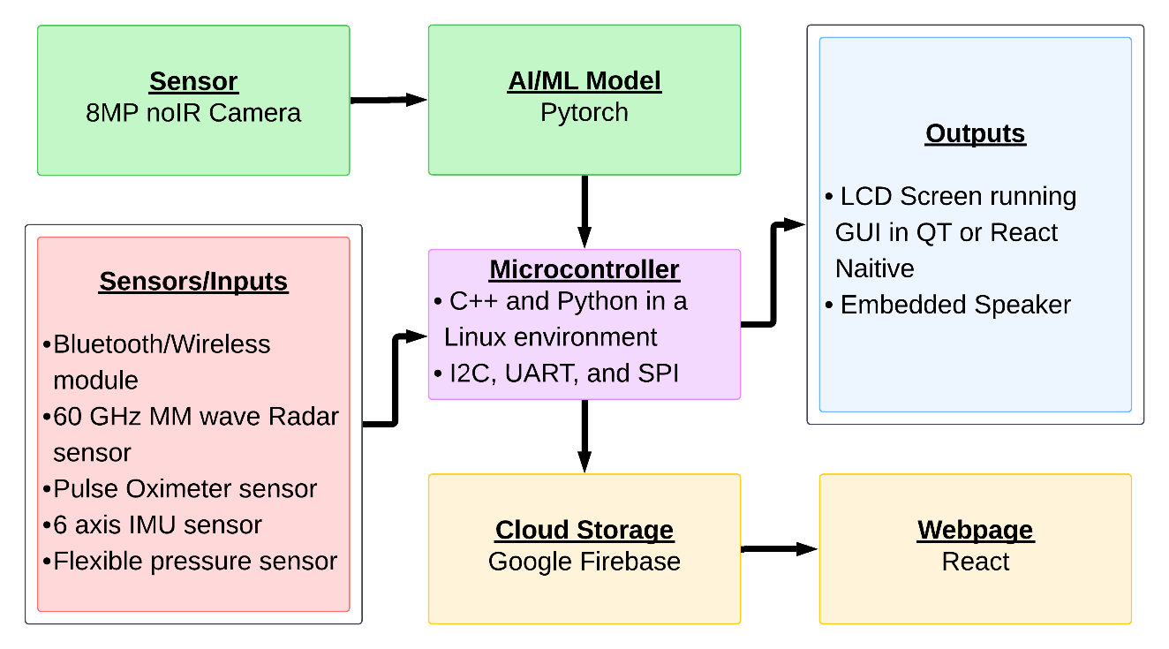Figure 5.2: Software Architecture

The software architecture of the system is designed to help with interaction between sensors, AI processing, cloud storage, and user interfaces. As illustrated in the provided software architecture diagram, the system consists of multiple components working together.

## Front-End (Graphical User Interface)

* ***The Website:***

**Figure 5.3:** Login page. Entering an email/username and password, then clicking “Sign In” will sign the user into their account if the provided information is correct. Clicking “Forgot Password” will take the user to a page to create a new password. Clicking “Sign up now” will take the user to a page to create a new account.

**Figure 5.4:** Forgot password page. The user can enter their email address to receive a link to reset their account password.

**Figure 5.5:** Create account page. The user can create a new account here.

**Figure 5.6:** Connected drivers page. Clicking “Add Driver” will take the user to the “Add New Driver” page. Entering key words into the search will filter profiles based on user input. The dropdown will sort profiles based on a chosen attribute. Clicking the options in the navigation bar will navigate to each respective page. Clicking “Edit Driver” button will take the user to the Edit driver page. Clicking “Remove Driver” will remove the corresponding driver.

**Figure 5.7:** Add new driver page. The user can enter a driver’s personal informatiom. Clicking “Add Driver” will save the driver profile to the database and display its corresponding card on the dashboard.

**Figure 5.8:** Edit driver page. The driver’s preexisting details populate the input fields, and the user can make edit to these fields, which will save after clicking “Save Changes.”

**Figure 5.9:** View driver card page. This shows the current status information of the driver, along with a list of event logs and their recorded details.

**Figure 5.10:** Edit account page. The user can make changes to their own account details.

**Figure 5.11:** Contact us page. The user can submit a form to the team, which will send an email containing the information and message provided in the input fields. A confirmation email will be sent to the address confirming the receival of the message.

* ***MOCK UI FOR THE SMALL EMBEDDED SCREEN:***

The user interface for the small, embedded screen was developed using **React.js** and deployed with **Electron.js**, ensuring compatibility with the **ARM64 architecture** of the **NVIDIA Jetson Nano**. This setup enables a responsive GUI and a streamlined deployment process on embedded Linux systems using a unified codebase.

The interface displays the driver’s real-time status: **Normal**, **Drowsy**, or **Critical,** based on local sensor input and AI model predictions. To minimize distraction, alerts are full-screen and dismissible by tapping anywhere on the screen. In **Critical** cases, a one-tap emergency contact option is available.

We are currently integrating **Firebase**, **API endpoints**, and **real-time model data** to enable cloud-connected functionality in future releases.

**Status Levels:**

* **Normal** – Driver is alert, no signs of fatigue.
* **Drowsy** – Early signs of tiredness detected, soft alert shown.
* **Critical** – Severe or sustained drowsiness, emergency option enabled.

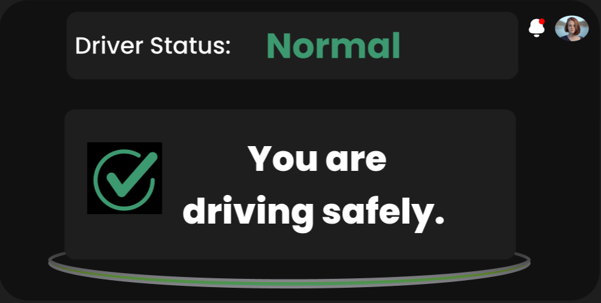

**Figure 5.12:** Display screen during normal status. Tapping the screen will dismiss the message.

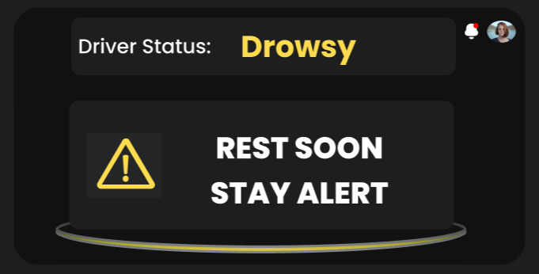

**Figure 5.13:** Display screen during drowsy status. Tapping the screen will dismiss the message.

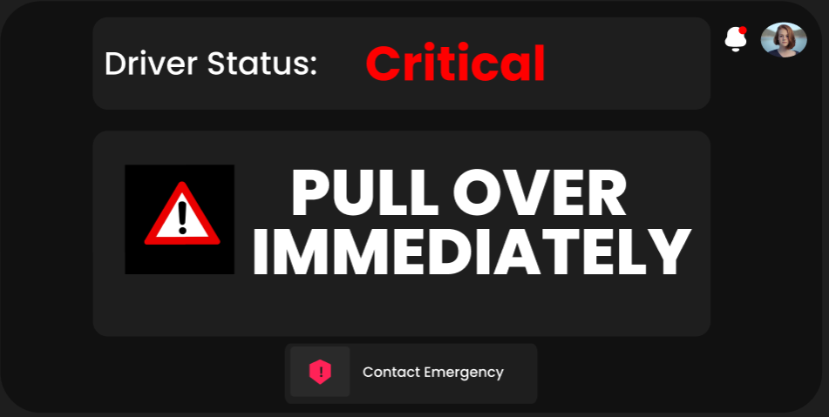

**Figure 5.14:** Display screen during critical status. Clicking “Contact Emergency” will dial 911.

## Back-End

* ***Cloud Integration- Firebase:***

For DriveSenseTM, we utilize Firebase as our backend service due to its scalability, real-time capabilities, and seamless integration with mobile and embedded applications. Firebase also provides a NoSQL cloud database (Firestore) that efficiently manages and synchronizes data across multiple devices in real-time. The system’s embedded hardware is powered by a Jetson Nano, which processes sensor data locally before transmitting relevant information to Firebase Firestore. We decided to store short video clips along with logs containing relevant sensor data to display on our Web UI in events when we detect drowsiness.  
  
We opted to go with Firebase’s Firestore and Firebase Cloud Storage instead of other databases for the reasons as follows:

1. Firebase Cloud storage is optimized for handling multimedia files, which makes it the ideal choice for storing short video clips that were captured during the drowsiness detection event. The logs consist of sensor data (such as heart rate, ppg, speed, mmWave radar data) are stored in Firestore, allowing for structured retrieval and analysis of the data.
2. Firebase provides out of the box solutions that allow direct communication from the Jetson Nano, which helps simplify the process of uploads and retrievals. Any other alternatives such as AWS or DynamoDB would require additional setup and IAM configurations, increasing the development overhead.
3. Firestore ensures that event logs and metadata are updated instantly across devices. This real-time capability is crucial as it allows for immediate updates to occur on our web UI, notifying the user immediately after the event.
4. Firebase automatically scales based on usage, ensuring reliable performance even with large video storage needs. Additionally, Firebase Authentication enables secure access to stored logs and video files.
5. Firebase comes with built-in authentication services (e.g., Firebase Auth), allowing secure access control without requiring a custom authentication implementation.

The Jetson Nano continuously monitors driver behavior using onboard sensors and machine learning models. When drowsiness is detected the following sequence of events in relation to the database and the system carry out:

1. Sensor data (heart rate, PPG, mmWave radar data, speed) along with camera input is processed by Jetson using onboard AI models, and if drowsiness is detected a short video clip recording begins. This recording will continue for up to one minute. All sensor data during period is saved locally initially in a JSON file format (log rotation and auto-detection policies will be set in place to prevent excessive storage consumption).
2. This locally saved data is then transmitted to the cloud after the one-minute period has elapsed. The sensor data is sent to Firebase Firestore via a Firebase REST API that will be developed by us.
3. The driver dashboard on our website will be automatically updated, each driver's status is updated and any data related to their events is available to view.
4. Firebase cloud functions will be used in addition to manual API updated to our web dashboard, we will trigger alerts and send notifications automatically to the emergency contact registered depending on the severity of the driver's data.

Our team has prior experience using Firebase in past courses (SEG 2105), making it an ideal choice for DriveSenseTM. This familiarity allows us to efficiently develop and optimize the backend infrastructure of our software without a steep learning curve. Also, Firebase has a very large developer community with extensive documentation, making troubleshooting and feature development manageable compared to other cloud service options.

* ***AI Model:***

As part of the backend processing for DriveSenseTM, we developed and integrated an AI-powered drowsiness detection system. This model is responsible for analyzing live facial video input and determining the driver's state in real-time: Normal, Drowsy, or Critical. The system combines the output of two specialized sub-models to make this classification: an Eye Detection Model and a Yawning Detection Model.

* The Eye Detection Model: uses facial landmarks extracted via the DLIB library to calculate the Eye Aspect Ratio (EAR). Based on this metric, it determines whether the driver's eyes are open or closed. This model relies on a pre-trained shape predictor trained on the 300-W dataset and does not require retraining for deployment.

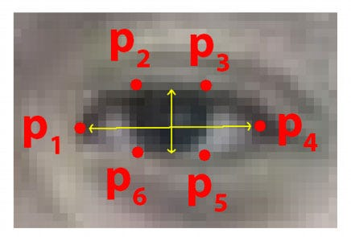

Figure 5.15: DLIB eye anchors/landmarks

* The Yawning Detection Model: is a Convolutional Neural Network (CNN) trained on a Kaggle-sourced dataset. It classifies images into two categories: yawning and not yawning. The model architecture includes multiple convolutional and fully connected layers, optimized using the Adam optimizer and Binary Cross-Entropy Loss. It was trained for 75 epochs, achieving high accuracy while showing some signs of overfitting during the later stages.

These two models are stacked into a meta-model, which takes the outputs of both the eye and yawn detectors to compute the overall drowsiness status. The final classification is then passed to the UI for appropriate action: displaying alerts, enabling emergency contact functionality, and logging events.

Currently, the model runs locally on the Jetson Nano as a backend service, processing sensor and camera input in real time. Future iterations will include integration with Firebase and REST APIs to enable full synchronization between the model outputs, the database, and both the embedded and web-based user interfaces.

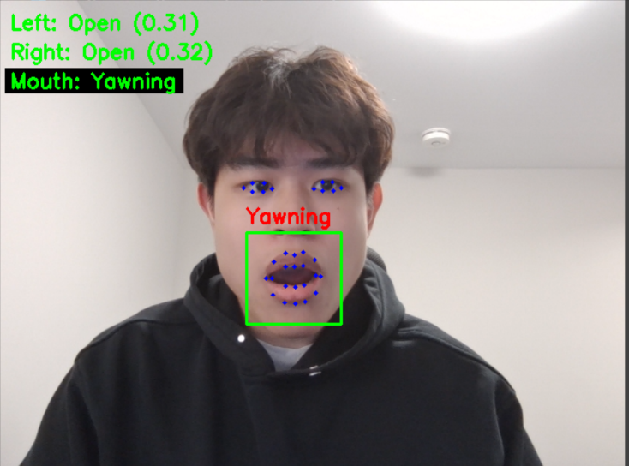

|  |
| --- |
| Figure 5.16: Model identifying Yawning |

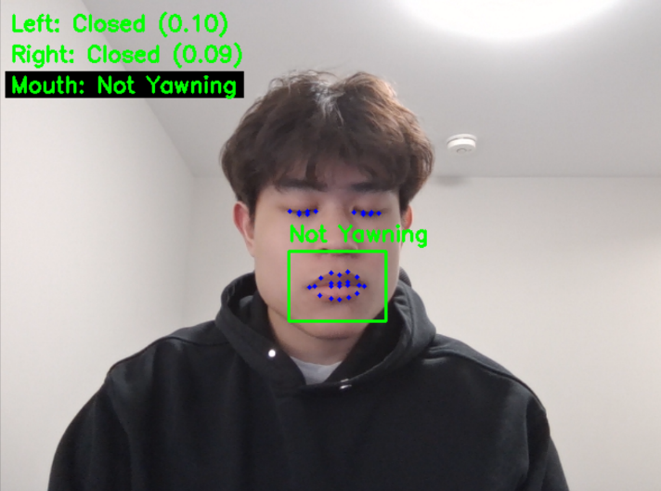

#### Figure 5.17: Model identifying closed eyes

# Hardware Design

Our project is using many different hardware components, with the most important being the SBC (Nvidia Jetson Orin Nano), Camera, and integrated touchscreen. There is a conglomeration of sensors that interface with the SBC and provide data that is to be used on top of the data extracted from the camera system. This entire system works locally/autonomously and connects to the internet to allow remote management

## Hardware Components and Specifications

|  |  |  |
| --- | --- | --- |
| **Component** | **Specifications** | **Reasons to select this component** |
| **Nvidia Jetson Orin Nano Super Developer Kit** | CPU: 6-core ARM Cortex-A78AE 64-bit, GPU: 1024-core NVIDIA Ampere, Storage: microSD (Expandable), RAM: 8GB LPDDR5, Interfaces: 2x USB 3.2, 1x HDMI, 1x M.2 Key M, 1x M.2 Key E, Camera: 2x MIPI CSI-2. | * Run images through model quickly * Push data to cloud without compromising system performance * Has CUDA acceleration and dedicated GPU cores for our workload |
| **PI NOIR CAMERA V2 IMX219 8MP** | Resolution: 8MP (3280 × 2464), Sensor: Sony IMX219, Interface: MIPI CSI-2, Features: No IR filter for night vision. | * 8MP because the subject is within 1m * No IR to capture images in any lighting conditions * Manufacturer and Community supported |
| **4.3-inch HDMI LCD 800x480 IPS Capacitive Touch Screen** | Resolution: 800 × 480, Display Type: IPS LCD, Touch: Capacitive, Interface: HDMI + USB (for touch), Power: 5V. | * Small screen that isn't intrusive when driving * Touch for easy interaction (dismissing alerts) * Compatible with Jetson over DisplayPort (manufacturer supported) |
| **HD Speakers** | Wattage: 3W, Low-level signal. | * Easy to play tunes using any softare * Allows for modularity in sound selection, potentially even custom alarms |
| **GY-521 MPU-6050 3-Axis Accelerometer and Gyroscope** | Sensor: MPU-6050, Interface: I2C, Axes: 3-Axis Accelerometer + 3-Axis Gyroscope, Voltage: 3.3V-5V. | * To collect vehicle metrics to determine the state of the car and driver * Industry-standard and highly compatible six-axis IMU providing all position vectors needed to find out information about the driver |
| **Thin Film Pressure Sensor Flex Bend Sensor SF15 600 10kg** | Type: Thin Film Pressure Sensor, Range: Up to 10kg, Interface: Analog. | * Used to measure pressure applied to steering wheel as a metric for determining drowsiness * Thin and flat, able to fit on steering wheel without impeding driver |
| **Digital ADC Module 16-Bit ADS1115 I2C 4-Channel ADC** | Resolution: 16-bit, Channels: 4, Interface: I2C, Voltage: 2V - 5.5V. | * Interface between pressure sensor and Jetson because Jetson doesn’t have an onboard ADC * Highly configurable chip |
| **Heart Rate Sensor Module MAX30102** | Measures: Heart Rate, SpO2 (Blood Oxygen), Interface: I2C, Voltage: 1.8V - 3.3V. | * Used to measure heart rate of driver as a metric for determining drowsiness * Small and compact, allowing easy integration without impeding driver and other components |
| **Infineon BGT60TR13C 60 GHz mmWave Sensor** | Frequency: 60 GHz, Range: Up to several meters, Resolution: High-precision motion and vital sign detection, Interface: SPI, Power: Low-power operation. | * Tracks human vitals (heart rate, respiration) without contact * Works in any lighting condition * Detects through obstructions (e.g., clothing, blankets) |
| **AW-CB375NF Dual-Band Wireless NIC** | Wi-Fi: IEEE 802.11a/b/g/n/ac, Dual-Band 2.4GHz (up to 300Mbps) and 5GHz (up to 867Mbps), Interface: NGFF (M.2 A/E Key).  Bluetooth: Version 5.0, Supports BLE, Voltage: 3.5V. | * Provides high-speed wireless connectivity and Bluetooth support for devices with an M.2 A/E Key slot. |

## Hardware Block Diagram

Block diagram showing connections between components and direction of data flow.

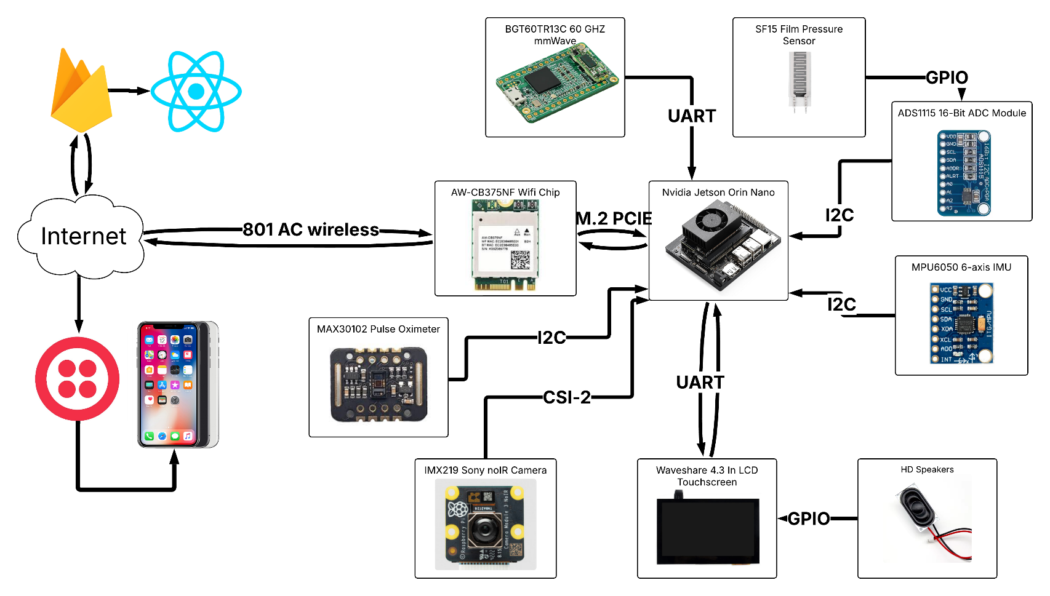

**Figure 6.1:** Array of components with labelled connections and data flow

# Testing

Put here tables of tests to perform such that the project can be tested by people outside your Project Group. You may list the tests in one column and the results in another column.

|  |  |
| --- | --- |
| **Test** | **Result** |
| Create an account | On the website, user clicks “create an account” button, after which they will be directed to a new page that prompts their name, email, password and phone number. If the email is not already taken, the account will be created. Otherwise, the user is prompted to use a different email address. |
| Log in | On the website, the user enters their email address and password associated with their account and clicks “log in”. If the information correctly corresponds to an account, they are signed in and can proceed to the next page. |
| Reset password | On the website, the user clicks “Forgot password,” which takes them to the corresponding page. The user then enters their email address in the input field, after which an email is sent to them with a link to reset their password. |
| Create an account | On the website, the user clicks “Create an account” which takes them to the create account page. After entering their account details in the input fields, they click “Submit.” A pop-up confirms that the details were saved and that the account was created, and they are taken back to the login page. |
| Add driver profile | On the website, user clicks “add driver,” which takes them to the new driver page. After entering the driver’s details, the user clicks “Submit,” which creates a new driver with the saved details. |
| Edit driver profile | On the website, user clicks “edit driver” and is taken to a new page where they can edit the details of the chosen driver. |
| Delete driver profile | On the website, user clicks “delete driver” and the respective driver profile is deleted. |
| View driver profile | On the website, the user clicks a driver card, which takes them to a status page of the driver. The page shows the status of the driver, as well as an event log involving the driver. |
| Contact the team | On the website, the user clicks “Contact Us” in the navbar, which takes them to the contact page. After entering their name, email address, and desired message and clicking “Submit,” the user receives a confirmation email informing them that their message was received. |
| Edit account | On the website, user clicks “my account,” which takes them to the account page. The user then edits account information and clicks “save” to save the changes. |
| Sign out | On the website, the user clicks “Sign Out” in the navbar. They are taken back to the login page. |
| Sort driver profile cards | On the website dashboard, the user can change the order in which driver profile cards are displayed by selecting different options from the dropdown menu. |
| Filter driver profile cards | On the website dashboard, the user can filter out driver cards by entering into the search bar. Only drivers with names relevant to the search input will populate the dashboard. |
| Warning dismissal | On the touchscreen display, the user clicks a warning message to dismiss it. |
| Speaker sound | Speaker produces sound. |
| Camera | Camera records and gives video feedback, identifies human face and eyes. |
| IMU sensor | Records and displays positional information on all 6 axes (Acceleration and gyroscopic data on X, Y, and Z axes). |
| Pressure sensor | The pressure of holding the sensor with either your palm or an individual finger has a different reading. Pressing the sensor with a finger results in a far smaller analog-to-digital converted value in comparison to applying pressure with your palm. |
| AI model | The AI model consists of a yawning detection model and an eye open and close model. The yawning model can successfully identify when someone is yawning. Even if someone is talking or laughing it does not pick up any false positives. The position of the camera affects the results, and the model will be tuned to increase this accuracy. |
| Firebase Realtime Database | Sensor readings can be uploaded, fetched, updated and removed from the database using REST APIs. |

## Software

### Verification

Comparison of requirements listed at the beginning of the project with the currently implemented requirements.

|  |  |  |
| --- | --- | --- |
| **Software Requirement** | **Description** | **Implementation** |
| User authentication | The user inputs username and password, system verifies. | Partially implemented. |
| Machine Learning Model | The system should detect when drowsiness occurs. | Partially Implemented. |
| Management of user profiles | The user can add, delete, and edit driver profiles. | Fully implemented. |
| Display interface | The system provides visual warnings when drowsiness is detected. The user can dismiss warnings when they occur. | Partially implemented. |
| Events log | The system populates a list of events recorded by the sensors in the order that they occurred, along with their timestamps. | Partially implemented. |
| Account management | The user edits details of their account. | Partially implemented. |

Table 3: Software Requirements Verification

### Validation

Detailed testing to ensure how well the software components are functioning.

|  |  |  |  |
| --- | --- | --- | --- |
| **Software Requirement** | **Description** | **Test** | **Result** |
| User authentication | The user inputs username and password, system verifies. | Try valid and nonvalid username/password combinations. | System correctly verifies valid username/password combinations. |
| Machine Learning Model | The system detects objects with 95% accuracy. | Present face in front of camera, while changing facial expressions (blinking, yawning, closing eyes). | Model can accurately identify eyes and mouth on face. Model can identify when mouth and/or eyes are closed. The model can predict whether someone is yawning or not, and if their eyes are closed or open. We will use these results in the next term of capstone to create an algorithm to determine when someone is drowsy. |
| Management of user profiles | The user can add/edit/delete driver profiles. | Try clicking the buttons for adding, deleting and editing profiles. Try editing information belonging to a specific user. | Profiles are added and deleted when their respective buttons are pressed. |
| Display interface | The system gives visual warning when prompted, and the user can dismiss it. | Prompt system to give warning, click the warning to dismiss it. | Results have yet to be produced. |
| Events log | The system populates a list of events recorded in chronological order. | Stimulate events to be recorded by the system. | Events are added in chronological order with their respective information and video of the event. |
| Edit account | The user edits details of their account. | Edit account information and save changes. | Account details are modified after saving changes. |
| Password reset | The user receives a link to reset password. | Click “Forgot password” and enter email address, then click “Submit.” | An email is sent to the user’s email address with a link. |
| Contact organization | The user sends a message to the team. | Click “Contact Us,” enter name, email address and message, and click “Submit.” | An email is sent to the user confirming that their message was sent. |
| Sign out | The user signs out of their account. | Click “Sign Out.” | The user is taken back to the login page. |
| Sort driver profile cards | The user sorts the driver profile cards by certain criteria. | Select options from the dropdown menu. | The driver profile cards are arranged in order according to the option selected in the dropdown. |
| Filter driver profile cards | The user filters out driver profile cards by name. | Type into the search bar. | Only drivers with names related to the search input will populate the dashboard. |
| Firebase Realtime database | The database stores sensor readings, drivers, and event logs. | Upload dummy data, fetch it, edit it, fetch again and then delete and try to fetch again. | The REST APIs for the database can successfully upload, edit and remove different types of data like sensor readings. |

Table 4: Software Validation Tests & Results

## Hardware Testing

Making sure all hardware components are functioning as required. How well you met the requirements promised at the beginning of the project.

E.g. you claimed you can detect objects at 30 meters, do you actually? Is the range still 30 meters, or is it 25?

|  |  |  |
| --- | --- | --- |
| **Hardware Component** | **Test** | **Result** |
| mmWave sensor | Able to detect breathing rate when positioned in front of user. | Results have yet to be produced. |
| Camera | Capture 1280x720 images at 30 fps, able to record IR light enabling low light recording. | Using OpenCV, camera successfully records frames at specification and records IR light. |
| IMU sensor | Testing positional data by moving the sensor to different locations and orientations. | Successfully tested reading values using acceleration due to gravity, all 6 axes (Gyroscope and acceleration in x ,y ,and z plane) are correct |
| Speaker | Play Sound clips | Successfully played sounds, and we were able to play both high an low pitch tones to ensure that the audio alerts to the driver are alerting. |
| Pressure sensor and ADC | Apply pressure using a person’s hands. | Results indicate that the analog measurement is in the range of the ADC (Analog-to-Digital converter) when the sensor is pressed with a finger versus a person's palm. The measurement is on the lower range of the ADC when pressed with the finger, whereas, when pressed with the palm the value is on the higher end of the ADC range. |
| Heart rate sensor | Measure heart rate, pulse, blood oxygen levels, and breathing rate. | Results matched closely with the Apple Watch built-in heartbeat sensor with a small margin of error. |

Table 5: Hardware Tests & Results

# Project Management

## Protocols and Procedures

**1 - Development Protocols**

* **Object-Oriented Programming (OOP) Standards:**
  + Driver code must follow OOP principles, including encapsulation, inheritance, and polymorphism, to enhance modularity and maintainability.
  + Each class should serve a distinct function, with clear separation between hardware control, data processing, and logging.
* **Branching and Version Control Protocol:**
  + The team will use Git with a structured branching strategy (e.g., main, develop, feature, bugfix branches).
  + All feature development must occur in separate branches and follow a merge request (MR) template before merging.
  + Code reviews will be mandatory before merging into the develop branch to ensure quality.
* **Conflict Resolution Protocol:**
  + Developers must pull the latest changes before making modifications.
  + In case of conflicts, developers must attempt resolution locally and document the changes.
  + If unresolved, a peer review session or an in-person meeting will be scheduled to resolve the issue collaboratively.
* **Continuous Integration / Continuous Deployment (CI/CD) Protocol:**
  + All commits will trigger automated unit tests and linting checks in a CI/CD pipeline before code integration.
  + Builds must pass all predefined tests before merging to the main branch.
  + Any failed pipeline must be addressed before proceeding with further development.
* **Documentation Protocol:**
  + All code must be documented following docstring standards (e.g., Doxygen for C++ or Sphinx for Python).
  + Each module should include a README file detailing its purpose, dependencies, and usage.
  + Major design decisions should be logged in the project documentation repository for future reference.

**2 - Development Procedures**

1. Driver Code Development Procedure
   1. Who: All developers
   2. What: Implementing and testing driver code while adhering to OOP principles
   3. Where: Development will take place in the repository (feature branches) and tested on local machines or Raspberry Pi setups
   4. When: During the development phase before integration with the main system
   5. Why: To ensure a structured, maintainable, and modular codebase
2. Code Review and Merge Procedure
3. Who: Developers and reviewers (designated team members)
4. What: Conducting peer reviews before merging code into develop
5. Where: Code reviews will occur through GitHub/GitLab pull requests
6. When: Before any major merge into develop or main
7. Why: To maintain code quality, prevent bugs, and ensure adherence to OOP and security standards
8. CI/CD Enforcement Procedure
   1. Who: All developers
   2. What: Ensuring the CI/CD pipeline successfully validates each commit
   3. Where: GitHub Actions/GitLab CI/CD or an equivalent automation tool
   4. When: Every time a new feature branch is pushed or a pull request is created
   5. Why: To prevent integration issues and ensure a stable development environment
9. Conflict Resolution Procedure
10. Who: Developers involved in the conflicting code
11. What: Identifying, resolving, and documenting code conflicts
12. Where: Resolved locally, with discussions in team meetings if necessary
13. When: When a merge conflict occurs
14. Why: To ensure a smooth integration process and avoid loss of work
15. In-Person Meeting Procedure
16. Who: All team members
17. What: Discussing project progress, blockers, and major design decisions
18. Where: STEM building (makerspace) or designated team workspace
19. When: Weekly or as needed when major issues arise
20. Why: To ensure alignment among team members and resolve issues efficiently
21. Hardware Damage Reporting Procedure
22. Who: Any team member who identifies an issue
23. What: Reporting, diagnosing, and replacing damaged hardware components
24. Where: Issues logged in a shared hardware status document, replacement handled in the makerspace
25. When: Immediately upon detecting hardware malfunction
26. Why: To prevent delays in development and testing due to faulty components

## Tasks and Timelines

|  |  |  |
| --- | --- | --- |
| **Date** | **Milestone** | **Deliverable** |
| 1/17/25 |  | Project proposal |
| 1/22/25 | EEF form submitted |  |
| 1/28/25 | Requirements and constraints identified |  |
| 1/29/25 | Software UI Mockups created |  |
| 1/29/25 | Parts picked and ordered |  |
| 2/5/25 | Hardware architecture designed |  |
| 2/7/25 |  | SCRUM and Sprint checkpoint Alpha |
| 2/9/25 | Login page created, add/delete drivers function implemented |  |
| 2/9/25 | Sensors and camera initial implementation complete |  |
| 2/10/25 | Screen and Nano CAD design files made and printed |  |
| 2/11/25 |  | Mid-term presentation and demonstration – Term 1 |
| 2/24/2025 |  | Mid-term progress report – Term 1 |
| 3/24/2025 | ML model made functional |  |
| 3/30/2025 | All website pages implemented |  |
| 3/30/2025 | Firebase Realtime database implemented |  |
| 4/1/2025 |  | Final Presentation and demonstration – Term 1 |
| 4/14/2025 |  | Final Progress Report – Term 1 |

Table 3: Dates and Milestones

**Figure 8.1:** Gantt chart for term 1.

**Figure 8.2:** Gantt chart for term 2.

## Work Force

|  |  |
| --- | --- |
| **Completed Tasks** | **Members** |
| Project Proposal | All members |
| Agile management (Jira) | Keith, Abdullah, Saurav |
| Work Breakdown Structure | Saurav |
| Gantt Chart | Keith |
| AI model and dataset research | Aaditya, Kevin, Saurav, Keith |
| Selecting hardware components | Aaditya, Keith |
| Ordering hardware components | Aaditya |
| EEF form | Aaditya, Keith |
| Website development | Kevin, Keith |
| Display UI development | Hajer |
| Hardware CAD | Abdullah |
| Hardware programming | Aaditya |
| Hardware architecture | Aaditya |
| Software UML design | Abdullah |
| Progress Report | All members |
| Presentation slideshow | Hajer |
| Hardware assembly | Aaditya, Abdullah |
| Database development | Saurav |

## Work Breakdown Structure

**Figure 8.3:** Current Work Breakdown Structure

## Jira Board

**Figure 8.4:** Jira Board for Sprint 9

## Risk Management Plan

|  |  |  |  |  |  |  |
| --- | --- | --- | --- | --- | --- | --- |
| Risk | Prob | Impact | Type | Mitigation/Solution | Priority | Responsibility |
| System overheats | Medium | High | Internal | Always keep the stress on the system to a minimum. Ensure that cooling fans Implement a temperature cutoff point in which an emergency shut off is triggered. | High | Aaditya |
| Absence of a team member | Medium | Low | Internal | Ensure that work is equally divided among members, temporarily redistribute responsibilities temporarily | Medium | Team leader |
| Jetson Nano stops working | Low | High | Internal | Keep a backup, order a new one | High | Aaditya |
| Merge conflict on Git | Medium | Low | Internal | Use the in-built git extension in VS code to help resolve merge conflicts. Also, ensure to pull changes from GitHub prior to pushing. | Low | Software team |
| Jira stops working | Low | Low | External | Use alternative applications, use other methods for management (e.g. calendar reminders) | Low | Keith |
| Jetson OS issues from installing packages | Medium | High | Internal | Use a virtual environment space to install and manage all packages | Medium | Aaditya |
| Twilio stops providing API SMS messaging service | Low | High | External | Use another service that offers SMS messaging with an API | High | Aaditya |
| Sensors or power supply shorts out | Low | High | Internal | Run a voltmeter through components and identify failures. Ensure components are properly grounded. | High | Aaditya |
| The Jetson cannot save data locally prior to pushing to database. | High | High | Internal | Use an external memory device to temporarily save data, and when resources are available save to cloud. | High | Saurav |
| Image quality degrades through processing | Medium | High | Internal | Minimize compression and test rescaling and resizing images to be processed by our model. Standardize image resolutions being used to send to the model. | Low | Saurav |
| Camera model face detection issues in the dark | Medium | High | Internal | Find different models for the face detection library and test them | Medium | Abdullah |
| Delays in emergency alert notifications | Medium | High | Internal | Optimize network requests and implement priority queuing for emergency alerts. | High | Hajer |
| Inaccurate detection due to poor sensor calibration | Medium | High | Internal | Continuously refine the detection model, apply real-world calibration tests, and adjust threshold values based on feedback. | High | Hardware Team |
| Data loss due to unexpected shutdown | Low | High | Internal | Implement periodic auto-saving of data to Firebase or local storage and introduce failover mechanisms. | Medium | Backend Team |
| Inclement weather on day of meeting or presentation | Low | Medium | External | Reschedule event, communicate remotely online | Low | Team Leader |

# Future Works & Closing Remarks

The DriveSenseTM project emphasizes reliability and safety, warning drivers of potential drowsiness and providing real-time remote monitoring by a third party. However, many adjustments and additions can be implemented to further increase user safety and ease of access. The following are some possible improvements to the base project that can be implemented in the future.

* **Enhanced power dissipation:** a decrease in power dissipation can increase the efficiency of the device, as well as improving system reliability by decreasing the chance of overheating or power failure
* **Voice activation and control**: device control via voice commands will improve accessibility. It also increases the safety of the system, as a lone driver need not divert their attention to interact with the system
* **Web monitoring on other platforms**: porting the web application to other platforms such as mobile will increase system accessibility, allowing users to monitor the device outside the home via their mobile phone
* **OBD port compatibility**: allowing the system to connect to the OBD port will increase its adaptability, allowing it to be fitted into a greater range of vehicles.

# APPENDIX A: PROJECT CODE

The source code for the website can be accessed [here](https://github.com/LockedIn-LTD/Cookies-n-cream).

The source code for the display UI can be accessed [here](https://github.com/LockedIn-LTD/Pistachio).

The source code for the hardware components can be accessed [here](https://github.com/LockedIn-LTD/Maple-walnut).

The source code for the ML model can be accessed [here](https://github.com/LockedIn-LTD/Green-Tea).

# APPENDIX B: PROJECT DIARIES