DriveSenseTM Midterm Project Report

Document Version: 1.0

Author: Keith Tran
Author E-Mail: ktran033@uottawa.ca
Author Department: Engineering
Author Division: University of Ottawa

www.eecs.uottawa.ca
2023F

Document Control Information

Document Approval

Name | Responsibility | E-Mail | Date
Saurav Guduru | Scrum Master | sgudu104@uottawa.ca
Keith Tran | Technical Representative | Ktran033@uottawa.ca
Abdullah Ramadan | Internal Project Manager | Arama014@uottawa.ca
Kevin Dang | Security Representative | kdang038@uottawa.ca
Hajer Fguir | Customer/Vendor Project Manager | hfgui039@uottawa.ca
Aaditya Shah | CEO | Ashah203@uottawa.ca

Change History

Version | Date | E-Mail | Flag | Change Description
1.0 | 02/13/2025 | Ktran033@uottawa.ca | INIT | Version 1.0 - Original Document
1.1 | 02/13/2025 | Ktran033@uottawa.ca | CHG | E.g. Changed names of section 3.3 and 5.2 added Table 1, Table 2, Table 3, and Table 4.
1.2 | 2/20/2025 | Arama014@uottawa.ca | CHG | Added in sections 3.5, 3.8, 4.4, 6.1. Filled in contact emails.

Contents
1 Document Control Information 2
1.1 Document Approval 2
1.2 Change History 2
3 Introduction 4
3.1 Project Description 4
3.2 Goals, Objectives & Scope 4
3.3 Assumptions, Constraints & Risks 4
3.4 Project Deliverables 4
3.5 Schedule & Budget Summary 4
3.6 Acronyms, Terms and Definitions 4
3.7 References 5
3.8 Limitations, Issues and Concerns 5
3.9 Change of information 5
3.10 Confidential Information 5
3.11 Third Party Confidentiality Restriction 5
4 Roles & Responsibilities 6
4.1 Objective 6
4.2 Project Stages 6
4.3 Clients 6
4.4 Participants 6
4.5 Market Space and Industry Sector 6
5 Requirements 6
5.1 Functional Requirements 6
5.2 Non-Functional Requirements 6
5.3 Constraints 6
6 Software Architecture 6
6.1 High Level Design: Architectural Views 6
6.2 Front-End (Graphical User Interface) 7
6.3 Back-End 7
7 Hardware Design 7
7.1 Hardware Components 7
7.2 Hardware Specifications 7
7.3 Hardware Block Diagram 7
8 Testing 7
8.1 Software 7
8.1.1 Verification 7
8.1.2 Validation 8
8.2 Hardware Testing 8
9 Project Management 9
9.1 Protocols and Procedures 9
9.2 Dates, Milestones & Deliverables 9
9.2.1 Presentations 9
9.2.2 Project Report 9
9.2.3 Demonstration of the Features of the Prototype. 9
9.3 Tasks and Timelines 9
9.4 Work Force 9
9.5 Work Breakdown Structure 10
9.6 Trello Board 10
9.7 Risk Management Plan 10
10 Future Works & Closing Remarks 10
11 APPENDIX A: PROJECT CODE 11
12 APPENDIX B: PROJECT DIARIES 11

Introduction

Project Description
This document provides an outline of the architecture and high-level design of DriveSenseTM, a device designed for detection of driver drowsiness, and its components. Specifically, this document describes, in detail, the roles and responsibilities of the parties involved in the project’s development, the functional and non-functional requirements to be achieved by the project, the architecture of both the software and hardware modules, testing procedures, and the management of the project.

Goals, Objectives & Scope
List the goals of the project and divide them into smaller objectives.

The scope of this document is to provide a basis for the design and implementation of the XYZ prototype. This prototype stems from the set of requirements obtained and listed in Section 3.6. 2.1 …
Based on these basic functional characteristics of XYZ as shown in Section 3.6.1 are designed.
These functional characteristics are then mapped onto various user interfaces as shown in Section 3.

High level design notes are listed in some of the sections of this document
aux. In addition to this, this document serves as a stand-in for the GroupiveSE functionality description.

Assumptions, Constraints & Risks

Project Deliverables
The deliverables of the project include the project proposal, this project report, the mid-term and final presentations, a working device with both hardware and software components and a web application.

Schedule & Budget Summary

Acronyms, Terms and Definitions
[Define all the technical terms and abbreviations used in this document and lists them in alphabetical order.]

Terms, acronyms, abbreviations | Definitions
Table 1: Table of Definitions, Acronyms and Terms

References
This document contains no references to outside material.

Limitations, Issues and Concerns
Some limitations, issues, or concerns that have been or are anticipated to be experienced are:
- Availability of optimal microcontroller: there was difficulty in finding a microcontroller capable of meeting the requirements of the project while remaining affordable relative to the project’s budget, as well as available on the market. Eventually, the Nvidia Jetson Orin Nano was found, and was obtained after direct contact with a supplier at a price amicable with the project’s budget.

Change of information
The information in this document is for informational purposes and may change at the sole discretion of CEG4912-13 without notice.

Confidential Information
This documentation contains confidential regarding DriveSenseTM design specification information and is purely intended for ___ and not for release/disclosure in whole or in part to any other party unless agreed upon in writing by CEG4912-13, Inc.

Third Party Confidentiality Restriction
There are no third-party confidentiality restrictions concerning the DriveSenseTM project.

Roles & Responsibilities

Objective
The objective of the DriveSenseTM project is to create a device that can be fitted inside a vehicle and detect drowsiness in the driver based on stimuli measured internally to the vehicle, and provide warning or emergency assistance if deemed necessary.

Project Stages
- Initialization: the idea of the project is created, and a project proposal is submitted and approved. Research is conducted to produce clear objectives for the project.
- Design: The design of the project is created and finalized, and the necessary components are identified and requisitioned. Functional and non-functional requirements are identified. Funding for the project is secured.
- Management: roles and responsibilities are identified and assigned to project members.
- Development, testing, and prototyping:

The stages described herein are from the perspective of processes high level processes such as external interactions, internal interactions, approvals, starting-points, checkpoints, end-points. This section provides a high level “road-map” giving the direction of the project.]

Clients
[This section gives a simple listing of the clients being satisfied by this project. Their background information should be given as well as their main interest in this project.]

Participants
[The types of people which will participate in this project should be mentioned along with their involvement in the project. The table below lists such an example.]

Person | Org. | Contact | Role | Contribution | CEG4912-13 Liaison
Keith Tran | LockedIn LTD | Ktran033@uottawa.ca | Logistics agile manager and sensors software developer |  | Ahmed Hassanein, Hamideh Ghanadian, Haseeb Ur Rehman
Saurav Guduru | LockedIn LTD | sgudu104@uottawa.ca | Scrum Master and backend developer |  | Ahmed Hassanein, Hamideh Ghanadian, Haseeb Ur Rehman
Abdullah Ramadan | LockedIn LTD | Arama014@uottawa.ca | CAD designer and software and hardware developer | Designed CAD models for car, sensor, and camera mounts. Helped develop sensors and enclosures. | Ahmed Hassanein, Hamideh Ghanadian, Haseeb Ur Rehman
Kevin Dang | LockedIn LTD | kdang038@uottawa.ca | User interface software designer and developer |  | Ahmed Hassanein, Hamideh Ghanadian, Haseeb Ur Rehman
Hajer Fguir | LockedIn LTD | hfgui039@uottawa.ca | Embedded User interface software designer and developer |  | Ahmed Hassanein, Hamideh Ghanadian, Haseeb Ur Rehman
Aaditya Shah | LockedIn LTD | Ashah203@uottawa.ca | Hardware equipment, sensor and microcontroller hardware and software developer |  | Ahmed Hassanein, Hamideh Ghanadian, Haseeb Ur Rehman
Table 2: Project Participants

Market Space and Industry Sector
[A description of the market space(s) and industry sector(s) served for this project.]

Requirements
[Here a listing will be provided to indicate the type of hardware software and technology sectors involved in this project.]

Functional Requirements

Non-Functional Requirements

Constraints

Software Architecture
[This section lists the expected kind or instance of software encompassed by the end product or services to be delivered by this project.]

High Level Design: Architectural Views
[This subsection describes the architectural views of the Project, use cases, message charts. UML diagrams, Finite State Machines (FSM), flowcharts should be used where appropriate.

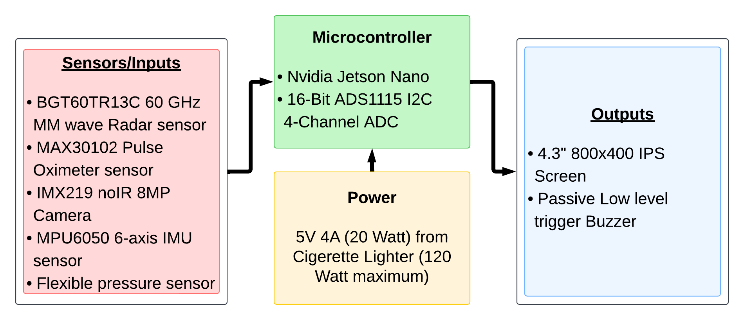Figure 2: Hardware Architecture
The hardware architecture of the system consists of key components that interact to ensure real-time monitoring and response. As shown in the provided hardware architecture diagram, the system is structured into three main sections: Sensors/Inputs, Microcontroller, and Outputs, all powered by the vehicle's cigarette lighter socket.

Front-End (Graphical User Interface)
Screenshots of front-end design and explanation of functionality. (E.g. what happens if you press a button)

Back-End
Any servers, database connections why you chose that specific service and how it connects to the rest of the project.

Hardware Design
[This section lists the expected computer hardware on which the end product or services to be delivered by this project will reside and execute.]

Hardware Components
A survey of the available components in the market and justification for the choice of hardware used in the project.

Hardware Specifications
Detailed list of hardware specifications

Hardware Block Diagram
Block diagram showing connections between components and direction of data flow.

Include a brief description of regular operation procedures (flowcharts may be used)

Testing
Put here tables of tests to perform such that the project can be tested by people outside your Project Group. You may list the tests in one column and the results in another column.

Software

Verification
Comparison of requirements listed at the beginning of the project with the currently implemented requirements. Make sure that all tasks that were promised have been indeed fulfilled. If that is not the case include an explanation of why this specific task was removed, changed or not achieved.

Software Requirement | Description | Implementation
User authentication | User inputs username and password, system verifies | Fully Implemented
Machine Learning Model | System should detect 5 different objects | Only detects 3 out 5 objects
YouTube Plugin | A plugin to allow the use of YouTube within the app | Scheduled for next semester/not going to be implemented
Table 3: Software Requirements Verification

Validation
Detailed testing to ensure how well the software components are functioning.

Software Requirement | Description | Test | Result
User authentication | User inputs username and password, system verifies | Try valid and nonvalid username/password combinations | System correctly verifies valid username/password combinations
Machine Learning Model | System detects objects with 95% accuracy | Hold object in front of camera for detection | Accuracy is 75 %
Table 4: Software Validation Tests & Results

Hardware Testing
Making sure all hardware components are functioning as required. How well you met the requirements promised at the beginning of the project.
E.g. you claimed you can detect objects at 30 meters, do you actually? Is the range still 30 meters, or is it 25?

Hardware Component | Test | Result
Ultrasonic Sensor Range | Hold objects at different distances from the sensor | Ultrasonic successfully detects objects in the range of 4cm to 28cm
Table 5: Hardware Tests & Results

Project Management

Protocols and Procedures
[The protocols and procedures to follow for the execution of this project must be listed here. a protocol is a predefined written procedural method in the design and implementation of experiments. Protocols are written whenever it is desirable to standardize a laboratory method to ensure successful replication of results by others in the same laboratory or by other laboratories.
A procedure is designed to describe who, what, where, when, and why by means of establishing anwork flow in support of the implementation of a "policy".]

Tasks and Timelines
The internal deadlines and milestones of this project must be listed here. These will be calculated by the project manager(s) based on deliverables and deadlines set in the SOW as well as expected completion dates for the deliverables by engineering and development teams.]

[The project deliverables state what the project customer will receive as a result of project completion. The statement of work is built on these deliverables, such as PPT presentations, project report and a working prototype.]

Date | Milestone | Deliverable
Table 3: Dates and Milestones

Include a Gantt Chart for clarification.

Work Force
[Typically this section simply cross references documents, spreadsheets, and project management systems specifically dealing with this aspect of project management. The list of project team members and of the tasks completed by each of the team members, shall be given here ]

Work Breakdown Structure

Trello Board

Risk Management Plan

Future Works & Closing Remarks
Project diaries for each of the members of the team working on Project XYZ

APPENDIX A: PROJECT CODE
[Please, list the well-formatted project source code here] -

APPENDIX B: PROJECT DIARIES

