**RECIPIENT’S PROFILE**

Requestor's Name: Brian Joshua V.. Gania TEL No. / CP # 093463578321

ADDRESS: Gania Residence, purok - 3, Malguit, Paracale, Camarines Norte, 4600

**PROJECT PROFILE**

LOCATION PROJECT/PLANTING SITE: dsfsdfasfdafsda

LAND CLASSIFICATION OF THE PROPERTY: Public

IF PRIVATE (Pls. attach Xerox copy)

Purpose of the Activity: sdfafdsafsdafsda

LOCATION / VICINITY MAP OF PLANTING SITE:

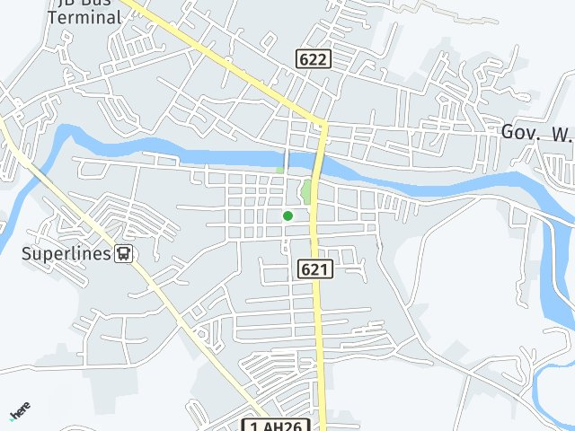

Total Number of Seeds: 213231 Seedling Type: Bagras

**PROMISSORY NOTE**

I am aware that PG-PENRO staff will monitor the growth of the planted seedlings. I will maintain and protect said seedlings to ensure a 150% survival rate. Otherwise, I will pay for the seedlings that do not survive in the amount of THIRTY PESOS (P30.00 each).

Signed this November 27, 2024



Brian Joshua V.. Gania

(Name and Signature of the Requesting Person)

Recommending Approval: APPROVED BY:

LEOPOLDO P. BADIOLA HON. RICARTE R. PADILLA

Prov’l Environmental and Natural Resources Officer Governor