HW1
WP2:
Answer the questions in the comments in pointer.c. For example, why are some of the statements valid and some are not?
1. int main(int argc, char * argv[]) { // What is the type of argv?
答：argv 的类型是 char *[]。在函数参数传递中，它会退化为 char ，即一个“指向字符指针的指针”。
2. printf("char d = %c\n", d); // What does this print?
答：将会打印 char d = 6。
原因：字符串 "6.172" 在内存中作为字符数组存储。指针 pc 指向数组 c 的首地址，也就是字符 '6' 的位置。解引用 *pc 取出了这个字符。
3. pcp = argv; // Why is this assignment valid?
答：pcp 被声明为 char。argv 作为参数传递时其类型退化为 char 。两者类型完全一致，因此赋值是合法的。
4. char const * pcc2 = c; // What is the type of pcc2?
答：pcc2 的类型是“指向常量字符的指针”。它在语义和功能上与上一行的 const char * pcc 完全等价。
5. *pcc = '7'; // invalid?
答：无效。因为 pcc 是 const char *。const 修饰的是指针所指向的数据，这意味着不能通过解引用 pcc 来修改它所指向的内存块的内容。
6. pcc = *pcp; // valid?
答：有效。pcc 本身并不是常量，只是它指向的数据被当作常量对待。因此，你可以改变 pcc 的指向。*pcp 解引用后是一个普通的 char *，将其赋值给 const char * 是合法的。
7. pcc = argv[0]; // valid?
答：有效。argv[0] 的类型是普通的 char *，改变 pcc 的指向是允许的。
8. cp = *pcp; // invalid?
答：无效。cp 的类型是 char * const。此时 const 修饰的是指针变量本身，这意味着 cp 在初始化后，它的内存地址指向就被锁死了，不能再指向其他地方。

9. cp = *argv; // invalid?
答：无效。编译器不允许给常量指针重新分配指向的地址。
10. *cp = '!'; // valid?
答：有效。虽然 cp 的指向不能改变，但它指向的数据类型是普通的 char。因此，可以通过解引用来修改该地址里面存放的内容。
11. cpc = *pcp; // invalid?
答：无效。cpc 的类型是 const char * const。靠近 cpc 的那个 const意味着指针本身是常量，不可重新赋值改变其指向。
12. cpc = argv[0]; // invalid?
回答：无效。不允许改变常量指针的地址指向。
13. *cpc = '@'; // invalid?
答：无效。靠近 char 的那个 const意味着指针所指向的数据也是常量。因此，既不能改变指针的指向，也不能通过解引用修改指针指向的数据。

WP3:
For each of the types in the sizes.c exercise above, print the size of a pointer to that type. Recall that obtaining the address of an array or struct requires the & operator. Provide the output of your program (which should include the sizes of both the actual type and a pointer to it) in the writeup.
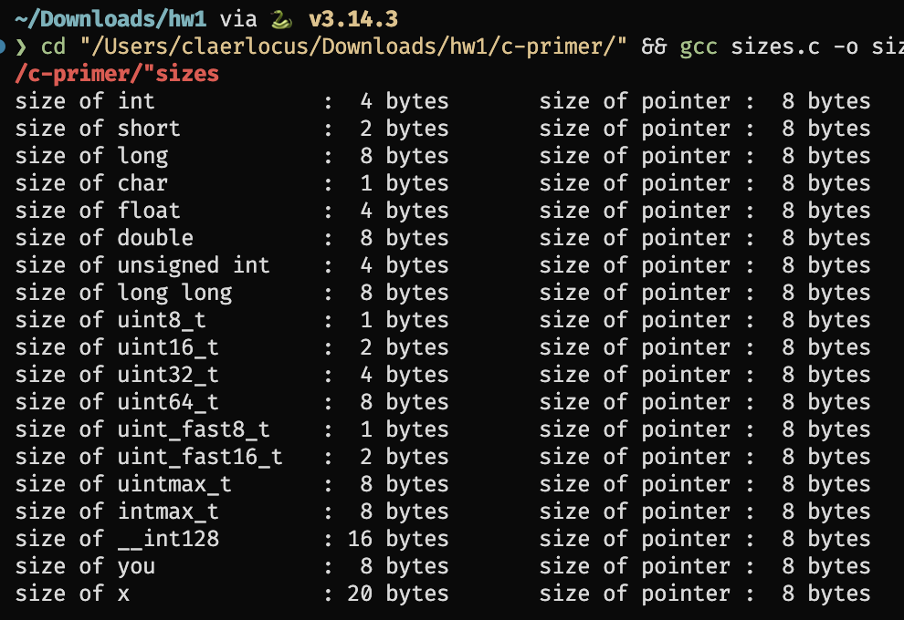
WP4:
File swap.c contains the code to swap two integers. Rewrite the swap() function using pointers and make appropriate changes in main() function so that the values are swapped with a call to swap(). Compile the code with make swap and run the program with ./swap. Provide your edited code in the writeup. Verify that the results of both sizes.c and swap.c are correct by using the python script verifier.py.
修正后的代码（swap和main）：
// 1. 参数改为接收 int 类型的指针
void swap(int *i, int *j) {
int temp = *i; // 解引用获取 i 指向的值存入 temp
*i = *j; // 将 j 指向的值赋给 i 指向的内存
*j = temp; // 将 temp 赋给 j 指向的内存
}
int main() {
int k = 1;
int m = 2;
// 2. 使用 & 运算符获取 k 和 m 的地址并传递给 swap
swap(&k, &m);
printf("k = %d, m = %d\n", k, m);
return 0;
}
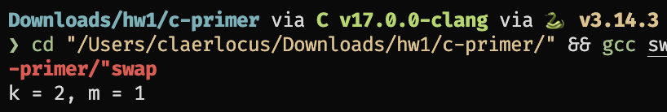
写作业过程中遇到的问题：
由于我是用的是MacOS的Apple clang在底层某些变量的实现上与windows的clang有所不同，如下图uint_fast16_t例子：
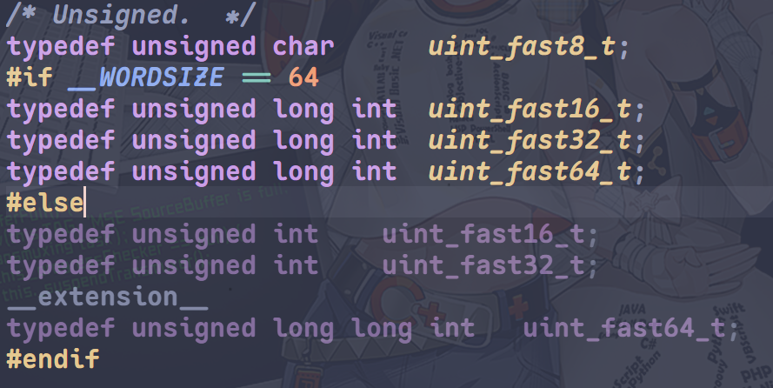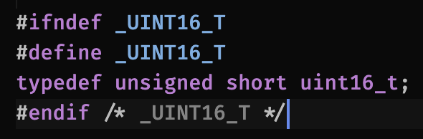
左侧为clang实现，右侧为apple clang实现，可以发现数据类型分别为int和short，我注意到了这个问题，因此修改了测试脚本。
测试结果：
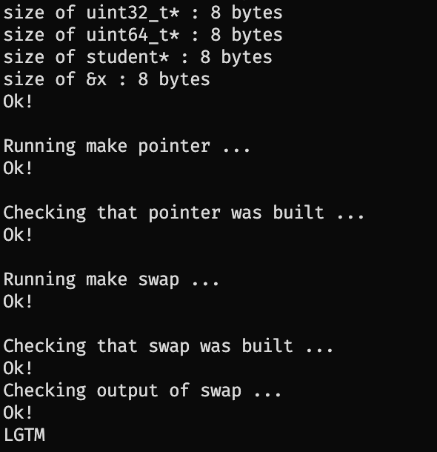
WP5:
Now, what do you see when you type make clean; make?
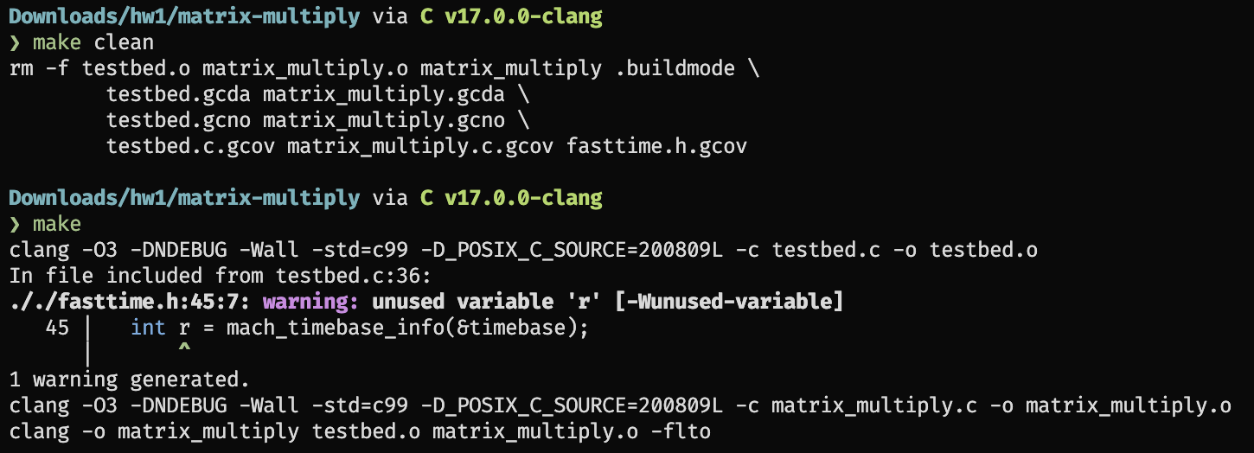
通过输出可以看出，先执行了 make clean 删除了旧的 .o 目标文件和可执行文件。接着执行 make 时，编译器 clang 成功使用了修改后的 -O3 优化标志来重新编译 testbed.c 和 matrix_multiply.c。

WP6:
What output do you see from AddressSanitizer regarding the memory bug? Paste it into your writeup here.
报错：
Setup
Running matrix_multiply_run()...
=================================================================
==8167==ERROR: AddressSanitizer: heap-buffer-overflow on address 0x603000001d10 at pc 0x000102541964 bp 0x00016d8be120 sp 0x00016d8be118
READ of size 8 at 0x603000001d10 thread T0
#0 0x000102541960 in matrix_multiply_run matrix_multiply.c:90
#1 0x000102540f90 in main testbed.c:134
#2 0x00019c7e2b94 (<unknown module>)
0x603000001d10 is located 0 bytes after 32-byte region [0x603000001cf0,0x603000001d10)
allocated by thread T0 here:
#0 0x000102d01330 in malloc+0x78 (libclang_rt.asan_osx_dynamic.dylib:arm64e+0x3d330)
#1 0x00010254134c in make_matrix matrix_multiply.c:46
#2 0x000102540a6c in main testbed.c:96
#3 0x00019c7e2b94 (<unknown module>)
SUMMARY: AddressSanitizer: heap-buffer-overflow matrix_multiply.c:90 in matrix_multiply_run
Shadow bytes around the buggy address:
0x603000001a80: 00 00 00 00 fa fa 00 00 00 00 fa fa 00 00 00 00
0x603000001b00: fa fa 00 00 00 00 fa fa 00 00 00 00 fa fa 00 00
0x603000001b80: 02 fa fa fa 00 00 00 00 fa fa 00 00 00 00 fa fa
0x603000001c00: 00 00 00 00 fa fa 00 00 04 fa fa fa 00 00 04 fa
0x603000001c80: fa fa 00 00 04 fa fa fa 00 00 04 fa fa fa 00 00
=>0x603000001d00: 00 00[fa]fa 00 00 00 00 fa fa fa fa fa fa fa fa
0x603000001d80: fa fa fa fa fa fa fa fa fa fa fa fa fa fa fa fa
0x603000001e00: fa fa fa fa fa fa fa fa fa fa fa fa fa fa fa fa
0x603000001e80: fa fa fa fa fa fa fa fa fa fa fa fa fa fa fa fa
0x603000001f00: fa fa fa fa fa fa fa fa fa fa fa fa fa fa fa fa
0x603000001f80: fa fa fa fa fa fa fa fa fa fa fa fa fa fa fa fa
Shadow byte legend (one shadow byte represents 8 application bytes):
Addressable: 00
Partially addressable: 01 02 03 04 05 06 07
Heap left redzone: fa
Freed heap region: fd
Stack left redzone: f1
Stack mid redzone: f2
Stack right redzone: f3
Stack after return: f5
Stack use after scope: f8
Global redzone: f9
Global init order: f6
Poisoned by user: f7
Container overflow: fc
Array cookie: ac
Intra object redzone: bb
ASan internal: fe
Left alloca redzone: ca
Right alloca redzone: cb
==8167==ABORTING
[1] 8167 abort ./matrix_multiply

WP7:
After you fix your program, run ./matrix_multiply -p. Paste the program output showing that the matrix multiplication is working correctly.
正常程序输出：
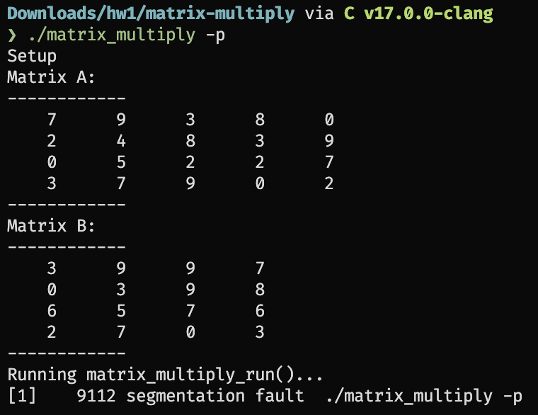

WP8:
Paste the output from Valgrind showing that there is no error in your program.
