Spring Pow 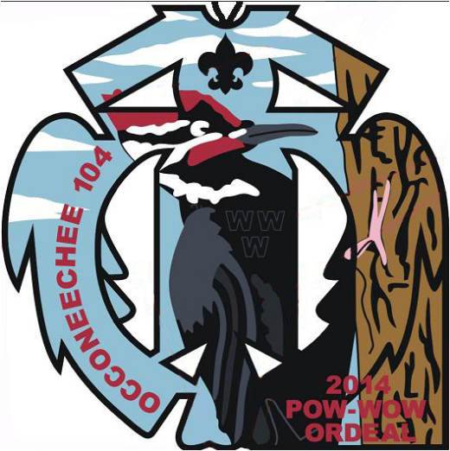 Wow 2014

# March 14-16, 2014 • Camp Durant

# Occoneechee Lodge #104

**FRIDAY**

5:00-7:30 Registration and Ordeal Check-in *Administration*

Collection of Conclave Food Drive Items *Administration*

7:00 Chainsaw Training *Armstrong Shelter*

7:30 Pre-Ordeal Ceremonies *Ceremony Rings*

**8:00 Evening** **Show**  *Grand Lodge*

Cook Team Meeting GL Kitchen

8:45Brotherhood Candidates’ Meeting Beluga Club

8:45-9:45 Cracker-barrel *Grand Lodge*

9:15 Lodge Committee Meeting *Beluga Club*

9:45 Executive Committee Update *Beluga Club*

**10:00 Movie**  *Grand Lodge*

**SATURDAY**

7:00 Vigil Breakfast *Grand Lodge*

7:50 Assembly • Flag Raising *Grand Lodge*

8:00 Breakfast *Grand Lodge*

2014 Camporee Meeting *Beluga Club*

Registration re-opens *Sullivan Center*

9:00-12:00 **Service Projects** *Meet at Sullivan (Vista)*

9:00 CPR Certifications ($5 cost) Health Lodge

9:30 AIA Ceremonies Competitions

Pre-Ordeal: *Holt Thornton Ring* • Brotherhood: *Eno Ring*

11:00 Chapter Chiefs’ meeting *Sullivan Green Room*

Chapter Advisers’ meeting *Sullivan Yellow Room*

12:20 Assemble for Lunch *Grand Lodge* 1:15 Dining area closes; Netami report for cleaning

**Service Projects Resume**  *Meet at Sullivan*

Brotherhood Trail *Beech Campsite*

Chapter Vice-Chiefs’ & Advisers’ Meetings *Sullivan Center*

Program: *Archery* • Administration: *Red Room*,

Communications: *Yellow Room* • Finance: *Green Room*

AIA Outfit Judging *Dance Arbor*

2:00 Dance Competition/Powwow begins *Dance Arbor*

3:45 Chapters welcome Ordeal Candidates *Sullivan Center (Vista)*

4:30 **Quest for the Golden Arrow** *Activity Field*

5:30Taco Brawl *Activity Field*

Dinner for Ceremonialists (ticket required) Grand Lodge

5:50 Assemble for Dinner *Grand Lodge*

AIA Awards Presentation

6:00 Dinner *Grand Lodge*

7:15 Ordeal Candidates assemble *Campfire Arena*

7:30-9:30 Ordeal Ceremonies *Ceremony Rings*

8:15 Brotherhood Candidates assemble *Archery Shelter*

8:30 Brotherhood Ceremonies *Ceremony Rings*

8:45-10:30 **i**Thunderfiesta! Sullivan Center and *Vista*

Lauchoseen report for serving.

Powwow (Sing, dance, and enjoy free soda!) *Dance Arbor*

10:30 Serving of Food Ends

**SUNDAY**

7:30 Assembly • Flag Raising *Grand Lodge*

7:45 Breakfast *Grand Lodge*

8:15 New Member Forum (during breakfast) Grand Lodge

9:00 Scout’s Own Service *Chapel*

Campsite Inspections *Campsites*

9:45 Break Camp

Executive Committee Meeting *Sullivan Center*

**Chapter Duty Roster**

*Report to the cook crew for directions at the time listed. Thank you!*

|  |  |  |  |
| --- | --- | --- | --- |
|  | **Meal** | **Preparation & Serving** | **Cleanup** |
| Fri | Cracker Barrel | Self-serve | Temakwe/Netapolis10:30 PM |
| Saturday | Breakfast | Netami A 7:45 AM | Neusiok A 8:30 AM |
| Lunch | Neusiok B 12:10 PM | Netami B 1:00 PM |
| Dinner | Ilau Machue 5:30 PM | Kiowa 7:00 PM |
| Thunderfest | Lauchoseen 9:15 PM | Eluwak 10:30 PM |
| Sun | Breakfast | Mimahuk 7:30 AM | Saponi 8:30 AM |

**Chapter Campsite Assignments**

Ilau Machque • *Ash* Netapolis • *Red Cedar/Holly* Kiowa • *Maple*

Netami • *Red Oak/Poplar* Eluwak • *Hickory* Neusiok • *Sweetgum*

Saponi • *Loblolly/Poplar* Temakwe • *Dogwood* Mimahuk • *Beech*

Lauchoseen• *Magnolia/Sassafras*

Join The Fiesta! Register.sr7b.org