Computer Architecture

**Fall, 2022**

**Week 8**

**2021.10.30**

**組別：＿＿＿＿＿　簽名：＿＿＿＿＿＿＿＿＿＿＿＿＿＿＿＿＿＿＿＿＿＿＿＿＿＿＿＿＿＿＿＿**



**Group6**

Which of the following statements are true?



(A) 0 10000101 01001100000000000000000 in IEEE 754 represents 83.375 in decimal.



(B) 1 10000010 10010100000000000000000 in IEEE 754 represents -12.625 in decimal.

(C)If some values are divided by zero, MIPS will raise an exception.

(D)In bias 15, 01101 represents -2.



**Group14**

Please explain/fill in the following according to the IEEE 754 standard:

1. Why is there a need for the designation of denormal (subnormal numbers) in the standard?
2. Why does the value of the mantissa (significand) always ignores the digit left to the decimal point?
3. Why is there a need for the biased notation (instead of a 2’s complement representation for signed numbers)?
4. How many different NaN values are there in the single-precision floating point number standard? (Answer can be presented in exponent notation)



**Group 2**

Please fill out the table according to steps of 1011/0110 and the following flow chart. Write down Quotient and Remainder.

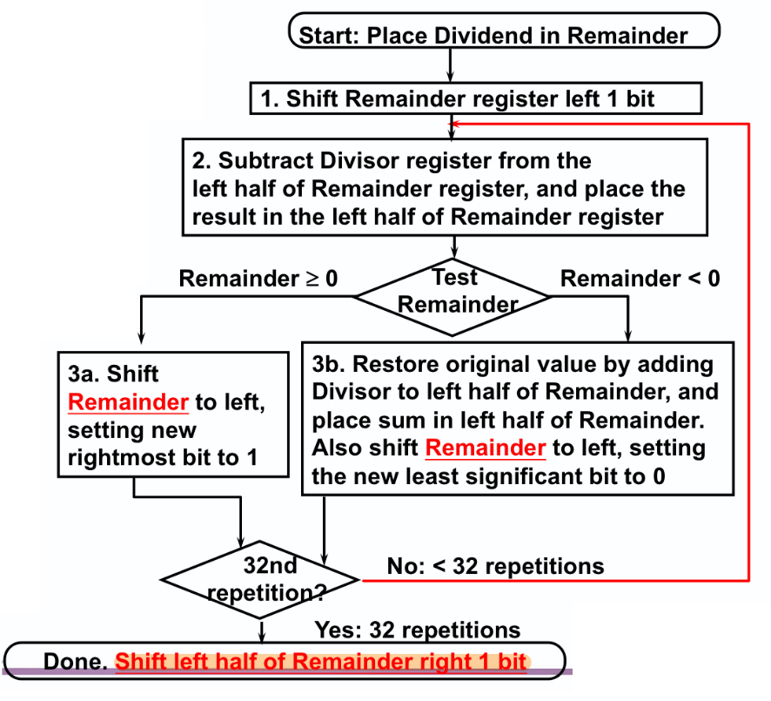



|  |  |  |  |  |
| --- | --- | --- | --- | --- |
| Step | Remainder | | Divisor | Description |
| 0 | 0000 | 1011 | 0110 | Initialization |
|  |  |  |  |
|  |  |  |  |
|  |  |  |  |
|  |  |  |  |
|  |  |  |  |
|  |  |  |  |
|  |  |  |  |
|  |  |  |  |
|  |  |  |  |
|  |  |  |  |

Quotient: Remainder:

Hint:

To fill the Description, there are some options:

* Shift xxxxxxxxx left/right
* xxxxxxxxx < 0 / > 0
* Restore original value
* Subtract/Add xxxxxxx
* Set the new significant bit to 1/0

……

**Group4**

Which of the following statements are true?

1. The unsigned multiplier of two 32-bit numbers requires a 32-bit register for multiplicand and a 32-bit register for product.



1. Based on 32-bit IEEE 754 standard’s single precision, no other floating point number is greater than 0x7f800000.



1. Hi and Lo registers are used in both multiplication and division, and Hi would store the quotient in division.



1. If there were only 16 bits for significand field in floating point representation, it is equivalent to 4 decimal digits of precision.
2. For 32-bit unsigned division, we only need 32 iterations and shift one register to get the correct result.
3. By IEEE-754 single precision floating-point representation, the largest positive normalized number is .
4. Exponents with all 1’s are reserved for and NaN.



**Group12**

True or False:

1. when we use mult $t1, $t2, we will push most significant 32 bits to lo and least significant 32 bits to hi.



1. In multiply version 2 we will place multiplier to product register’s right hand and shift right until the multiply end.
2. Divide version 1 and multiply version 1 have same repetition times.
3. when we use div $t1, $t2, we will push remainder to hi and quotient to lo, and we can use mflo $t3 and mfhi $t4 to copy the lo and hi value to register t3 and t4.
4. For 32-bit IEEE 754 floating-point standard, the smallest positive single precision denormalized number is: 0.0000 0000 0000 0000 0000 0012 x 2 ^ -126.
5. 0.687510 = 0.01112
6. In the IEEE 754 floating-point representation, the precision of represented numbers is determined by the size of exponent.
7. In the IEEE 754, we use 2’s complement in exponent field .



**Group1**

Below are some steps for performing a basic floating-point multiplication. Please order the steps.

1. Normalize the product and check for overflow/underflow when shifting
2. Add the exponents of operands to get the exponent of the product
3. Round the mantissa and renormalize when necessary
4. Multiply the mantissa of operands
5. Set the sign of the product



**Group 7**

Half-precision floating-point (FP16) has 1 bit of signed bit, 5 bits of exponent, and 10 bits of mantissa. The exponent uses bias of 15.

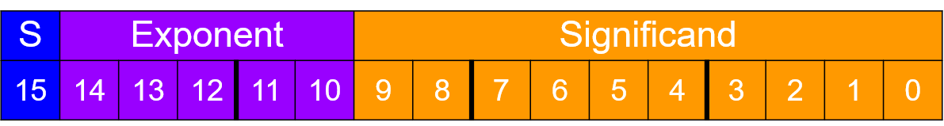

For the following question, calculate the results and represent them in FP16 bit representation:

1) 13(10)



2) 1.111(2) * 2^-14 - 1.000(2) * 2^-13



3) 1024(10) * 512(10)



(hint : 512 = 2^9, 1024 = 2^10)

