# Generate web-images from schematics

Turn off guidelines (dots): **View -> Show Guidelines** : OFF

Print each schematic into a BMP

**File -> Export** : *.bmp

Select all BMP (from each group), right-click and use **Snag-It -> ”Batch Convert Images”**  using options:

* “Drop Shadow Edge”
* “Auto-Trim”
* Modify file name to prefix “z80-“

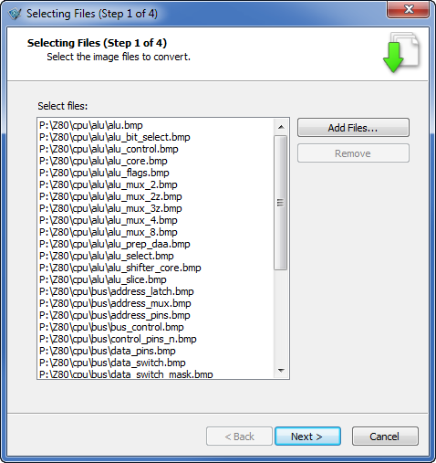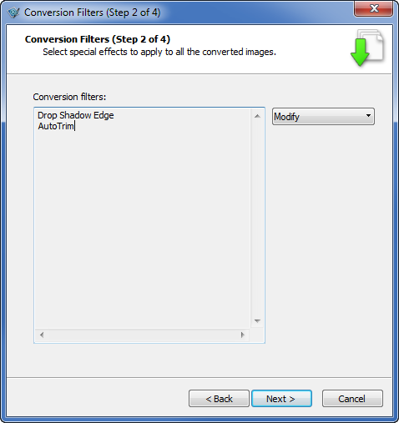

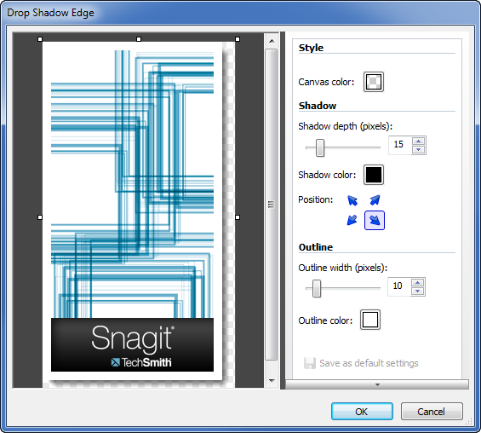 Outline = 10 pixels, color = white

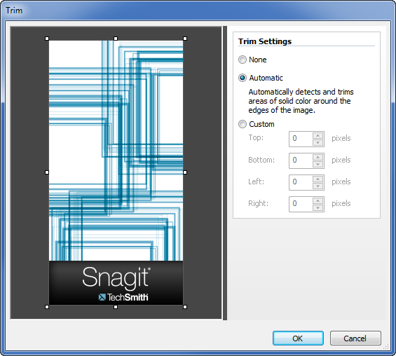

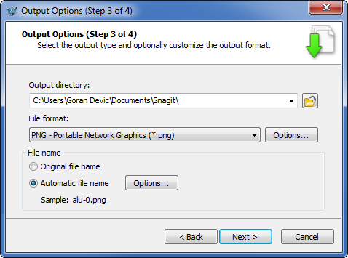 Automatic file name…

Add the “z80-“ prefix to each file name:

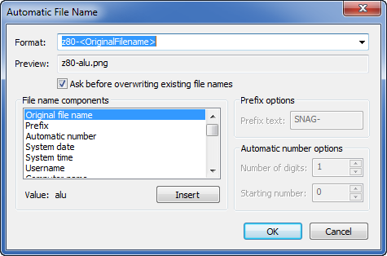

# Generate XPS files for printing the schematic

**Tools -> Options ->** Headers & Footers Settings

Clear all, just put on the top-right “File: %f”

Set margins that are good for binding (left margin is relatively large and the rest are narrow)

**File -> Page Setup** :

L=**1**, R=0.4, T=0.4, B=0.4 (for portrait)

L=**0.4**, R=0.4, T=**1.5**, B=0.4 (for landscape)

**Print -> XPS Writer** or **Ctrl-P**

(May want to set it as a default printer for the job)

Some larger schematics need to be printed little bit differently to get a better image:

Landscape:

alu/alu_core

alu/alu_slice

alu/alu_shifter_core

control/sequencer

bus/address_latch

Some very large schematics should be printed using **View -> Multipage Setup** :

alu/alu (3x1)

bus/inc_dec (2x1)

registers/reg_file (2x1)

(don’t forget to adjust margins accordingly!)