Johnathan Luu

Intro to Python

Assignment 5

5/17/2022

To Do List

Intro

This week’s assignment calls for a few new skills. It introduces dictionary vs lists as well as calls for a usage for a standardized script format. This can be demonstrated by creating a template, but it also is presented with the header, followed by the “Data”, “Processing”, and “Presentation” sections.

Creating the program

Due to the starter script being made available, we only needed to write the script that allows for the 5 commands shown in the menu.

1: Show current data

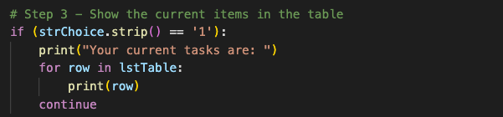

Showing the current data is fairly straight forward. From our previous modules and assignments, showing the current data requires a print() function for context, followed by another print() function that shows the data in the list, labelled “lstTable”.

2. Add a new item

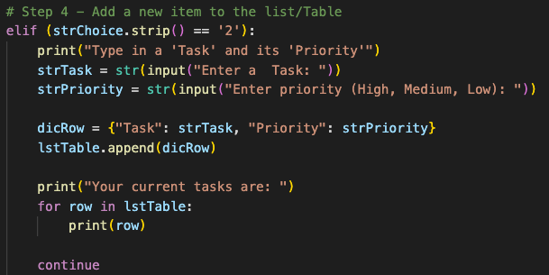

Adding a new item will require 2 input() functions that define the “Task”, as well as the “Priority” of the task. The inputs would be entered in the dictionary and defined as so. When there are multiple entries, they would be added or “appended” to the list defined as ‘lstTable’.

3. Remove an existing item

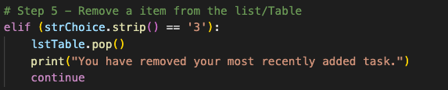

Removing an existing item can be done by using the pop() function in relation to the ‘lstTable’ list. The pop() function by default will remove the last added task from the task list.

4. Save data to file

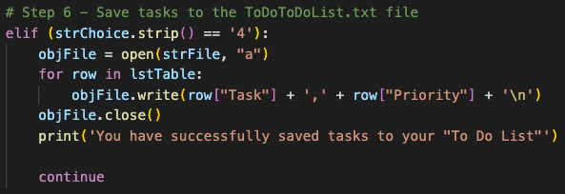

Saving data to file can be done by first opening the file that we would like to “write” or “append” to. Then a write() function would be used to write the data from the task list, in this situation it is the “Task” and “Priority”. A ‘for’ function was used to write the tasks and to separate each task into individual rows.

5. Exit Program

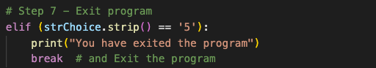

All that was necessary to exit the program was to add break to the statement. To end the program, an exit() function can also be used to completely end and terminate the script.

Results

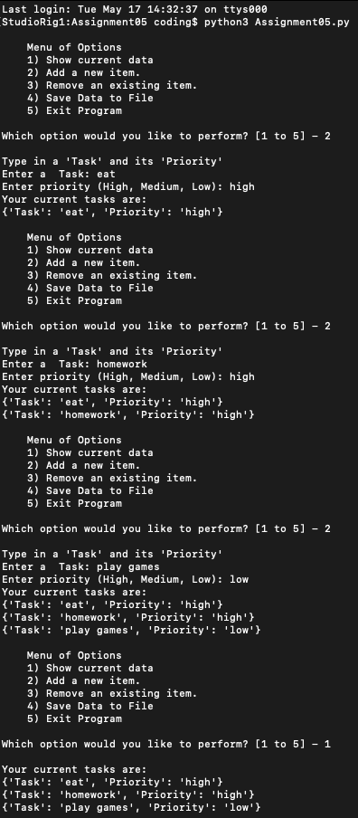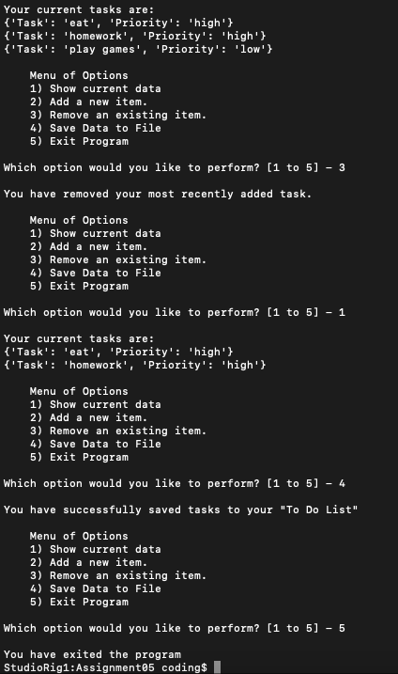

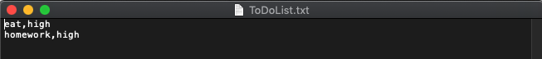

Summary

In summary, a combination of our past work an assignments accumulated together contributed to creating this script, but the new elements that were added in this new module was the implementation of dictionaries as well as the formatting of the script. The main takeaway is that dictionaries hold a key as well as a value. This creates a key-value pair whereas a list is a collection of various elements.