**EEE305 – ASSESSMENT 1**

|  |  |
| --- | --- |
| Assessment Number | 1 |
| Contribution to Overall Marks | To be announced. |
| Submission Deadline | To be announced. |

**Assessment Objective**

This assessment aims at evaluating students’ ability to exploit the deep learning knowledge, which is accumulated during lectures, and after-class study, to analyze, design, implement, develop, test and document the images classification using CNN framework. The assessment will be based on the Pytorch software.

**General Guidelines**

1. The descriptions in the Problem Specifications are required to be analyzed with mathematic equations, combined with the explanations of all elements in each equation.
2. The modified part of the source codes are required to include in the report.
3. The final classification performance that you obtain should be reported in the lab report. Meanwhile, the screenshot of the final performance results are also required in the report.
4. For the final performance results that you obtained, the numeric quantitative results are required. In addition, is also important to include some subjective image examples in the report.
5. Students need to conduct the coding and experiment all by yourself. The obtained results can not be shared and each student should analyze the results and write the report individually.

**Handwritten digits (MNIST) recognition**

Overall Description:

This lab is to use the Pytorch software and CNN (Convolutional Neural Network) framework for handwritten digits classification. Image classification aims to predict the category of object in an image (one image can only have one object in it). It has attracted much attention within the computer vision community in recent years as an important component for computer vision applications, such as self-driving vehicles, video surveillance and robotics. It is also the foundation of other computer vision research topics, such as object detection and instance segmentation.

CNN is a framework with both feature extraction and classification using deep convolutional neural network. A typical CNN pipeline is shown below.

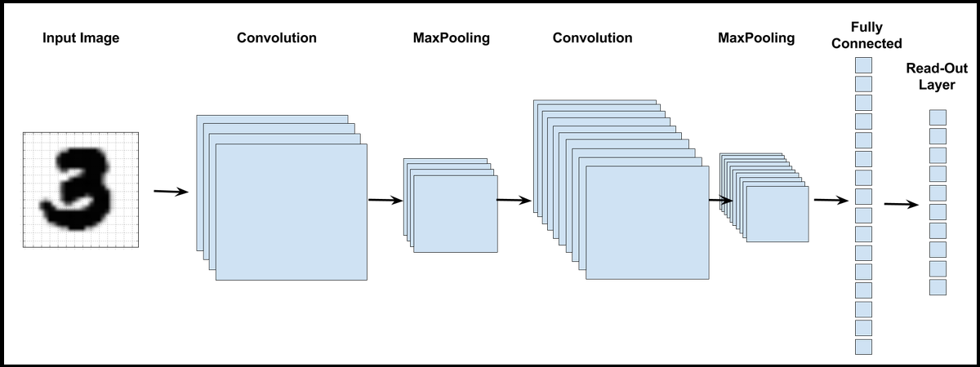

Figure 1. CNN image classification pipeline.

The Dataset we will use is MNIST dataset, it has a training set of 60,000 examples, and a test set of 10,000 examples. The dataset is originally available on Yann Lecun’s website. The followings are examples of handwritten digits in MNIST dataset.

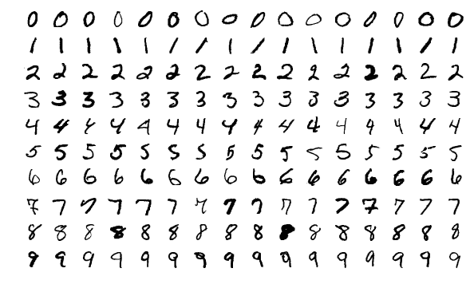

Figure 2. Examples of handwritten digits in MNIST dataset.

Problem Specifications:

1. Please describe the 2 key components in the CNN framework: the convolutional kernel and the loss functions used in the framework. (20%)
2. Please train (or fine-tune) and test the framework on MNIST and report the final accuracy performance that you have achieved. Please also report some well classified and misclassified images by including the images and corresponding classification confidence value. (40%).
3. Propose your own method to further improve the classification performance or reduce the model size. You need also compare different methods with the performance you obtained and explain why. The final classification accuracy is not the most important part, you may better refer to some latest published papers and code these state of the art methods to improve the performance. The explanation and analysis of your adopted method is highly related to your final score. (40%)

Environment Preparation:

**1 Install Anaconda**

1.1 Install Anaconda on Windows

Anaconda is open-source software that contains Jupyter, spyder, etc that is used for large data processing, data analytics, heavy scientific computing.

Conda is a package and environment management system that is available across Windows, Linux, and MacOS, similar to PIP. It helps in the installation of packages and dependencies associated with a specific language like python, C++, Java, Scala, etc. Conda is also an environment manager and helps to switch between different environments with just a few commands.

Step 1: Visit this website

https://www.anaconda.com/products/individual-d

and download the Anaconda installer.



Step 2:  Click on the downloaded .exe file and click on Next.

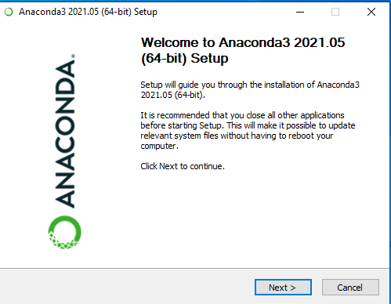

Step 3: Agree to the terms and conditions.



Step 4: Select the installation type.

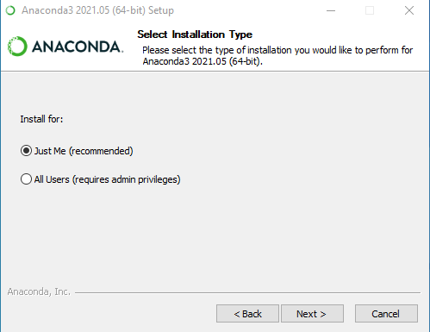

Step 5: Choose the installation location.

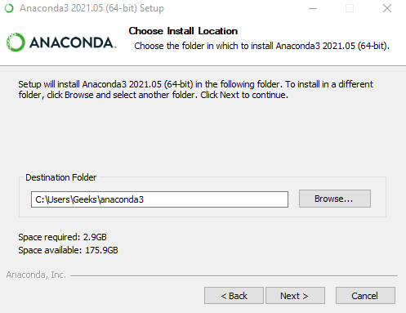

Step 6: Now check the checkbox to add Anaconda to your environment Path and click Install.

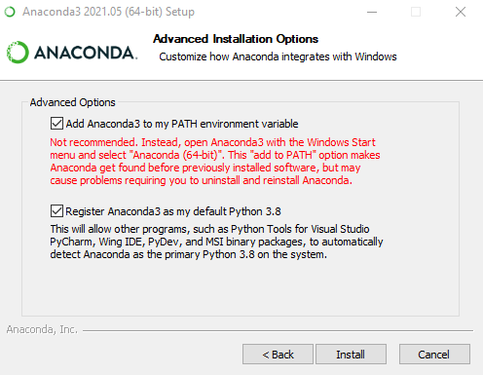

This will start the installation.

Step 7: After the installation is complete you’ll get the following message, here click on Next.

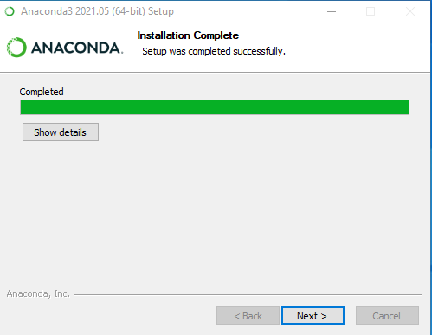

Step 8: You’ll get the following screen once the installation is ready to be used. Here click on Finish.

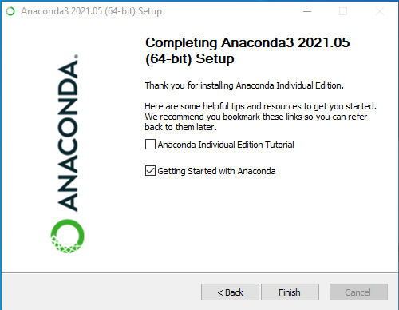

### Verifying the installation:

Now open up the Anaconda Power Shell prompt and use the below command to check the conda version:

coda -V

If conda is installed successfully, you will get a message as shown below:

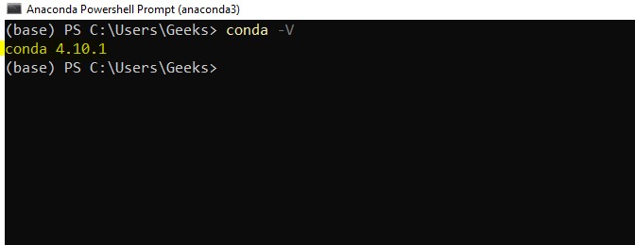

1.2 Install Anaconda on Linux

## Prerequisites

Firstly, open terminal on your Ubuntu system and execute the command mentioned below to update packages repository:

sudo apt update

Then install the curl package, which is further required for the downloading the installation script.

sudo apt install curl -y

## Step 1 – Prepare the Anaconda Installer

Now I will go to the /tmp directory and for this purpose we will use cd command.

cd /tmp

Next, use the curl command line utility to download the Anaconda installer script from the official site. Visit the Anaconda installer script [download page](https://repo.anaconda.com/archive/) to check for the latest versions. Then, download the script as below:

curl --output anaconda.sh https://repo.anaconda.com/archive/Anaconda3-2021.05-Linux-x86_64.sh

To check the script SHA-256 checksum, I will use this command with the file name, though this step is optional:

sha256sum anconda.sh

Output:

25e3ebae8905450ddac0f5c93f89c467 anaconda.sh

Check if the hash code is matching with code showing on download page.

## Step 2 – Installing Anaconda on Ubuntu

Your system is ready to install Anaconda. Let’s move to the text step and execute the Anaconda installer script as below:

bash anaconda.sh

Follow the wizard instructions to complete Anaconda installation process. You need to provide inputs during installation process as described below:

01. Use above command to run the downloaded installer script with the **bash** shell.

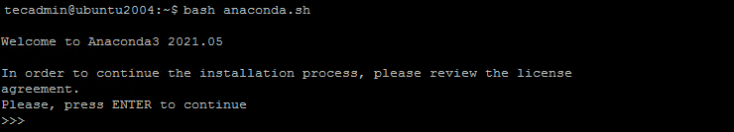

02. Type **“yes”** to accept the Anaconda license agreement to continue.



03. Verify the directory location for Anaconda installation on Ubuntu 20.04 system. Just hit **Enter** to continue installer to that directory.

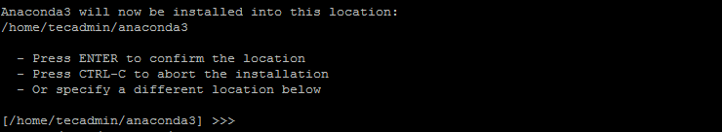

04. Type **“yes”** to initialize the Anaconda installer on your system.

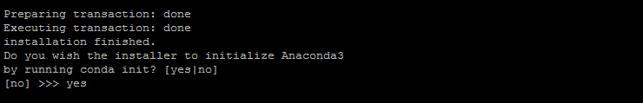

05. You will see the below message on successful Anaconda installation on Ubuntu 20.04 system.

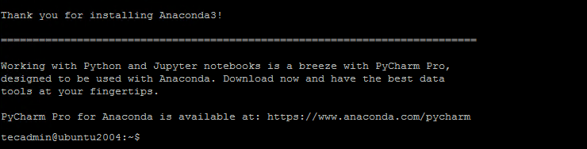

The Anaconda Installation Completed Sucessfully on your Ubuntu system. Installer added the environment settings in .bashrc file. Now, activate the installation using following command:

source ~/.bashrc

Now we are in the default base of the programming environment. To verify the installation we will open conda list.

conda list

Output:

# packages in environment at /home/tecadmin/anaconda3:

#

# Name Version Build Channel

_ipyw_jlab_nb_ext_conf 0.1.0 py38_0

_libgcc_mutex 0.1 main

alabaster 0.7.12 pyhd3eb1b0_0

anaconda 2021.05 py38_0

anaconda-client 1.7.2 py38_0

anaconda-navigator 2.0.3 py38_0

anaconda-project 0.9.1 pyhd3eb1b0_1

anyio 2.2.0 py38h06a4308_1

appdirs 1.4.4 py_0

**2 Install and configure PyTorch on your machine.**

First, you'll need to setup a Python environment.

Open Anaconda manager via Start - Anaconda3 - Anaconda PowerShell Prompt and test your versions:

You can check your Python version by running the following command: python –-version

You can check your Anaconda version by running the following command: conda –-version

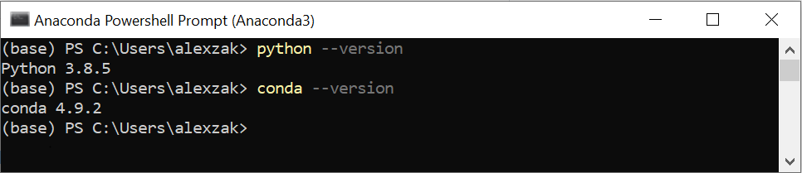

Now, you can install PyTorch package from binaries via Conda.

1. Navigate to <https://pytorch.org/>.

Select the relevant PyTorch installation details:

* PyTorch build – stable.
* Your OS
* Package – Conda
* Language – Python
* Compute Platform – CPU.

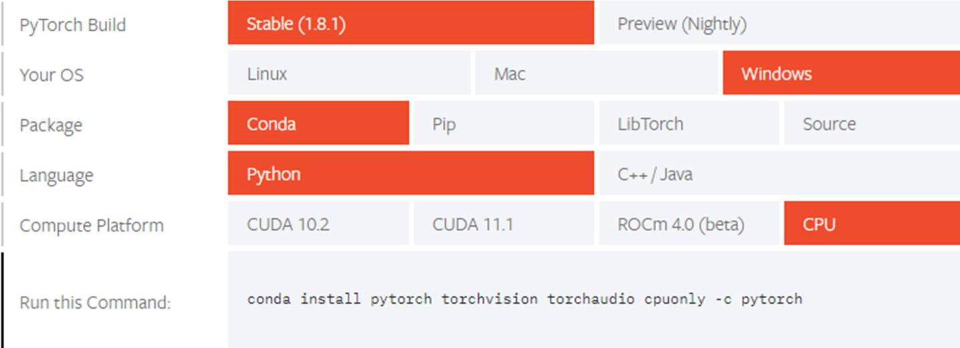

1. Open Anaconda manager and run the command as it specified in the installation instructions.conda install pytorch torchvision torchaudio cpuonly -c pytorch

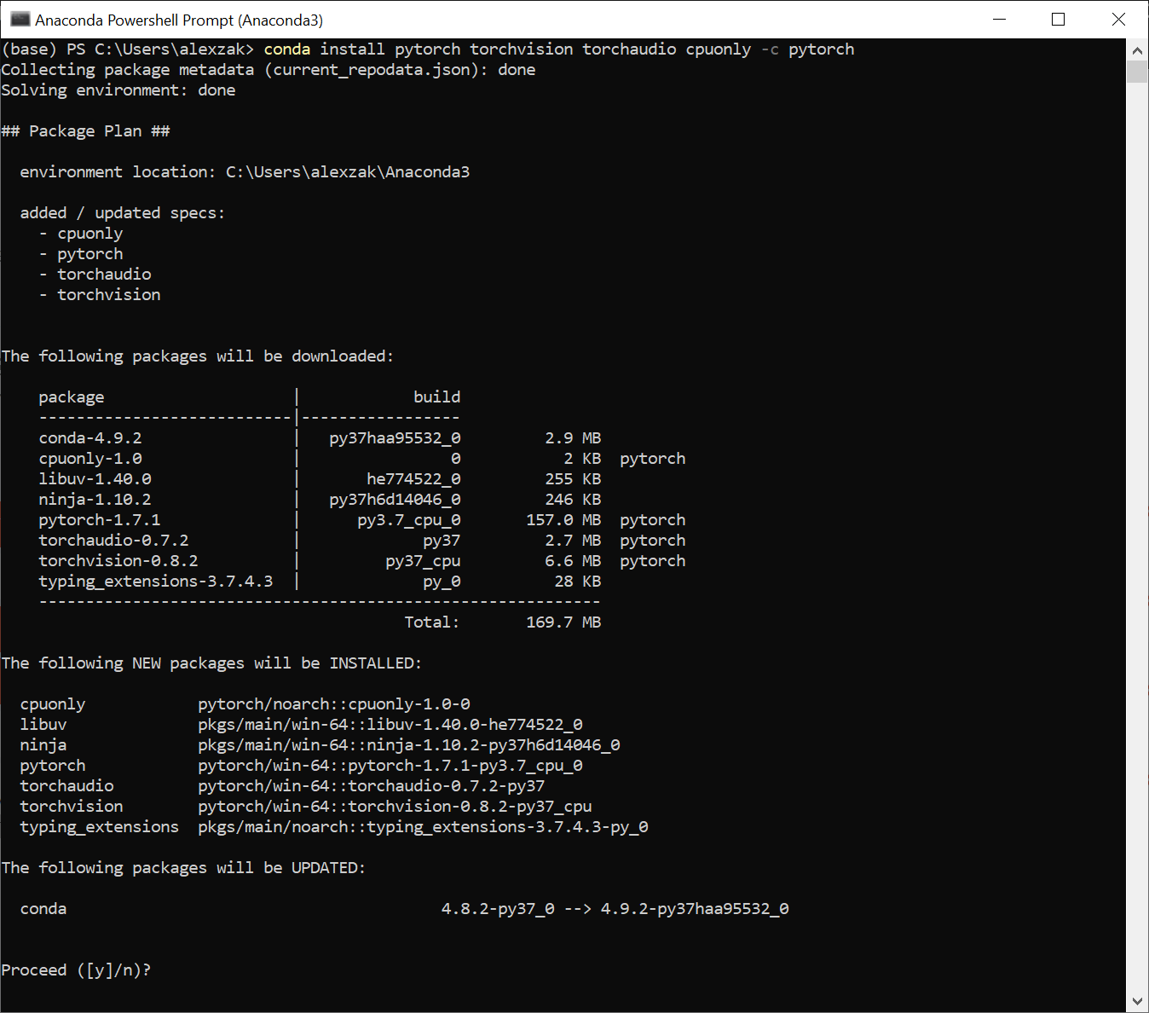

1. Confirm and complete the extraction of the required packages.

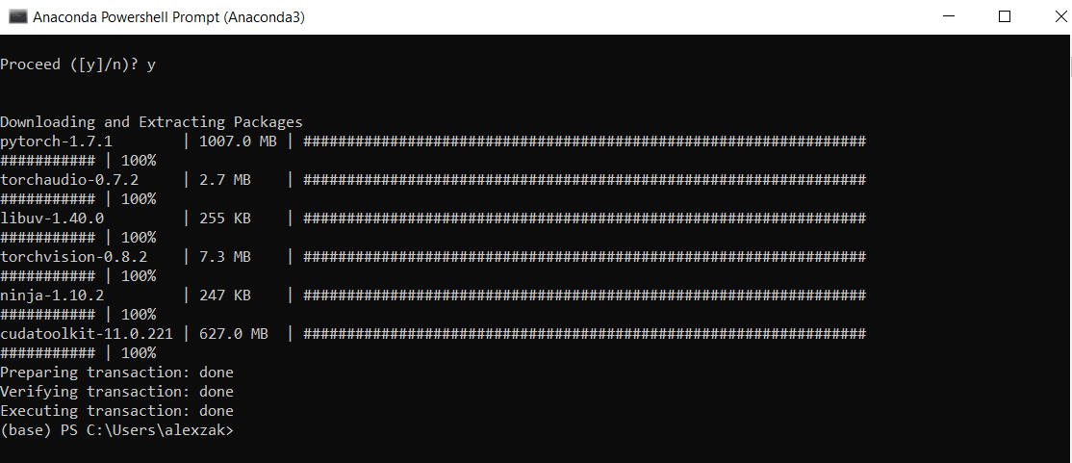

Let’s verify PyTorch installation by running sample PyTorch code to construct a randomly initialized tensor.

1. Open the Anaconda PowerShell Prompt and run the following command.

python

import torch

x = torch.rand(2, 3)

print(x)

The output should be a random 5x3 tensor. The numbers will be different, but it should look similar to the below.

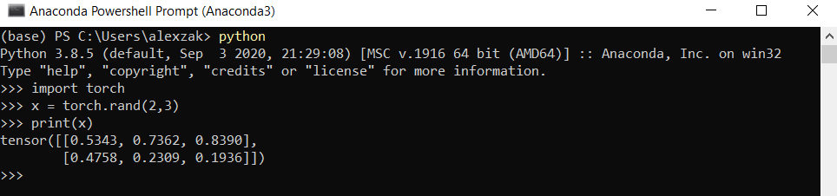

References

[1] <http://yann.lecun.com/exdb/mnist/>

[2] <https://github.com/Eng-Abdelrahman-M/handwritten_digit_recognition/blob/main/handwritten_digit_recognition.ipynb>