**Serious game development for dementia care using preferred music, music therapy**

**LW Fourie**

**31607500**

Research proposal for the research project submitted in *partial* fulfilment of the requirements for the degree BSc Hons 2023 in Computer Science and information systems in Potchefstroom at the North-West University

Supervisor: Prof. Gunther Drevin

Date of submission: 4-10-2023

Version: 1

Table of contents

1 Introduction 1

2 Background to study 1

3 Problem statement 4

4 Paradigmatic perspective 5

4.1 Meta-theoretic assumptions 5

4.2 Theoretic assumptions 5

4.3 Methodological assumptions 5

5 Research aim and objectives 5

5.1 Research aim 6

5.2 Research objectives 6

5.3 Study design 7

6 Research methodology 7

6.1 Study context 8

7 Rigour / Validity & reliability 9

8 Ethical considerations 9

9 Executive Summary 10

Bibliography 11

List of Tables

**No table of figures entries was found.**

List of Figures

Figure 1: a framework for serious game development in the medical field 2

Figure 2: short-time Fourier equation 4

Figure 3: full power spectrogram vs harmonic and percussive spectrograms 4

Figure 4: a framework for design science (Wieringa, 2014) 9

RESEARCH PROTOCOL

# Introduction

Using Music therapy as a base for the design of a serious game to improve cognitive function and quality of life in patients living with dementia. Music therapy is used because studies have shown evidence that persons with dementia's ability to respond to music are potentially preserved even in the late or severe stages of dementia when verbal communication may have ceased (Baird & Samson, 2015). For the project music therapy will incorporate preferred music by allowing caretakers to upload music to the game that the patients find favourable. Studies indicate that using preferred music with patients has a big outcome on anxiety, agitation, and pain relief. The artefact will consist of a serious game as well as a remote designed for the game. The project aims to allow more interaction between patients as well as between patients and caretakers through playing a serious game together. Thus, the target audience for this project is dementia patients with the main focus on patients with more moderate to severe cases of dementia.

The severity of dementia is identified mainly through the use of a mini-mental state exam score, or an MMSE score. MMSE is used to identify the severity of dementia cases and does not predict dementia cases and also does not identify early stages of dementia effectively (Myrberg *et al.*, 2020).

This proposal will further go into depth on how this project will be approached, this includes the problem statement, the paradigm used, the methodology used, and other information necessary for the completion of the project study as well as the artefact to be created for the project.

# Background to study

Dementia is a disease that affects a lot of people and thus a lot of families with the estimated amount of people living with dementia in 2019 being as much as 57 million, studies have also predicted that these numbers would more than triple by 2050 by 153 million people (inretnational). Dementia is a disease that influences the mind and causes it to deteriorate, this intern causes symptoms such as memory loss, agitation and behavioural issues in patients (James & Bennett, 2019).

The aim of using a serious game is because of the ease of use, a serious game can be played alone, or with others and supervision is not mandatory but still recommended as patients still need assistance in understanding the game. This is also why the aim of serious games for dementia care (SGDC) is to make the game simple enough for patients to understand while also keeping them interested in the game and needing minimal motivation for them to play. Using motivation techniques such as goal setting will appeal to some patients but not all which is why making the game as fun to play as possible will be the greatest form of motivation (van der Wardt *et al.*, 2020).

A serious game is defined as a game that doesn’t have fun, entertainment or enjoyment as its main purpose, the main purpose of the game is to have some form of educational service (Dietlein *et al.*, 2018). The Serious game will incorporate music therapy, music therapy is a music-based intervention used on different types of patients which includes dementia patients. Serious games are being used more and more for medical education, but for the game to be as effective as possible it is necessary to follow a framework for the development of the serious game. Using an adjusted version of a three-phase development and formative evaluation process that was designed after an in-depth review of 65 articles that focused on serious games (Olszewski & Wolbrink, 2017). The process is described in the following figure:

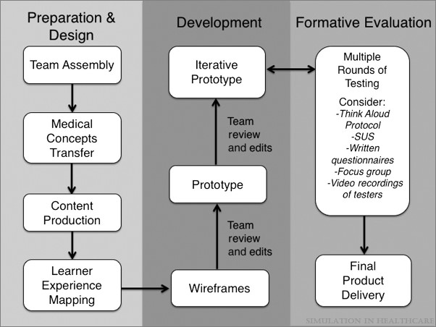

Figure 1: a framework for serious game development in the medical field

Preparation and design:

* Team assembly will not be done as the entire project including the development of the serious game will be done by one person throughout the project lifecycle. Thus, this step has been removed.
* Medical concepts transfer is done to allow the game developers to more easily understand how the game needs to be developed to benefit the patients that are the target of the game.
* Content production is using guidelines and recommendations set by experts in the medical field the serious game is targeting to allow developers to include the content into the game effectively.
* Learner experience mapping is to discuss with medical professionals to determine the functionality, flow, feedback and scoring based on the game theory and proposed game modelling.

Development:

* Wireframes are illustrations that help to visualise the proposed game concepts thus assisting in visual communication and design of the structure. This is done to illustrate all aspects of the game such as the learner interface, structure, functionality, and positioning of everything in the application.
* Prototype is to develop a version of the game that can be tested and reviewed by experts, this allows the developer to more easily identify and fix errors and also make adjustments according to expert opinions.
* Iterative prototyping is to review feedback on the original prototype and make adjustments accordingly to allow experts to review the prototype again. Incorporating all aspects of the game throughout the prototyping cycle.

Formative evaluation:

* Usability testing is formal testing done to identify content, design, functionality, and usability problems with the game that can be fixed by developers. Many strategies for testing were identified by the review but it is adjusted to only make use of expert reviewers for this project.
* Final product delivery is to deliver the final product of the project as well as discuss how long the developers will be available to make changes that were identified. For this project this is indicated by the completion of all aspect of the game that has been identified, as well as all adjustment identified by expert reviewers. After all, these are done the artefact of this project will be considered completed.

The music therapy will focus on preferred/favoured music. Preferred music is music that is preferred or enjoyed by the patients, this can be individual-preferred music, meaning it focuses solely on one individual patient and their music preference, or it can be group-preferred music, meaning that a group is interviewed to see what music they all prefer and through that finding a common genre everyone can enjoy (Raglio *et al.*, 2012). Studies were done on patients to find their preferred (VanWeelden & Cevasco, 2009) music might be outdated or not accurate to every individual. Preferred music has shown promise in reducing undesirable behaviours (Eggert *et al.*, 2015), as well as increasing patients’ functional connectivity (King *et al.*, 2019) and even has an effect on reducing pain levels during times of peak agitation (Park, 2010). Preferred music can be incorporated by getting a spectrogram of the mp3 signal, this can be done through using the short-time Fourier transformation. Short-time Fourier transformation takes a short block of time and then Fourier transforms them to receive the frequency domain representation of that block (Pihlajamäki, 2009).



Figure : short-time Fourier equation

Using this equation, it is possible to get a spectrogram of the signal which can then be dissected even further into harmonic and percussive spectrograms. Using these spectrograms as reference the onset of percussive instruments can be monitored and the timestamps extracted, allowing for the ability to incorporate these timestamps into a music therapy based serious game along with the mp3 file itself.

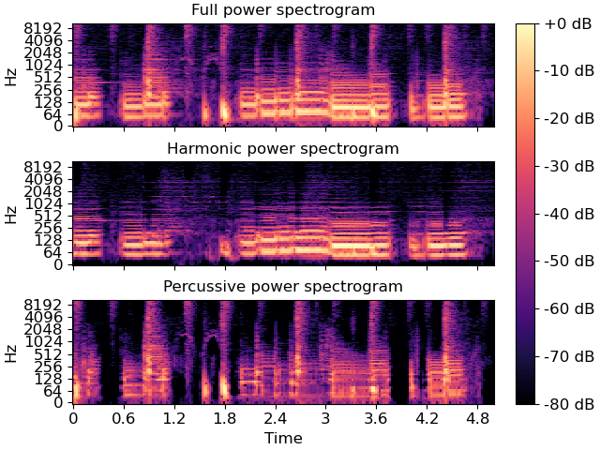

Figure : full power spectrogram vs harmonic and percussive spectrograms

This is the main method of incorporating preferred music into the music therapy based serious game that has been identified.

Using and developing a remote for the game is necessary as it is easier for patients to accept a serious game if the controls are simple to understand, thus keeping the game as well as the remote as minimal as possible is a necessity. Using colours that affect patients’ attention will allow the remote to have a better effect (McLachlan & Leng, 2021). Incorporating designs such as colourful big buttons, soft without sharp edges, and removing any hazards such as long cables, will make it easier and safer for patients to use. It will be developed using Raspberry PIs as the controllers as they have been identified as the most reliable as well as useful tool. While the base of the remote in terms of material has not been identified yet with current options being super wood, PVC, or normal 3d print plastic filament. Also allowing more than one person to play at a time will motivate interaction as well as influence others to play the game as well, it is much easier to use coercion to motivate patients to play than it is to use persuasion (Fernández-Llatas *et al.*, 2011).

# Problem statement

Previous serious games that use music therapy have been proven to be effective in dementia care with results showing to have a positive effect on patients’ depressive states (Moreno-Morales *et al.*, 2020). These games have a set way of playing the game and only specific music you can play. Previous research has shown that preferred music has a large impact on patients living with dementia, with effects on reducing anxiety, and agitation as well as studies supporting evidence of pain relief during peak agitation periods. Thus, it is necessary to consider the effect of incorporating preferred music into a music therapy-based serious game to improve the quality of the intervention. using design science to incorporate preferred music into a music therapy-based serious game will allow patients to be more accepting of the intervention as well as allow the intervention to have a greater effect on patients’ quality of life. Further improving on the playability and understandability of the serious game can be done through the development of a remote designed to satisfy the needs of dementia patients, giving greater motivation to play the game by reducing the learning curve needed will allow patients to easier accept and enjoy the serious game and through that, the impact of the intervention will also be greater. If this is designed correctly it could improve the field of music therapy interventions for patients living with dementia. Doing intervention using a serious game will allow there to be minimal assistance needed through caretakers or other family members of patients.

# Paradigmatic perspective

The project will use positivism as its research paradigm, this means that the results of studies will be focused on to determine the direction of the study as well as the artefact. Positivism has a strict focus on pure data as well as facts, this study will use facts derived from other studies that made use of data, and no data will be gathered to be used for this study. These facts will be gathered from the results of studies without being influenced by any external interpretation. (Park *et al.*, 2020)

## Meta-theoretic assumptions

Using the theory gathered through the use of the methodology as well as the paradigm of the study it will be put into practice in the form of a serious game artefact. Previous studies have shown that all the different aspects of the study such as music therapy, preferred music, and serious games have a positive influence on patients, that is why the prospect of this study is so exciting as these aspects have not been put into one artefact. The results of these studies have influenced every aspect of not only the study but the artefact as well. Using data and facts gathered through various methods such as different studies and reviews will be used as the backing and foundation of the practical part of the project.

Epistemology involves concepts of knowledge, evidence, justification, probability and other concepts that fall under these categories (Fumerton, 2009). Thus, the epistemological aspect of the positivist paradigm focuses on empirical data, observable and measurable facts. These facts are gathered through previous studies done by accredited academics in the case of this study. The facts gathered from the empirical evidence available are then implemented in the design phase of the study, using only results that have shown improvement in one aspect or another for dementia care.

Ontology as a branch of philosophy focuses on the science of what is in relation to every area of reality (Smith, 2012). Ontological aspect of the positive paradigm does not allow for any assumptions in regards to study results, making only use of the facts is necessary to keep the study as reliable as possible. Analysing the results of previous studies thoroughly to determine the approach to be used is how this study will be conducted.

## Theoretic assumptions

Theoretical assumptions will only be made if they are backed by credible sources, thus no personal experience will influence any knowledge gained from studies or expert opinions. This is to ensure that the study is done using the most accurate, up-to-date information, thus ensuring the reliability of the study as a whole.

## Methodological assumptions

The research assumptions will only be influenced by recent study results in the field with minimal personal experience or beliefs influencing the study. The only opinions that will be used are from experts in the field, and they will also be cited as sources of information. This is to ensure that the design science methodology is strictly followed, not allowing any personal bias to influence the study or the artefact.

# Research aim and objectives

The research aim of the study is the main goal of the study, or what the study aims to achieve at the end of its life cycle. Objectives are set in place to measure the progress of the project toward reaching the aim of the project and serve as guidelines for completing the project.

## Research aim

This project aims to investigate the potential of using preferred music in a music therapy-based serious game to enhance cognitive function, mood, behaviour, and overall quality of life for patients living with dementia. Through the use of a carefully designed serious game that incorporates music preferred by the patients undergoing therapy, the project aims to contribute to the development of innovative and effective music therapy interventions for dementia care, and ultimately improve patients’ quality of life.

## Research objectives

To be able to achieve this aim, the project has several key objectives.

1. A comprehensive literature research will be done on existing studies on all the relevant topics, this includes serious games, music therapy and music therapy-based serious games, preferred music, and how all these different aspects affect patients living with dementia. These studies are found using Google Scholar, NWU Library, Alzheimer’s Association, and more medical databases using different combinations of keyword searches to find studies containing “Music therapy”, “dementia”, “Preferred music”, and” Serious game”. More recent studies will be used unless it is not available on the specific topic while there is no minimum set on the number of participants for studies that use participants. This will provide a strong theoretical foundation for the project.
2. A serious game and a remote to be used for the game will be designed to facilitate patients’ acceptance of the intervention and their understanding of the tasks. These will be developed according to the findings of step 1, incorporating the result of studies will allow the project to be more easily accepted by the reviewers and thus by patients as well.
3. A program that can interpret music uploaded by caretakers to incorporate preferred music into the music therapy-based serious game will be developed. The program will be tested on various types of music and adjusted to give the best experience to patients by adjusting the difficulty to acceptable levels. Acceptable levels will be determined by using expert opinions on the number of beats per song as well as the frequency of the beats. If an acceptable level cannot be reached for a specific song it will prompt caretakers to take note that the song might be too difficult for patients. This will be achieved using the librosa library for Python, giving Python the ability to dissect music.
4. An approach will be established to identify a patient’s preferred genre/type of music and then provide recommendations to caretakers on how to acquire these genres of music by using royalty-free music.
5. Expert reviewers will be used to determine the useability and reliability of the serious game as an intervention method for dementia care, thus giving the ability to review features and adjust according to their recommendations.

These objectives will be pursued to develop a viable and effective music therapy-based serious game intervention for patients with dementia.

## Study design

This study will be approached using a design science methodology that will be further discussed and explained in the study. Only literature reviews will be used to create the artefact and there will be no interaction with the participant, in the case of this study dementia patients, as it is not necessary for the current proposed project. As no participants will be used there will also be no data, other studies that are referenced may use participants but only the methods, results, and conclusion of those studies will be used. Due to having no direct participants in this project as well as no information on patients being used for this study ethical considerations are minimal. The limiting factors of this study include optimizing the preferred music program to be able to interpret most, if not all types of music, with the assumption that the quality of the file uploaded is up to standard with no additional noise, as well as the relevant studies available as most studies might fall outside the preferred time frame. The study as well as the artefact for this project is expected to be finished by the end of the academic year.

# Research methodology

Due to the development of the artefact, the research methodology of this project is a design science methodology approach. Design science is designing and investigating artefacts in context (Wieringa, 2014). To use design science for a project the object of study needs to be understood which is an artefact in this case, and its two major activities need to be understood as well. The two major activities are designing and investigating the artefact in context. In the context of this project, this means that research needs to be done on every aspect of the project and to use the information gather to design and develop the artefact. The framework for a design science study is displayed in the next figure:

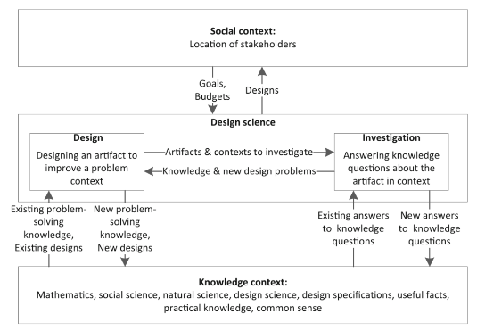

Figure : a framework for design science (Wieringa, 2014)

According to this figure in the investigation section, research needs to be done for, the design of a serious game, music therapy, preferred music, dementia patients, as well as the design of the remote for the game. A literature review needs to be done for all these aspects and their connections, this is then to be used in the implementation and development of the artefact. Following the framework for design science will allow this project to reach its goals more effectively and also ensure the best artefact is created. Data will not be used to determine features of the artefact or the study, but rather use literature reviews as well as study results to determine these features and the direction of the project. To determine if the project goals are reached expert reviewers will be used and their input on the artefact will determine the state of the artefact, either still in the development phase, adjustment phase or a finished product. The expert reviewers will be discussed in the rigour/validity & reliability section of the proposal. The paradigm used to evaluate studies used and the results implemented is a positivist approach, and this is discussed in detail under the paradigm perspective section of the proposal.

## Study context

The study context is the development of an artefact, no data will be used for the development of the artefact thus no data collection methods are used. The artefact to be developed for this project is a preferred music, music therapy game, the game allows patients or caretakers to upload their music and play the game using the uploaded songs, this is where the aspect of preferred music comes in. The game will focus on music therapy by allowing patients to play along with the beats, the python script will dissect the music uploaded to drums, claps and vocals. The drum beats will be exported as a CSV file of timestamps which the game will use to insert beats on the drum hits, patients are then expected to play along with these beats. There are two reasons claps are included as well, firstly to be used instead of drum beats when the song contains almost none or no drum beats, claps will then rather be used if it is deemed more appropriate. Secondly, claps will be used if there are too many drum beats and the game will be too difficult for patients if they are used, this might be in cases where the music has drum solos or something alike.

The patients will then use the remote designed in the artefact to play the game, hitting the buttons on the beats indicated by the game. This will give the effect of playing a song along with the game and this incorporates music therapy for the patients. Patients’ scores will be kept in the program and will not be displayed to patients, this is because the game is an error-less game, meaning patients are not punished for not playing the game correctly or for missing beats. This is to ensure patients don’t feel discouraged if they struggle with the game as we want to ensure they don’t feel any negative emotions while playing. These scores are saved in the background so they can be used to motivate patients accordingly, the game will use motivational reassurance in tangent with the score to give an appropriate response. If the score indicates a player is struggling, motivation will be used so they don’t feel discouraged and when a patient is doing well affirmation will be used to indicate to them that their effort is being recognized.

# Rigour / Validity & reliability

To prove the effectiveness of the final artefact and the project as a whole expert tester will be used. They will go through all the steps patients would which consist of, finding preferred music, learning how to use the remote, learning how to play the game, and finally playing the game with their preferred music to test the effectiveness of the game. Throughout this process, they will give their opinions on where patients living with dementia mind find it difficult to use or understand what to do. Through this, the projects’ reliability and effectiveness can be measured and defined by experts in the field.

# Ethical considerations

Expert opinions will be used as sources of information throughout the study but no questions directly relating to patients under their care will be asked. Questions that primarily focus on their opinion, as well as experience with patient care, will be asked and thus no ethical considerations are needed regarding this.

# Executive Summary

Previous serious games developed for dementia care have influenced most of them to have issues regarding understanding and continuity of play. Music therapy has also been shown to have resulted in the improvement of patients well being as well as their quality of life (Matthews, 2015) with the limitations of needing a caretaker or someone capable of doing the intervention. Preferred music has been shown to have great effects on patients in many different aspects. This project, in terms of study and artefact, aims to incorporate all three of these aspects’ advantages while minimizing their disadvantages. By designing a remote and developing a game that is easy to understand the project can remove the disadvantage of patients not being able to understand the tasks of the game or how to use the controller, by implementing music therapy through the game there will be no need for a caretaker, and by making use of preferred music we can make use of all the advantages it has on patients and their quality of life.

In conclusion, the main focus of this project will be designing and developing not only a preferred music-based music therapy serious game but also a remote to be used for the game itself. Using studies as a reference to design the game as well as the remote to be tailored towards dementia patients is crucial to ensure the effectiveness and reliability of the artefact. Using design science as a methodology and a positivist paradigmatic approach will ensure the study is done in a way that can be replicated and get the desired results, as well as ensuring no steps are missed in the completion of the project. Using the positivist paradigm will also ensure the validity of the studies used as there will be minimal personal opinions or considerations used in the development of the project to have the main aspects backed by reliable and relevant study results.

Bibliography

1. Baird, A. & Samson, S. 2015. Music and dementia. *Progress in brain research*, 217:207-235.
2. Dietlein, C., Eichberg, S., Fleiner, T. & Zijlstra, W. 2018. Feasibility and effects of serious games for people with dementia: a systematic review and recommendations for future research. *Gerontechnology*, 17(1):1-17.
3. Eggert, J., Dye, C.J., Vincent, E., Parker, V., Daily, S.B., Pham, H., ... Roy, T. 2015. Effects of viewing a preferred nature image and hearing preferred music on engagement, agitation, and mental status in persons with dementia. *SAGE open medicine*, 3:2050312115602579.
4. Fernández-Llatas, C., Garcia-Gomez, J.M., Vicente, J., Naranjo, J.C., Robles, M., Benedi, J.M. & Traver, V. 2011. Behaviour patterns detection for persuasive design in nursing homes to help dementia patients*.* In. 2011 annual international conference of the IEEE engineering in medicine and biology society. IEEE. pp. 6413-6417.
5. Fumerton, R. 2009. *Epistemology*. John Wiley & Sons.
6. inretnational, A.s.d. *Dementia statistics*. 03/15.
7. James, B.D. & Bennett, D.A. 2019. Causes and patterns of dementia: an update in the era of redefining Alzheimer's disease. *Annual review of public health*, 40:65-84.
8. King, J., Jones, K., Goldberg, E., Rollins, M., MacNamee, K., Moffit, C., ... Amaro, J. 2019. Increased functional connectivity after listening to favored music in adults with Alzheimer dementia. *The journal of prevention of Alzheimer's disease*, 6:56-62.
9. Matthews, S. 2015. Dementia and the power of music therapy. *Bioethics*, 29(8):573-579.
10. McLachlan, F. & Leng, X. 2021. Colour here, there, and in‐between—Placemaking and wayfinding in mental health environments. *Color Research & Application*, 46(1):125-139.
11. Moreno-Morales, C., Calero, R., Moreno-Morales, P. & Pintado, C. 2020. Music therapy in the treatment of dementia: A systematic review and meta-analysis. *Frontiers in medicine*, 7:160.
12. Myrberg, K., Hydén, L.-C. & Samuelsson, C. 2020. The mini-mental state examination (MMSE) from a language perspective: an analysis of test interaction. *Clinical linguistics & phonetics*, 34(7):652-670.
13. Olszewski, A.E. & Wolbrink, T.A. 2017. Serious gaming in medical education: a proposed structured framework for game development. *Simulation in Healthcare*, 12(4):240-253.
14. Park, H. 2010. Effect of music on pain for home-dwelling persons with dementia. *Pain Management Nursing*, 11(3):141-147.
15. Park, Y.S., Konge, L. & Artino, A.R. 2020. The positivism paradigm of research. *Academic Medicine*, 95(5):690-694.
16. Pihlajamäki, T. 2009. Multi-resolution short-time fourier transform implementation of directional audio coding. *Helsinki University of Technology*,
17. Raglio, A., Bellelli, G., Mazzola, P., Bellandi, D., Giovagnoli, A.R., Farina, E., ... Ubezio, M. 2012. Music, music therapy and dementia: a review of literature and the recommendations of the Italian Psychogeriatric Association. *Maturitas*, 72(4):305-310.
18. Smith, B. 2012. Ontology. In. *The furniture of the world*: Brill. pp. 47-68.
19. van der Wardt, V., Hancox, J., Pollock, K., Logan, P., Vedhara, K. & Harwood, R.H. 2020. Physical activity engagement strategies in people with mild cognitive impairment or dementia–a focus group study. *Aging & mental health*, 24(8):1326-1333.
20. VanWeelden, K. & Cevasco, A.M. 2009. Geriatric clients' preferences for specific popular songs to use during singing activities. *Journal of music therapy*, 46(2):147-159.
21. Wieringa, R.J. 2014. *Design science methodology for information systems and software engineering*. Springer.