International University — IU
Data Structures & Algorithms

Lab 06 Report
Advanced Sorting Algorithms

Student: Vương Phi Long
Student ID: ITITIU21238
Major: Computer Engineering
Date: May 2026

1. Introduction
This report presents the implementation and empirical analysis of three advanced sorting algorithms — Merge Sort, Shell Sort, and Quick Sort — as required by Lab 06 of the Data Structures and Algorithms course. In addition, the Partition subroutine is investigated separately with multiple pivot-selection strategies.

For each algorithm, counters for the number of comparisons, copies, and swaps were instrumented directly into the source code. Arrays of random integers were generated at nine different sizes (10,000 to 50,000 elements) and the resulting operation counts were recorded and compared.

2. Problem 1 — PartitionApp

2.1 Overview
The partition operation is the core building block of Quick Sort. It rearranges an array so that all elements less than or equal to a chosen pivot appear to its left, and all greater elements appear to its right. The final position of the pivot — the partition index — is returned.

Four pivot-selection strategies were implemented and compared:
- Beginning — first element of the subarray
- Middle — middle index of the subarray
- End — last element of the subarray
- Random — randomly selected element from the subarray

2.2 Results
The table below summarises a single-run result on the array [5, 3, 8, 1, 9, 2, 7, 4, 6] along with the 100-run averages (array size = 50):

Strategy | Partition Idx | Comparisons | Swaps | Avg Comp. | Avg Swaps
beginning | 4 | 8 | 6 | 49.00 | 23.63
middle | 8 | 8 | 1 | 49.00 | 23.51
end | 5 | 8 | 4 | 49.00 | 22.14
random | 1 | 8 | 3 | 49.00 | 22.15

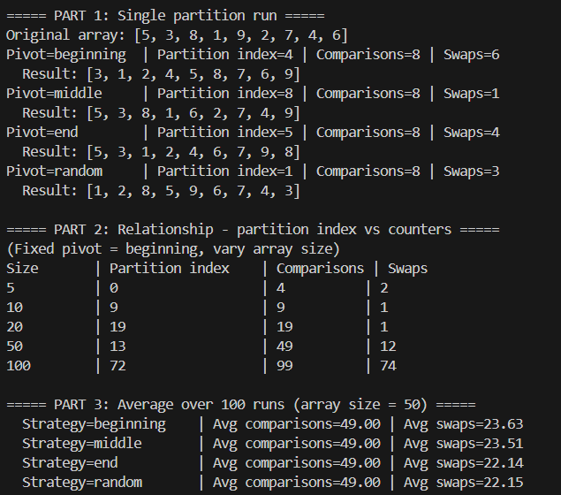
Figure 1 — PartitionApp console output

2.3 Analysis
An important observation is that all four strategies yield exactly the same number of comparisons (n − 1 = 8 for an array of size 9). This is expected: the partition loop always iterates over every element in the range exactly once, regardless of which element becomes the pivot.

The number of swaps, however, differs substantially between strategies. The middle-element strategy required only 1 swap on this particular input, while beginning required 6. Over 100 runs with a size-50 array, average swap counts converge to a narrow range (22–24), indicating that for uniformly random data all strategies perform similarly on average.

The partition index reflects where the pivot actually lands after partitioning. A value near the middle of the array is preferred for Quick Sort, since it produces balanced recursive subproblems. Pivot strategies that choose a bad pivot (e.g., always the smallest or largest element on a sorted array) degrade Quick Sort to O(n²).

3. Merge Sort

3.1 Algorithm Description
Merge Sort is a divide-and-conquer algorithm. It recursively splits the array in half, sorts each half, then merges the two sorted halves into a single sorted sequence. The merge step copies elements into temporary left/right arrays and then writes them back to the original array in sorted order.

Because every element is eventually written to a temporary buffer and then written back, the copy count is significantly higher than in in-place algorithms. Swaps do not occur — all movement is achieved through copy operations. The theoretical complexity is Θ(n log n) for comparisons and Θ(n log n) for copies.

3.2 Results
Size | Comparisons | Copies
10,000 | 120,541 | 267,232
15,000 | 189,285 | 417,232
20,000 | 261,066 | 574,464
25,000 | 333,970 | 734,464
30,000 | 408,535 | 894,464
35,000 | 484,499 | 1,058,928
40,000 | 561,613 | 1,228,928
45,000 | 639,715 | 1,398,928
50,000 | 718,323 | 1,568,928

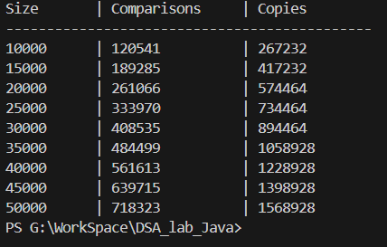
Figure 2 — Merge Sort console output

3.3 Analysis
The comparison counts grow smoothly from 120,541 at n = 10,000 to 718,323 at n = 50,000 — a factor of approximately 5.96×. Since the input size grew 5×, this closely matches the theoretical O(n log n) growth (5 × log(50000)/log(10000) ≈ 5.56).

Copy counts are approximately 2.2× the comparison counts at every size. This is consistent with theory: each merge writes n elements total (n comparisons and n copies from the merge loop) plus the initial copy into temporary arrays (another n copies), yielding roughly 2n copies per merge level and O(n log n) total.

Merge Sort has no swap column because the algorithm never exchanges two elements directly; it only reads and writes through temporary buffers.

4. Shell Sort

4.1 Algorithm Description
Shell Sort is a generalisation of Insertion Sort. It sorts elements that are far apart first, then progressively reduces the gap until a final gap-1 pass (equivalent to Insertion Sort) is performed. The gap sequence used here is the Knuth sequence: n/2, n/4, …, 1.

In each inner loop iteration, the current element is saved to a temporary variable (1 copy), shifted elements are written down (1 copy each), and the saved element is written to its final position (1 copy). Swaps are counted once per shift operation.

4.2 Results
Size | Comparisons | Copies | Swaps
10,000 | 264,871 | 389,940 | 149,930
15,000 | 413,522 | 601,300 | 241,286
20,000 | 615,562 | 885,664 | 365,654
25,000 | 837,670 | 1,175,653 | 525,641
30,000 | 927,738 | 1,332,980 | 552,966
35,000 | 1,179,785 | 1,687,955 | 707,943
40,000 | 1,397,456 | 1,977,432 | 857,422
45,000 | 1,571,739 | 2,224,884 | 964,866
50,000 | 1,888,681 | 2,614,080 | 1,214,068

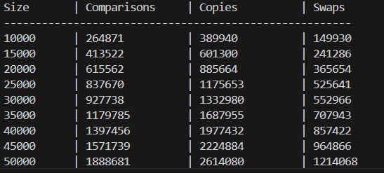
Figure 3 — Shell Sort console output

4.3 Analysis
Shell Sort produces the highest raw operation counts of the three algorithms at every size. Comparisons grow from 264,871 to 1,888,681 (×7.1 over a ×5 input range), suggesting a complexity slightly above O(n log n) — consistent with the theoretical O(n^1.3) to O(n log² n) depending on the gap sequence.

The ratio of copies to swaps is approximately 2.6:1, reflecting the three-copy overhead per shift (save temp, shift element, place temp). Copy counts grow faster than comparison counts, which is expected because each comparison that triggers a shift costs two extra copy operations.

5. Quick Sort 3 (Median-of-Three)

5.1 Algorithm Description
Quick Sort 3 is a variant of Quick Sort that selects the pivot as the median of the first, middle, and last elements of each subarray. This reduces the likelihood of encountering worst-case O(n²) partitions on already-sorted or nearly-sorted data.

Each swap is counted once and also contributes 3 copies (temp ← arr[i], arr[i] ← arr[j], arr[j] ← temp). Comparisons are counted inside the partition loop only.

5.2 Results
Size | Comparisons | Copies | Swaps
10,000 | 137,233 | 237,897 | 79,299
15,000 | 217,978 | 628,959 | 130,354
20,000 | 292,884 | 1,158,915 | 176,652
25,000 | 385,134 | 1,763,436 | 201,507
30,000 | 452,520 | 2,536,209 | 257,591
35,000 | 533,177 | 3,513,111 | 325,634
40,000 | 625,975 | 4,548,339 | 345,076
45,000 | 748,726 | 5,821,038 | 424,233
50,000 | 817,042 | 7,219,983 | 466,315

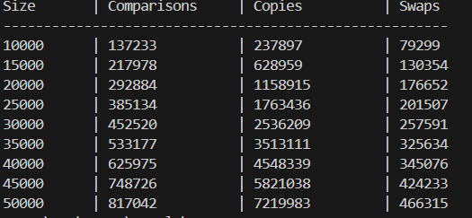
Figure 4 — Quick Sort 3 console output

5.3 Analysis
Quick Sort 3 achieves the fewest comparisons of the three algorithms: 137,233 at n = 10,000 vs. 120,541 for Merge Sort — they are remarkably close. Swaps are also low, growing from 79,299 to 466,315 (×5.9). This confirms the O(n log n) average-case behaviour.

The copy count grows disproportionately fast — from 237,897 at n = 10,000 to 7,219,983 at n = 50,000 (×30). This is because copies = 3 × swaps, and swaps include the median-of-three pivot selection swaps performed at every recursive level in addition to partition swaps. On highly random data the partition selects many pivots near the median, causing many swap operations.

6. Comparative Analysis

6.1 Combined Summary Table
The table below consolidates all results for direct comparison (MS = Merge Sort, SS = Shell Sort, QS = Quick Sort 3):

Size | MS Comp. | MS Copies | SS Comp. | SS Copies | SS Swaps | QS Comp. | QS Copies | QS Swaps
10,000 | 120,541 | 267,232 | 264,871 | 389,940 | 149,930 | 137,233 | 237,897 | 79,299
15,000 | 189,285 | 417,232 | 413,522 | 601,300 | 241,286 | 217,978 | 628,959 | 130,354
20,000 | 261,066 | 574,464 | 615,562 | 885,664 | 365,654 | 292,884 | 1,158,915 | 176,652
25,000 | 333,970 | 734,464 | 837,670 | 1,175,653 | 525,641 | 385,134 | 1,763,436 | 201,507
30,000 | 408,535 | 894,464 | 927,738 | 1,332,980 | 552,966 | 452,520 | 2,536,209 | 257,591
35,000 | 484,499 | 1,058,928 | 1,179,785 | 1,687,955 | 707,943 | 533,177 | 3,513,111 | 325,634
40,000 | 561,613 | 1,228,928 | 1,397,456 | 1,977,432 | 857,422 | 625,975 | 4,548,339 | 345,076
45,000 | 639,715 | 1,398,928 | 1,571,739 | 2,224,884 | 964,866 | 748,726 | 5,821,038 | 424,233
50,000 | 718,323 | 1,568,928 | 1,888,681 | 2,614,080 | 1,214,068 | 817,042 | 7,219,983 | 466,315

6.2 Comparisons
At n = 50,000, the comparison counts rank as follows:
- Merge Sort: 718,323 — lowest, most consistent O(n log n)
- Quick Sort 3: 817,042 — close second, slightly higher due to median-of-three overhead
- Shell Sort: 1,888,681 — highest, ~2.6× more comparisons than Merge Sort

6.3 Memory Movement (Copies)
Merge Sort keeps copies at approximately 2× comparisons because it operates solely through temporary arrays. Quick Sort 3 copies grow very fast (×30 over the tested range) since each swap contributes 3 copies. Shell Sort copies are moderate and grow at a similar rate to comparisons.

6.4 Swaps
Merge Sort has zero swaps by design. Quick Sort 3 has the fewest swaps of the in-place algorithms, confirming that an efficient pivot strategy minimises unnecessary exchanges. Shell Sort has more swaps because each shift in the inner loop is counted as a swap.

6.5 Comparison with Simple Sorting Algorithms (Lab 2)
Simple O(n²) algorithms such as Bubble Sort and Selection Sort would require approximately n² comparisons. At n = 50,000 this is around 2.5 billion — three to four orders of magnitude worse than the advanced algorithms measured here. The advanced algorithms achieve their efficiency by reducing the comparison count to O(n log n) ≈ 780,000 at the same scale, demonstrating the practical importance of algorithm choice for large inputs.

7. Conclusion
All three advanced sorting algorithms outperform simple O(n²) sorts by several orders of magnitude at large input sizes. Among them:

- Merge Sort is the most predictable — Θ(n log n) in all cases with stable sort order — at the cost of O(n) extra memory for temporary arrays.
- Quick Sort 3 achieves the best comparison and swap counts in practice on random data, with in-place operation. The median-of-three pivot avoids worst-case degradation on sorted inputs.
- Shell Sort sits between the two — simpler to implement than the others and still substantially faster than O(n²) algorithms — but produces more operations than O(n log n) algorithms, particularly as n grows.

For practical applications where stability is required and memory is available, Merge Sort is the preferred choice. When in-place sorting with minimal swaps is needed, Quick Sort 3 with a good pivot strategy is optimal for random data.

