SE Lab 4 – Requirement specification + System modeling
Group name:
Topic: Employee Attendance System Database
Member | Tasks
1.  Vương Phi Long-ITITIU21238 | Draw Use Case, ERD Diagram, Class Diagram
2.
3.

Documents of diagrams:
Use case:
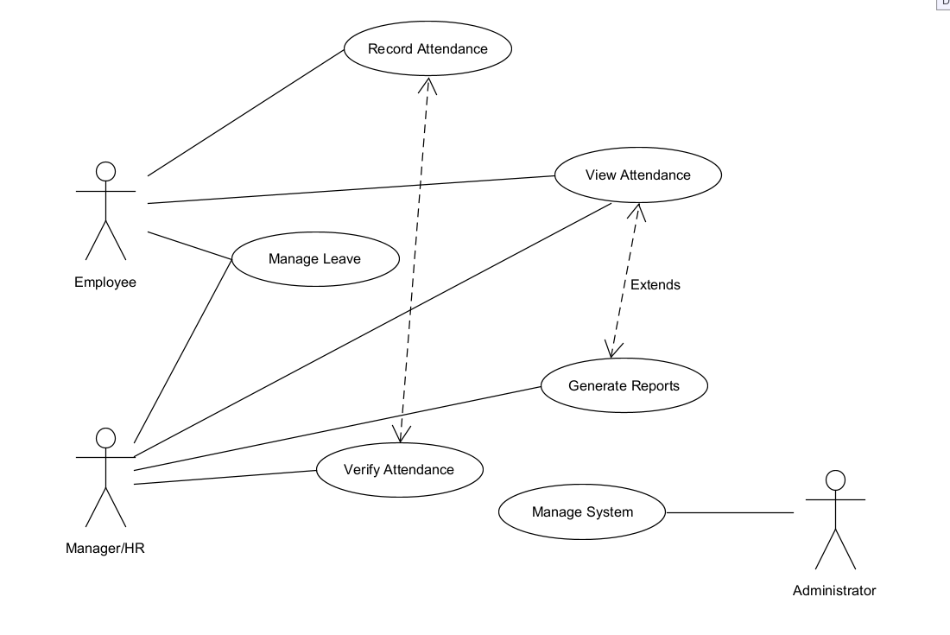

ERD:
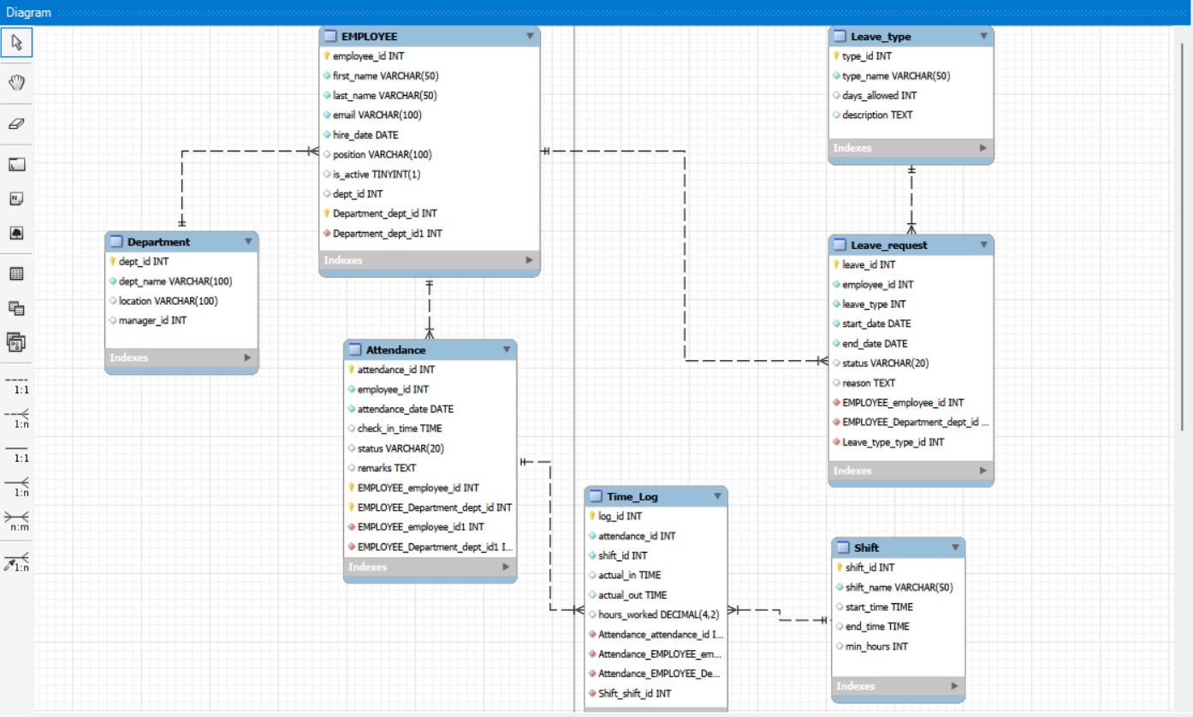

Class Diagram:
