**CA 1**

**Software Testing using Selenium**



**727721EUIT082**

**Logadheep N**

1.

package solutions;

import org.openqa.selenium.By;

import org.openqa.selenium.WebDriver;

import org.openqa.selenium.WebElement;

import org.openqa.selenium.firefox.FirefoxDriver;

import org.openqa.selenium.firefox.FirefoxOptions;

import org.openqa.selenium.support.ui.Select;

import io.github.bonigarcia.wdm.WebDriverManager;

public class Question1 {

public static void main(String args[]) {

WebDriverManager.firefoxdriver().setup();

WebDriver driver;

FirefoxOptions fo=new FirefoxOptions();

fo.addArguments("--remote-allow-origins=*");

driver = new FirefoxDriver();

driver.manage().window().maximize();

driver.getWindowHandle();

driver.get("https://www.amazon.in/Logitech-Hyperion-Ultra-Gaming-Mouse/dp/B00NFD0ETQ/");

String title = driver.getTitle();

System.out.println(title);

driver.findElement(By.id("add-to-cart-button")).click();

if(driver.findElement(By.xpath("//*[@id=\"NATC_SMART_WAGON_CONF_MSG_SUCCESS\"]/span")).getText()=="Added to cart") {

System.out.println("1. The product was added to cart.");

driver.findElement(By.id("sw-gtc")).click();

WebElement quantity = driver.findElement(By.id("a-autoid-0-announce"));

quantity.click();

Select select=new Select(quantity);

select.selectByIndex(9);

String drop=driver.findElement(By.xpath("//*[@id=\"quantity\"]")).getText();

System.out.println("3. The quantity was updated to "+drop);

WebElement checkout = driver.findElement(By.name("proceedToRetailCheckout"));

checkout.click();

if(driver.getTitle().equals("Amazon Sign In"))

System.out.println("4. Proceeded to checkout(Sign in page)\n 5. Verified that the checkout is being processed");

driver.navigate().back();

driver.findElement(By.name("submit.delete.88484e16-6dbe-47f0-afc1-5611661a416a")).click();

String removal =

driver.findElement(By.xpath("/html/body/div[1]/div[2]/div[3]/div[5]/div/div[2]/div[1]/div/form/div[2]/div/div/div[1]/span")).getText();

if(removal.contains("removed")) System.out.println("2. "+removal);

}

}

}

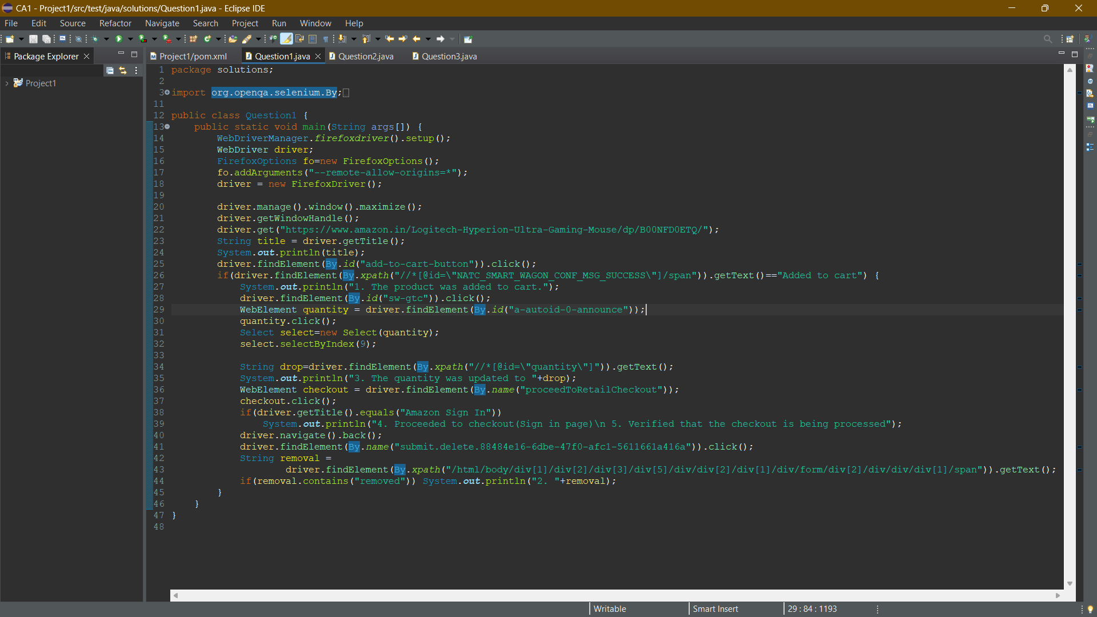

2. 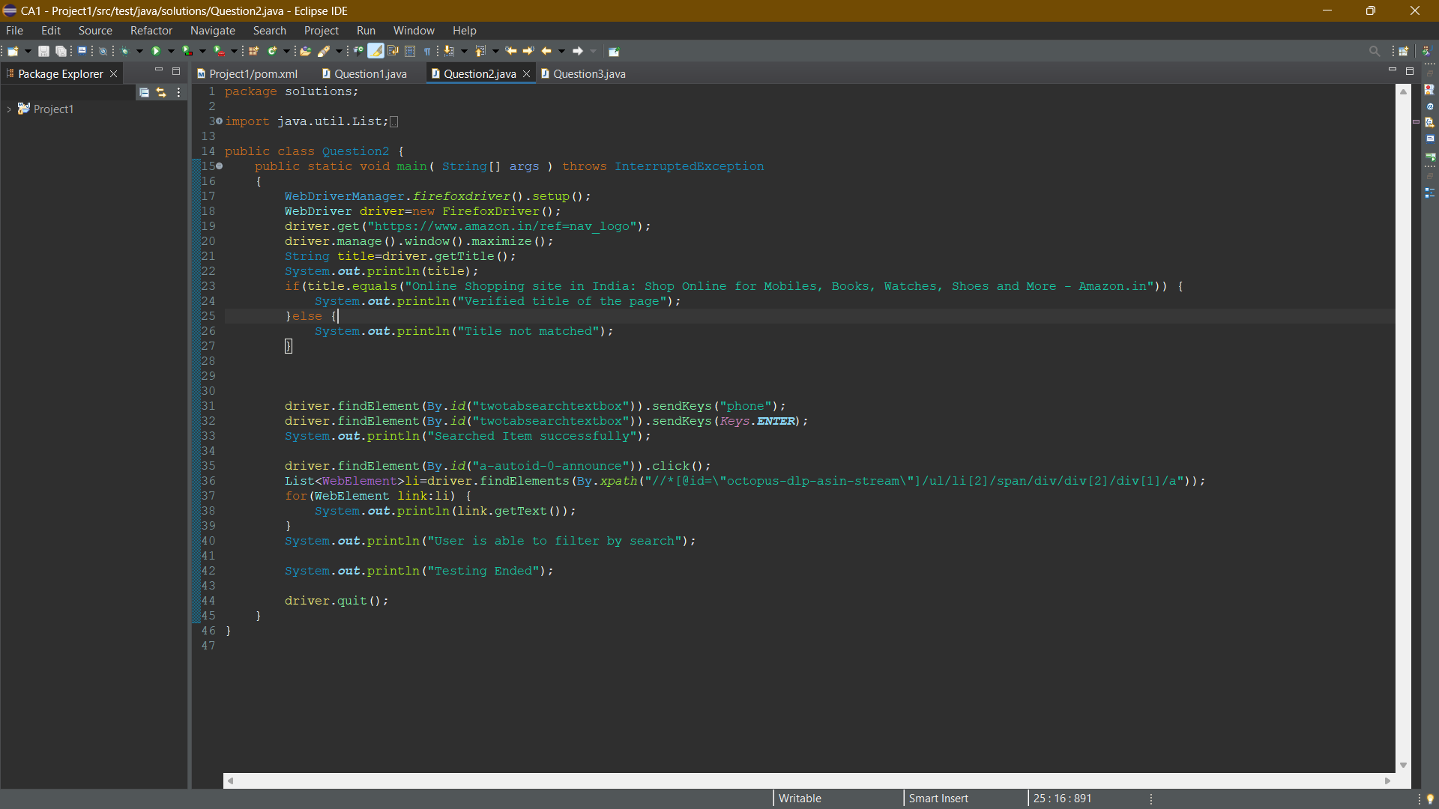

package solutions;

import java.util.List;

import org.openqa.selenium.By;

import org.openqa.selenium.Keys;

import org.openqa.selenium.WebDriver;

import org.openqa.selenium.WebElement;

import org.openqa.selenium.firefox.FirefoxDriver;

//import org.openqa.selenium.firefox.FirefoxOptions;

import io.github.bonigarcia.wdm.WebDriverManager;

public class Question2 {

public static void main( String[] args ) throws InterruptedException

{

WebDriverManager.firefoxdriver().setup();

WebDriver driver=new FirefoxDriver();

driver.get("https://www.amazon.in/ref=nav_logo");

driver.manage().window().maximize();

String title=driver.getTitle();

System.out.println(title);

if(title.equals("Online Shopping site in India: Shop Online for Mobiles, Books, Watches, Shoes and More - Amazon.in")) {

System.out.println("Verified title of the page");

}else {

System.out.println("Title not matched");

}

driver.findElement(By.id("twotabsearchtextbox")).sendKeys("phone");

driver.findElement(By.id("twotabsearchtextbox")).sendKeys(Keys.ENTER);

System.out.println("Searched Item successfully");

driver.findElement(By.id("a-autoid-0-announce")).click();

List<WebElement>li=driver.findElements(By.xpath("//*[@id=\"octopus-dlp-asin-stream\"]/ul/li[2]/span/div/div[2]/div[1]/a"));

for(WebElement link:li) {

System.out.println(link.getText());

}

System.out.println("User is able to filter by search");

System.out.println("Testing Ended");

driver.quit();

}

}

3. 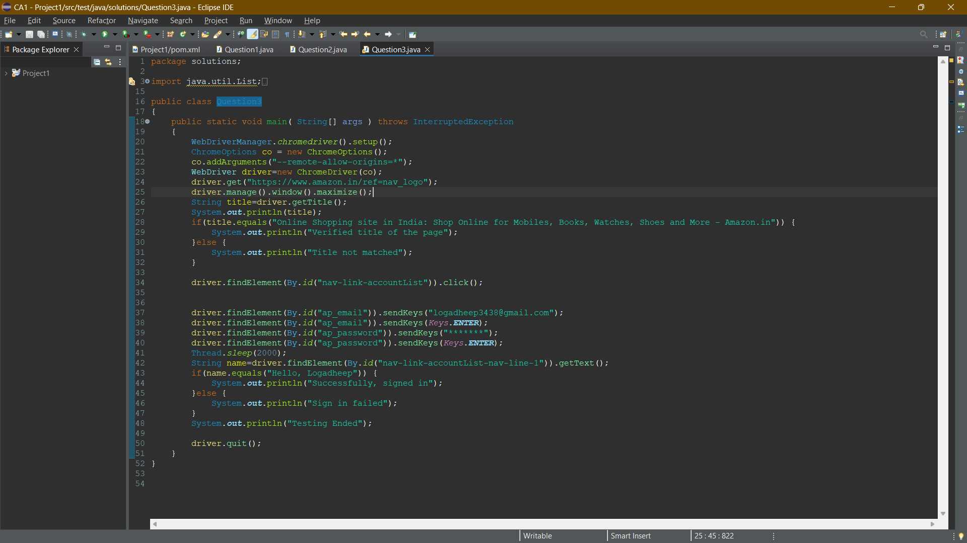

package solutions;

import java.util.List;

import org.openqa.selenium.By;

import org.openqa.selenium.JavascriptExecutor;

import org.openqa.selenium.Keys;

import org.openqa.selenium.WebDriver;

import org.openqa.selenium.WebElement;

import org.openqa.selenium.chrome.ChromeDriver;

import org.openqa.selenium.chrome.ChromeOptions;

import org.openqa.selenium.support.ui.Select;

import io.github.bonigarcia.wdm.WebDriverManager;

public class Question3

{

public static void main( String[] args ) throws InterruptedException

{

WebDriverManager.chromedriver().setup();

ChromeOptions co = new ChromeOptions();

co.addArguments("--remote-allow-origins=*");

WebDriver driver=new ChromeDriver(co);

driver.get("https://www.amazon.in/ref=nav_logo");

driver.manage().window().maximize();

String title=driver.getTitle();

System.out.println(title);

if(title.equals("Online Shopping site in India: Shop Online for Mobiles, Books, Watches, Shoes and More - Amazon.in")) {

System.out.println("Verified title of the page");

}else {

System.out.println("Title not matched");

}

driver.findElement(By.id("nav-link-accountList")).click();

driver.findElement(By.id("ap_email")).sendKeys("logadheep3438@gmail.com");

driver.findElement(By.id("ap_email")).sendKeys(Keys.ENTER);

driver.findElement(By.id("ap_password")).sendKeys("*******");

driver.findElement(By.id("ap_password")).sendKeys(Keys.ENTER);

Thread.sleep(2000);

String name=driver.findElement(By.id("nav-link-accountList-nav-line-1")).getText();

if(name.equals("Hello, Logadheep")) {

System.out.println("Successfully, signed in");

}else {

System.out.println("Sign in failed");

}

System.out.println("Testing Ended");

driver.quit();

}

}