Part 1:

Implement an OvS Container on the host.

Step 1: Run docker containers for OvS1 and OvS2 and run Ryu container

sudo docker run -itd --name OvS1 --cap-add NET_ADMIN socketplane/openvswitch:2.3.1

sudo docker run -itd --name OvS2 --cap-add NET_ADMIN socketplane/openvswitch:2.3.1  
sudo docker run -dit --name ryu_cont --network=host osrg/ryu

Force all traffic (ingress/egress) from/to the host to traverse the OvS Container

Step 1: Create the host bridge, sdn bridge, and traffic bridge by creating a docker network

sudo docker network create host

sudo docker network create sdn

sudo docker network create public

Step 2: Connect the bridges to OvS1

sudo docker network connect host OvS1

sudo docker network connect sdn OvS1

sudo docker network connect public OvS1

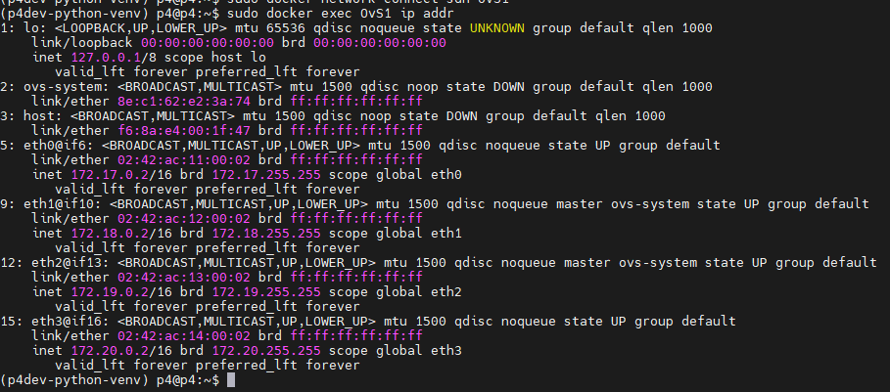

Step 4: Add the bridge ports to OvS1

ovs-vsctl add-br host

ovs-vsctl add-port host eth1

ovs-vsctl add-port host eth2

ovs-vsctl add-port host eth3

Step 5: Start and Connect Ryu

sudo docker exec -it ryu_cont ryu-manager ryu.app.simple_switch_13

sudo docker exec OvS1 ovs-vsctl set-controller host tcp:172.17.0.1:6633

The Problem

The problem is that when I initiate a ping to 8.8.8.8 directed at the host bridge interface, it hits OvS1 and sees it in its basic flow table, but flows like handling ping or just simply trying to get a port to send all traffic to the controller like the base flow does not work.

As you can see above, the flow I added to the OvS should see packets incrementing for the flow that denotes all traffic coming in port 1 should go to the controller, but that is not the case and it is hitting the base controller flow instead. I am not sure what I am doing wrong here, it could be that I don’t understand how docker bridges/networks work and me connecting those ports are simulating a host just being on the endpoint and it not being a true bridge?

If I can get these flows to work, I think my behavior of sending a ping to a specific location should satisfy the requirements met in the lab, but currently I have not yet implemented connectivity through OVSs. My reasoning behind adding a controller was seeing if the simple_switch_13 application would handle my ping any differently than the static flow I am adding. Other than that, I would implement floodlight purely for their flow pusher rest API.