Software-Defined Networks

Lab 2

GNS3 – Mininet Integration & Hardware

University of Colorado Boulder

Department of Computer Science

Professor Levi Perigo, Ph.D.

# Summary

The real world currently encompasses proprietary devices from vendors such as Cisco, Juniper, Brocade, and Arista. The world is moving from these traditional networks to a software-defined one. However, this transition is slow and requires a hybrid approach before phasing out the traditional hardware. This lab acquaints you with virtual and physical hardware, as well as traditional and SDN using GNS3, networking hardware, and Mininet in a hybrid topology. Please use this lab as a base to develop much more complex topologies to demonstrate a traditional and SDN hybrid network.

# Part 1: GNS3 – Mininet Integration

## Objective 1 – Install GNS3

1. Visit <http://gns3.com/> and download the latest version of GNS3 available.
2. Make sure you have an IOS image to be used in your router. If not, then please download the following image by searching on web:



1. Add the IOS image to the list of images in GNS3 as shown below: **[5 points]**

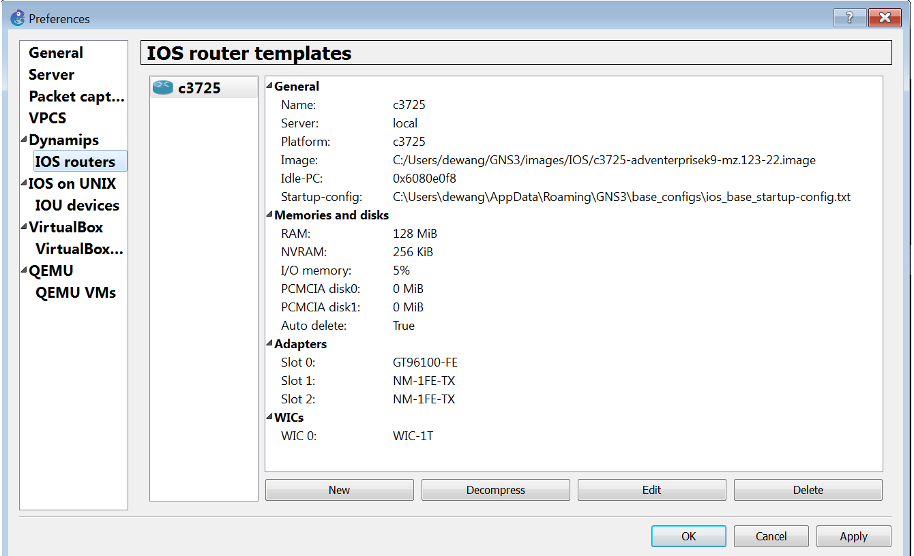

# Objective 2 - Integrating Mininet with VirtualBox

1. Configure two network interfaces as ‘Not Attached’ for the Mininet+OFM VM.
2. Add Mininet VM and enable console support for it by going to **Edit > Preferences > VirtualBox > New** in GNS3. Paste the screenshot after successfully adding the Mininet VM in VirtualBox by going to **Edit > Preferences > VirtualBox**. **[10 points]**

# Objective 3 - Topology Creation and Achieving Connectivity

1. Create the topology in GNS3 as shown **[10 points]**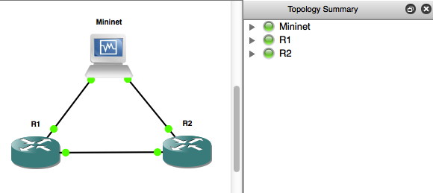

1. Start all the devices and add IP addresses to the interfaces of R1 and R2 such that the ones connecting Mininet are in 10.0.0.0/24 network excluding 10.0.0.1 and 10.0.0.2 (which will be used for end hosts inside Mininet VM) and the link connecting R1 and R2 in the 20.0.0.0/24 network.

Use Cisco CLI to configure interfaces of routers. Issue the appropriate Cisco CLI command to indicate all the router IP addresses and interface status. **[10 points].**

1. Initialize the default Mininet network topology using **sudo mn** and bind the interfaces to the actual physical interfaces using following two commands:

**Mininet> py s1.attach(‘eth0’)**

**Mininet> py s1.attach(‘eth1’)**

* 1. Paste the screenshot of the topology created in Mininet **[20 points]**

1. Check for full connectivity by pinging R2 from R1. Paste the screenshot of the ping command **[10 points]**

1. Enable ARP debugging on the routers to check the MAC address and IP mapping learned. Achieve router end-to-end connectivity. Paste the screenshot of the ARP debug results seen after executing ARP debugging on R1 and R2, that indicates the virtual hosts MAC addresses. **[10 points]**

Virtual hosts mac addresses:

R1:

R2:

# Objective 4 – Report Questions

1. Why do you think this lab is relevant for SDN? (*Think critically about virtualization, traditional networks, hybrid networks, etc.)* **[5 points]**
   1. This lab is relevant for SDN because it shows that legacy equipment can successfully connect and communicate with SDN capable hardware.

# Part – II: Installing OVS in GNS3

## Objective 1 – Add Open vSwitch (OVS) in GNS3

1. Add OVS appliance in GNS3 using the link: <https://gns3.com/marketplace/appliances/open-vswitch>.
2. If there are issues installing the appliance, configure it to use the local GNS3 VM, which can be downloaded from: <https://github.com/GNS3/gns3-gui/releases/download/v2.0.2/GNS3.VM.VirtualBox.2.0.2.zip>
3. Paste the screenshot of the current version of Open vSwitch from its console window. **[10 points]**

## Objective 2 - Topology Creation and Achieving Connectivity

1. Create the topology in GNS3 as shown-

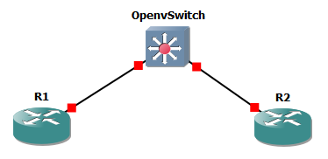

1. Assign static IP addresses to R1 and R2 in the same network.

Can you ping between R1 and R2 connected to the two OVS ports? Explain why this would or wouldn’t work, and provide a screenshot from OVS that supports your decision [**20 points**]

I can ping between R1 and R2. This works because OVS has flows to manage L2 traffic. It is pre-installed with APIs that include L2 learning and can learn any hosts that are connected to it and manage L2 traffic. As you can see in the above screenshot, the OVS is passing traffic between eth0 and eth1 which is where the two routers are connected to.

# PART – III: Connecting hardware switches to external controller

# Objective 1 – Connect Arista switch to an SDN controller

* + - 1. Each team will use one Arista switch for this objective. You can console into the Arista switch to access its CLI. [Login: admin]
      2. Connect the Arista switch to an external SDN controller.

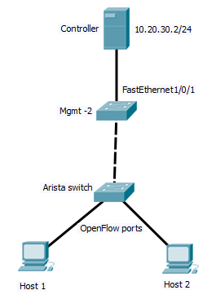

* + - * 1. The controller IP is 192.168.1.7/24 :6633 and it connected to the ‘Mgmt - 2’ switch on FastEthernet1/0/1. (Don’t change any config on this port)
        2. Connect two laptops to two ports on the Arista switch. Assign static IP's to the 2 laptops connected in another subnet (apart from 192.168.100.0/24 and 10.20.30.0/24).
        3. Follow the ‘Lab Devices-Arista-SFP’ document on Canvas to activate 10G ports.
        4. Follow Arista documentation instructions to activate OpenFlow ports on the hardware. [<https://www.arista.com/en/um-eos/eos-section-47-3-openflow-configuration#ww1141650>]
        5. To connect to the controller, connect one free port on the Arista switch to any of the Gig ports on the ‘Mgmt - 2’ switch.
        6. Make 2 new VLAN's on Arista - one for the traditional port connecting to the management switch, and another for the two OpenFlow ports connected to your laptops.
        7. Assign an IP to the traditional VLAN interface as: 10.20.30.20X/24 where X is your team number (for example, team 5 will assign 10.20.30.205/24).
        8. List all the commands needed in the Arista switch to connect to the controller; indicate in the switch that it is connected to the controller via the OpenFlow channel. [**25 points**]

4. Ping between two hosts connected to the Arista switch; show the success/failure of the ping, and the corresponding flow table on the switch. [**25 points**]

# Objective 2 – Connect HP switch to an SDN controller

1. Each team will use 1 HP switch from Switch 2 (192.168.100.2) , Switch 3 (192.168.100.3) or Switch 7(192.168.100.7) for this objective.
2. Use the IP’s provided to connect to the switch. Connect your workstation to the patch panel outside the Data Center in the panel labelled ‘NGN – Levi Perigo’. Then connect the corresponding port on the patch panel inside the data center to your HP switch on any port. Assign an IP in the range 192.168.100.100-200/24 to your workstation. To access the switch, Telnet on port 23 from your workstation to your HP switch IP. Do not change any configurations for Vlan 1, otherwise you will lose access to the switch.
3. Connect the HP switch to an external SDN controller.

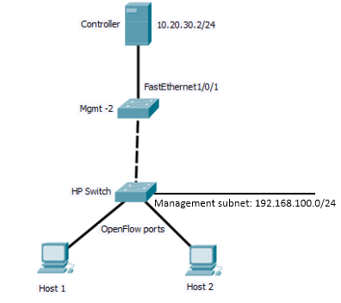

* + - * 1. The controller IP is 192.168.1.7/24 :6633 and it connected to the ‘Mgmt - 2’ switch on FastEthernet1/0/1.
        2. Connect two laptops to two free ports on the HP switch. Assign static IP's to the 2 laptops connected in another subnet (apart from 192.168.100.0/24 and 10.20.30.0/24).
        3. Follow HP documentation instructions to activate OpenFlow ports on the hardware. [<https://support.hpe.com/hpsc/doc/public/display?sp4ts.oid=1839466&docLocale=en_US&docId=emr_na-c04777809>]
        4. To connect to the controller, connect one free port on the HP switch to any of the FastEthernet ports 4-48 on the ‘Mgmt - 2’ switch.
        5. Make 2 new VLAN's on HP - one for the traditional port connecting to the management switch, and another for the two OpenFlow ports connected to your laptops. (Note: these VLANs are in addition to the 192.168.100.0 subnet on management VLAN 1, which is just to manage the switch - the management VLAN doesn't have anything to do with OpenFlow or the lab, it is just to access the HP CLI for configuration purposes.)
        6. List all the commands needed in the HP switch to connect to the controller; indicate in the switch that it is connected to the controller via the OpenFlow channel. [**25 points**]

4. Ping between two hosts connected to the HP switch; show the success/failure of the ping, and the corresponding flow table on the switch. [**25 points**]

# Objective 3 – Connect Arista to HP switch

1. Connect the Arista switch to the HP switch –

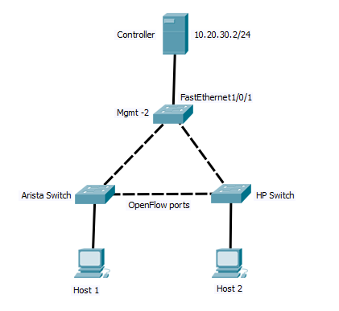

1. Provide screenshots from the OVS and HP switch showing the OpenFlow configurations and controller connectivity via the OpenFlow channel. [**20 points**]
2. Ping between the two hosts; show the success/failure of the ping, and the corresponding flow tables on the switches. [**20 points**]

**Total - _______ / 285**