SDEV1000 Project
Team Members:
- Logan
- Evan
- Sam

1. Problem Analysis & Decomposition for Entire System
Write solution here.
Flowchart for whole system (high-level).

2. Inventory Management Module

Problem Analysis and Decomposition for this module
Write solution here.

Adding a New Product
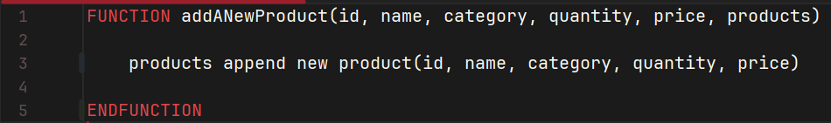Flowchart here.

Updating an Existing Product
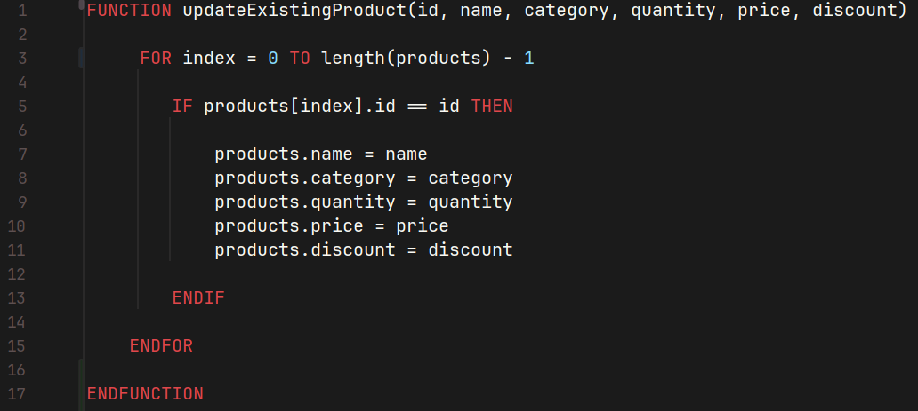Flowchart here.

Removing an Existing Product
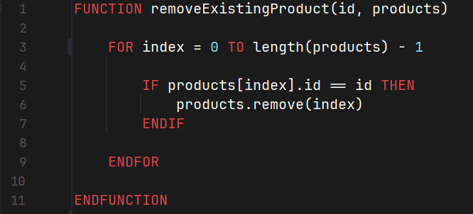Flowchart here.

Linear Search
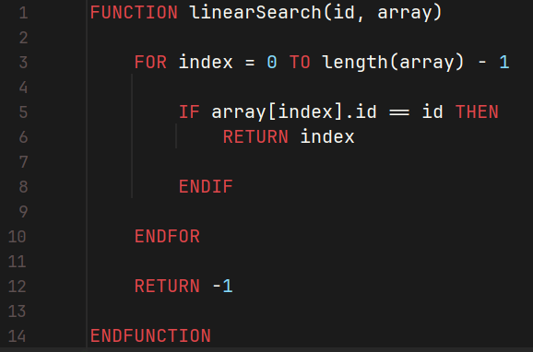

Binary Search

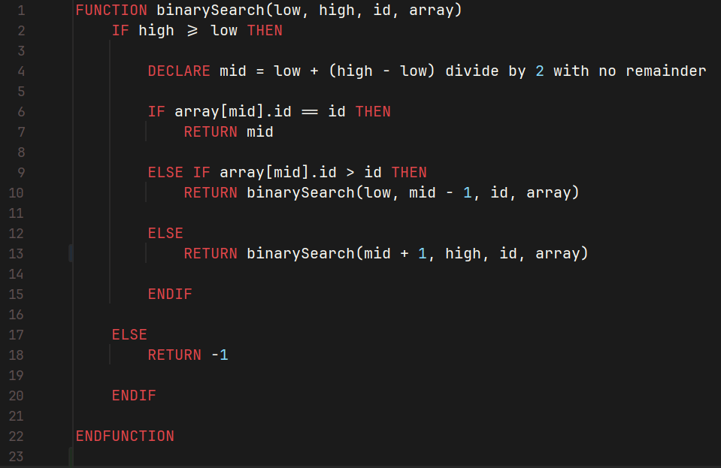
Bubble or Merge Sort
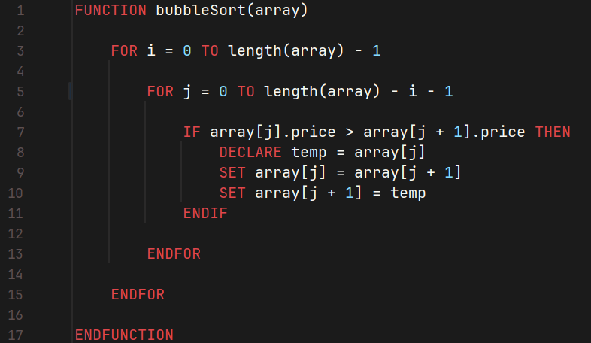

Justification of Algorithm Choice
Write justification here.

3. Sales Processing Module

Problem Analysis and Decomposition for this module
Write solution here.

Processing a Transaction
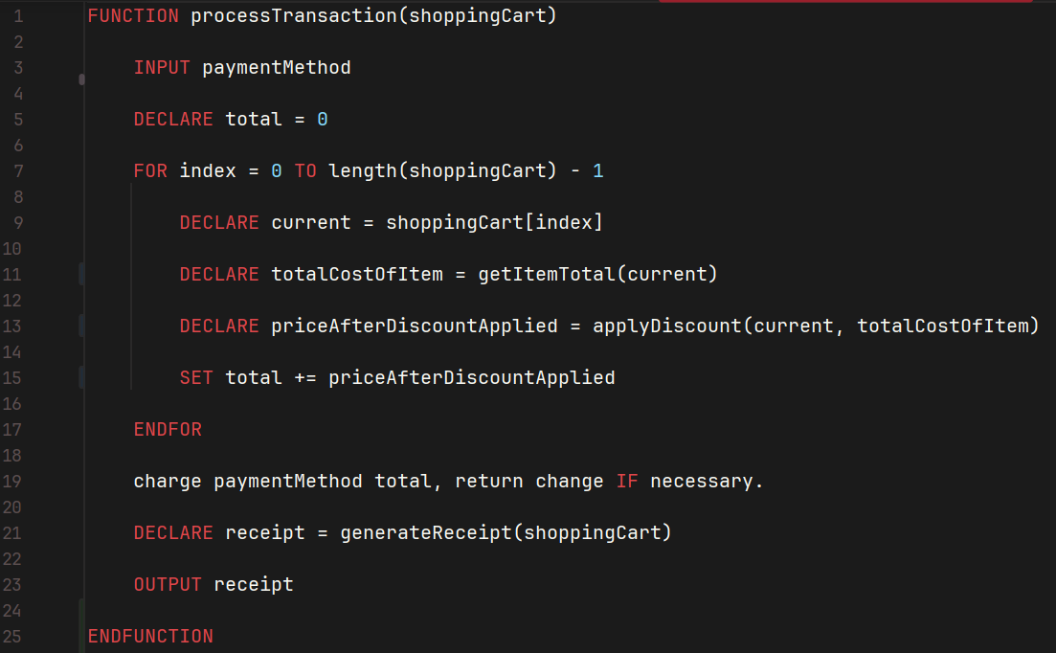Flowchart here.

Generating Receipts
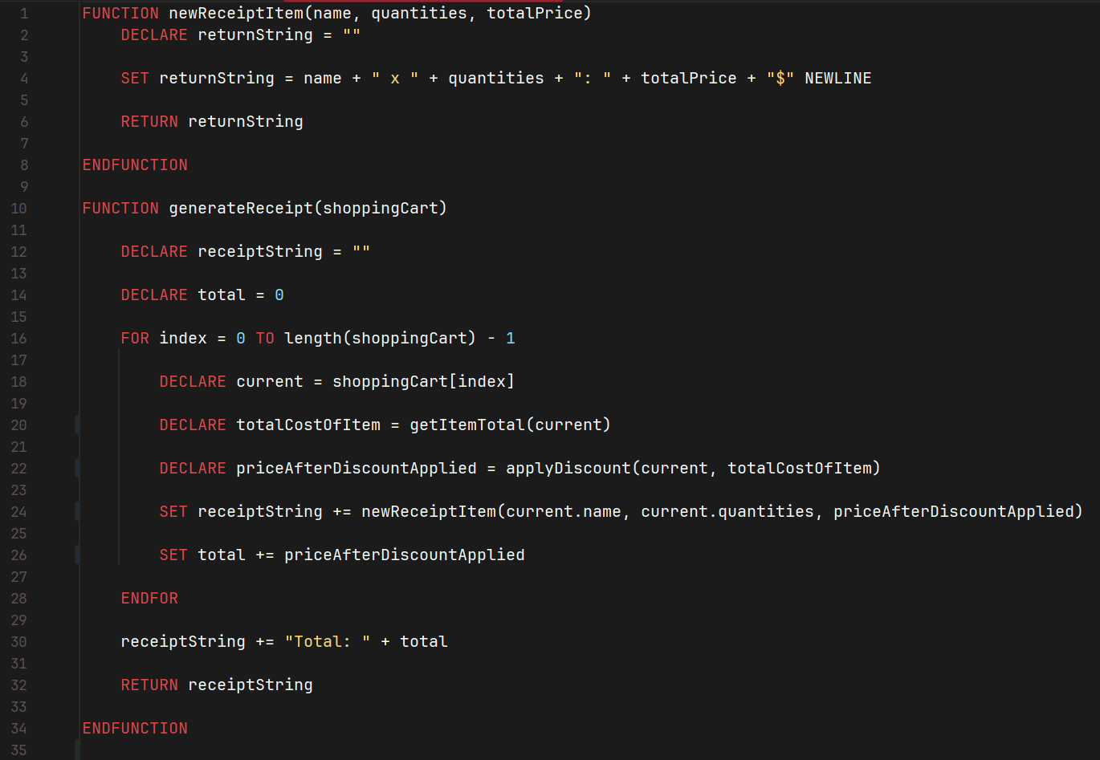Flowchart here.

Discount Calculation
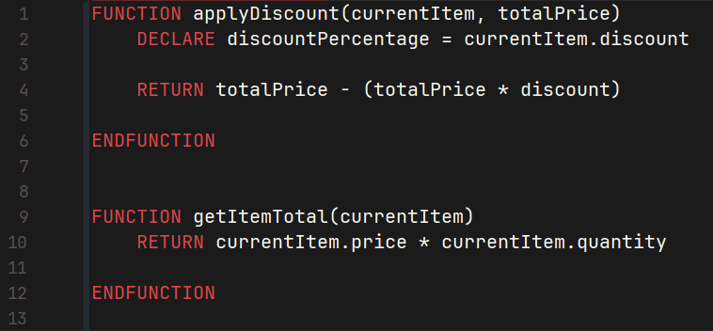Flowchart here.

4. Reporting Module

Statistical Analysis
Problem Analysis and Decomposition
Write solution here.

Product Analysis
Problem Analysis and Decomposition
Write solution here.

Correlation Analysis
Problem Analysis and Decomposition
Write solution here.

Probability Analysis
Problem Analysis and Decomposition
Write solution here.

Trend Analysis
Problem Analysis and Decomposition
Write solution here.

5. Algorithm Implementation & Justification

Sorting Algorithms
Bubble Sort (Simple Implementation):
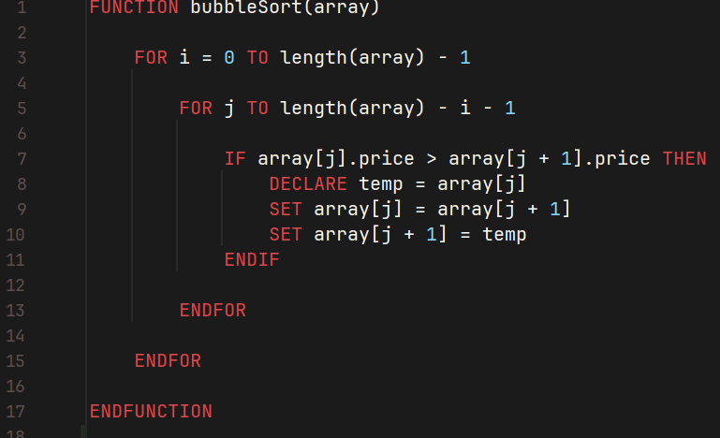Write explanation here.
Write justification here.
Merge Sort (Efficient Implementation):
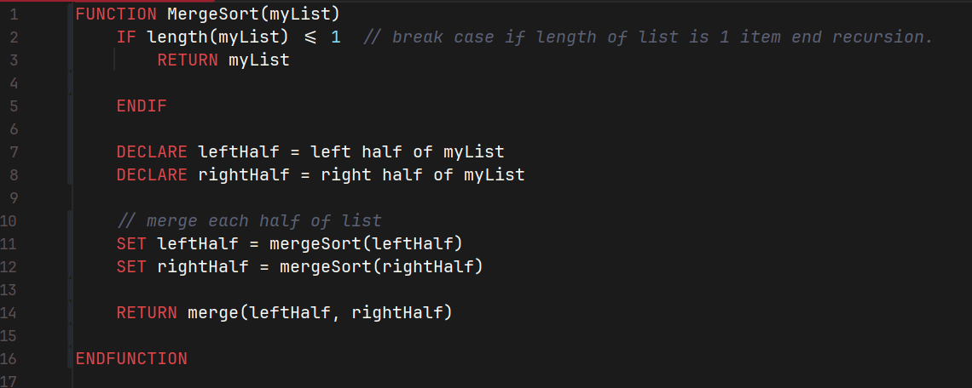
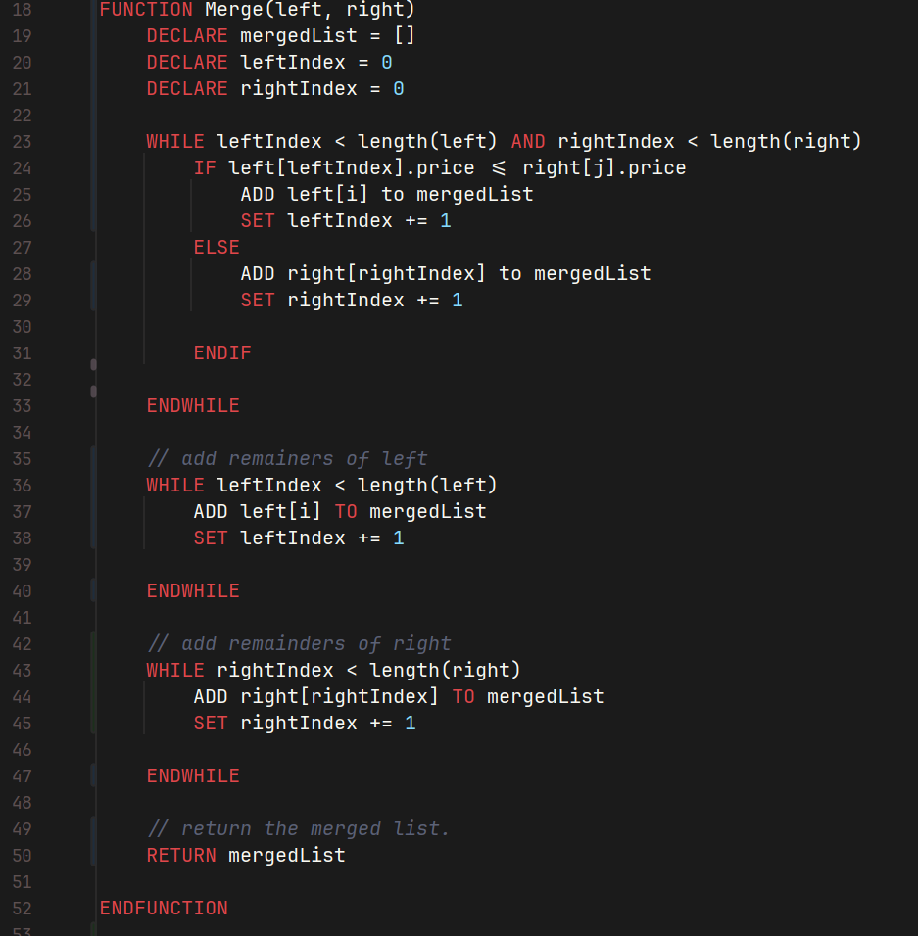Write explanation here.
Write justification here.

Searching Algorithms
Linear Search:
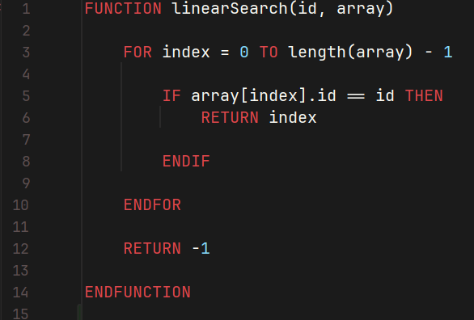Write explanation here.
Write justification here.
Binary Search:
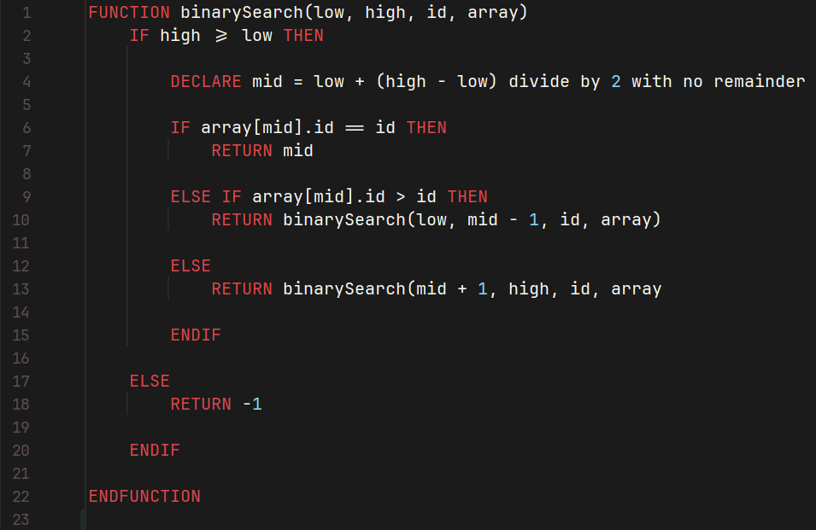Write explanation here.
Write justification here.

Optimizations
Write solution here.

6. Optimization & Validation

Optimizations
Write solution here.

Validations
Write solution here.

