Designing and Simulating a Secure Tech Startup Network with VLAN Segmentation, DMZ, and VPN Access

By:
Karrie Butcher
Camryn McPhaul
Daniel Opemipo Oni

- Introduction

Number of Major Areas
The network is broken into five major areas. The core layer is the backbone of the network and connects all the distribution-layer switches together, making sure traffic can move between segments quickly. The distribution layer is responsible for routing between VLANs and applying policies that control which departments can communicate with each other. The access layer is where all the end devices connect, and it covers three department VLANs for HR, Engineering, and Finance. There is also a DMZ that holds the web server and email server, keeping them accessible from the internet without exposing the internal network. The last area is the remote access segment, which allows off-site employees to connect through a VPN to securely reach resources on the internal network.

Security Measures
Security is handled at multiple points throughout the network. The following measures are implemented:
• Perimeter Firewall (ASA 5505): The Cisco ASA 5505 sits at the boundary between the internet, the DMZ, and the internal network. It performs stateful packet inspection — tracking the state of active connections rather than just evaluating packets in isolation — which allows it to distinguish between legitimate response traffic and unsolicited inbound probes. All traffic is denied by default; only flows explicitly defined in the security policy are permitted.
• VLAN Segmentation: HR, Engineering, and Finance are each placed on a separate VLAN, creating isolated Layer 2 broadcast domains. Devices on different VLANs cannot communicate at Layer 2, meaning even if a device in HR is compromised, the attacker cannot see or directly reach Engineering or Finance systems without first passing through the distribution layer — where ACLs are enforced.
• Access Control Lists (ACLs): ACLs are applied on the distribution-layer SVIs and define a whitelist of permitted inter-VLAN traffic flows. By default, cross-department communication is blocked. Only explicitly permitted flows — such as a specific application server that all departments need to reach — are allowed. This is the internal equivalent of the perimeter firewall.
• DMZ Architecture: Public-facing servers are isolated in a dedicated DMZ segment. The firewall enforces strict directional rules: inbound internet traffic can reach the DMZ servers on designated ports, but DMZ servers cannot initiate connections into the internal network. A compromise of the web or email server is contained within the DMZ.
• VPN Gateway: All remote employee connections are encrypted using IPSec and require authentication before access is granted. This ensures that remote traffic cannot be intercepted in transit and that only authorized users can establish a connection to internal resources.
• Port Security: Configured on all access-layer switch ports with sticky MAC address learning. Only the first device to connect to a given port is permitted. Unknown MAC addresses trigger a port violation, and the port is shut down until an administrator reviews it.

Type and Number of Devices
The following table lists all 21 devices included in the simulation, the quantity of each, and the specific role each plays in the network. All device models were selected based on Cisco Packet Tracer compatibility and their real-world equivalents in enterprise deployments.

Device Type | Quantity | Role
Core Router | 1 | Central routing and backbone connectivity
Layer 3 Distribution Switch | 2 | Inter-VLAN routing and ACL enforcement
Layer 2 Access Switch | 3 | Connects end devices in HR, Engineering, and Finance
Firewall (ASA 5505) | 1 | Perimeter security between internet, DMZ, and internal network
VPN Gateway Router | 1 | Encrypted remote access for off-site employees
Web Server | 1 | Public-facing company website hosted in the DMZ
Email Server | 1 | Public-facing email service hosted in the DMZ
Department PCs | 9 | 3 per VLAN (one set each for HR, Engineering, and Finance)
Remote Laptop | 1 | Simulates a remote employee connecting via VPN
Internet Cloud Node | 1 | Represents the external internet connection

The 21-device count represents a realistic entry-level enterprise topology. In a production deployment there would be more end-user devices and likely redundant core routers, but for simulation purposes this set is sufficient to demonstrate every major network function and verify all security controls end-to-end.

Initial Physical View -- Cisco Packet Tracer
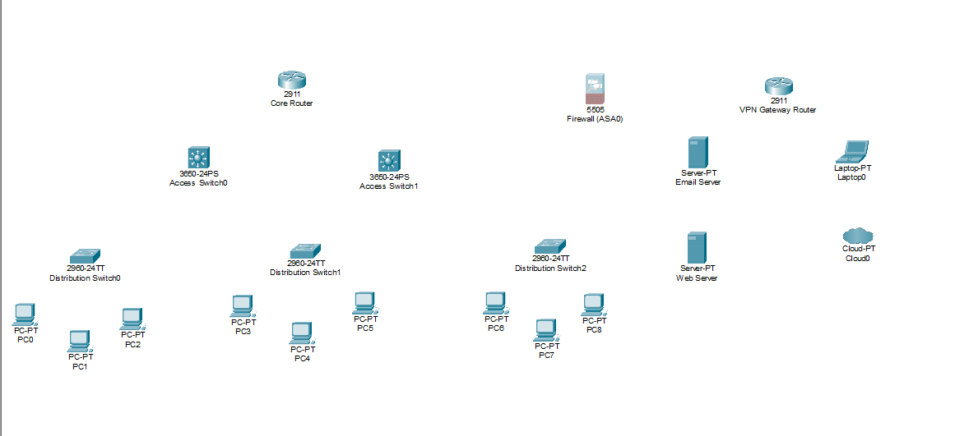

Workload Distribution

We divided the project work among three team members and will each present the section of work they personally completed in the video presentation. The table below shows the specific contributions of each team member for the project deliverable.

Team Member | Contributions
Karrie Butcher | Project topic selection, motivation write-up, overall project plan, report compilation, and video presentation introduction section
Camryn McPhaul | Device type and quantity documentation, Cisco Packet Tracer initial device placement and topology setup, screenshot capture, and video demo section
Daniel Opemipo Oni | Number of major areas documentation, security measures write-up, VLAN and ACL design planning, and video security section

Conclusion

This project demonstrates how a tech startup can implement a secure, scalable, and well-organized network using industry-standard architectural principles. By separating department traffic with VLANs, isolating public-facing servers in a DMZ, enforcing access control at the distribution layer, and providing encrypted remote access through a VPN gateway, the design addresses the most common attack vectors a startup network would face. Simulating the network in Cisco Packet Tracer allows the team to validate every design decision before committing to real hardware. The experience reinforces the importance of planning network security from the ground up rather than adding it as an afterthought.

