|  |  |
| --- | --- |
| 320-828-0805 | Logan.T.Anglin@gmail.com |

**Logan Anglin**

# **OBJECTIVE**

Motivated and technically skilled IT professional seeking an entry-level position in cybersecurity. Recently earned an AAS in Computer Programming (GPA 4.0) and currently pursuing a bachelor’s in computer science at Florida Gulf Coast University. Possesses foundational knowledge in network security, systems administration, and threat detection. Dedicated to protecting digital assets and supporting secure IT operations through proactive risk management and continuous learning.

# **TECHNICAL SKILLS**

* Security & Networking: LAN, Web Server Administration (Apache), Networking Architecture, System Hardening (intro), Secure Coding Practices
* Programming Languages: Python, Java, C#, JavaScript, PHP, SQL, MySQL
* Web Development: HTML, CSS, JavaScript, Front-end Development, Full-stack Development
* Databases: MySQL, Oracle, SQL
* Operating Systems: Windows, Mac OS, Linux
* Networking: LAN, Networking Architecture, Web Server Administration (Apache)
* Tools & Platforms: Microsoft Power Apps, Microsoft Power Automate, Microsoft Office Suite, Wireshark (intro), PowerShell
* Troubleshooting: Technical Troubleshooting, IT Support, Software Installation, System Maintenance
* Relevant Coursework: Network Security Fundamentals, Operating Systems, Database Management Systems, Systems Analysis and Design

**EDUCATION**

|  |  |  |
| --- | --- | --- |
| Maple Lake High School  GPA 4.0 | Ridgewater Community College  Major: Computer Programming  GPA: 4.0 | Florida Gulf Coast University  Major: Computer Science |

**EXPERIENCE**

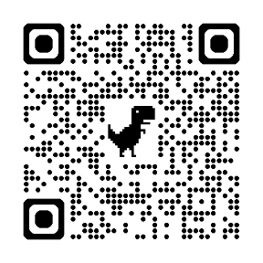*August 2020 – July 2025*

*Assistant / Aerial Photographer • City and Lakes Real Estate*

* Managed digital media assets and file systems, ensuring organization and accessibility.
* Contributed to team operations through coordination, scheduling, and technical support.
* Enhanced the company's online presence through image editing and basic web updates.

**ADDITIONAL SKILLS**

Personal Portfolio

* Analytical Thinking and Attention to Detail
* Passion for Cybersecurity and Ethical Practices
* Effective Team Communication and Collaboration
* Adaptable and Eager to Learn Emerging Technologies