Project 4 – Hazard Assessment

Nomaan Ahmed, Hunter Anciaux, Logan Baardson, Max Perry
CIVE 202
21 April 2026

Table of Contents
Introduction 3
Risk Comparison 3
Methods 4
Discussion of Results 6
Conclusion 10
Sources 11

Table of Figures
Figure 1 - Top and Bottom 10 Counties by Risk Score 6
Figure 2 - Top and bottom 10 counties by hurricane risk, Louisiana 7
Figure 3 - NRI vs adjusted risk for coastal flooding, Florida 8
Figure 4 - NRI vs adjusted risk for hurricanes, Louisiana 9

Introduction
This project aims to inspect and compare the risk of two natural hazards across two states. The chosen states are Florida and Louisiana, as they are close geographically and therefore would be exposed to similar natural hazards, while also sharing somewhat similar conditions on a social vulnerability level. Data from the National Risk Index (NRI), which was collected by the Federal Emergency Management Agency (FEMA), was utilized to show the risk “scores” for each hazard in the selected states. Data from the Social Vulnerability Index (SVI) was also inspected. The NRI is used to determine the relative risk of natural disaster events in the United States. Risk is defined as the product of probability of an event at times the impact of the event, should it occur. A risk value is determined by taking the expected annual loss times the social vulnerability divided by the community’s resilience. The expected annual loss is a dollar amount for the average economic loss each year from 18 different natural hazards. Social vulnerability is the susceptibility of social groups to negative impacts of natural hazards. Community resilience is the community’s ability to prepare, adapt to, and overcome hazardous effects. These three numbers are scored from a percentile ranking of 0-100. Those numbers are then used to determine a risk value. Then, for comparison, as requested by the client, a different definition of risk was created. This involved using the total exposure, expected annual frequency, and historic loss caused by each hazard in each census tract in the states. These two risk definitions could then be compared to see if any bias or major discontinuities existed. With the collected data, choropleth maps and other figures can be generated to visually represent and compare the two risk definitions.

Risk Comparison
The NRI risk definition takes into account the resilience of a community in how the risk affects them. This is somewhat subjective, though, and may vary with time or with what hazard is impacting them. Our adjusted risk looks at the frequency and exposure of the risk as its probability, with the population impact as the impact itself. The NRI’s impact is a dollar amount of damage, while ours looks at the impact on human life, which is far more important in the grand scheme.

Methods
Task 0 – Setting up coding environment:
The coding for this task was done in Python in the Jupyter Notebook environment. For this project, some tasks required tools that don’t exist in the base version of Python, so the packages NumPy, MatPlotLib, Pandas, and GeoPandas were imported. Then, the data used for the project was imported. CSVs containing the NRI and SVI data for Florida and Louisiana were imported, as well as a shapefile for the United States. The datasets had to be merged in order to perform calculations using both of them, so a column containing common data, “STCNTY”, was used to join them.

Task 1 – Determining and calculating alternative risk definition:
The way to determine risk that would be compared to the NRI’s was created using data from the NRI dataset. Risk is the probability multiplied with impact. The probability of the event was alternatively determined to be the product expected annual frequency and exposure. These two combined show how many times such an event will occur and how far they reach, so this is a good baseline for how likely they are to occur. The impact that was used was the historic loss ratio for population, which is the “percent of property/people have historically been lost from hazard in a given area” (FEMA). The product of these two columns correlated to hurricanes and coastal flooding were used as the second risk definition.

Task 2 – Comparing with bar graphs:
To visually compare the data sets, bar graphs are a good way to show magnitude side by side. It was determined that an effective way to show the two risk assessments side by side would be a bar graph displaying the top and bottom 10 counties ranked by each risk definition. To do this, the data was filtered by the created risk score and ranked by this value. Therefore, the counties displayed would be the top and bottom 10 by our calculated definition, and not necessarily by both. They were then plotted on a bar plot made with MatPlotLib.

Task 3 – Comparing using choropleth maps
To fully show the risk of each hazard across both states, it was necessary (and requested by the client) to generate a map of the area. To do this, the datasets were grouped by the NRI risk score and then by the adjusted risk score to display the values across the states. The GeoPandas package was used to combine the shapefile and the data to generate the plot. The coordinate systems of the two had to be set as the same so the map would line up correctly. The coordinate system ESRI:102003 was used, as this is common for maps of the contiguous United States. Null values in the counties were originally displayed in the dataset as values of -9999. These were subsequently replaced with NaN so they wouldn’t skew the data visually. Finally, the data was plotted and customized for the best visualization.

Discussion of Results
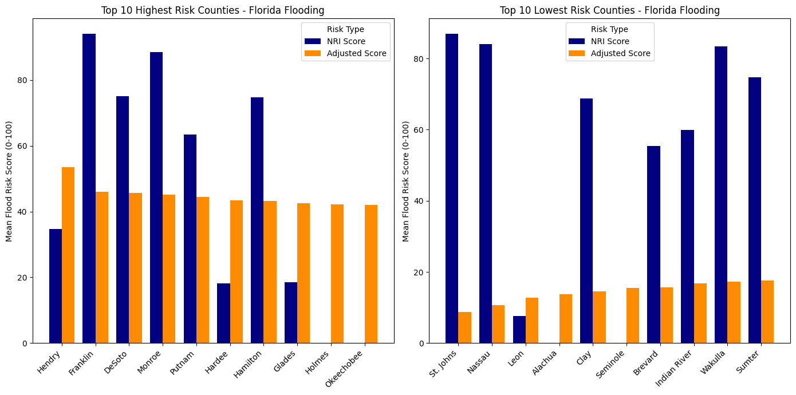
Figure 1 - Top and Bottom 10 Counties by Risk Score
It is evident that our calculated risk score seems to be less varied than the NRI’s. While they do not match directly, they generally do follow the same trend in the top 10. In the bottom 10, there is a large discrepancy. St. John’s county has the lowest score in the adjusted definition but one of the highest in the NRI’s. This could be where the impact of resilience comes into effect. It may be so that the SVI deems this county to be less able to recover from coastal flooding compared to others, and therefore it is going to have a much higher score. Some of the counties have an NRI value of 0. This means that the risk index does not consider there to be any concern in these areas from coastal flooding, even though it is calculated in our adjusted score that there is some loss of life.

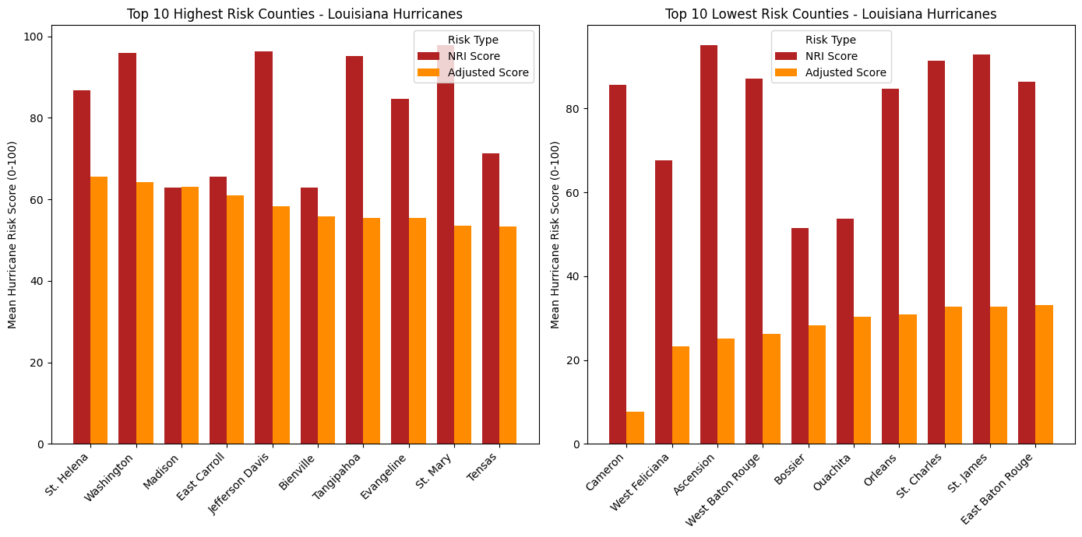
Figure 2 - Top and bottom 10 counties by hurricane risk, Louisiana
Our second state was Louisiana, and the second hazard examined was hurricanes. Again, the top 10 in each seem to have closer correlation, while the bottom 10 shows great discrepancy. There are no counties that either risk definition determines to be at zero risk from hurricanes. It is again likely due to the resilience factor that makes the NRI have so much larger values for the adjusted risk’s bottom 10. (Note that technically Louisiana does not have “counties”, rather it has parishes, but they are effectively the same and were examined as such).

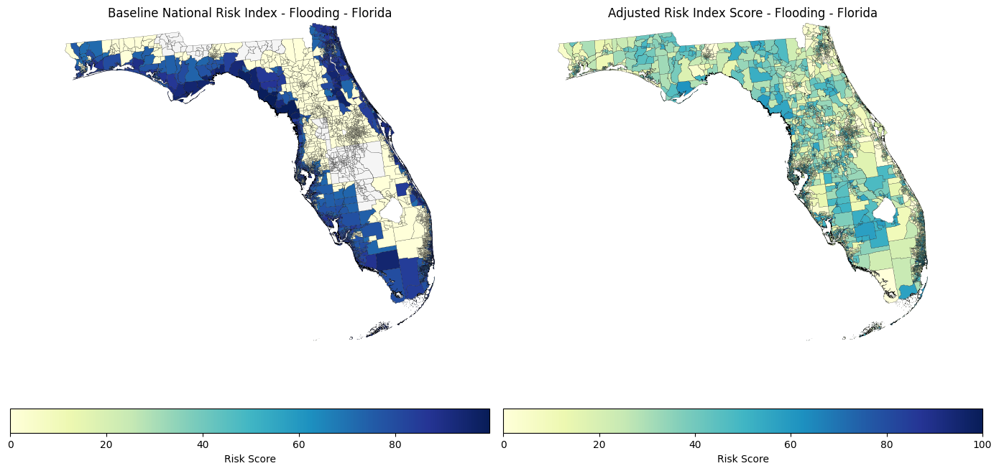
Figure 3 - NRI vs adjusted risk for coastal flooding, Florida
The NRI risk of coastal flooding in Florida seems to be largely geographically based. This does inherently make sense, as the closer to the coast something is, the more likely it is to be impacted by oceanic floods. This does not directly correlate to loss of life, though. The adjusted risk has some higher areas inland. This may be due to more historic devastating floods that could have caused higher proportional loss of life in lower populated areas. The most damage to infrastructure will occur at the coast, so that explains the trend in the NRI data. People inland, however, are less prepared to handle such events and therefore would be more likely to lose their lives.

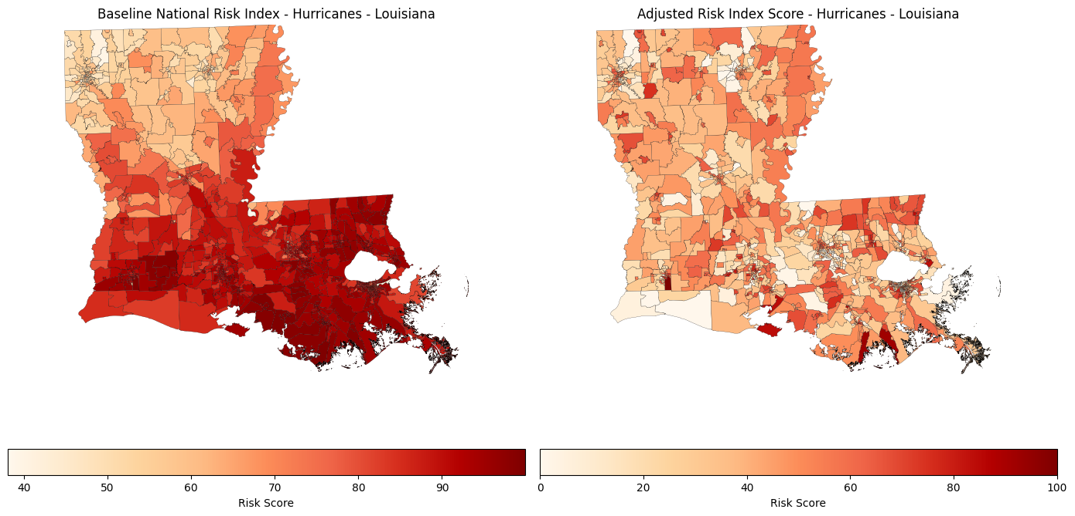
Figure 4 - NRI vs adjusted risk for hurricanes, Louisiana
The NRI hurricane risk again seems to be correlated with distance from the Gulf of Mexico. The discrepancies between the two are likely due to similar reasons as stated above. The adjusted risk score is more evenly distributed throughout the state, but the highest risk areas still existed closest to the gulf.

Conclusion
There are numerous ways that one could define the term “risk”. From the perspective of a risk consulting group such as Risk Averse, LLC, it is imperative that multiple angles are examined when examining the risk of a hazard in a given area. Every way to mathematically and programmatically calculate risk is going to have some benefits and some drawbacks. Understanding what they are, where they come from, and how they impact the results is important when making decisions related to management strategies and aid.

Sources
National Risk Index Discover the landscape of natural hazard risk Casey Zuzak, Senior Risk Analyst Risk Management Directorate. (n.d.). Retrieved April 21, 2026, from https://www.esri.de/content/dam/distributor-restricted/esri-de/files/landingpages/destatis/fema-national-risk-index-overview-casey-zuzak.pdf
‌

