;

**COMP 4320**

**Introduction to Computer Networks**

Project #: Lab 2

Logan Bolton

10/6/2025

# Executive Summary

Format:

* Font: Arial
* Font Size: 11
* Spacing: Double

This section should begin on a new page. The executive summary should include a summary of the findings and decisions

# Table of Contents

This section should begin on a new page. The table of contents below is generated using the "References" menu.

Table of Contents

Executive Summary 2

Table of Contents 3

List of Figures 4

List of Tables 5

1 Part (1) 6

2 Part (2) 6

2.1 First Subheading 6

2.2 Second Subheading 6

2.2.1 First Sub-subheading 6

2.2.2 Second Sub-subheading 7

3 Acknowledgements 7

4 References 7

5 AI Generated Statement 7

Appendix A: Place the title of appendix here 8

# List of Figures

This section should begin on a new page. This should be one of the last pages to be completed. Each Figure should have a descriptive caption.

# List of Tables

This section should begin on a new page. All tables must have a caption. If no tables are needed this section can be omitted.

# 1 Part 1 – TCP

## 1.1 Beginning Questions

1. My IP address is 172.17.48.138 and my port number is 64701.

2. The server IP address is 217.21.95.185. It’s port number is 80.

## 1.2 TCP Basics

1. The segment that initiates the connection has a relative sequence number of 0. It can be identified by how it says [SYN] and Seq=0 in the info.

2. The sequence number of the reply is 0. The value of the acknowledgement field is 1. Since the seq value was 0, the ack value was +1, resulting in the value 1. [SYN, ACK] in the info identifies it as a SYNACK segment.A screenshot of a computer screen

3. The sequence number of the segment containing the POST command was 149055.

4.

|  |  |  |  |  |  |
| --- | --- | --- | --- | --- | --- |
| Segment | Seq | Time | RTT | Ack Time | EstimatedRTT |
| 403 | 1 | 6.425416 | 0.288396000 | 6.137020 | 0.288396000 |
| 404 | 1 | 6.425418 | 0.288295000 | 6.137123 | 0.288383375 |
| 405 | 1 | 6.428940 | 0.291726000 | 6.137214 | 0.288801203 |
| 406 | 1 | 6.428941 | 0.291700000 | 6.137241 | 0.289163553 |
| 407 | 1 | 6.431449 | 0.293985000 | 6.137464 | 0.289766234 |
| 408 | 1 | 6.431451 | 0.293965000 | 6.137486 | 0.290291079 |

5. The length is 0

6. The minimum window size was 743 with a calculated window size of 95104. There was never any throttling.

7. Yes, there was one retransmission. It says it in the info section



8. In the ACK for one request, the window size was about 2054. I did not find instances of skipping.

9. The first data segment sent was 6.137516s and the last ACK that confirms the final byte was 6.431453s. 6.431453 − 6.137516 = 0.293937 s. The total amount of bytes in the POST was 149,393 bytes.  
149,393 bytes / 0.293937 s = 508,248 B/s.

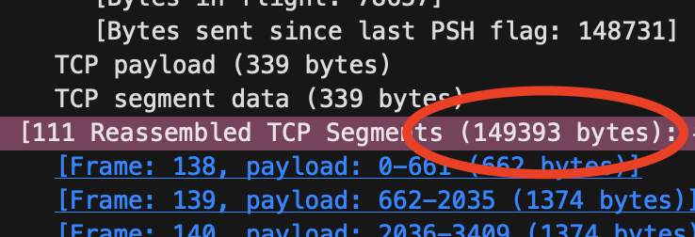

## 1.2 TCP congestion control in action

1. The low start is visible from about 0.28 s through 1.34 s. The upload completes before any transition to congestion avoidance. Unlike the ideal model, it starts with a larger initial window and shows irregular growth.

# 2 Part 2 - UDP

### 2.2.1 First Sub-subheading

### 2.2.2 Second Sub-subheading

Avoid any further divisions under the sub-subheading. Otherwise, the number of divisions becomes distracting and difficult to follow.

# 3 Part 3 - IPv4 vs IPv6 Traceroute

# 4 Acknowledgements

This section allows authors to acknowledge contributors and other sources that are not appropriate to list in the references section.

# 5 References

This is the last section of the report, prior to any appendices. The references should not be double-spaced, but single-spaced. For a technical report, use the CSE style.

[1] Reference 1 information.

[2] Reference 2 information.

[3] Reference 3 information.

# 6 AI Use Reflation Statement

As part of this assignment, you are required to explain how Artificial Intelligence (AI) tools were used in your work. For this you need to describe:

* Purpose of Use – Why you chose to use AI (for example: brainstorming, outlining, checking grammar, simplifying complex ideas, or generating examples).
* Extent of Use – To what degree AI contributed (for example: “I used AI to help refine my outline, but the analysis and arguments were entirely my own”).
* My Contribution – How I ensured the final assignment represents my own original thinking, understanding, and interpretation.

Reflections – What I found useful, what limitations I noticed, and how AI influenced my learning process.

**By writing this reflection, I acknowledge that AI is a support tool, not a substitute for my own effort, and I take full responsibility for the final submission.**