**Report 6122 A**

Name: Zilong Fan

GTID: 90391944

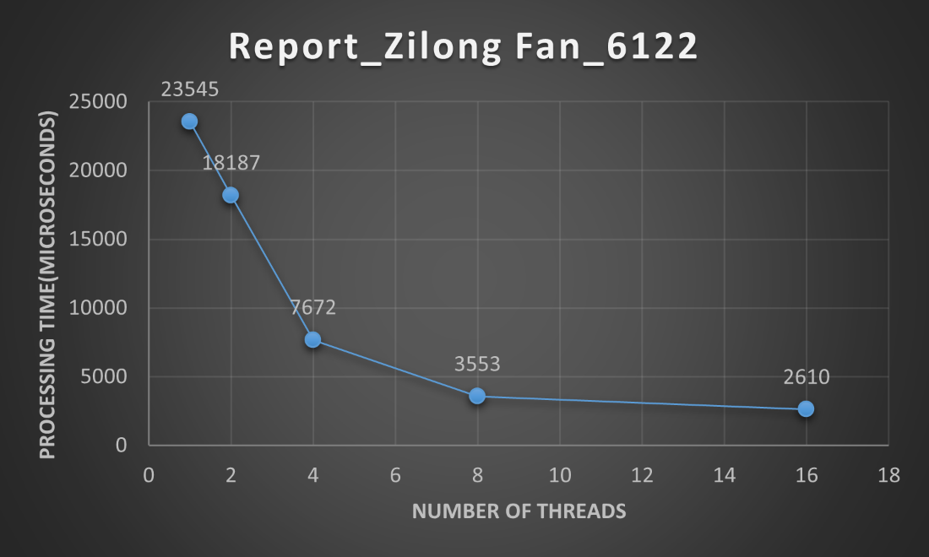

Number of Threads: This column indicates how many threads were used to perform the task concurrently. Processing Time (microseconds): This column shows the time it took to complete the task in microseconds (1 millionth of a second).

In summary, as I increase the number of threads from 1 to 16, the processing time generally decreases, indicating improved parallelism and faster task execution. However, after a certain point (in this case, between 8 and 16 threads), the reduction in processing time becomes less significant, suggesting that adding more threads may not provide further performance gains for this specific task.