CIS 1250 Python

Program1 – SquarePyramid

Objectives:
1.4. Demonstrate how to use numbers and expressions in python.
1.7. Demonstrate how to use IDLE to write a program.
1.8. Demonstrate how to declare and use variables in python.
1.9. Demonstrate how to get keyboard input from the user and store it in a variable.
1.10. Demonstrate how to write statements that will calculate results for the program.
1.11. Demonstrate how to use the print statement to display output to the screen.
1.12. Demonstrate how to use key functions in Python.
1.13 Demonstrate how to access more functions by importing modules.
1.14. Demonstrate how to save and execute programs.

Turn in Requirements:
5 pts. Name your project LastnameP1, such as NelsonE2.

Documentation Requirements:
- 5 pts. Write the file name, your name, email address and purpose of the program at the top of your source code in a comment.

# <your last name>P1
# Programmer: <your name>
# EMail: <your email address.
# Purpose: provides user capability to calculate
# volume of a pyramid.

- 5 pts. Add comments as appropriate. Be sure that your program output is neatly presented to the user.

Problem:
Write a program to calculate the surface area and volume of a square pyramid.
A square pyramid has a base that is square and all triangle faces are congruent isosceles triangles. (An isosceles triangle is a triangle in which two of the sides are equal.) Here is a picture of a square pyramid, and one that shows various labeled lines.
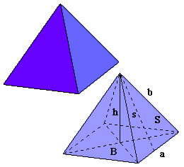 | Length of the base: a  Height of the pyramid: h  Volume = a²h/3  Slant height, s = sqrt(h² + (a/2)²) This is the  Pythagorean Theorem part.  Area of one pyramid side = s*a/2

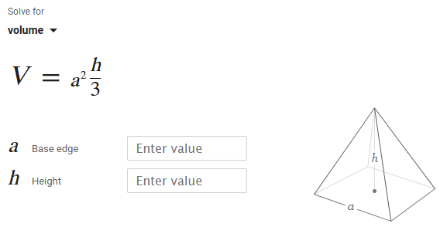
This formula does not include the area of the base. To find the surface area of a pyramid without the base, look at its four sides. Each side is a triangle. First, find the area of one triangle. Then multiply that area by 4 to get the total surface area.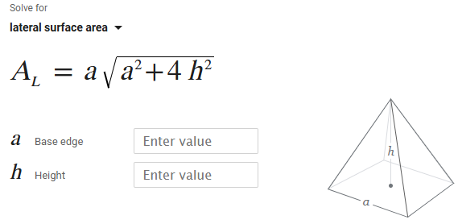
For this program you are to determine two things about a square pyramid, 1) the surface area of the four sides, and 2) the volume. Do not include the surface area of the base.

Program:
Be sure that your program output is neatly presented to the user.
The program asks the user to enter the pyramid height (in feet) and length of the base (in feet).
Your program will need to determine the surface area of the faces by using the Pythagorean theorem. The formulas are in the box above.
Your output should neatly show the height, base, total surface area, and volume of the pyramid using 3 decimal places of accuracy for all values.

Hints:

- You will need to import the math.sqrt function. >>> from math import sqrt
- Pay attention to order of operations in math formulas you write. You may need to use parenthesis to force the correct order of operations.
- In order to see output with a program you have to use the print statement. Programs do not automatically output the results of expressions the same way the interactive interpreter does.

