Logan Lipke
10/29/20
CISS 247
Lab 5 Report

Introduction:
For this lab we were tasked with adding onto our work from the previous lab. We needed to add a the SUBI, BL, and BR operations as well as a working stack.
Process:
The instructions themselves were very simple to add as they are very similar to operators I was already using. For SUBI I reused my code for ADDI but switched the plus sign to a minus sign. BR was simple as well. Since it branches to the contents of a register I could just set the pc to the value stored at the desired register. BL is a bit different, since it is used for sub-processes it sets the LR register to the current pc before jumping. That was all I had to do to get the operators finished.
The more complex part of this lab is the stack. Since it needs to be put into memory with the program I decided to use a define statement for the size similar to how I allocated space for the code itself. This stack size was then added to the number of max lines in the array.
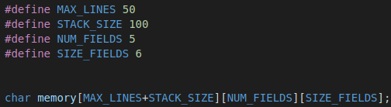

The tricky part about the stack would be growing it downwards and reflecting the size of it in the programs. The stack has to be set on double word boundaries, meaning it would need to decrement by 8 instead of the 4 that memory and code was incremented by. I chose to show this by setting register 28 (SP) to the number of (MAX_LINES+STACK_SIZE-1)*8. This would give a correct index in the memory array when divided by 8 as well as accurately show the size of the stack. This made printing the stack as it grew simple as well. Here is how I did it:
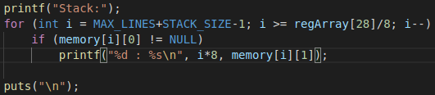

This helps produce this output:

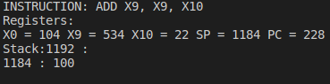

The only thing left to do with the stack was to set limits for how big it could grow or where the SP could point to. I chose to limit it to between the memory allocated for the program and the size of the stack. If it was larger than the total size of memory or went into the program memory an error would be printed and the program would exit.
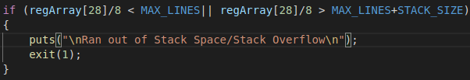
Testing:
Similar to lab 4, the best way to test the functionality of the new operations and the stack is to write an ARM program. For this lab I will be using two sets of code. One is a modified version of the original code.txt to test the stack. The second program will test the stack as well as the new branch operators. Here is the first program:
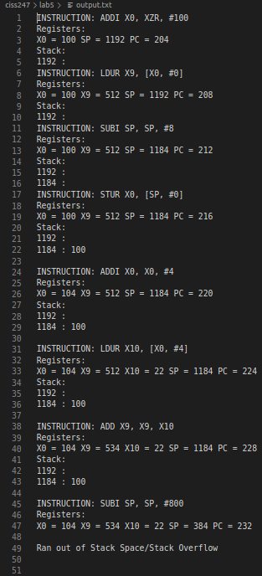

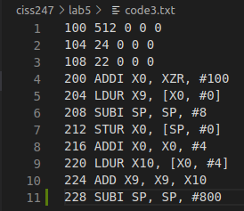

Here is the output --------------------------------->

Normally you would need to hit enter for each line, but I removed that to get this output. This program will do the same thing as the original code.txt but it adds 100 into the second spot in the stack. Towards the end I added a SUBI to subtract 800 from SP this is to test the limit of SP. As you can see by the final line it was caught because the stack got too big. Without having this exception you would be able to read a bunch of stuff in the memory of the program itself, which is a buffer overflow.

Results:

Conclusions:

