Logan Lipke
10/20/20
CISS 247
Lab 4 Report

The purpose of this lab is to build an emulator for ARM programs.

In order to properly accomplish this task I will need to 1) build a file parsing function that can get the needed information from the text files, 2) conditionally act on this information, and 3) call function equivalents for each ARM instruction.

The most important part of parsing the file would be determining how to organize the information. Since each line is formatted in a specific way, I could use this to help stay organized. Next I needed to decide on what type of storage to use. My initial thought was to use an array that would hold the strings so that every 5th item was the memory address to be used. I wasn’t quite successful in implementing this however, and decided to try another method. Instead of using an array of strings, I decided on an array of structs:
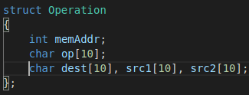

My reasoning for using this over an array of strings was that it would be easier for me to stay organized and maintain readability in the code when accessing the necessary components of the operation. I also created an array of structs for the memory that is created prior to the operations:
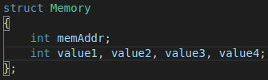

With my methods of storage decided, I now had what I needed to parse the file. This is the final function I ended up with:
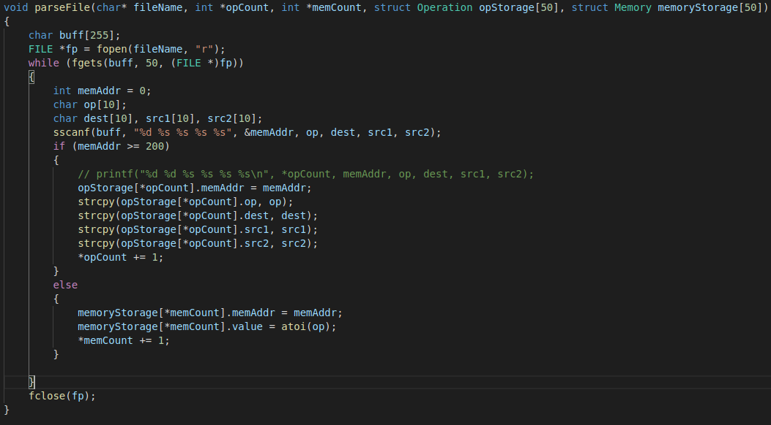
I wanted a way to keep track of the number of operations so I can accurately use a program counter and know when the program is complete, as well as a way to count the “memory” that gets used. I ran into some trouble for awhile parsing the file because I was trying to assign the struct values to the address of the functions local variable. This caused all the struct values to be set to the same thing, that being the final operation in the file. I decided to use strcpy to fix this problem. As far as the memory goes, I used the same method as the operations. This would allow me to easily access the memory location and its values in an array.

