Logan Lipke
10/14/20
Assignment 1 Report
CISS 247

The purpose of this assignment was to decrypt the contents of two files using a key and a series of bit manipulating functions.

It would take about 6 steps to decrypt the text in the files.
1) Obtain two keys from the key passed in as an argument and convert the key and text file contents into integers.
2) XOR the value of each 7 byte segment of input with the second key
3) Shuffle the nibbles of the input into the correct order
4) XOR the resulting bits with the first key
5) Rotate each septet to the left three bits
6) Convert the septets to characters to be printed

I used one function in a few other functions to help me extract bits more easily:
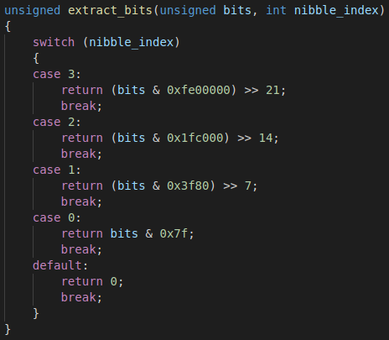

This function would return 7 bits that had been taken out according to the index of the section they were in. They would then be shifted over by a relative amount so they could be used without much more manipulation.

Step 1was mostly achieved with this function:
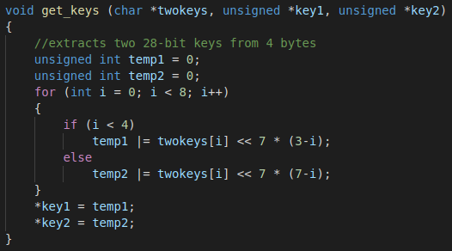
Since the keys have to be 8 characters long, I could use a for loop to split the two halves of the key. Key one was found by shifting the bits to the left by 7 times 3 minus the current character index. This allowed me to get 7 bit chunks of the key and push them in order to the leftmost side of the bits, preserving their order. This was repeated with the second half. By increasing the value that the index was subtracted from, I was able to keep a positive shift value.

Steps 2 and 4 were both achieved by setting the values of the bits I was working with to the bits XORed by the necessary parts of the key

Step 3 involved shuffling bits around. This is the function I used to accomplish this:
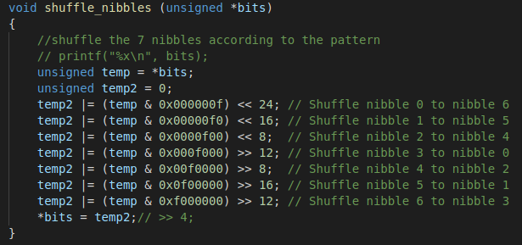
Since bits was always going to be 7 sections of 4 bits I used hex to easily isolate each set of bits. After this I was able to push them into the positions they needed to be in relative to where they were by multiplying 4 and the number of 4 bit sections they needed to be moved by.

Step 5 was one of the function I struggled with for awhile. This is the function I used to complete this step:
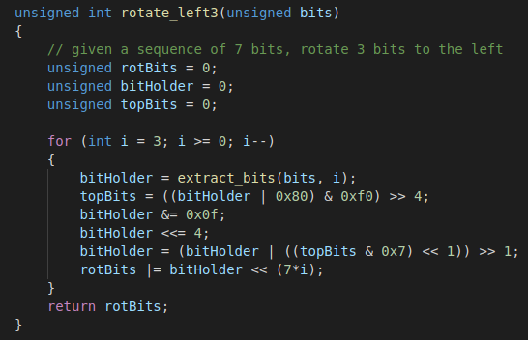
The idea I eventually had with this function was to make each septet into an octet by ORing the current bits with a value of 0b10000000. This would allow me to easily grab the top four bits. After this was done I removed the top four bits completely and was left with the bottom four that were then shifted to the left by four bits. I could then take the value of whatever I had extracted before, shift it right by four bits, and OR it with the new highest bits after shifting one to the left again. Finally the whole thing was shifted to the right one last time and could be considered successfully rotated by three bits.

Step 6 was one of the simpler steps to complete given that the previous steps were done correctly:
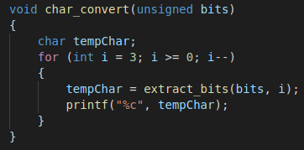

All this function does is use the extract_bits function to get the bits from left to right and then prints them to stdout while converting their numerical value to an ascii character.

The following screenshot shows my results and commands used in decrypting the text file contents:

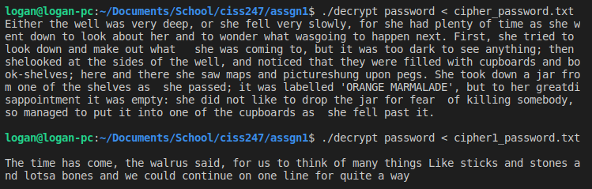
In conclusion, while this was a time consuming, and at times frustrating assignment, I believe it went well. I learned a lot about bit manipulation and troubleshooting some of the weirder errors in C. I ran into a few segmentation faults in the beginning but was able to fix those eventually. I’m hoping that my newfound knowledge of bit manipulation can help me in becoming a more efficient programmer in the future.

