The purpose of this lab is to convert two numbers to decimal, add them together, convert them back to their original base, and return the result.

In order to do this I needed to create two functions: toDecimal and fromDecimal. ToDecimal takes two arguments: an int base, and a pointer to a char array number. fromDecimal takes three arguments: an int base, an int decimal, and a pointer to a char array number.

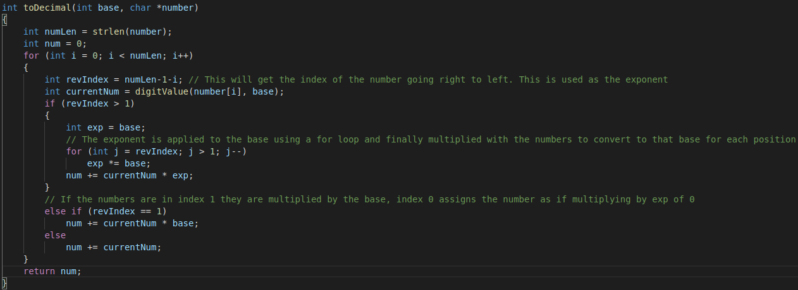
In order to convert to a decimal number I will need to iterate over the number array and compute the value in each place. I did this with a for loop. Inside the for loop I created an integer variable call revIndex to keep track of the index from right to left. I then used another for loop to compute the value of the base to the power of the index. This would allow me to use the equation numberAtIndex * base ^ index. This allows me to easily convert number bases to decimal.

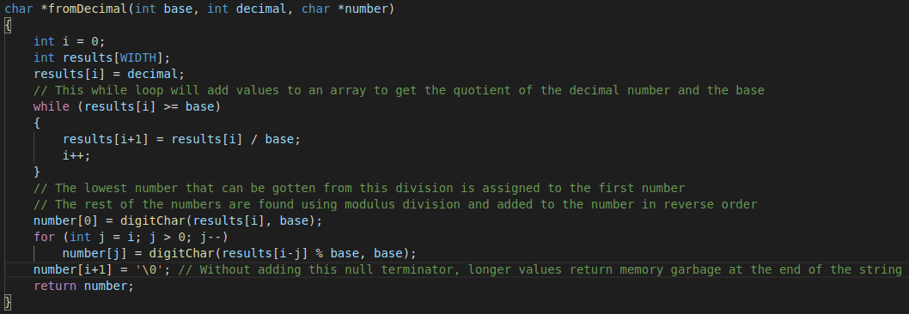
To convert from a decimal to any other base would require me to divide the number by the base until I reached a number less than or equal to the base. These numbers were all stored in an array of integers. After this, I used modulus division to find the values that should go into each place of the number. In doing this I found that it would give you the correct numbers, but in the opposite order they needed to be in so I reversed the order that they get added to the number array that gets returned.
To test that my program was working as it should I wrote a short bash script that runs the commands similar to in the lab description. The following screenshot shows my script and results.
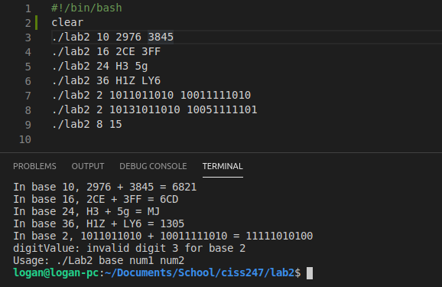
All tests performed as expected with varying sizes and bases the numbers were easily converted and computed.

Based on the results of this lab I can conclude that my program is a success. The biggest obstacles I ran into were getting the math right for the conversions, the reversed order of the fromDecimal conversions, and I also noticed that some outputs were adding random characters, often non-valid ascii, to the ends of the final number. I fixed that by adding a null terminator character to the end of the number char array before it was returned. Examples of this are below.

Before fix (notice the l, invalid character and U after the base 2 conversion, this could also happen to the other results if I changed the value of WIDTH to be greater than 25):

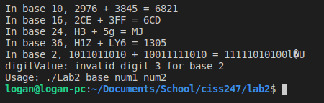

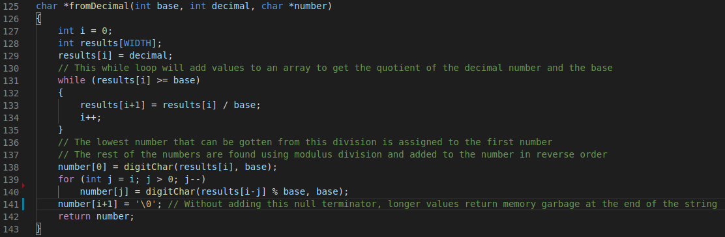
The fix I used (line 141):

